|  |  |  |
| --- | --- | --- |
| **O****WNER**:  **DG TAXUD** | **ISSUE DATE:**  06/12/2019 | **VERSION:**  **5.00** |
| **Taxation and Customs Union DG**  SUBJECT:  **Design Document for National Export Application (DDNXA) for AES-P1** | | |
| Framework Contract  **Specific Contract 21** | | |

Document History

| **Edition** | **Revision** | **Date** | **Description** | **Action[1]** | **Pages** |
| --- | --- | --- | --- | --- | --- |
| 2 | 00 | 01/03/2019 | Implementing QTMR291.  Submitted for Review (SfR) to Taxation and Customs Union DG. | I/R | All |
| 2 | 10 | 28/04/2019 | Implementing QTMR291.  Submitted for Acceptance (SfA) to Taxation and Customs Union DG. | I/R | All |
| 2 | 12 | 29/05/2019 | Implementing QTMR291.  Submitted for Information (SfI) to Taxation and Customs Union DG. | I/R | All |
| 3 | 00 | 24/06/2019 | Implementing QTMR291.  Submitted for Review (SfR) to Taxation and Customs Union DG. | I/R | All |
| 3 | 01 | 10/07/2019 | Implementing QTMR291.  Submitted for Information (SfI) to Taxation and Customs Union DG | I/R | All |
| 3 | 10 | 02/08/2019 | Implementing QTMR291.  Submitted for Acceptance (SfA) to Taxation and Customs Union DG. | I/R | All |
| 4 | 00 | 26/08/2019 | Implementing QTMR291.  Submitted for Review (SfR) to Taxation and Customs Union DG. | I/R | All |
| 4 | 10 | 13/09/2019 | Implementing QTMR291.  Submitted for Acceptance (SfA) to Taxation and Customs Union DG. | I/R | All |
| 4 | 11 | 16/10/2019 | Implementing QTMR291.  Submitted for Information (SfI) to Taxation and Customs Union DG. | I/R | All |
| 5 | 00 | 06/12/2019 | Implementing QTMR291.  Submitted for Review (SfR) to Taxation and Customs Union DG. | I/R | All |

Table of Contents

Document History 2

Table of Contents 3

List of Appendices 6

List of Figures 7

List of Tables 14

I General Introduction 16

I.1 Document Overview 16

I.1.1 Purpose of DDNA document 16

I.1.2 DDNA Structure 16

I.1.3 Purpose of the DDNXA for AES volume 17

I.1.4 Scope of DDNXA volume 17

I.1.5 Intended audience 18

I.1.6 Structure of DDNXA volume 19

I.1.7 Document service information 21

I.1.8 Definitions 21

I.1.9 Terminology 21

I.1.10 Acronyms and Abbreviations 22

I.2 Applicable and reference documents 23

I.2.1 Applicable documents 23

I.2.2 Reference documents 26

I.2.3 AES L4 BPMs/FSS & EUCDM 27

I.2.4 Alignment to UCC Data Annex B 28

I.2.5 DDNXA usage policy 31

I.3 Symbolism and Conventions Used 32

II Scope of development 33

II.1 Information Exchange overview 33

II.2 Information Exchange Maps 33

II.3 Message format definition policy 35

III AES 36

III.1 Introduction 36

III.1.1 Overview 38

III.1.2 Physical movements 40

III.1.3 Export Actors 40

III.2 Scenarios and Time Sequence Diagrams 41

III.3 Time Sequence Diagrams versus State Transition Diagrams 42

III.4 Time Sequence Diagrams 42

III.4.1 Export Process 42

III.4.2 Exit Summary Declaration 274

III.4.3 Re-Export Notification 303

III.5 State Transition Diagrams 325

III.5.1 Customs Office of Export STD 326

III.5.2 Customs Office of Lodgement STD 340

III.5.3 Customs Office of Exit STD 341

III.5.4 Presentation Customs Office STD 361

III.6 Timers 365

III.6.1 Functional Timers 365

III.6.2 Timely Response Recommendations 373

III.6.3 CCN/CSI Related Timers 373

IV AES Transitional Scenarios 375

IV.1 Introduction 375

IV.2 Identification of “To Be” NA operational mode in Common Domain 376

IV.2.1 Start of operations in the “To Be” NA operational mode in Common Domain Phase 376

IV.2.2 Not implemented/supported functionality 376

IV.2.3 Identification of Recipient NA operational mode by Sender in “To Be” 376

IV.3 Scope during Transition Period 377

IV.3.1 Mandatory Existing processes (continuity) 377

IV.3.2 New processes between “To Be” countries 409

IV.3.3 Existing processes being phased out 444

IV.3.4 Existing processes upgraded under UCC to be applied at the end of the Transition 444

IV.3.5 AES-P1Transitional Scenarios and Time Sequence Diagrams 451

IV.4 Principles for Data Structures and IEs during TP 468

IV.4.1 Data Mapping and Conversion of IEs 469

IV.4.2 Technical Message Structures 471

IV.4.3 Decisive date for BRT/TRT validation 473

IV.4.4 Codelist Analysis and Mapping between “Legacy” and “To Be” 473

IV.4.5 R&Cs in NCTS-P4/ECS-P2 473

IV.5 Protocol for Common Domain exchanges during TP 474

IV.5.1 General principles 474

IV.5.2 Common domain exchange patterns 474

V Central Services 476

VI Systems Administration 477

VII Technical Message Structure 478

VIII Design principles 479

VIII.1 Approach 479

VIII.2 Exception Handling 479

VIII.3 Constraints 479

VIII.3.1 Timing constraints 479

VIII.3.2 Suspension of sending messages 479

IX XML message formatting 480

X Transport of messages via CCN/CSI 481

X.1 The CCN communication reminder 481

X.1.1 The Quality of Service 481

List of Appendices

Appendix A: Message Scope Appendix

Appendix B: Transitional Analysis Appendix

Appendix J: AES Correlation Tables Appendix

Appendix K: Rules and Conditions Mapping Appendix

Appendix M: Scenario Transition Analysis output Appendix

Appendix N: State Machine Transition Analysis output Appendix

Appendix Q2: Technical Message Structures Appendix

Appendix R: XML Mapping Appendix

Appendix X: XML Schemas Appendix

Appendix Y: Data Groups & Transaction Hierarchy Appendix

Appendix Z: Data Items Appendix

List of Figures

Figure 1: Information Exchange Map of AES 34

Figure 2: Hierarchical organisation of scenarios (levelling) 36

Figure 3: Unique identification of scenarios 37

Figure 4: Classification of scenarios for AES system L0-L1-L2 38

Figure 5: Overview of Information Exchanges between Customs Offices 39

Figure 6: Export Process 43

Figure 7: Core Flow scenario 43

Figure 8: E-EXP-CFL-M-001 Core flow 46

Figure 9: Export specific scenarios 47

Figure 10: E-EXP-EXP-A-001 Control at Export with release for Export (Standard declaration) 49

Figure 11: E-EXP-EXP-A-002 Control at Export with release for Export refused 50

Figure 12: E-EXP-EXP-A-003 Declaration submission prior to presentation 54

Figure 13: E-EXP-EXP-A-004 Correction of the pre-lodged declaration prior to presentation of goods 58

Figure 14: E-EXP-EXP-A-005 Cancellation of the pre-lodged declaration prior to presentation of goods 61

Figure 15: E-EXP-EXP-E-001 Declaration submission prior to presentation with timer expiry 63

Figure 16: E-EXP-EXP-A-006 Declaration submission prior to presentation with invalid presentation notification 66

Figure 17: E-EXP-EXP-A-007 Export and Exit when the customs office of export is the customs office of exit 69

Figure 18: E-EXP-EXP-E-002 Rejection of declaration 70

Figure 19: E-EXP-EXP-A-008 Declaration amendment accepted 72

Figure 20: E-EXP-EXP-E-003 Declaration amendment rejected 74

Figure 21: Centralised Clearance specific scenarios 75

Figure 22: E-EXP-CCE-M-001 SCO recommends pre-release - No controls at SCO and PCO 81

Figure 23: E-EXP-CCE-A-001 SCO recommends pre-release - Satisfactory/considered satisfactory control results at PCO 84

Figure 24: E-EXP-CCE-A-002 SCO recommends pre-release - Unsatisfactory control results at PCO 87

Figure 25: E-EXP-CCE-E-001 SCO recommends pre-release – Expiry of timer for receiving control decision from PCO 89

Figure 26: E-EXP-CCE-A-003 SCO recommends control at PCO – Satisfactory/Considered satisfactory control results at PCO 93

Figure 27: E-EXP-CCE-A-004 SCO recommends control at PCO - Unsatisfactory control results at PCO 96

Figure 28: E-EXP-CCE-E-002 SCO recommends control at PCO - PCO decides not to perform any control 99

Figure 29: E-EXP-CCE-E-003 SCO recommends control at PCO - Expiry of timer for receiving control decision from PCO 102

Figure 30: E-EXP-CCE-A-005 Unsatisfactory documentary control results at SCO 104

Figure 31: E-EXP-CCE-A-006 Declaration amendment accepted under centralised clearance 107

Figure 32: Declaration Invalidation scenarios 108

Figure 33: E-EXP-INV-A-001 Invalidation by Trader before release of the movement for Export 110

Figure 34: E-EXP-INV-A-002 Invalidation requested by Trader for a Released Movement 112

Figure 35: E-EXP-INV-A-003 Invalidation initiated by the Customs Officer at Export 114

Figure 36: E-EXP-INV-E-001 Invalidation requested by Trader before the release of the movement for export refused 116

Figure 37: E-EXP-INV-A-004 Invalidation requested by Trader for a released movement refused 117

Figure 38: E-EXP-INV-A-009 Invalidation requested by Trader for a released movement refused by the Customs Office of Exit 122

Figure 39: Simplified and Supplementary Declaration specific scenarios 123

Figure 40: E-EXP-SSD-M-001 Simplified Declaration 125

Figure 41: E-EXP-SSD-A-001 Control at Export with release for Export (Simplified Declaration) 127

Figure 42: E-EXP-SSD-A-002 Recording of Supplementary Declaration 128

Figure 43: E-EXP-SSD-E-001 Rejection of Supplementary Declaration 129

Figure 44: E-EXP-SSD-E-002 Expiry of timer for lodgement of Supplementary Declaration 130

Figure 45: E-EXP-SSD-A-003 Recording of Supplementary Declaration under centralised clearance 132

Figure 46: Goods under Excise duty suspension arrangement specific scenarios 133

Figure 47: E-EXP-GUE-M-001 Core flow with goods under excise duty suspension arrangement 139

Figure 48: E-EXP-GUE-E-001 Rejection of declaration with goods under excise duty suspension arrangement due to e-AD request rejectionE-EXP-GUE-M-001 Core flow with goods under excise duty suspension arrangement 140

Figure 49: E-EXP-GUE-E-002 Rejection of declaration with goods under excise duty suspension arrangement due to negative cross-check 141

Figure 50: E-EXP-GUE-A-001 Control at Export with release for Export when goods are under excise duty suspension arrangement 144

Figure 51: E-EXP-GUE-A-002 Control at Export with release for Export refused when goods are under excise duty suspension arrangement 145

Figure 52: E-EXP-GUE-A-003 Control at Exit with release for Exit refused when goods are under excise duty suspension arrangement 148

Figure 53: E-EXP-GUE-A-004 Declaration submission prior to presentation when goods are under excise duty suspension arrangement 153

Figure 54: E-EXP-GUE-A-005 Correction of the pre-lodged declaration prior to presentation of goods when goods are under excise duty suspension arrangement 159

Figure 55: E-EXP-GUE-A-006 Cancellation of the pre-lodged declaration prior to presentation of goods when goods are under excise duty suspension arrangement 161

Figure 56: E-EXP-GUE-E-003 Declaration submission prior to presentation with timer expiry when goods are under excise duty suspension arrangement 163

Figure 57: E-EXP-GUE-A-007 Declaration amendment accepted when goods are under excise duty suspension arrangement 167

Figure 58: Exit specific scenarios 169

Figure 59: E-EXP-EXT-E-001 Rejection of arrival notification 170

Figure 60: E-EXP-EXT-A-001 Control at Exit with release for Exit 172

Figure 61: E-EXP-EXT-A-002 Control at Exit with release for Exit refused 174

Figure 62: E-EXP-EXT-A-003 Arrival at Exit registered by customs officer 176

Figure 63: E-EXP-EXT-A-004 Exit after Storing 178

Figure 64: E-EXP-EXT-A-005 Exit after reception of multiple manifests 181

Figure 65: E-EXP-EXT-E-002 Rejection of Manifest 183

Figure 66: E-EXP-EXT-A-006 Exit information available through other systems 185

Figure 67: Export Followed by Transit specific scenarios 186

Figure 68: E-EXP-EFT-M-001 Core Flow of the Export Followed by Transit – External Transit 190

Figure 69: E-EXP-EFT-M-002 Core Flow of the Export Followed by Transit – Internal Transit 193

Figure 70: E-EXP-EFT-A-002 Lodgement of Transit Declaration having Export as Previous Procedure – Unknown Export MRN and Positive IE503 197

Figure 71: E-EXP-EFT-A-003 Amendment of a Transit declaration 200

Figure 72: E-EXP-EFT-A-007 Invalidation by Transit 202

Figure 73: E-EXP-EFT-A-004 Departure notifies Office of Exit for non appropriate Office of Destination – Release for Exit by alternative evidence 206

Figure 74: E-EXP-EFT-A-005 Non-appropriate Office of Destination – Invalidation 210

Figure 75: E-EXP-EFT-A-008 Departure notifies Office of Exit of unsatisfactory destination control results - Release for Exit by alternative evidence 213

Figure 76: E-EXP-EFT-A-009 Departure notifies Office of Exit of destination unsatisfactory control results - Invalidation due to lack of or insufficient alternative evidence 216

Figure 77: Diversions specific scenarios 221

Figure 78: E-EXP-DIV-M-001 International Diversion accepted 224

Figure 79: E-EXP-DIV-A-001 International Diversion rejected 226

Figure 80: E-EXP-DIV-A-002 Multiple Diversions 230

Figure 81: Query Movement Information specific scenarios 231

Figure 82: E-EXP-QMI-M-001 Movement Information available 231

Figure 83: E-EXP-QMI-E-001 Movement Information unavailable 232

Figure 84: Enquiry Procedure specific scenarios 233

Figure 85: E-EXP-ENQ-M-001 238

Figure 86: E-EXP-ENQ-A-001 Expiry of time limit to receive exit results – Confirmation of exit by Alternative Evidence (Enquiry information code: “Exited-Alternative Evidence”) 241

Figure 87: E-EXP-ENQ-E-001 Expiry of time limit to receive exit results – Invalid Enquiry information/Insufficient Alternative Evidence, if any 244

Figure 88: E-EXP-ENQ-A-002 Expiry of timer to receive exit results - Invalidation after expiry of time limit to receive Alternative Evidence 247

Figure 89: E-EXP-ENQ-A-003 Expiry of time limit to receive exit results – Enquiry information code: “Expected to Exit” 250

Figure 90: E-EXP-ENQ-A-004 Expiry of time limit to receive exit results – Enquiry information code: “Will not exit” 252

Figure 91: E-EXP-ENQ-A-005 Expiry of time limit to receive exit results after international diversion occurred - Exit Results received after Enquiry Procedure 254

Figure 92: E-EXP-ENQ-A-006 Trader sends Enquiry Information on his/her own initiative (Enquiry information code: “Exited-Alternative Evidence” or “Exited-No Alternative Evidence”) - Exit Results received after Enquiry Procedure 257

Figure 93: E-EXP-ENQ-A-007 Trader sends Enquiry Information on his/her own initiative (Enquiry information code: “Exited-Alternative Evidence”) - Confirmation of exit by Alternative Evidence 260

Figure 94: E-EXP-ENQ-A-008 Trader sends Enquiry Information on his/her own initiative (Enquiry information code: “Exited-Alternative Evidence”) - Insufficient Alternative Evidence 262

Figure 95: E-EXP-ENQ-A-009 Trader sends Enquiry Information on his/her own initiative (Enquiry information code: “Exited-No Alternative Evidence”) – No Release for Exit at the Customs Office of Exit 265

Figure 96: E-EXP-ENQ-E-002 Trader sends Enquiry Information on his/her own initiative (Enquiry information code: “Exited-Alternative Evidence” or “Exited-No Alternative Evidence”) - Invalid Enquiry Information 267

Figure 97: Exception of message sequencing in the Common Domain specific scenarios 268

Figure 98: E-EXP-EMS-M-001 Status request/response 270

Figure 99: E-EXP-EMS-A-001 Status request/response with release for exit 271

Figure 100: E-EXP-EMS-A-002 AER missing 273

Figure 101: Exit Summary Declaration specific scenarios 274

Figure 102: Core Flow Specific Scenario 274

Figure 103: E-EXS-CFL-M-001 Core Flow 276

Figure 104: Lodgement specific scenarios 276

Figure 105: E-EXS-LDG-A-001 EXS lodged at another customs office 279

Figure 106: E-EXS-LDG-E-001 Declaration rejected 280

Figure 107: Exit specific scenarios 280

Figure 108: E-EXS-EXT-E-001 Rejection of arrival notification 281

Figure 109: EXS Amendment Accepted 283

Figure 110: E-EXS-EXT-E-002 EXS Amendment Rejected 285

Figure 111: E-EXS-EXT-A-002 Control at Exit with release for Exit 286

Figure 112: E-EXS-EXT-A-003 Control at Exit with release for Exit refused 287

Figure 113: E-EXS-EXT-A-004 Arrival at Exit registered by customs officer 288

Figure 114: E-EXS-EXT-E-003 Exit notification not received 290

Figure 115: E-EXS-EXT-E-004 Initial manifest rejected 291

Figure 116: E-EXS-EXT-A-005 Exit after Storing 292

Figure 117: E-EXS-EXT-A-006 Exit after reception of multiple manifests 294

Figure 118: E-EXS-EXT-A-007 Exit information available through other systems 295

Figure 119: Diversions specific scenarios 296

Figure 120: E-EXS-DIV-M-001 Diversion Accepted 297

Figure 121: E-EXS-DIV-Α-001 Diversion Rejected 299

Figure 122: Invalidation specific scenarios 300

Figure 123: E-EXS-INV-A-001 Invalidation requested by Trader 301

Figure 124: E-EXS-INV-E-001 Invalidation requested by Trader refused 302

Figure 125: Re-Export Notification specific scenarios 303

Figure 126: Core flow specific scenario 303

Figure 127: E-REN-CFL-M-001 Core flow 305

Figure 128: Registration specific scenarios 306

Figure 129: E-REN-REG-E-001 Rejection of Re-Export Notification 307

Figure 130: E-REN-REG-A-001 Control at Exit with release for Exit 308

Figure 131: E-REN-REG-Α-002 Control at Exit with release for exit refused 309

Figure 132: E-REN-REG-A-003 Re-Export Notification amendment accepted 310

Figure 133: E-REN-REG-E-002 Re-Export Notification amendment rejected 311

Figure 134: Exit specific scenarios 312

Figure 135: E-REN-EXT-E-001 Exit Notification not received 314

Figure 136: E-REN-EXT-A-001 Exit after Storing 315

Figure 137: E-REN-EXT-E-002 Initial manifest rejected 316

Figure 138: E-REN-EXT-A-002 Exit after reception of multiple manifests 318

Figure 139: E-REN-EXT-E-003 Rejection of exit notification 320

Figure 140: E-REN-EXT-A-003 Exit information available through other systems 321

Figure 141: Invalidation specific scenarios 322

Figure 142: E-REN-INV-A-001 Invalidation requested by Trader 323

Figure 143: E-REN-INV-E-001 Invalidation requested by Trader refused 324

Figure 144: State Transition Diagram for the Customs Office of Export up to the release of the movement 333

Figure 145: State Transition Diagram for the Customs Office of Export after the release of the movement 337

Figure 146: State Transition Diagram for Customs Office of Export – Invalidation 339

Figure 147: State Transition Diagram for the Customs Office of Lodgement 341

Figure 148: State Transition Diagram for the Customs Office of Exit when processing an Export Declaration 347

Figure 149: State Transition Diagram for Customs Office of Exit – Invalidation 348

Figure 150: State Transition Diagram for the Customs Office of Exit when processing an EXS 354

Figure 151: State Transition Diagram for Customs Office of Exit - EXS - Invalidation 355

Figure 152: State Transition Diagram for the Customs Office of Exit when processing a Re-Export Notification 359

Figure 153: State Transition Diagram for Customs Office of Exit - Re-Export Notification - Invalidation 360

Figure 154: State Transition Diagram for Presentation Customs Office - Export Declaration 364

Figure 155: Exception and expiration reports 374

Figure 156: Additional Information Exchanges scope for Export Process - Declaration submission prior presentation related to New processes between “To Be” countries functionality 413

Figure 157: Existing processes upgraded under UCC to be applied at the end of the Transition 446

Figure 158: Information Exchanges in the scope of Existing processes upgraded under UCC to be applied at the end of the Transition 450

Figure 159: E-EXP-INV-A-TP-009 Invalidation requested by Trader for a released movement refused by the Customs Office of Exit (Transitional Scenario) (Case 1: Office of Export [AES] and Office of Exit [ECS-P2]) 453

Figure 160: E-EXP-INV-A-TP-009 Invalidation requested by Trader for a released movement refused by the Customs Office of Exit (Transitional Scenario) (Case 2: Office of Export [ECS-P2] and Office of Exit [AES]) 455

Figure 161: E-EXP-EFT-A-TP-004 Non-appropriate Office of Destination - Release for Exit by alternative evidence (Transitional Scenario) (Case 1: Office of Export [AES] and Office of Exit [ECS-P2]) 457

Figure 162: E-EXP-EFT-A-TP-004 Non-appropriate Office of Destination - Release for Exit by alternative evidence (Transitional Scenario) (Case 2: Office of Export [ECS-P2] and Office of Exit [AES]) 459

Figure 163: E-EXP-QMI-E-TP-001 Movement Information unavailable (Transitional Scenario) (Case 1: Office of Export [ECS-P2] and Requesting Customs Office [AES-P1]) 460

Figure 164: E-EXP-QMI-E-001 Movement Information unavailable (Transitional Scenario) (Case 2: Office of Export [AES-P1] and Requesting Customs Office [ECS-P2]) 461

Figure 165: ECSP2-EXP-ENQ-TP-Follow-Up with exit resumed (Transitional Scenario)(Case 1: Office of Export [ECS-P2] and Office of Exit [AES]) 462

Figure 166: ECSP2-EXP-ENQ-TP-Follow-Up with negative response (Transitional Scenario) (Case 1: Office of Export [ECS-P2] and Office of Exit [AES]) 464

Figure 167: E-EXP-EFT-A-TP-006 Departure notifies Office of Exit of unsatisfactory destination control results - Release for Exit by alternative evidence (Transitional Scenario) (Case 1: Office of Export [AES] and Office of Exit [ECS-P2]) 466

Figure 168: E-EXP-EFT-A-TP-006 Departure notifies Office of Exit of unsatisfactory destination control results - Release for Exit by alternative evidence (Transitional Scenario) (Case 2: Office of Export [ECS-P2] and Office of Exit [AES]) 468

Figure 169: Upgrade and Downgrade IE conversion 469

Figure 170: Conversion Technical Specifications 470

Figure 171: Technical Message Structures and BRTs/TRTs 472

Figure 172: The data structure for the transition and final periods by orchestrating the BRT and TRT 472

List of Tables

Table 1: Acronyms and Abbreviations 23

Table 2: Applicable Documents 25

Table 3: Reference Documents 27

Table 4: Justified deviations with UCC Data Annex B [A6] 29

Table 5: Justified deviations with UCC Data Annex B [A6] 31

Table 6: Role types and organisations in Export Control 41

Table 7: States of an MRN at a Customs Office of Export 340

Table 8: States of an MRN at a Customs Office of Lodgement 341

Table 9: States of an MRN at a Customs Office of Exit for Export Process 349

Table 10: States of an MRN at a Customs Office of Exit for an EXS 356

Table 11: States of an MRN at a Customs Office of Exit for a Re-Export Notification 361

Table 12: States of an MRN at a Presentation Customs Office 365

Table 13: Functional Timers 372

Table 14: AES-P1 Export Process scenarios related to Mandatory Existing processes (continuity) 391

Table 15: States of an MRN at a Customs Office of Export during TP for Mandatory Existing processes (continuity) - Export Process (IV.3.1.1) 393

Table 16: States of an MRN at a Customs Office of Exit during TP for Mandatory Existing processes (continuity) - Export Process (IV.3.1.1) 395

Table 17: Information Exchanges scope for Export Process - Mandatory Existing processes (continuity) 398

Table 18: AES-P1 Exit Summary Declaration related to Mandatory Existing processes (continuity) 402

Table 19: States of an MRN at a Customs Office of Exit during TP for Mandatory Existing processes (continuity) - Exit Summary Declaration (IV.3.1.2) 404

Table 20: Information Exchanges scope for Exit Summary Declaration - Mandatory Existing processes (continuity) 406

Table 21: Other Scenarios from “Legacy” phase to be supported in “To Be” 408

Table 22: AES-P1 Export Process - Declaration submission prior presentation scenarios related to New processes between “To Be” countries processes 410

Table 23: States changes of an MRN at a Customs Office of Export for Export Process - Declaration submission prior presentation scenarios related to New processes between “To Be” countries processes 412

Table 24: AES-P1 Export Process – Centralised Clearance scenarios related to New processes between “To Be” countries functionality 415

Table 25: States changes of an MRN at a Customs Office of Export for Export Process - Declaration submission prior presentation scenarios related to New processes between “To Be” countries processes 418

Table 26: Additional Information Exchanges scope for Export Process – Centralised Clearance related to New processes between “To Be” countries functionality 420

Table 27: AES-P1 Export Process - Simplified and Supplementary Declaration scenarios related to New processes between “To Be” countries functionality 421

Table 28: Additional Information Exchanges scope for Export Process - Simplified and Supplementary Declaration related to New processes between “To Be” countries functionality 423

Table 29: AES-P1 Export Process - Export Followed by Transit scenarios related to New processes between “To Be” countries functionality 426

Table 30: States changes of an MRN at a Customs Office of Exit for Export Process - Export Followed by Transit 428

Table 31: Additional Information Exchanges scope for Export Process - Export Followed by Transit related to New processes between “To Be” countries functionality 430

Table 32: AES-P1 Export Process - Goods under Excise duty suspension arrangement scenarios related to New processes between “To Be” countries functionality 432

Table 33: Additional Information Exchanges scope for Export Process - Goods under Excise duty suspension arrangement related to New processes between “To Be” countries functionality 434

Table 34: AES-P1 Export Process - Centralised Clearance & Simplified and Supplementary Declaration scenarios related to New processes between “To Be” countries functionality 436

Table 35: Additional Information Exchanges scope for AES-P1 Export Process - Centralised Clearance & Simplified and Supplementary Declaration related to New processes between “To Be” countries functionality 437

Table 36: AES-P1 Export Process - Declaration submission prior presentation & Goods under Excise duty suspension arrangement scenarios related to New processes between “To Be” countries functionality 440

Table 37: AES-P1 Re-Export Notification scenarios related to New processes between “To Be” countries functionality 442

Table 38: Information Exchanges scope for AES-P1 Re-Export Notification related to New processes between “To Be” countries functionality 444

Table 39: States changes of an MRN at a Customs Office of Exit for additional CD exchanges with Customs Office of Lodgement related to Existing processes upgraded under UCC to be applied at the end of the Transition 448

Table 40: Decisive date for BRT/TRT validation 473

Table 41: Common Domain exchanges patterns during TP 475

Table 42: Suspension of sending messages for AES 479

Table 43: Main Information Exchanges for AES 482

# General Introduction

## Document Overview

### Purpose of DDNA document

The DDNA, the **Design Document for National Applications**, supersedes the Design Document for National Applications for NCTS Phase 4 (NCTS-P4), NCTS Phase 5 (NCTS-P5), ECS Phase 2 (ECS-P2), AES and ICS Phase 1 (ICS-P1). It specifies the design requirements to which any Customs Movement Application needs to conform. The DDNA is applicable to every Customs Movement Application and must be considered as a mandatory document for all implementation and verification activities.

The DDNA is **applicable to every Transit and Export Control Application** and must be considered as a mandatory document for all implementation and verification activities.

The DDNA consists of six volumes. Two volumes exist for Transit (NCTS-P4 and NCTS-P5), two volumes for Export (ECS-P2 and AES) and one volume for ICS-P1 defining the design requirements of the specific system and phase. In addition, one common volume exists for all systems defining the common operations and methods. This volume is the Design Document for Common Operations and Methods (DDCOM) volume. For more information about DDNXA’s purpose and structure, please refer to sections I.1.3 and I.1.6 respectively.

Information Exchanges are foreseen in the Common Domain (between National Administrations), in the National Domain (local to a National Administration), and in the External Domain (between National Administration and Traders). Common Domain exchanges will always take place via the CCN/CSI communication platform or the Inter(Extra)net. The different formatting and transport mechanisms will therefore be defined in detail in the DDNA. Moreover, additional design constraints and additional details on error and exception handling will be stated.

Within the Customs systems, the Central Project Team (CPT) will produce a number of Centrally Developed Customs Application (CDCA) tools (e.g. STTA[2], TTA2, CS/RD2, CS/MIS, CS/ieCA[3] and CTA3) in order to assist the NAs in implementing, verifying and operating their National Customs Application (NCA). All these CDCA tools must conform to this document, although their specification is not part of this document. In order to construct an NCA, the NA should therefore use this document, in order to decide which functionality remains to be implemented.

### DDNA Structure

The DDNA consists of the following six volumes:

* Design Document for National Transit Application volume (DDNTA) for NCTS-P4;
* Design Document for National Export Application volume (DDNXA) for ECS-P2;
* Design Document for National Import Application volume (DDNIA) for ICS-P1;
* Design Document for National Transit Application volume (DDNTA) for NCTS-P5;
* Design Document for National Export Application volume (DDNXA) for AES;
* Design Document for Common Operations and Methods volume (DDCOM).

### Purpose of the DDNXA for AES volume

This volume, which is the **Design Document for National Export Applications** for AES, is applicable to every AES Application and must be considered as a mandatory document for all implementation and verification activities.

The purpose of this volume is twofold:

* To state unambiguously what needs to be developed. This will be achieved by specifying the sequences of Information Exchanges to be supported, as a number of message exchange protocols, the State Transition Diagrams and the detailed structure and building rules of these Information Exchanges.

Regarding the Message Exchange Protocols and the State Transition Diagrams, this volume will also define any Transitional Message Exchange Protocols (Transitional scenarios) for AES in case they are different from Message Exchange Protocols in Post Transitional phase.

* To define how the Information Exchanges need to be performed and transported between the Export Control Applications. The message formatting, the technical as well as the transport mechanisms are described in the DDCOM volume [A11].

This volume addresses two dimensions:

* the TO-BE functionality (chapter III)
* the transition from legacy AS-IS to final TO-BE (chapter IV).

### Scope of DDNXA volume

The DDNXA volume is applicable to AES-P1. It implements the relevant UCC DA/IA and UCC Data Annex B applicable to Export and Exit domains (TO-BE functionality) as well as includes the transition analysis and the definition of necessary scenarios (and Time Sequence Diagrams) which shall be applied during the transitional period (hereafter Transitional Scenarios) – please refer to Scope during Transition Period in section IV.3.

This volume is restricted to the electronic Information Exchanges within AES-P1.

The DDNXA volume had as starting point [R10] and [R11] (please see I.2.3) and as basis the UCC Data Annex B [A6] and relevant UCC legal provisions. These elaborated by implementing decisions from the technical specifications Project Groups meetings.

AES-P1 TO-BE functionality covers the handling of:

* The Export Process, which consists of:
  + The Customs formalities at the Customs Office of Export/Supervising Customs Office (in the case of Centralised Clearance) regarding the Customs declaration acceptance, declaration amendment, the movement controls, the goods release for export, the certification of goods exit and the Supplementary Declaration acceptance;
  + The Customs formalities at the Customs Office of Exit regarding the movement arrival at exit, the movement controls and the goods release for exit;
  + The Customs formalities at the Presentation Customs Office (in the case of Centralised Clearance) regarding the handling of pre-release recommendation from Supervising Customs Office, handling of control recommendation from Supervising Customs Office and the movement controls at Presentation Customs Office.

The above include cases of Goods under Excise duty suspension arrangement (interface with EMCS) and Export Followed by Transit (interface with NCTS).

* The Exit Summary Declaration, which consists of:
  + The Customs formalities at the Customs Office of Exit regarding the EXS acceptance, the movement arrival at exit, the movement controls, the goods release for exit and the EXS amendment;
  + The Customs formalities at the Customs Office of Lodgement regarding the EXS acceptance.
* Re-Export Notification, which concerns non-union goods, consists of:
  + The Customs formalities at the Customs Office of Exit regarding the notification acceptance, the movement controls, the goods release for exit and the notification amendment.

It should be noted that for the (mandatory) Information Exchanges (Information Exchanges in the Common Domain), DDNXA should therefore be considered as an applicable document, while for the category of (Recommended, Strongly Recommended or Optional) Information Exchanges, DDNXA should only be considered as a guideline with recommendations. The applicability of DDNXA is discussed further in this document (see Scope of development).

### Intended audience

The intended audience for this document includes:

* EC services and National Customs administration services responsible for the functional specifications of AES;
* EC services and National Customs administration services and Economic Operators Service Providers responsible for the development of software in the context of AES;
* EC services and National Customs administration services and Economic Operators responsible for the definition of tests for AES;
* Anyone within the affected service suppliers in the CCN/CSI projects responsible for the delivery of the required services to AES;
* Any other authorised body affected by AES, including Electronic Customs Group, OLAF, and Traders Associations.

Readers are assumed to have a good understanding of the IT concepts and terminology used in this document. Also, it is assumed that readers are familiar with [A6]

### Structure of DDNXA volume

This document comprises the sections, chapters and lists of appendices summarised below:

**I General Introduction** includes the following chapters:

* Chapter 1 describes the **purpose** and the **scope** of DDNXA for AES, the **intended audience**, the **internal structure** of the document,plus some document **service information**. Additionally, it contains **definitions** used in this document (terminology, acronyms and abbreviations);
* Chapter 2 describes the **relationship of this document with other Customs baseline documents**. It defines dependencies with these documents and states the applicability of these documents. It also explains how this document, together with the other Customs documentation, should be used during the development and verification of any Customs application;
* Chapter 3 describes the **symbolism and the conventions** used in the various models included in this document. It also discusses the technical naming conventions used for the data dictionary that has been included in this document.

**II Scope of development** describes the items that need to be developed in AES-P1 applications. In addition, describes the transitional scenarios that might be necessary for implementation during Transition Period. Appendix A for AES accompanies this section. This section provides an overview of Information Exchanges between different business roles.

**III AES** describes the Business for the complete AES-P1 (TO-BE functionality). It deals with the Export scenarios performed by the different parties in Export (Customs Office of Export, Customs Office of Exit, Customs Office of Lodgement, Supervising Customs Office, Presentation Customs Office, Declarant/Representative, Trader at Exit and Declarant/Representative for Export Control and processing the Exit Summary Declaration and the Re-Export Notification.

The following sections contain a detailed definition of the **message protocols** to be supported for the different Business Processes in Export. These message protocols are described by a collection of **Time Sequence Diagrams**, supported by **State Transition Diagrams**.

**IV AES Transitional Scenarios** provides the outcome of transition analysis and the definition of necessary scenarios (and Time Sequence Diagrams and if any State Transition Diagrams) which shall be applied during the transitional period.

**VI Systems Administration** deals with issues such as logging and tracing and any other administration function to be foreseen.

**VII Technical Message Structure** defines the detailed technical structure of the Information Exchanges of AES.

**VIII Design principles**explains how the system, defined in the previous sections, needs to be built. Basically, every Information Exchange, needs to be formatted in XML format and needs to be transmitted across CCN/CSI. This section states a number of principles that are common, regardless of the message format and transportation mechanism.

**IX XML message formatting** defines how messages need to be formatted in an XML format.

**X** **Transport of messages via CCN/CSI** defines how messages need to be transported across the CCN/CSI communication platform.

**APPENDICES FOR AES**

* Appendix A defines the Message Scope for AES;
* Appendix B describes the transitional analysis approach;
* Appendix C contains a definition of all Code Lists used for AES. This Appendix is accompanied with Appendix C2, which contains all business Code Lists and their domain applicability;
* Appendix J presents how the different Data Groups and Data Items are correlated to the messages;
* Appendix K presented the mapping of Rules and Conditions;
* Appendix M defines the output of Scenarios Transition Analysis as per approach explained in Appendix B.
* Appendix N defines the output of State Machine Transition Analysis as per approach explained in Appendix B.
* Appendix Q contains the definition of all messages for AES;
* Appendix R contains the XML mapping of all Data Items and Data Groups of the AES messages;
* Appendix X contains the XML Schemas of the AES messages;
* Appendix Y and Appendix Z contain a data dictionary for all elements (Data Items and Data Groups) used to construct these messages.

### Document service information

The different parts that constitute DDNA will each be submitted individually to configuration and version control. Individual components may be upgraded and delivered separately.

Maintenance will be provided for this document. The Taxation and Customs Union DG will define and schedule the different deliveries.

Comments can be submitted to this document, either via organised reviews or via calls to the ITSM Service Desk.

Whenever a part of this document is referred to, reference will be given either to an entire section or an entire chapter (within a section) or a paragraph (for any other subdivision).

This document will be submitted as a Word file with the following naming convention:

* DDNXA-Main Document-vy.zz-Sfaa, where vy and zz are version and revision numbers. ‘aa’ is if the document is submitted for Information (‘I’) or for Review (‘R’) or for Acceptance (‘A’).

All appendices (except the appendix X) of AES will be delivered as:

* DDNXA-APP_W-vy.zz-Sfaa.DDD, where:
  + W stands for the Appendix name;
  + y and zz are version and revision numbers;
  + DDD is the document type;
* aa is if the document is submitted for Information (‘I’) or for Review (‘R’) or for Acceptance (‘A’).

### Definitions

Definitions of many of the terms used in this document may be found in the “Glossary of Terms” (R3]).

### Terminology

The corresponding chapter from DDCOM [A11] is applicable to AES.

### Acronyms and Abbreviations

The following acronyms are used in this document:

| **Acronym** | **Description** |
| --- | --- |
| AAR | Anticipated Arrival Record |
| AEO | Authorised Economic Operator |
| AER | Anticipated Export Record |
| AES | Automated Export System |
| ARC | Administrative Reference Code |
| CCN | Common Communication Network |
| CD | Common Domain |
| CDCA | Centrally Developed Customs Application |
| CoA | Confirm on Arrival |
| CoD | Confirm on Delivery |
| OoDep | Customs Office of Departure |
| OoExp | Customs Office of Export |
| OoExt | Customs Office of Exit |
| COL | Customs Office List |
| OoLdg | Customs Office of Lodgement |
| OoReq | Requesting Customs Office |
| CPT | Central Project Team |
| CS/ieCA | Central Services IE Conversion Application |
| CS/MIS | Central Services Management Information System |
| CS/RD2 | Central Services Reference Data |
| CSE | Consolidated Specifications Environment |
| CSI | Common Systems Interface |
| DDNA | Design Document for National Applications |
| DDNTA | Design Document for National Transit Applications |
| DDNXA | Design Document for National Export Applications |
| e-AD | Electronic Administrative Document |
| EBP | Elementary Business Process |
| EC | European Community |
| ECS | Export Control System |
| EDI | Electronic Data Interchange |
| EMCS | Excise Movement and Control System |
| EU | European Union |
| EXC | Exception Report |
| EXP | Expiration Report |
| EXS | Exit Summary Declaration |
| FSS | Functional System Specification |
| HTTP | HyperText Transfer Protocol |
| IE | Information Exchange |
| IT | Information Technology |
| KEL | Known Error List |
| MRN | Master Reference Number |
| MSAExp | MSA of Export |
| N/ieCA | National IE Conversion Application |
| NA | National Administration |
| NCA | National Customs Application |
| NCTS | New Computerised Transit System |
| NECA | National Export Control Application |
| OLAF | Office Europeen de Lutte Anti-fraude / European Anti-fraud Office |
| OoExtA | Customs Office of Exit (Actual) |
| OoExtD | Customs Office of Exit (Declared) |
| PCO | Presentation Customs Office |
| QoS | Quality of Service |
| RD | Reference Data |
| SCO | Supervising Customs Office |
| STD | State Transition Diagram |
| STTA | Standard Transit Test Application |
| TAXUD | TAXation and Customs Union DG |
| TC | Technical Centre |
| TCP | Transit Computerisation Project |
| TraExp | Trader at Export |
| TraExt | Trader at Exit |
| TTA | Transit Test Application |
| UBR | Body Record Unique Reference |
| UCC | Union Customs Code |
| XML | eXtensible Markup Language |

Table 1: Acronyms and Abbreviations

## Applicable and reference documents

### Applicable documents

The following documents are applicable to this document:

| **Ref.** | **Reference** | **Title** | **Version** |
| --- | --- | --- | --- |
| A1 | UCC | [Regulation (EU) No 952/2013 of the European Parliament and of the Council of 9 October 2013 laying down the Union Customs Code](https://eur-lex.europa.eu/legal-content/AUTO/?uri=CELEX:32013R0952&qid=1522853648735&rid=1) | [Consolidated version 15/05/2019](http://data.europa.eu/eli/reg/2013/952/2019-05-15) |
| A2 | UCC IA | [Commission Implementing Regulation (EU) 2015/2447 of 24 November 2015 laying down detailed rules for implementing certain provisions of Regulation (EU) No 952/2013 of the European Parliament and of the Council laying down the Union Customs Code](http://data.europa.eu/eli/reg_impl/2015/2447/oj) | [Consolidated version 21/04/2018](http://data.europa.eu/eli/reg_impl/2015/2447/2018-04-21) |
| A3 | UCC DA | [Commission Delegated Regulation (EU) 2015/2446 of 28 July 2015 supplementing Regulation (EU) No 952/2013 of the European Parliament and of the Council as regards detailed rules concerning certain provisions of the Union Customs Code](http://data.europa.eu/eli/reg_del/2015/2015/oj) | [Consolidated version 02/09/2018](http://data.europa.eu/eli/reg_del/2015/2015/2018-09-02) |
| A4 | UCC TDA | [Commission Delegated Regulation (EU) 2016/341 of 17 December 2015 supplementing Regulation (EU) No 952/2013 of the European Parliament and of the Council as regards transitional rules for certain provisions of the Union Customs Code where the relevant electronic systems are not yet operational and amending Delegated Regulation (EU) 2015/2446](http://data.europa.eu/eli/reg_del/2016/341/2016-05-01) | [Consolidated version 01/05/2016](http://data.europa.eu/eli/reg_del/2016/341/2016-05-01) |
| A5 | UCC WP | [Commission Implementing Decision (EU) 2016/578 of 11 April 2016 establishing the Work Programme relating to the development and deployment of the electronic systems provided for in the Union Customs Code](https://eur-lex.europa.eu/legal-content/EN/TXT/?uri=CELEX:32016D0578)  It is currently in the process of being further updated following the [Regulation (EU) 2019/632 of the European Parliament and of the Council of 17 April 2019 amending Regulation (EU) No 952/2013 to prolong the transitional use of means other than the electronic data-processing techniques provided for in the Union Customs Code](https://eur-lex.europa.eu/legal-content/EN/TXT/PDF/?uri=OJ:L:2019:111:FULL&from=EN) | 15/04/2016 |
| A6 | Revised UCC Data ANNEX B | [Annex B of the UCC-DA and the UCC-IA](https://circabc.europa.eu/ui/group/a2f02052-ad24-463c-9205-8b0439fbdbdf/library/98fafa66-6b67-4d31-a016-d0bb2ab61ae3/details) | 0.81 |
| A7 | Convention on the simplification of formalities in trade in goods | https://ec.europa.eu/taxation_customs/sites/taxation/files/docs/body/convention_simplification_formalities_en.pdf | Consolidated text, updated at 27.04.2015 |
| A8 | UCC AES Vision | UCC Automated Export System (AES) -  Vision | 1.40 |
| A9 | Transition Strategy for ECS-P2 to AES | Transition Strategy from ECS Phase 2 to AES | 2.0 |
| A10 | AES NCTS-P5 Transition Implementation Plan | Implementation of the Transition  from “Legacy” NCTS-P4 & ECS-P2  to “To Be” NCTS-P5 & AES-P1 | 0.7  12/09/2019 |
| A11 | DDCOM | Design Document for Common Operations and Methods | 19.00 |
| A12 | DDNEA | Design Document for National Excise Applications | 2.02  22/02/2019 |
| A13 | NCTS-P5 DDNTA | Design Document for National Transit Application | 4.10 |
| A14 | CD3-NCTS_P5-AES-Architecture Overview | NCTS P5/AES Architecture Overview | 2.00 |
| A15 | ToC-eCUST-TES | Terms of Collaboration for the Customs Trans-European Systems | 4.80 |
| A16 | SLA-eCUST-TES-ACM | Service Level Agreement for Availability and Continuity of Customs Trans-European Systems | 2.80 |
| A17 | MASP | [Electronic Customs Multi-Annual Strategic Plan (MASP)](http://ec.europa.eu/taxation_customs/sites/taxation/files/resources/documents/customs/policy_issues/e-customs_initiative/masp_strategic_plan_en.pdf) | 1.4  (Revision 2017) |
| A18 | CD3-ieCA-SAD-System Architecture Document | ieCA System Architecture Document (ieCA-SAD) | 1.60 |
| A19 | CD3-FQP | Framework Quality Plan | 1.00  30/04/2015 |
| A20 | TAXUD/2013/CC/124 | Framework Contract | 11/11/2013 |
| A21 | SC21 | Specific Contract 21 under the Framework Contract TAXUD/2018/DE/126 | 07/08/2018 |

Table 2: Applicable Documents

Note that all documents listed above are applicable to this document (and are input to this document). Any change in any of the documents above is likely to have direct and immediate consequences for this document:

* Documents [A1] is the Union Customs Code (UCC), [A3] is the UCC Delegated Act (DA), [A2] is the UCC Implementing Act (IA) and [A4] is the UCC Transitional Delegated Act (TDA);
* Document [A5] is the UCC Work Programme;
* Document [A6] is the Annex B of the UCC-DA and the UCC-IA;
* Document [A8] is the UCC Automated Export System (AES) Vision document;
* Document [A9] is the Transition Strategy from ECS-P2 to AES;
* Document [A10] is the Implementation of the Transition from “Legacy” NCTS-P4 & ECS-P2 to “To Be” NCTS-P5 & AES-P1;
* Document [A11] is the Design Document for Common Operations and Methods;
* Document [A12] is the Design Document for National Excise Applications;
* Document [A13] is the Design Document for National Transit Applications;
* Document [A14] is the NCTS-P5/AES Architecture Overview;
* Document [A15] is the Terms of Collaboration for the Customs Trans-European Systems;
* Document [A16] is the Service Level Agreement for Availability and Continuity of Customs Trans-European Systems;
* Document [A17] is the Electronic Customs Multi-Annual Strategic Plan (MASP);
* Document [A18] is the ieCA System Architecture Document.

The Central Project Team of NCTS and AES will implement configuration management on all documents and CDCA software versions in order to assure coherence.

### Reference documents

The following documents are also of interest to the AES designer:

| **Ref.** | **Reference** | **Title** | **Version** |
| --- | --- | --- | --- |
| R1 | 31992R2913 | Council Regulation (EEC) No 2913/92 of 12 October 1992 establishing the Community Customs Code | Consolidated version 01/01/2014 |
| R2 | 31993R2454 | Commission Regulation (EEC) No 2454/93 of 2 July 1993 laying down provisions for the implementation of Council Regulation (EEC) No 2913/92 establishing the Community Customs Code | Consolidated version 08/12/2015 |
| R3 | TMP-GDL-GLSRY | Glossary of Terms | 3.11 |
| R4 | [TSS-FSF-REL4](https://circabc.europa.eu/w/browse/63430292-8421-4d5e-8d14-3b378292ebba) | FTSS 4.00 | Corrigendum *1/2017* |
| R5 | [FSS – AES](https://circabc.europa.eu/w/browse/733252b1-29b5-44f0-97aa-07a7fe8c9fce) | FSS – AES Addendum: ECS | Corrigendum *1/2017* |
| R6 | FSS – AIS | FTSS – AIS Addendum: ICS | Corrigendum 1/2017 |
| R7 | [DDNXA](https://circabc.europa.eu/w/browse/60cc87a2-ed78-4ad3-9399-cd4afc3790c5) | Design Document for National Export Application | 11.00 |
| R8 | AES-Conversion Technical Specifications | AES - Conversion Technical Specifications (CTS) | 4.10 |
| R9 | AES_DMP | Data Mapping Artefacts & Reports for AES | 4.10 |
| R10 | FSS-AES-P1 | Functional System Specification – AES Document | 2.20 |
| R11 | AES L4 BPMs | EU Customs Functional Requirements BPM Report for Automated Export System (AES) | 8.00 |
| R12 | EUCDM | EU Customs Data Model | 4.0 |

Table 3: Reference Documents

* Documents [R1] is the Community Customs Code (CCC) and [R2] is the CC Implementing Provisions;
* Document [R3] contains the glossary applicable to NCTS and/or AES (terminology, acronyms and abbreviations used in NCTS);
* Documents [R7], [R5], [R6] and [R4] contain the specifications for NCTS-P5, ECS-P2, ICS-P1 and NCTS-P4 respectively, foreseeing a number of electronic exchanges;
* Document [R8] is the Conversion Technical Specifications for AES-P1;
* Document [R9] is the Data Mapping Artefacts & Reports for AES.

### AES L4 BPMs/FSS & EUCDM

The Functional System Specifications for AES [R10] and L4 BPMs for AES [R11] will be revisited in alignment to the latest amendment of UCC legal provisions and the Technical Specifications following their approval. Consequently, DDNXA prevails in case of contradiction.

Similarly, EUCDM [R12] will be updated as above and in alignment to the UCC Data Annex B final accepted version. Consequently, DDNXA prevails in case of contradiction.

### Alignment to UCC Data Annex B

DDNXA is aligned to the UCC Data Annex B version as indicated in [A6]. Nevertheless, the following topics must be considered during the reading of DDNXA in relationship to UCC Data Annex B [A6]:

Mandatory elements (I.2.4.1)

Date/Time fields (I.2.4.2)

Justified deviations with UCC Data Annex B (I.2.4.3)

Additional implemented data elements (I.2.4.1)

#### Mandatory elements

The mandatory elements in DDNXA message structures have been defined by considering:

* UCC Data Annex B [A6] including the annotation and applicable footnote(s).
* Operational practices as discussed in the Project Group meetings;
* Convertibility with “Legacy” phase

#### Date/Time fields

UCC Data Annex B defines in a more a generic format for date/time fields with a maximum length (Date has format an..10 and Date/time has format an..19).

DDNXA date/time format are defined in V.2.1.1.3 of DDCOM [A11]. The Date and/or Time fields are as per W3C XML Schema specification except that:

* all years in DateTime and Date fields are in the Common Era (i.e. AD), hence the negative sign is not permitted;
* for all times in DateTime fields the time zone must be omitted. For the Common Domain messages, the time in all DateTime fields must be the UTC time. The local time can be used for the External Domain messages, but the NCA must convert the local time into the UTC time before sending the message over the CCN. It is recommended that the recipient also store the DateTime fields in UTC (even if displayed for the NCA's end user in local time);
* the fractional seconds must not be used in DateTime fields.

Therefore, stricter format has been applied in the technical specifications as per applications needs. More details about Date/Time fields specifications can be found in section V.2.1.1.3 of DDCOM [A11].

#### Justified deviations with UCC Data Annex B

The following justified deviations must be considered with UCC Data Annex B [A6]. Although UCC Data Annex B [A6] define some data elements as mandatory, other information must be combined for defining the optionality in the technical message structures of DDNA such as applicable footnotes of UCC Data Annex B [A6]. More information about mandatory elements in the technical message structures of DDNA is also provided in section I.2.4.1.

| **DE No** | **Data element/class name** | **Status in Annex B v8.1 [A6] in AES applicable columns** | **Definition in Appendix Q2** |
| --- | --- | --- | --- |
| 00110000 | Additional procedure | A | Optional[4] |
| 1201000000 | Previous document | A | Optional with guidelines[5] |
| 1203000000 | Supporting document | A | Optional with guidelines5 |
| 1202000000 | Additional Information | A | Optional with guidelines5 |
| 1204000000 | Additional reference | A | Optional with guidelines5 |
| 1212000000 | Authorisation | A | Optional[6] |
| 1808000000 | CUS code | A (under B1 dataset) | Optional with Rule |
| 1910000000 | Seal | A (under A1 dataset) | Optional with Rule and Conditions |
| 1203013000 | Document line item number | A (under B1, B2 dataset) | Optional for the technical specifications |
| 1807000000 | Dangerous Goods | Optionality change for data group ‘Dangerous Goods’ in IE6xx (set “O” instead of “R”). | Optional since declared goods may not be always in the UN dangerous goods list. |

Table : Justified deviations with UCC Data Annex B [A6]

#### Additional implemented data elements

The following data elements are expected to be included in the next version of the UCC Data Annex B and their implementation has been already incorporated in the DDNTA technical specifications of this DDNXA package.

| DE No | Data element/class name | Summary | Comment Source |
| --- | --- | --- | --- |
| 1203000000  1201000000  1204000000  1205000000 | Supporting Document  Previous Document  Additional Information  Transport Document | Relocation of data groups a) Supporting Document; b) Previous Document; c) Additional Information under Goods Shipment and d) data group Transport Document under Goods Shipment/Consignment. | Comment #76 (from file AES CSE consolidated APO) |
|  | Additional Reference | Data group Additional Reference to be introduced in IE6xx (EXS) & IE57x (Re-export notification) | Comment #2003 (from file AES CSE consolidated APO) |
| 1803000000 | Total gross mass | Total gross mass renamed to ‘Gross mass’ | Comment #2005 (from file AES CSE consolidated APO) |
| 1804000000 | Gross mass | Gross mass format changed to n..16,3 (previously n..16,6) | Comment #2034 (from file AES CSE consolidated APO) |
| 1103000000 | Goods item number | 1/6 – Goods item number renamed to ‘Declaration goods item number’. Comment filed for NCTS and AES was also impacted. | #8, #9, #161 (from file NCTS-P5 CSE consolidated APO) |
| - | Address (T) | Data group ‘Address (T)’ introduced under Location of goods | Comment #98 (from file AES CSE consolidated APO) |
| - | Person Confirming Exit | Data item ‘Role’ introduced under ‘Person Confirming Exit’ in IE590. | Comment #106 (from file AES CSE consolidated APO) |
| 1316000000 | Holder of authorisation | Data item ‘Holder of authorisation’ introduced under data group ‘Authorisation’. Data item introduced for the case where Type = ‘BTI’. | - |
| 1403000000 | Calculation of Taxes | Restructure of data group ‘Calculation of taxes’ as per NA BE comment and harmonisation with CCI. | Comment #145 (from file AES CSE consolidated APO) |
| 1615048000 | GPS | Data group ‘GPS’ renamed to ‘GNSS’ | #97, #151, #169 (from file NCTS-P5 CSE consolidated APO) |
| 1903000000 | Mode of transport at the border | Data item ‘Mode of transport at the border’ moved under Goods Shipment. | Comment #84 (from file AES CSE consolidated APO) |
| 1201004000  1201003000 | Number of packages  Type of packages | ‘Number of packages’ and ‘Type of packages’ added under data group ‘Previous Documents’ at goods item level only for: a) the case of re-export; b) re-export notification | Comment #104 (from file AES CSE consolidated APO) |

Table : Justified deviations with UCC Data Annex B [A6]

### DDNXA usage policy

This document should be considered as the main applicable document for all technical aspects regarding AES

* Any NECA will be developed as the sum of two components: DDNXA plus National Specifications;
* The [A6], [R10][7] and [R11]7 should be considered as the applicable document for all operation, legal and procedural issues for AES;
* All CDCA tools will be based on this document.

The DDNXA does not consider the fallback procedure. The fallback scenarios will be defined in a separate fallback document which will be produced by DG TAXUD.

## Symbolism and Conventions Used

This section describes the **symbolism and the conventions** used in the various models included in this document. It also discusses the technical naming conventions used for the data dictionary. The section I.4 from [A11] is applicable to AES.

# Scope of development

## Information Exchange overview

The IE scope of AES-P1 is depicted in Appendix A, which defines the Information Exchanges to be supported for AES-P1, their optionality, format and exchange mechanism.

## Information Exchange Maps

The Information Exchanges to be supported in AES and the different parties involved for this functional stage are summarised in the diagram below (Figure 1). More detailed specifications of those message exchanges are presented in III.

Please note that these diagrams are not Time Sequence Diagrams; they only summarise the different possible sources and Destinations for the various Information Exchanges. This diagram highlights between which Domain the different exchanges are to be foreseen. The National Domain has been added only to indicate the location of NECA. The domains are defined in NCTS-P5/AES Architecture Overview [A14].

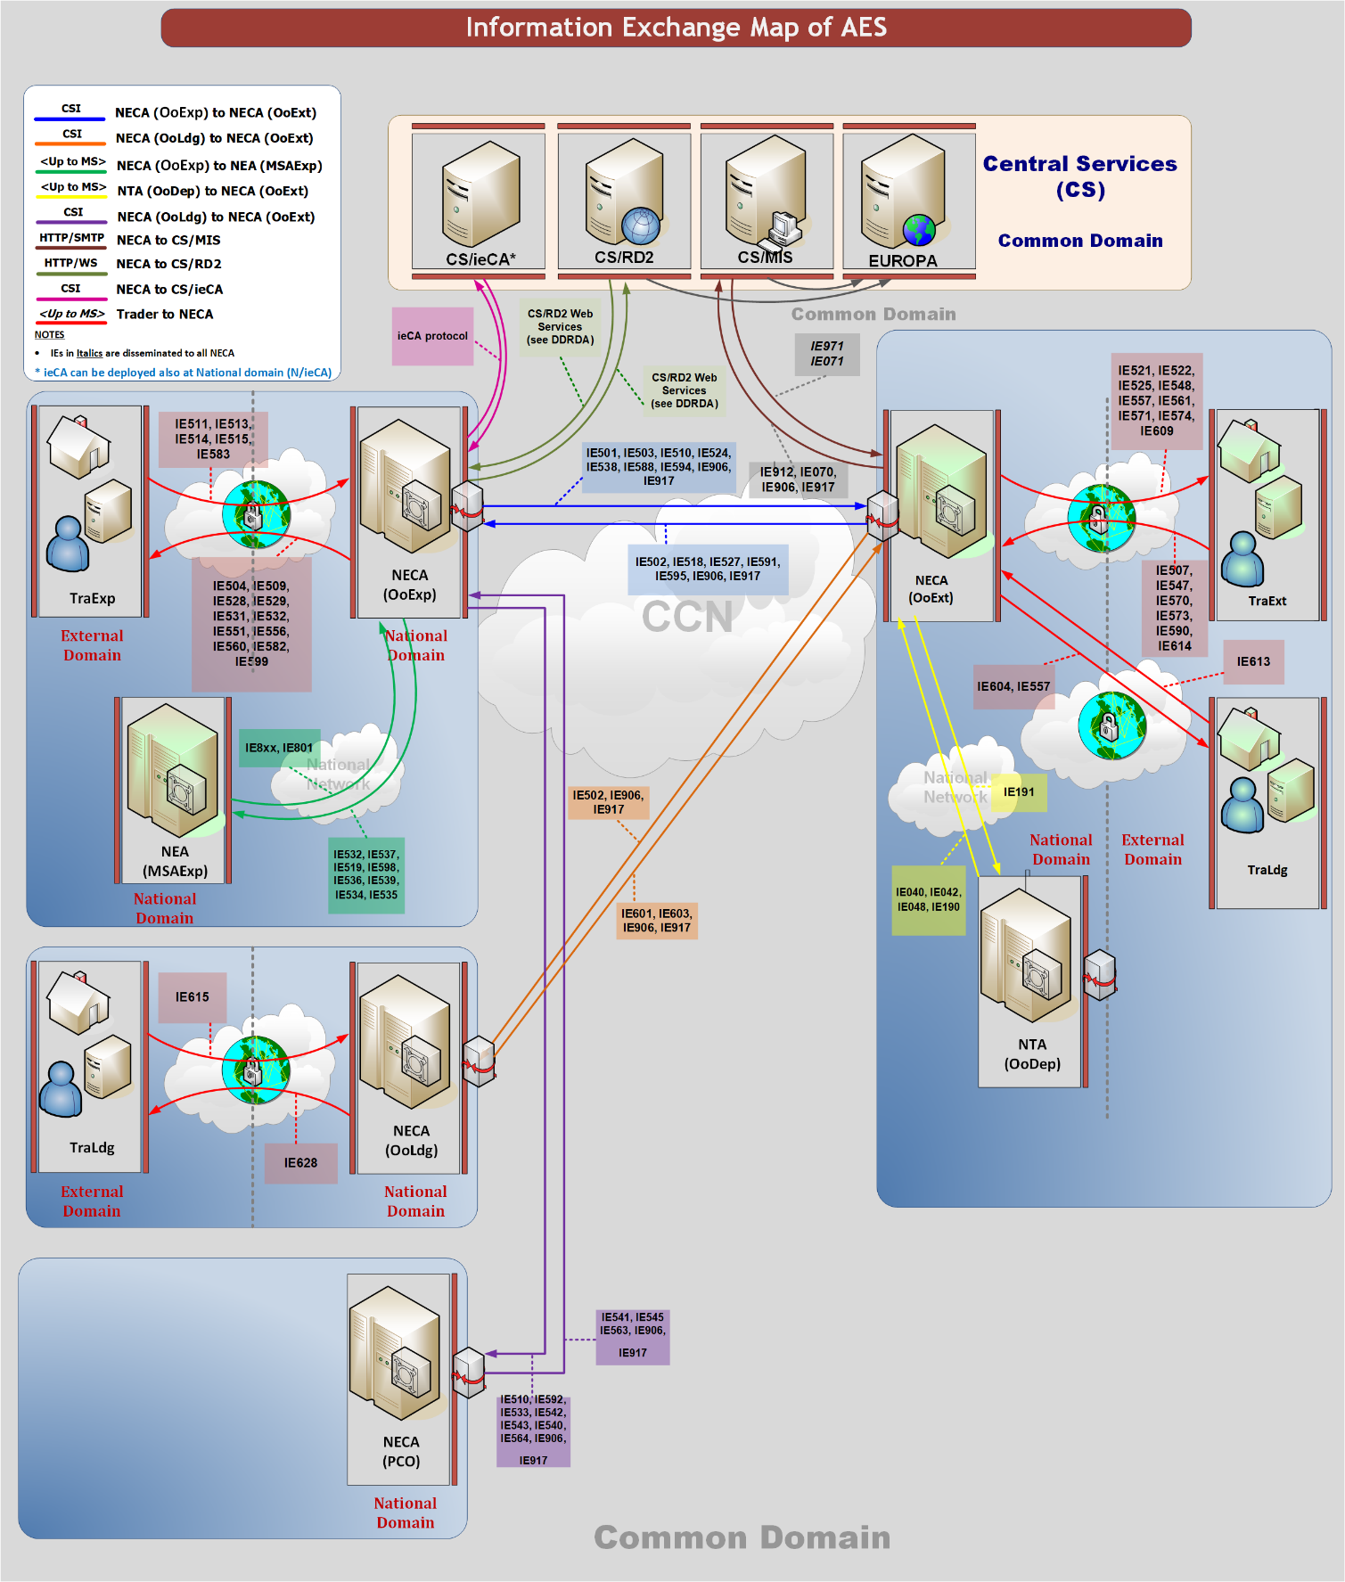

Figure 1: Information Exchange Map of AES

## Message format definition policy

Within this document, the overall approach is to define the XML format for all messages. Please refer to the Sections IV, and VI of DDCOM [A11].

# AES

## Introduction

The AES scenarios are classified according to the following approach:

* L0 is the root system functionality (AES);
* L1 is the high-level scenario categories;
* L2 concerns a sub-grouping of scenarios based on the covered business;
* L3 are the detailed scenarios belonging to a scenario group.

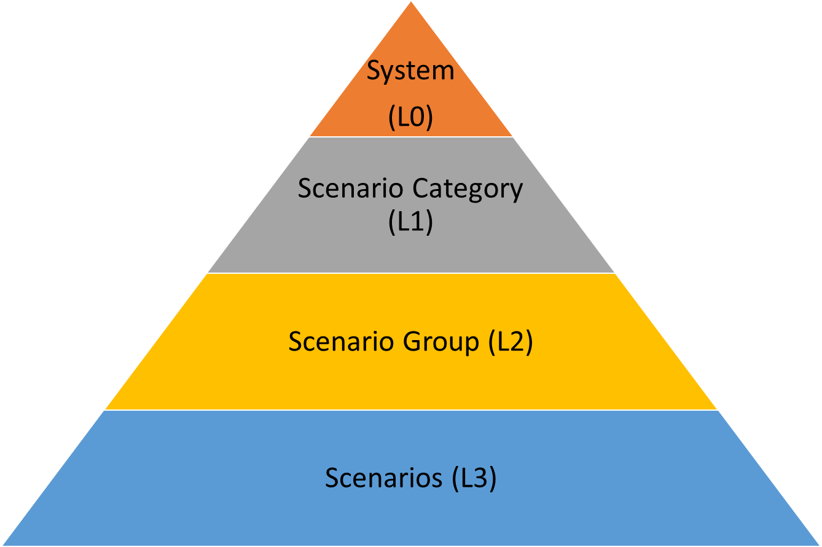

Figure 2: Hierarchical organisation of scenarios (levelling)

Section III describes the complete business for AES. It deals with the main export and exit scenarios performed by the different parties in AES (Customs Office of Export, Customs Office of Exit, Customs Office of Exit (Declared), Customs Office of Exit (Actual), Supervising Customs Office, Presentation Customs Office, MSA of Export, Requesting Customs Office, Customs Office of Lodgement, Declarant/Representative, Trader at Exit) and is applicable to the complete AES. It is divided into three sub-sections.

* **Sub-Section III-4.1: Export Process***.* This sub-section deals with the scenarios performed by the different parties in the export and exit formalities regarding the customs declaration (Customs Office of Export, Customs Office of Exit, Customs Office of Exit (Declared), Customs Office of Exit (Actual), Supervising Customs Office, Presentation Customs Office, MSA of Export, Requesting Customs Office, Declarant/Representative, Trader at Exit), and is applicable to the complete AES;
* **Sub-Section III-4.2: Exit Summary Declaration***.* This sub-section deals with the scenarios performed by the different parties included in the handling of the Exit Summary Declaration (Customs Office of Exit, Customs Office of Lodgement, Trader at Exit) in AES. Where goods are to be taken out of the Customs territory of the Union and a Customs declaration or a re-export declaration is not lodged as pre-departure declaration, an Exit Summary Declaration shall be lodged at the Customs Office of Exit, as defined in UCC Article 271 [A1].
* **Sub-Section III-4.3: Re-Export Notification***.* This sub-section deals with the scenarios performed by the different parties included in the handling of the Re-Export Notification (Customs Office of Exit, Trader at Exit) in AES. Where non-Union goods referred to in points (b) and (c) of UCC Article 270 (3) [A1] are taken out of the Customs territory of the Union and the obligation to lodge an exit summary declaration for those goods is waived, a re-export notification shall be lodged, as defined in UCC Article 274 [A1].

To classify the AES scenarios, a unique identifier is introduced per scenario. The structure of the unique identifier (e.g. E-EXP-EXP-A-001) follows the convention defined below:

**Scenario ID: <System>-<Scenario Category>-<Scenario Group>-<Scenario Type>-<Scenario Number>**

Figure 3: Unique identification of scenarios

**System (L0)**: **E** for AES (Export).

**Scenario Category (L1):** **EXP** for AES Core Business, **EXS** for Exit Summary Declaration and **REN** for Re-Export Notification.

**Scenario Group (L2):** please see the decomposition in Figure 4.

**Scenario Type: *M*** *for Main Flow,* ***A*** *for Alternative Flow and* ***E*** *for Exception Flow (rejections).*

**Scenario Number:** sequential number per group of scenarios.

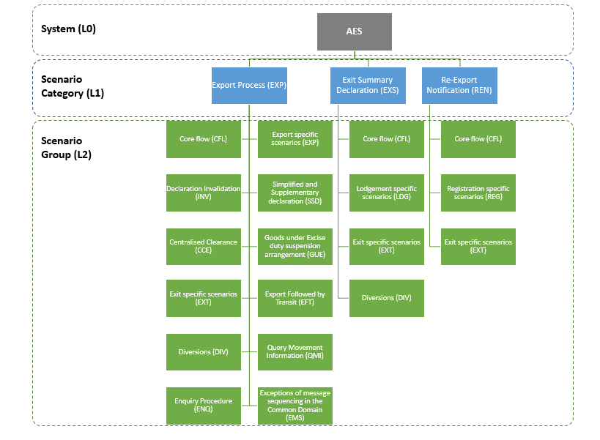

Figure 4: Classification of scenarios for AES system L0-L1-L2

### Overview

This section contains the detailed specification for the message exchange protocols relevant to the Automated Export System (AES) 1.1, the Information Exchanges supported, and the different parties involved are summarised in Figure 5 below. The diagram displayed in the figure is not a Time Sequence Diagram; it is only a summary of the different possible sources and destinations for the various Information Exchanges.

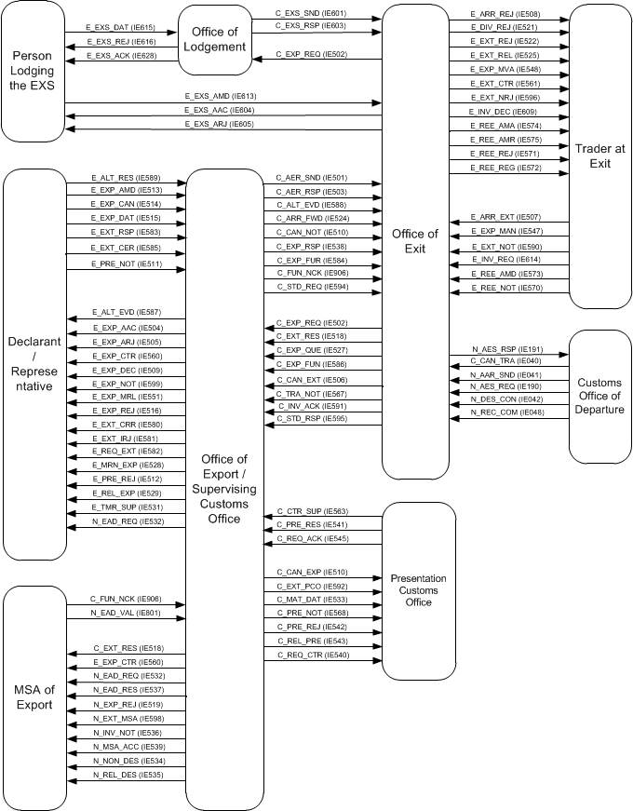

Figure 5: Overview of Information Exchanges between Customs Offices

In particular, Figure 5 illustrates the different exchanges foreseen for the Automated Export System.

A prefix of “C_” denotes exchanges within the Common Domain between the following roles:

* Customs Office of Departure;
* Customs Office of Exit;
* Customs Office of Export;
* Customs Office of Lodgement;
* Presentation Customs Office;
* Supervising Customs Office

A prefix of “E_” denotes exchanges in the External Domain (between National Administrations and Traders).

A prefix of “N_” denotes exchanges within the National Domain between the following roles:

* Customs Office of Departure;
* Customs Office of Exit;
* Customs Office of Export;
* MSA of Export;
* Presentation Customs Office (concerning cases of Centralised Clearance);
* Supervising Customs Office (concerning cases of Centralised Clearance)

All Information Exchanges related to exceptions are discussed in VIII Design principles.

The scope of Information Exchanges for AES are defined in Appendix A.

### Physical movements

Physical movements are not depicted on the Time Sequence Diagrams. A possible physical movement is Customs Control: this happens when the Office of Export decides to control the consignment following the risk analysis results and before releasing the goods for Export. A Customs Officer inspects the consignment at the place of presentation. This can eventually lead to a “Not Released for Export” state.[8]

### Export Actors

The following roles (Table 6) can be taken by organisations in AES.

|  |  |  |
| --- | --- | --- |
| **Role Type** | **Role Name** | **Organisation** |
| OoExp | Customs Office of Export | Customs Office |
| MSAExp | MSA of Export | Excise Office |
| SCO | Supervising Customs Office | Customs Office |
| PCO | Presentation Customs Office | Customs Office |
| OoExt | Customs Office of Exit | Customs Office |
| OoExtA | Customs Office of Exit (Actual) | Customs Office |
| OoExtD | Customs Office of Exit (Declared) | Customs Office |
| OoDep | Customs Office of Departure | Customs Office |
| OoLdg | Customs Office of Lodgement | Customs Office |
| OoReq | Requesting Customs Office | Customs Office |
| TraExp | Declarant/Representative | Trader |
| TraExt | Trader at Exit | Trader |

Table 6: Role types and organisations in Export Control

## Scenarios and Time Sequence Diagrams

The different message exchange protocols are defined as a number of message exchange scenarios, each documented by one Time Sequence Diagram.

The different possible scenarios are grouped for the main export, re-export and exit processes in the following categories:

* Export Process:
* Core Flow;
* Export specific scenarios;
* Centralised Clearance;
* Declaration Invalidation;
* Simplified and Supplementary Declaration;
* Goods Under Excise duty suspension arrangement;
* Exit specific scenarios;
* Export Followed by Transit;
* Diversions;
* Query Movement Information;
* Enquiry Procedure;
* Exceptions of message sequencing in the Common Domain.
* Exit Summary Declaration:
* Core Flow;
* Lodgement specific scenarios;
* Exit specific scenarios;
* Diversions;
* Exit Summary Declaration Invalidation.
* Re-Export Notification:
* Core Flow;
* Registration specific scenarios;
* Exit specific scenarios;
* Re-Export Notification Invalidation.

The scenario for the core flow should form the basis of every implementation. The other scenarios require the implementation of the core flow scenario and should be considered as extensions to it.

In some scenarios, iterations and/or repetitions are possible. In such cases, the corresponding Time Sequence Diagram includes two iterations and/or repetitions, but more iterations and/or repetitions should also be supported.

## Time Sequence Diagrams versus State Transition Diagrams

The different Time Sequence Diagrams should be read in conjunction with the State Transition Diagrams that have been included in chapter III.5.

The different states and state transitions in one State Transition Diagram are deducted from all the Time Sequence Diagrams the corresponding business role participates in.

In the description of each scenario, the transition to a state is presented, per Office role, when the corresponding trigger occurs (e.g. a message is sent/received, or a decision is taken). Each state inside a scenario description contains a link to the corresponding State Transition Diagram.

Every application should implement both the Time Sequence Diagrams and the State Transition Diagrams logic. At the end of each State Transition Diagram a table presents the optionality per state (i.e. Required, Strongly Recommended).

## Time Sequence Diagrams

This section contains the Time Sequence Diagrams for the AES processes. In these diagrams, when more than one message starts from (or ends in) the same focus of control, it means that these messages are sent (or received) shortly after each other. In this case, the arrows will appear close to each other and the order of sending (or receiving) these messages are not important.

### Export Process

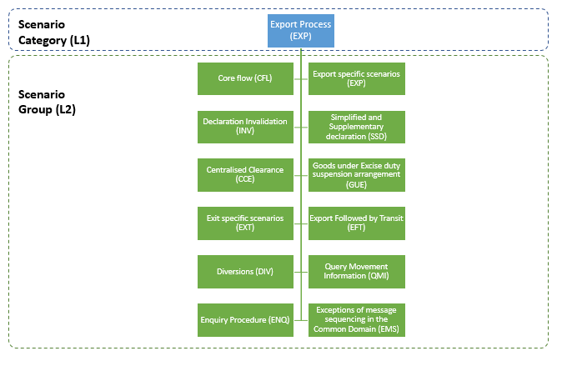

Figure 6: Export Process

#### E-EXP-CFL-M-001 Core flow

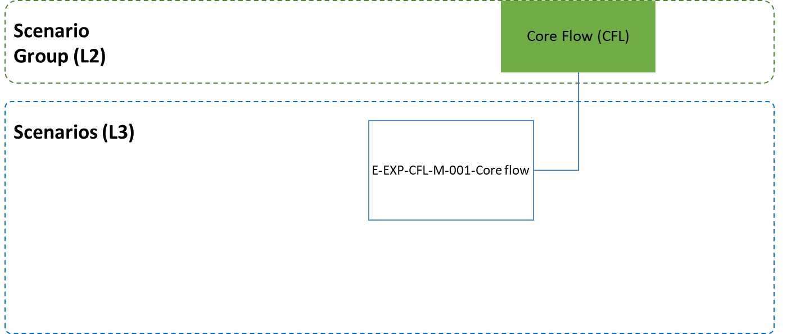

Figure 7: Core Flow scenario

The current section describes the scenario of standard Export process. Other business scenarios are defined as referenced below:

* the scenarios of a Simplified Export Declaration are described in section III.4.1.5 Simplified and Supplementary Declaration;
* the scenarios of an Export Declaration for goods under Excise duty suspension arrangement are depicted in section III.4.1.6 Goods under Excise duty suspension arrangement;
* the scenarios of an Export Declaration under Centralised Clearance procedure are presented in III.4.1.3 Centralised Clearance.

**[Step 1]** The scenario starts with the Declarant/Representative submitting an Export Declaration via an ‘Export Declaration’ E_EXP_DAT (IE515) message to the Customs Office of Export and at the same time presenting the goods at that office.

After a successful validation of the Export Declaration, AES at the Customs Office of Export checks and verifies that all required authorisations exist and are valid. In addition, AES at the Customs Office of Export verifies that the Export Declaration was not submitted prior to the goods presentation to the Customs Office of Export (i.e. the additional declaration type is not equal to “D” or “E” or “F”).

The Customs Office of Export registers the Export Declaration and allocates a Master Reference Number (MRN).

**[Step 2]** The Customs Office of Export informs the Declarant/Representative with an ‘Export MRN Allocated’ E_MRN_EXP (IE528) message of the Export Declaration acceptance and the MRN assignment and the movement state is set to “Accepted”.

Following the Trader’s notification of the declaration acceptance, AES interfaces with the national risk analysis systems of the Member States to request a Risk Analysis.

**[Step 3]** The Customs Officer at the Customs Office of Export decides not to control the goods and therefore the export movement is released for export, meaning that the consignment leaves the Office of Export and is transported towards the Customs Office of Exit (Declared).

The Customs Office of Export sends the anticipated export record via an AER C_AER_SND (IE501) message to the Customs Office of Exit (Declared) **[Step 4]** and communicates the release for export to the Declarant/Representative via a ‘Release for Export’ E_REL_EXP (IE529) message. **[Step 5]**. The movement state at the Customs Office of Export is set to “Goods Released for Export”, while the Time Limit to Receive Exit Results (T_Receive_Exit_Results) **[Step 6]** and the Time Limit to Certify Exit (T_Certify_Exit) both start at this point **[Step 7]**. After receiving the ‘Anticipated Export Record’ C_AER_SND (IE501), the AES at the Customs Office of Exit validates the received message (according to specifications in Appendix Q2 for recipients) and may request the national risk analysis systems for Risk Analysis feedback. The state of the movement at the Customs Office of Exit is set to “AER Created”.

**[Step 8]** Upon the arrival of the consignment at the Customs Office of Exit, the Trader at Exit sends an arrival notification via an ‘Arrival at Exit’ E_ARR_EXT (IE507) message to the Customs Office of Exit and requests that the goods are allowed to leave immediately the European Union Customs Territory.

AES verifies that the arrival notification is valid, and that the AER is available at the Customs Office of Exit. The movement state at the Customs Office of Exit is set to “Goods Presented at Exit”.

**[Step 9]** Following the presentation of goods at the Customs Office of Exit and based on the Risk Analysis results, the Customs Officer at the Office of Exit decides not to perform any control on the goods and to authorise the exit of goods, so the movement state at the Customs Office of Exit is set to “Goods Ready to be Released”.

**[Step 10]** AES verifies that the Trader at Exit had requested the immediate release of the goods and therefore an ‘Exit Release Notification’ E_EXT_REL (IE525) message is sent to the Trader at Exit informing him/ her of the release, while the movement state at the Customs Office of Exit is set to “Goods Released for Immediate Leave”.

**[Step 11]** When the consignment has left the European Union Customs Territory, the Trader at Exit[9] notifies the Customs Office of Exit via an ‘Exit Notification’ E_EXT_NOT (IE590) message that the goods have exited and the movement state is set to “Exited”.

**[Step 12]** The Customs Office of Exit confirms to the Customs Office of Export via an Exit Results C_EXT_RES (ΙΕ518) message; the exit of the consignment including the exit control results.

**[Step 13]** The Time Limit to Receive Exit Results (T_Receive_Exit_Results) at the Customs Office of Export stops at this point.

AES verifies that the exit control results are found positive at the Customs Office of Export.

The movement state at the Customs Office of Export is set to “Exported” and the Time Limit to Certify Exit (T_Certify_Exit) stops at this point **[Step 14]**.

**[Step 15]** The Customs Office of Export notifies the Declarant/Representative via an ‘Export Notification’ E_EXP_NOT (IE599) message that the movement has successfully exited the European Union Customs Territory providing all the export details.

The scenario stops here. Different variations are possible to this scenario (at Export, and/or at Exit) as presented in the subsequent paragraphs.



Figure 8: E-EXP-CFL-M-001 Core flow

#### Export specific scenarios

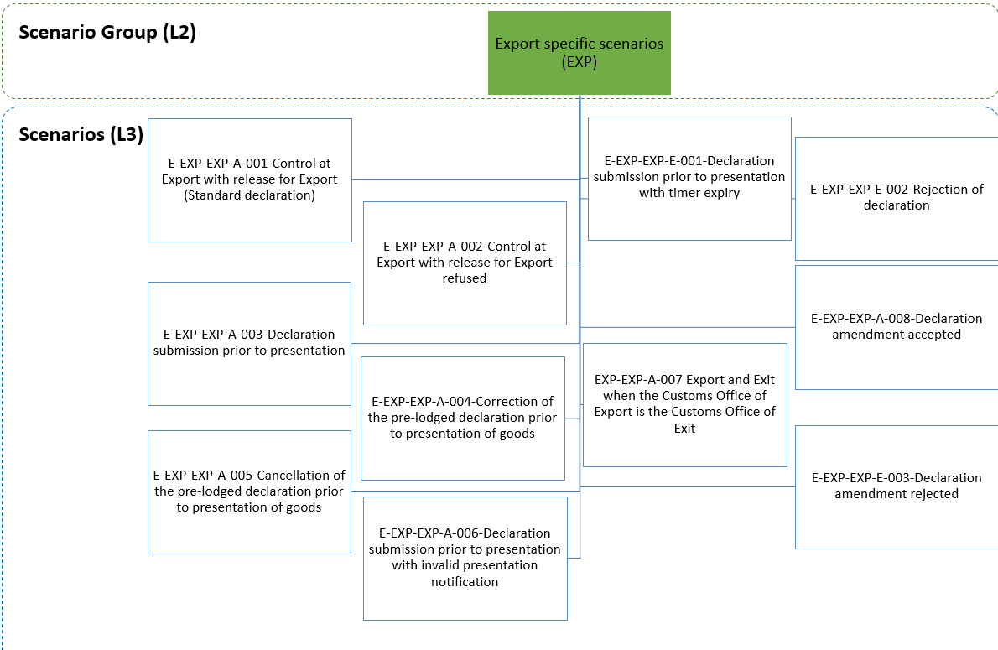

Figure 9: Export specific scenarios

The current section describes export specific scenarios of a standard Export process. The scenarios can be categorised in the following major groupings:

* the handling of controls at the Customs Office of Export;
* the export formalities when the Export Declaration is submitted prior to the goods presentation;
* the handling of the Export Declaration amendment;
* the handling of the Export Declaration rejection;
* the export and exit formalities when the Customs Office of Export is the Customs Office of Exit.

Other specific business scenarios are defined as referenced below:

* the scenarios of a Simplified Export Declaration are described in III.4.1.5 Simplified and Supplementary Declaration;
* the scenarios of an Export Declaration for Goods under Excise duty suspension arrangement are depicted in section III.4.1.6 Goods under Excise duty suspension arrangement;
* the scenarios of an Export Declaration under Centralised Clearance procedure are presented in III.4.1.3 Centralised Clearance.

##### E-EXP-EXP-A-001 Control at Export with release for Export (Standard declaration)

Figure 10 shows the flow of information when the Customs Officer at the Customs Office of Export decides to control the goods lodged under a standard declaration, based on the Risk Analysis results.

The flow continues up until **[****Step 3****]** of the E-EXP-CFL-M-001 Core flow scenario. That is, **[**Step 1**]** until **[**Step 2**]** are the same as in the E-EXP-CFL-M-001 Core flow. In this case, the Customs Officer at the Customs Office of Export decides to control the goods and the Customs Office of Export sends an ‘Export Control Decision Notification’ E_EXP_CTR (IE560) to the Declarant/Representative (independently of the AEO status of the Declarant/Representative) in order to inform him/ her of the upcoming control activities. The movement state is set to “Under Control” **[Step 3]**.

After performing the necessary controls, the Customs Officer registers the satisfactory control results at the AES of the Customs Office of Export.

**[Step 4 until 15]** These steps are the same as the steps **[****Step 4****]** until **[**Step 15**]** of the E-EXP-CFL-M-001 Core flow.

It shall be noted that in case the decided control at the Customs Office of Export is not eventually performed and the goods are released for export, the Declarant/Representative will receive a ‘Release for Export’ E_REL_EXP (IE529) message in **[Step 5]** of the E-EXP-CFL-M-001 Core flow, in which the CONTROL RESULT data group will be omitted (as per the Rule R0335).



Figure 10: E-EXP-EXP-A-001 Control at Export with release for Export (Standard declaration)

##### E-EXP-EXP-A-002 Control at Export with release for Export refused

Figure 11 shows the sequence in case the Customs Officer at the Customs Office of Export decides to control the goods lodged under an export declaration and afterwards decides to not release the movement for Export following the outcome of the controls performed.

The flow continues up until **[****Step 3****]** of the E-EXP-CFL-M-001 Core flow scenario. That is, **[**Step 1**]** until **[**Step 2**]** are the same as in E-EXP-CFL-M-001 Core flow. In this case, the Customs Officer at the Customs Office of Export decides to control the consignment before release and sends an ‘Export Control Decision Notification’ E_EXP_CTR (IE560) to inform the Declarant/Representative of this decision. The movement state is set to “Under Control” **[Step 3]**.

After performing the necessary controls, the Customs Officer at the Customs Office of Export registers the control results with Control Result Code equal to “B1: Unsatisfactory” at the AES of the Customs Office of Export and decides that the consignment cannot be released for Export. Consequently, the AES at the Customs Office of Export informs the Declarant/Representative about the release rejection via an ‘Export No Release’ E_EXP_NRL (IE551) **[Step 4]**. The movement state is set to “Not Released for Export”, which is a final state.

The remaining steps of the E-EXP-CFL-M-001 Core flow ([Step 4] until [Step 15]) are not applicable, since the current scenario has terminated in [Step 4] above.



Figure 11: E-EXP-EXP-A-002 Control at Export with release for Export refused

##### E-EXP-EXP-A-003 Declaration submission prior to presentation

Figure 12 shows the flow of information when the Declarant/Representative submits a Pre-lodged Export Declaration via an ‘Export Declaration’ E_EXP_DAT (IE515) message to the Customs Office of Export before the goods presentation to that office.

**[Step 1]** The scenario starts with the Declarant/Representative submitting a Pre-lodged Export Declaration via an ‘Export Declaration’ E_EXP_DAT (IE515) message to the Customs Office of Export.

After a successful validation of the Pre-lodged Export Declaration, AES checks that all required authorisations exist and are valid.

In addition, AES verifies that the additional declaration type is equal to “D” or “E” or “F”, thus, the Export Declaration was submitted prior to the goods presentation to the Customs Office of Export and the movement state is set to “Registered and Waiting for Presentation of Goods”.

The Customs Office of Export registers the Pre-lodged Export Declaration and may pre-allocate a Master Reference Number (MRN). The Customs Office of Export does not communicate the MRN to the Declarant/Representative at this point.

Until the successful presentation of the goods and the Export Declaration acceptance, AES uses LRN as a key in all external and national domain information exchanges (e.g. IE515, IE519, IE511, IE556, IE513, IE504, IE514, IE509). Following the Export Declaration acceptance, MRN will be used instead of LRN.[10]

**[Step 2]** The Timer Awaiting for Export Presentation Notification (T_Awaiting_Export_Presentation_Notification) is initiated.

The National Risk Analysis system interfaced automatically with AES will perform the Risk Analysis.

Following the result of the Risk Analysis engine, the Customs Officer at the Customs Office of Export may select the pre-lodged declaration for potential control of the goods prior to their presentation. In such case, the time sequence diagram is similar to the current scenario, see Figure 12 below. The only difference (compared to the current scenario) is that the AES at the Customs Office of Export also notifies the Declarant/Representative (provided that he/she is an AEO), about the intention of the Customs Officer to potentially control the goods, via an ‘Export Control Decision Notification’ E_EXP_CTR (IE560). To keep the time sequence diagram generic and applicable for all cases (not AEO specific), the IE560 is not included in the specific figure but clearly displayed in the textual description of the scenario.[11]

**[Step 3]** The Declarant/Representative submits an ‘Export Presentation Notification’ E_PRE_NOT (IE511)[12] to AES at the Customs Office of Export, within the defined time limit.

**[Step 4]** AES validates successfully the ‘Export Presentation Notification’ E_PRE_NOT (IE511) and the Timer Awaiting for Export Presentation Notification (T_Awaiting_Export_Presentation_Notification) stops at this point. In addition, based on the information contained in the ‘Export Presentation Notification’ E_PRE_NOT (IE511), AES at the Customs Office of Export re-validates the Export Declaration information (considering the ‘Export Declaration’ E_EXP_DAT (IE515) and any latest ‘Export Declaration Amendment’ E_EXP_AMD (IE513)) and ensures the validity of the reference data.

**[Steps 5 until 18]** The scenario continues as per **[****Step 2****]** until **[**Step 15**]** of the E-EXP-CFL-M-001 Core flow.

It shall be noted that if following the reception of the ‘Export Presentation Notification’ E_PRE_NOT (IE511), the re-validation of the Export Declaration information (considering the ‘Export Declaration’ E_EXP_DAT (IE515) and any latest ‘Export Declaration Amendment’ E_EXP_AMD (IE513)) is unsuccessful (i.e. reference data are not valid), then the pre-lodged Export Declaration is rejected. In such case, AES at the Customs Office of Export sends to the Declarant/Representative a ‘Rejection from Office of Export’ E_EXP_REJ (IE556) giving the reason for rejection. The state of the movement changes to “Rejected” which is a final state and the scenario stops here.When an Export Declaration has been rejected, the normal way of proceeding is the Declarant/Representative to send a new Export Declaration’ E_EXP_DAT (IE515).

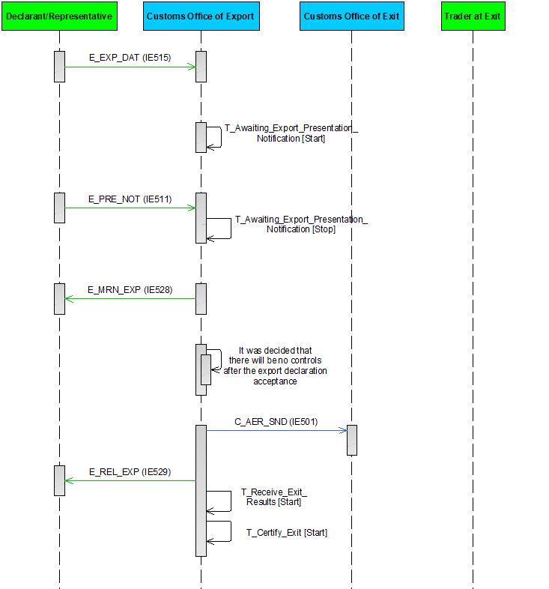

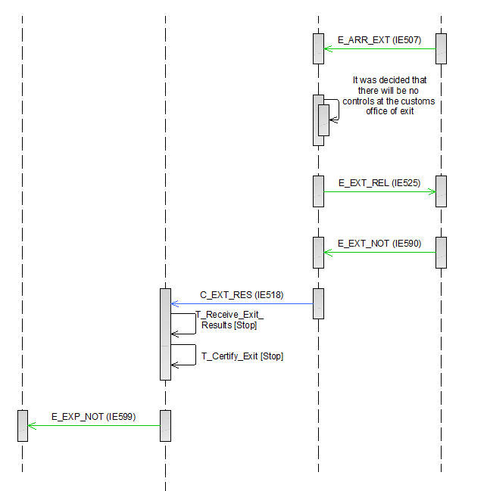

Figure 12: E-EXP-EXP-A-003 Declaration submission prior to presentation

##### E-EXP-EXP-A-004 Correction of the pre-lodged declaration prior to presentation of goods

Figure 13 shows the flow of information when the Declarant/Representative submits a Pre-lodged Export Declaration via an ‘Export Declaration’ E_EXP_DAT (IE515) message to the Customs Office of Export before the goods presentation to that office.

**[Step 1]** The scenario starts with the Declarant/Representative submitting a Pre-lodged Export Declaration via an ‘Export Declaration’ E_EXP_DAT (IE515) message to the Customs Office of Export.

After a successful validation of the Pre-lodged Export Declaration, AES checks that all required authorisations exist and are valid.

In addition, AES verifies that the additional declaration type is equal to “D” or “E” or “F”, thus, the Export Declaration was submitted prior to the goods presentation to the Customs Office of Export and the movement state is set to “Registered and Waiting for Presentation of Goods”.

The Customs Office of Export registers the Pre-lodged Export Declaration and may pre-allocate a Master Reference Number (MRN). The Customs Office of Export does not communicate the MRN to the Declarant/Representative at this point.

**[Step 2]** The Timer Awaiting for Export Presentation Notification (T_Awaiting_Export_Presentation_Notification) is initiated.

AES interfaces with the national risk analysis systems of the Member States to request a Risk Analysis.

Following the result of the Risk Analysis engine, the Customs Officer at the Customs Office of Export may select the pre-lodged declaration for potential control of the goods prior to their presentation. In such case, the time sequence diagram is similar to the current scenario, see Figure 13 below. The only difference (compared to the current scenario) is that the AES at the Customs Office of Export also notifies the Declarant/Representative (provided that he/she is an AEO), about the intention of the Customs Officer to potentially control the goods, via an ‘Export Control Decision Notification’ E_EXP_CTR (IE560). To keep the time sequence diagram generic and applicable for all cases (not AEO specific), the IE560 is not included in the specific figure but clearly displayed in the textual description of the scenario.11

To keep the time sequence diagram generic and applicable for all cases (not AEO specific), the IE560 is not included in the specific figure but clearly displayed in the textual description of the scenario.

**[****Step 3]** The Declarant/Representative decides to correct the Pre-lodged Export Declaration prior to the submission of the Export Presentation Notification and submits an ‘Export Declaration Amendment’ E_EXP_AMD (IE513) to the Customs Office of Export.

**[****Step 4]** Once the request is validated and accepted by AES, the Customs Office of Export sends the ‘Export Declaration Amendment Acceptance’ E_EXP_AAC (IE504) to the Declarant/Representative and the movement state remains as “Registered and Waiting for Presentation of Goods”. The Timer Awaiting for Export Presentation Notification (T_Awaiting_Export_Presentation_Notification) is not affected.

**[Step 5]** The Declarant/Representative submits an Export Presentation Notification to the Customs Office of Export with an ‘Export Presentation Notification’ E_PRE_NOT (IE511) message within the defined time limit.

**[Step 6]** AES validate successfully the ‘Export Presentation Notification’ E_PRE_NOT (IE511) and the Timer Awaiting for Export Presentation Notification (T_Awaiting_Export_Presentation_Notification) stops at this point. In addition, based on the information contained in the ‘Export Presentation Notification’ E_PRE_NOT (IE511), AES at the Customs Office of Export re-validates the Export Declaration information (considering the ‘Export Declaration’ E_EXP_DAT (IE515) and any latest ‘Export Declaration Amendment’ E_EXP_AMD (IE513)) and ensures the validity of the reference data.

**[Steps 7 until 19]** The scenario continues as per **[****Step 2****]** until **[**Step 15**]** of the E-EXP-CFL-M-001 Core flow.

It shall be noted that if the received correction request ‘Export Declaration Amendment’ E_EXP_AMD (IE513) is found invalid by the Customs Office of Export, then the AES at the Customs Office of Export sends a correction rejection via a ‘Rejection from Office of Export’ E_EXP_REJ (IE556) to the Declarant/Representative. In this case, the state of the movement at the Customs Office of Export remains as “Registered and Waiting for Presentation of Goods”. Then, the following cases are possible:

* The Declarant/Representative sends a new correction request (‘Export Declaration Amendment’ E_EXP_AMD (IE513)), in which case the flow continues as per [**Step 3**]of the current scenario E-EXP-EXP-A-004 Correction of the pre-lodged declaration prior to presentation of goods; OR
* The Declarant/Representative does not send a new correction request (‘Export Declaration Amendment’ E_EXP_AMD (IE513)), in which case the initial export declaration remains valid and the flow continues from [Step 3] of the E-EXP-EXP-A-003 Declaration submission prior to presentation.

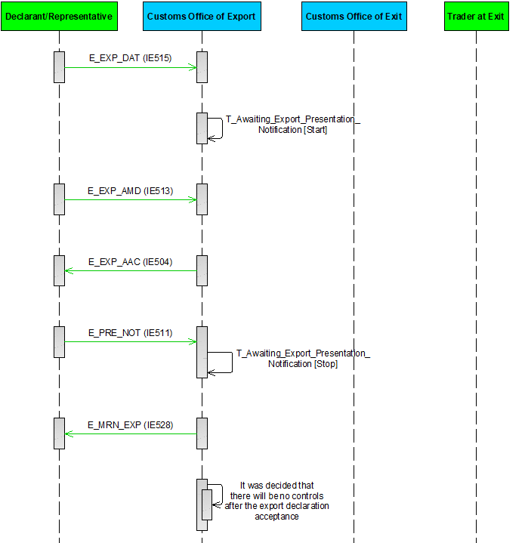

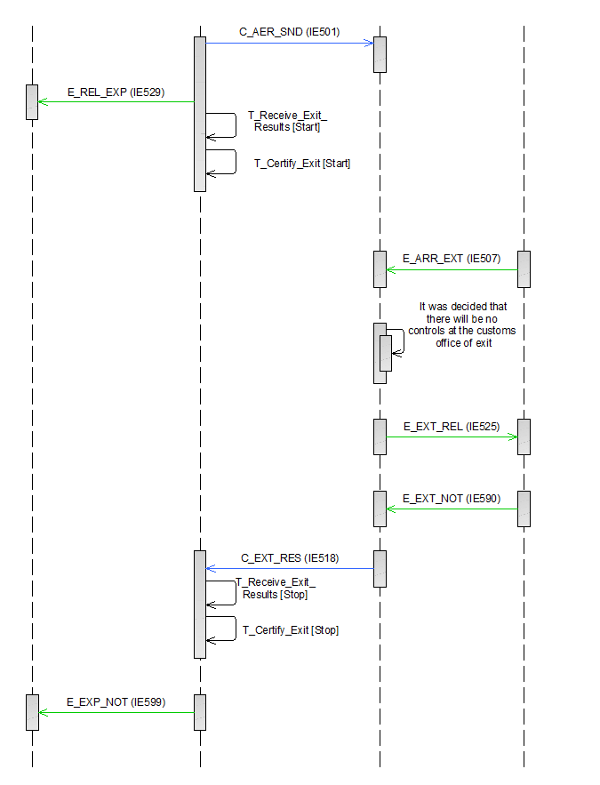

Figure 13: E-EXP-EXP-A-004 Correction of the pre-lodged declaration prior to presentation of goods

##### E-EXP-EXP-A-005 Cancellation of the pre-lodged declaration prior to presentation of goods

Figure 14 shows the flow of information when the Declarant/Representative submits a Pre-lodged Export Declaration via an ‘Export Declaration’ E_EXP_DAT (IE515) message to the Customs Office of Export before the goods presentation to that office.

**[Step 1]** The scenario starts with the Declarant/Representative submitting a Pre-lodged Export Declaration via an ‘Export Declaration’ E_EXP_DAT (IE515) message to the Customs Office of Export.

After a successful validation of the Pre-lodged Export Declaration, AES checks that all required authorisations exist and are valid.

The Customs Office of Export registers the Pre-lodged Export Declaration and may pre-allocate a Master Reference Number (MRN). The Customs Office of Export does not communicate the MRN to the Declarant/Representative at this point.

In addition, AES verifies that the additional declaration type is equal to “D” or “E” or “F”, thus, the Export Declaration was submitted prior to the goods presentation to the Customs Office of Export and the movement state is set to “Registered and Waiting for Presentation of Goods”.

**[Step 2]** The Timer Awaiting for Export Presentation Notification (T_Awaiting_Export_Presentation_Notification) is initiated.

AES interfaces with the national risk analysis systems of the Member States to request a Risk Analysis.

Following the result of the Risk Analysis engine, the Customs Officer at the Customs Office of Export may select the pre-lodged declaration for potential control of the goods prior to their presentation. In such case, the time sequence diagram is similar to the current scenario, see Figure 14 below. The only difference (compared to the current scenario) is that the AES at the Customs Office of Export also notifies the Declarant/Representative (provided that he/she is an AEO), about the intention of the Customs Officer to potentially control the goods, via an ‘Export Control Decision Notification’ E_EXP_CTR (IE560). To keep the time sequence diagram generic and applicable for all cases (not AEO specific), the IE560 is not included in the specific figure but clearly displayed in the textual description of the scenario.11

To keep the time sequence diagram generic and applicable for all cases (not AEO specific), the IE560 is not included in the specific figure but clearly displayed in the textual description of the scenario.

**[Step 3]** The Declarant/Representative decides to cancel the Pre-lodged Export Declaration and sends a cancellation request via an ‘Export Invalidation Request’ E_EXP_INV (IE514) message to the Customs Office of Export.

**[Step 4]** The Customs Office of Export examines the request and takes a positive decision to cancel the Pre-lodged Export Declaration and informs the Declarant/Representative via an ‘Export Invalidation Decision’ E_EXP_DEC (IE509) message. The movement state is set to “Cancelled”.

**[Step 5]** The Timer Awaiting for Export Presentation Notification (T_Awaiting_Export_Presentation_Notification) stops at this point. This is a final state and the flow ends here.

It shall be noted that if the received cancellation request (‘Export Invalidation Request’ E_EXP_INV (IE514)) is found invalid by the Customs Office of Export, then the AES at the Customs Office of Export sends a cancellation rejection via a ‘Rejection from Office of Export’ E_EXP_REJ (IE556) to the Declarant/Representative. In this case, the state of the movement at the Customs Office of Export remains as “Registered and Waiting for Presentation of Goods”. Then, the following cases are possible:

* The Declarant/Representative sends a new cancellation request (‘Export Invalidation Request’ E_EXP_INV (IE514)), in which case the flow continues as per **[Step 3]**of the current scenario E-EXP-EXP-A-005 Cancellation of the pre-lodged declaration prior to presentation of goods; OR
* The Declarant/Representative does not send a new cancellation request (‘Export Invalidation Request’ E_EXP_INV (IE514)), in which case the initial export declaration remains valid and the flow continues from [Step 3] of the E-EXP-EXP-A-003 Declaration submission prior to presentation.



Figure 14: E-EXP-EXP-A-005 Cancellation of the pre-lodged declaration prior to presentation of goods

##### E-EXP-EXP-E-001 Declaration submission prior to presentation with timer expiry

Figure 15 shows the flow of information when the Declarant/Representative submits a Pre-lodged Export Declaration via an ‘Export Declaration’ E_EXP_DAT (IE515) message to the Customs Office of Export before the goods presentation to that office.

**[Step 1]** The scenario starts with the Declarant/Representative submitting a Pre-lodged Export Declaration via an ‘Export Declaration’ E_EXP_DAT (IE515) message to the Customs Office of Export.

After a successful validation of the Pre-lodged Export Declaration, AES checks that all required authorisations exist and are valid.

The Customs Office of Export registers the Pre-lodged Export Declaration and may pre-allocate a Master Reference Number (MRN). The Customs Office of Export does not communicate the MRN to the Declarant/Representative at this point.

In addition, AES verifies that the additional declaration type is equal to “D” or “E” or “F”, thus, the Export Declaration was submitted prior to the goods presentation to the Customs Office of Export and the movement state is set to “Registered and Waiting for Presentation of Goods”.

**[Step 2]** The Timer Awaiting for Export Presentation Notification (T_Awaiting_Export_Presentation_Notification) is initiated.

AES interfaces with the national risk analysis systems of the Member States to request a Risk Analysis.

Following the result of the Risk Analysis engine, the Customs Officer at the Customs Office of Export may select the pre-lodged declaration for potential control of the goods prior to their presentation. In such case, the time sequence diagram is similar to the current scenario, see Figure 15 below. The only difference (compared to the current scenario) is that the AES at the Customs Office of Export also notifies the Declarant/Representative (provided that he/she is an AEO), about the intention of the Customs Officer to potentially control the goods, via an ‘Export Control Decision Notification’ E_EXP_CTR (IE560). To keep the time sequence diagram generic and applicable for all cases (not AEO specific), the IE560 is not included in the specific figure but clearly displayed in the textual description of the scenario.11

To keep the time sequence diagram generic and applicable for all cases (not AEO specific), the IE560 is not included in the specific figure but clearly displayed in the textual description of the scenario.

**[Step 3]** The Timer Awaiting for Export Presentation Notification (T_Awaiting_Export_Presentation_Notification) expires and the presentation notification has not been received.

**[Step 4]** As an effect, the Customs Office of Export sends to the Declarant/Representative a ‘Rejection from Office of Export’ E_EXP_REJ (IE556) message that the Pre-lodged Export Declaration is rejected, giving the reason for rejection and the movement state is set to “Rejected”. This is a final state and the flow ends here.



Figure : E-EXP-EXP-E-001 Declaration submission prior to presentation with timer expiry

##### E-EXP-EXP-A-006 Declaration submission prior to presentation with invalid presentation notification

Figure 16 shows the flow of information when the Declarant/Representative submits a Pre-lodged Export Declaration via an ‘Export Declaration’ E_EXP_DAT (IE515) message to the Customs Office of Export before the goods presentation to that office.

**[Step 1]** The scenario starts with the Declarant/Representative submitting a Pre-lodged Export Declaration via an ‘Export Declaration’ E_EXP_DAT (IE515) message to the Customs Office of Export.

After a successful validation of the Pre-lodged Export Declaration, AES checks that all required authorisations exist and are valid.

The Customs Office of Export registers the Pre-lodged Export Declaration and allocates a Master Reference Number (MRN) The Customs Office of Export does not communicate the MRN to the Declarant/Representative at this point.

In addition, AES verifies that the Pre-lodged Export Declaration was submitted prior to the goods presentation to the Customs Office of Export and the movement state is set to “Registered and Waiting for Presentation of Goods”.

AES interfaces with the national risk analysis systems of the Member States to request a Risk Analysis.

**[Step 2]** The Timer Awaiting for Export Presentation Notification (T_Awaiting_Export_Presentation_Notification) is initiated.

AES interfaces with the national risk analysis systems of the Member States to request a Risk Analysis.

Following the result of the Risk Analysis engine, the Customs Officer at the Customs Office of Export may select the pre-lodged declaration for potential control of the goods prior to their presentation. In such case, the time sequence diagram is similar to the current scenario, see Figure 16 below. The only difference (compared to the current scenario) is that the AES at the Customs Office of Export also notifies the Declarant/Representative (provided that he/she is an AEO), about the intention of the Customs Officer to potentially control the goods, via an ‘Export Control Decision Notification’ E_EXP_CTR (IE560). To keep the time sequence diagram generic and applicable for all cases (not AEO specific), the IE560 is not included in the specific figure but clearly displayed in the textual description of the scenario.11

To keep the time sequence diagram generic and applicable for all cases (not AEO specific), the IE560 is not included in the specific figure but clearly displayed in the textual description of the scenario.

**[Step 3]** The Declarant/Representative submits an Export Presentation Notification to the Customs Office of Export with an ‘Export Presentation Notification’ E_PRE_NOT (IE511) message within the defined time limit.

AES identifies that the Export Presentation Notification is invalid, so the Customs Office of Export rejects the presentation notification with a ‘Rejection from Office of Export’ E_EXP_REJ (IE556) message to the Declarant/Representative and the movement state remains as is **[Step 4]**.

**[Step 5]** The Declarant/Representative might send a second ‘Export Presentation Notification’ E_PRE_NOT (IE511) within the defined time limit. **[Step 6]** Assuming that the second Export Presentation Notification is valid, the Timer Awaiting for Export Presentation Notification (T_Awaiting_Export_Presentation_Notification) stops. In addition, based on the information contained in the ‘Export Presentation Notification’ E_PRE_NOT (IE511), AES at the Customs Office of Export re-validates the Export Declaration information (considering the ‘Export Declaration’ E_EXP_DAT (IE515) and any latest ‘Export Declaration Amendment’ E_EXP_AMD (IE513)) and ensures the validity of the reference data.

**[Step 7 until 18]** These steps are the same as the steps **[****Step 4****]** until **[**Step 15**]** of the E-EXP-CFL-M-001 Core flow.

It shall be noted that Declarant/Representative may submit sequential Presentation Notifications after the first one, (which in turn might be invalidated) until the Timer Awaiting for Export Presentation Notification (T_Awaiting_Export_Presentation_Notification) expires. It shall be noted that in case the timer expires, and no valid Export Presentation Notification is identified, then the movement state will be set to “Rejected”, which will be the final state.

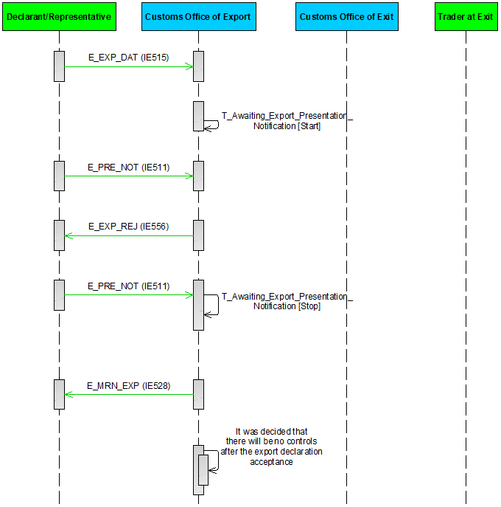

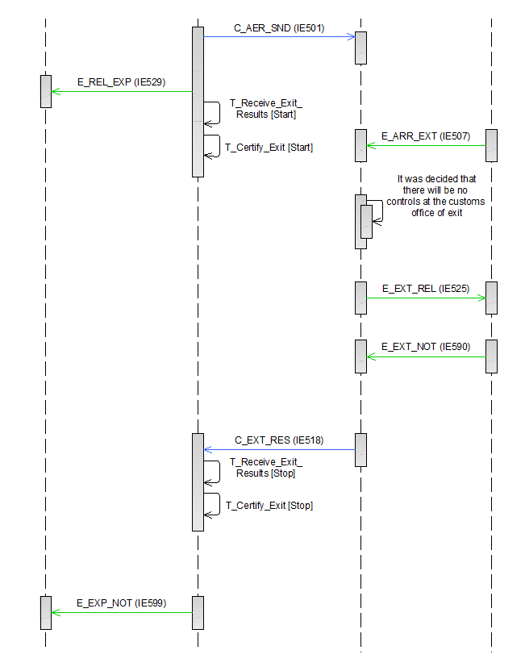

Figure 16: E-EXP-EXP-A-006 Declaration submission prior to presentation with invalid presentation notification

##### E-EXP-EXP-A-007 Export and Exit when the Customs Office of Export is the Customs Office of Exit

The scenario starts identically to the E-EXP-CFL-M-001 Core flow scenario. In this case, the Customs Office of Export is the same as the Customs Office of Exit (Direct export)[13].

The flow continues up until **[****Step 4****]** of the E-EXP-CFL-M-001 Core flow scenario. That is, **[**Step 1**]** until **[**Step 3**]** are the same as in E-EXP-CFL-M-001 Core flow. In this case, the anticipated export record will not be sent to the Customs Office of Exit (Declared), since the Customs Office of Export is the same as the Customs Office of Exit.

**[Step 4 until 10]** The scenario continues up until **[****Step 12****]** of the E-EXP-CFL-M-001 Core flow. That is, the steps with steps **[**Step 5**]** until **[**Step 11**]** of E-EXP-CFL-M-001 Core flow will be performed. In this case, the exit results will not be sent to the declared Customs Office of Export, since the Customs Office of Export is the same as the Customs Office of Exit.

[**Steps 11 until 13**] These steps are the same as the steps **[****Step 13****]** until **[**Step 15**]** of the E-EXP-CFL-M-001 Core flow.





Figure 17: E-EXP-EXP-A-007 Export and Exit when the customs office of export is the customs office of exit

##### E-EXP-EXP-E-002 Rejection of declaration

Figure 18 displays the scenario in which an ‘Export Declaration’ E_EXP_DAT (IE515) submitted by the Declarant/Representative is rejected.

**[Step 1]** The scenario starts with the Declarant/Representative submitting an Export Declaration via an ‘Export Declaration’ E_EXP_DAT (IE515) message to the Customs Office of Export and at the same time presenting the goods at that office.

**[Step 2]** In this case, AES identifies that the submitted declaration is invalid.

The Customs Office of Export sends to the Declarant/Representative a ‘Rejection from Office of Export’ E_EXP_REJ (IE556) message that the declaration is rejected, giving the reason for rejection. The scenario stops here.

It should be noted that if a rejected declaration does not have an MRN allocated then it does not have a state. In all cases, when a declaration is rejected, the state of the movement is set/changes to “Rejected”.When an Export Declaration has been rejected, the normal way of proceeding is to send a new Export Declaration that is acceptable. The handling of the rejected declaration and its LRN (storage, deletion or other treatment) will be decided by the National Customs Authorities as it concerns external domain information exchanges.



Figure 18: E-EXP-EXP-E-002 Rejection of declaration

##### E-EXP-EXP-A-008 Declaration amendment accepted

Amendments allow for the declaration data to be changed before the movement is released for export. The conditions under which a declaration amendment request can be sent are described in section III.5.1.1. It is worth noting that multiple declaration amendments (‘Export Declaration Amendment’ E_EXP_AMD (IE513)) can be sent to the Customs Office of Export, as long as those conditions are fulfilled.

Figure 19 shows such a scenario. The flow continues up until **[****Step 3****]** of the E-EXP-CFL-M-001 Core flow scenario. That is, **[**Step 1**]** until **[**Step 2**]** are the same as in E-EXP-CFL-M-001 Core flow. In this case, the Declarant/Representative who sent the initial declaration sends an ‘Export Declaration Amendment’ E_EXP_AMD (IE513) to the Customs Office of Export in the time period between the declaration acceptance and the release for export (while the movement state is set to “Accepted”) **[Step 3]**.

Once the request is validated and accepted by AES, the Customs Office of Export sends the ‘Export Declaration Amendment Acceptance’ E_EXP_AAC (IE504) **[Step 4]** to the Declarant/Representative and the movement state remains as “Accepted”.

The Customs Officer at the Customs Office of Export decides not to control the goods and therefore the export movement is released for export, meaning that the transportation of the consignment towards the Customs Office of Exit (Declared) can begin. At this point, the Customs Officer might otherwise decide to control the goods but for illustration purposes only the case of no control is presented.

**[Step 5 until 16]** These steps are the same as the steps **[****Step 4****]** until **[**Step 15**]** of the E-EXP-CFL-M-001 Core flow.





Figure 19: E-EXP-EXP-A-008 Declaration amendment accepted

##### E-EXP-EXP-E-003 Declaration amendment rejected

In Figure 20, the flow continues up until **[****Step 3****]** of the E-EXP-CFL-M-001 Core flow scenario. That is, **[**Step 1**]** until **[**Step 2**]** are the same as in E-EXP-CFL-M-001 Core flow. In this case, the Declarant/Representative sends an ‘Export Declaration Amendment’ E_EXP_AMD (IE513) **[Step 3]**, which is rejected by the Customs Office of Export due to errors (‘Rejection from Office of Export’ E_EXP_REJ (IE556)) **[Step 4]**. The state of the movement at the Customs Office of Export remains as “Accepted”.

The Declarant/Representative may send a new amendment request (‘Export Declaration Amendment’ E_EXP_AMD (IE513)) **[Step 5]**. Assuming that the second amendment request (‘Export Declaration Amendment’ E_EXP_AMD (IE513)) is valid, the Customs Office of Export will send the ‘Export Declaration Amendment Acceptance’ E_EXP_AAC (IE504) to the Declarant/Representative **[Step 6]**. The state of the movement at Export will remain in “Accepted” having stored the new version of the dataset.

**[Step 7 until 18]** These steps are the same as the steps [Step 4] until [Step 15] of the E-EXP-CFL-M-001 Core flow.

It shall be noted that if the Declarant/Representative does not send a new amendment request (‘Export Declaration Amendment’ E_EXP_AMD (IE513)) after the previously rejected amendment request, then the initial export declaration remains valid and the flow continues from [Step 3] of the E-EXP-CFL-M-001 Core flow scenario.

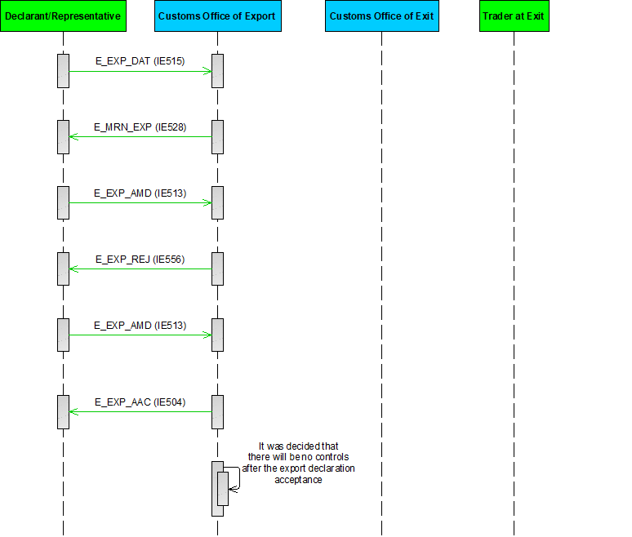



Figure 20: E-EXP-EXP-E-003 Declaration amendment rejected

#### Centralised Clearance

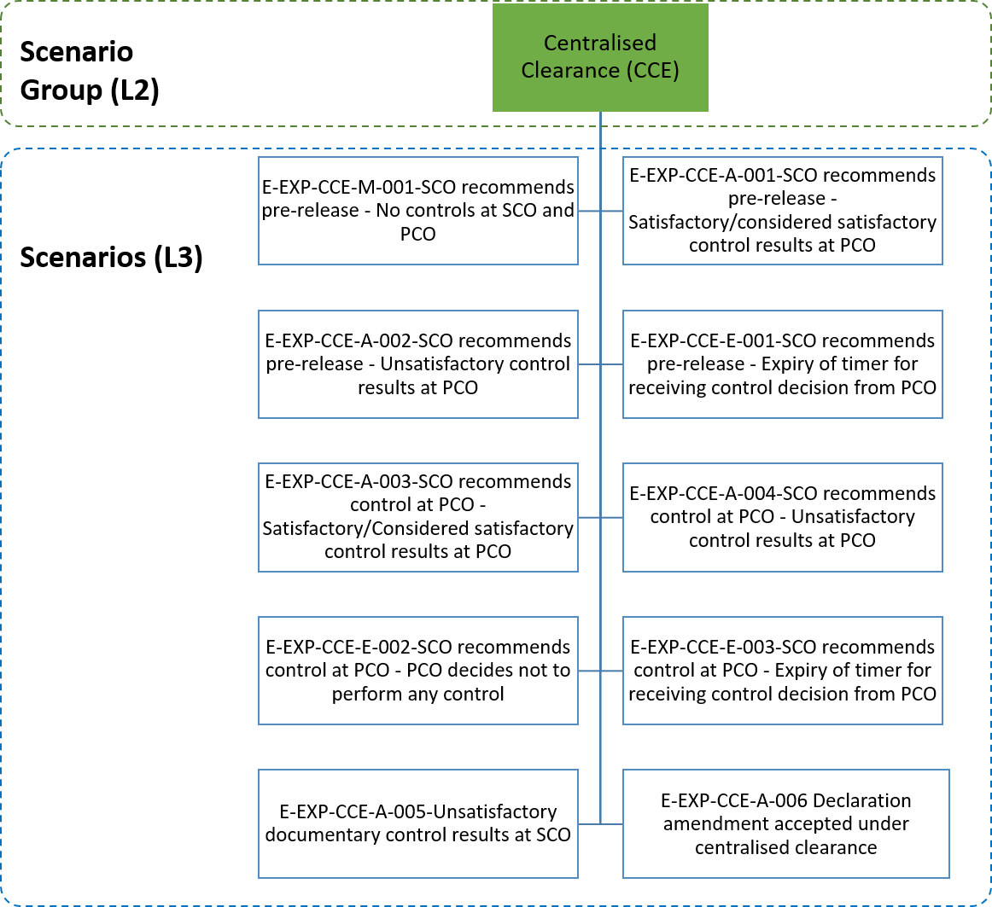

Figure 21: Centralised Clearance specific scenarios

The current section includes the scenarios concerning the Centralised Clearance for Export functionality, described in Article 179 UCC [A1]. In these scenarios, the customs declaration is lodged at one office (Supervising Customs Office) and the goods are presented at another office (Presentation Customs Office). According to these scenarios, it is identified that the ‘Export Declaration’ E_EXP_DAT (IE515) has been lodged under the Centralised Clearance procedure (“IE515.AUTHORISATION.Reference number” is equal to “CCL” in which case the “IE515.CUSTOMS OFFICE OF PRESENTATION” must be provided). Similarly to the normal sequence (see E-EXP-CFL-M-001 Core flow above), the AES at the Supervising Customs Office (SCO)[14] successfully validates the ‘Export Declaration’ E_EXP_DAT (IE515) and allocates the MRN (‘Export MRN Allocated’ E_MRN_EXP (IE528)) following the Export Declaration acceptance. AES at the SCO will then communicate the Export Declaration particulars to the Presentation Customs Office (PCO)[15].

Upon receipt of the Export Declaration, the PCO will perform the necessary controls and validation, including Risk Analysis for national purposes, and notify the SCO about its intention to perform controls, considering also the initial recommendation of the SCO.

All required supporting documents for both the PCO, and the SCO are included in the Export Declaration. In the case that any additional documents should be requested by PCO from the Declarant/Representative, the mechanism has been designed in the Centralised Clearance for Export for enabling this. Codification relies on commonly defined and governed code lists to allow harmonisation and proper declaration validation.

The flow of these scenarios differentiates, based on the decision for performing controls and their results, at the SCO and/or the PCO.

The Centralised Clearance for Export scenarios can be grouped into two main sets: the scenarios where pre-release applies; and the scenarios where pre-release does not apply, i.e. the SCO recommends to the PCO to perform certain controls. For the sake of completeness, the case that unsatisfactory documentary controls are found at the SCO is also described in the current section (E-EXP-CCE-A-005 Unsatisfactory documentary control results at SCO).

Pre-release applies when the SCO recommends no controls to the PCO. Namely, pre-release is applicable in the following cases:

* When the SCO decides that no controls are deemed required (neither by the SCO nor by the PCO); or
* When the SCO decides that only documentary controls are deemed required at the SCO and these documentary control results are found satisfactory. In this case, as above, the SCO recommends no controls to the PCO.

Depending on the control decision of the PCO after the pre-release, the control results and the respect of the time limit for submitting the control decision, the following variations of pre-release scenarios are possible:

* E-EXP-CCE-M-001 SCO recommends pre-release - No controls at SCO and PCO;
* E-EXP-CCE-A-001 SCO recommends pre-release - Satisfactory/considered satisfactory control results at PCO;
* E-EXP-CCE-A-002 SCO recommends pre-release - Unsatisfactory control results at PCO;
* E-EXP-CCE-E-001 SCO recommends pre-release – Expiry of timer for receiving control decision from PCO.

The below scenarios are applicable when the SCO decides to recommend controls to the PCO (in which case pre-release is not applicable). In these scenarios, it is possible for the SCO to also perform documentary controls if so decided. Depending on the control decision of the PCO, the control results and the respect of the time limit for submitting the control decision, the following scenarios are possible:

* E-EXP-CCE-A-003 SCO recommends control at PCO – Satisfactory/Considered satisfactory control results at PCO;
* E-EXP-CCE-A-004 SCO recommends control at PCO - Unsatisfactory control results at PCO;
* E-EXP-CCE-E-002 SCO recommends control at PCO - PCO decides not to perform any control;
* E-EXP-CCE-E-003 SCO recommends control at PCO - Expiry of timer for receiving control decision from PCO.

The aforementioned scenarios of Centralised Clearance for Export are also applicable:

* When goods are under Excise (National Domain exchanges between AES at the SCO and EMCS at the MSA of Export also apply, in alignment with the scenarios described in section III.4.1.6 Goods under Excise duty suspension arrangement)[16];
* When Export is followed by Transit (National Domain exchanges between AES at the Customs Office of Exit and NCTS at the Customs Office of Departure also apply, in alignment with the scenarios described in section III.4.1.8 Export Followed by Transit);
* When goods are lodged under Simplified Export Declaration scenarios below also apply (III.4.1.5). Only in case of recording a Supplementary Declaration, specific scenarios for centralised clearance is described in III.4.1.5.6[17];
* When declaration is submitted prior to the presentation of goods (pre-lodged declaration). The centralised clearance scenarios and communication of the SCO with the PCO do not change since the pre-lodged declaration exchanges are performed before the acceptance of the declaration (after the Customs Office of Export informs the Declarant/Representative with an ‘Export MRN Allocated’ E_MRN_EXP (IE528) message of the Export Declaration acceptance and the MRN assignment and the movement state is set to “Accepted”).

|  |
| --- |
| ! It shall be highlighted that the Presentation Customs Office is responsible for reporting for statistical purposes. The Supervising Customs Office does not provide information to the Statistical Office for the goods exported using Centralised Clearance. |

The subsequent Sub-Sections describe the scenarios concerning Centralised Clearance for Export.

##### E-EXP-CCE-M-001 SCO recommends pre-release - No controls at SCO and PCO

This is the main scenario of the Centralised Clearance for Export (Figure 22). According to this scenario, after receiving the ‘Pre-release/Control Notification’ C_PRC_NOT (IE540) recommending Pre-release from the Supervising Customs Office, the Presentation Customs Office decides to perform no controls. A pre-requisite for Centralised Clearance is that the Declarant/Representative is AEO certified.

More specifically, the current scenario starts identically to E-EXP-CFL-M-001 Core flow up to [Step 2]. That is, [Step 1] until [Step 2] are the same as in E-EXP-CFL-M-001 Core flow. From the [Step 1] of the E-EXP-CFL-M-001 Core flow, AES knows that the ‘Export Declaration’ E_EXP_DAT (IE515) has been lodged under the Centralised Clearance since the “IE515.AUTHORISATION.Reference number” is equal to “CCL” (in which case the “IE515.CUSTOMS OFFICE OF PRESENTATION” must be provided). It shall be highlighted that in the scenarios of Centralised Clearance for Export, the Supervising Customs Office is the Customs Office of Export.

**[Step 3]** The AES at Supervising Customs Office identifies that the ‘Export Declaration’ E_EXP_DAT (IE515) has been lodged under the Centralised Clearance procedure. According to this scenario (depicted in Figure 22 below), the Supervising Customs Office decides that no controls are deemed required (neither by the Supervising Customs Office nor by the Presentation Customs Office). Hence, the AES at the Supervising Customs Office informs the AES at the Presentation Customs Office, via a ‘Pre-release/Control Notification’ C_PRC_NOT (IE540) recommending Pre-release, that the declared goods are ready to be released for export (meaning that the consignment could go to the Customs Office of Exit (Declared)).

Note: It shall be noted, that the Pre-Release is possible in the following cases:

* when no controls are deemed required by Supervising Customs Office;
* when only documentary controls are deemed required to be performed by Supervising Customs Office and the control results are satisfactory.

The case where no controls are deemed required by the Supervising Customs Office is covered by the Figure 22 below. The same message exchanges will be transmitted in case where documentary controls are deemed required to be performed by Supervising Customs Office without the need to request documents, and the control results are satisfactory. The only difference lies in that since a ‘Pre-release/Control Notification’ C_PRC_NOT (IE540 recommending Pre-release) was preceded by a control decision, the state of the movement at the Supervising Customs Office is updated from “Accepted” to “Under Control”.[18]

**[Step 4]** After receiving the ‘Pre-release/Control Notification’ C_PRC_NOT (IE540) recommending Pre-release from the Supervising Customs Office, the state of the movement at the Presentation Customs Office is set to “Awaiting for PCO Control Decision”. Then, the AES at the Presentation Customs Office automatically sends a ‘Pre-release/Control Acknowledgement’ C_PRE_ACK (IE545) to the AES at the Supervising Customs Office.

**[Step 5]** Upon the reception of the ‘Pre-release/Control Acknowledgement’ C_PRE_ACK (IE545) from the Presentation Customs Office, the AES at the Supervising Customs Office initiates the Timer to Receive Control Notification from PCO (T_Awaiting_Control_Dec_Not) to expire at the time limit for receiving the control decision from the Presentation Customs Office. The state of the movement at the Supervising Customs Office is updated to “Awaiting for PCO Control Decision”.

**[Step 6]** Following this, the AES at the Presentation Customs Office interfaces with the national risk analysis systems of the Member States to request a Risk Analysis. According to this scenario, the Presentation Customs Office decides not to perform any control (considering the Risk Analysis results), hence the AES at the Presentation Customs Office sends to the AES at the Supervising Customs Office a ‘Control Decision from Presentation Customs Office’ C_PRE_DEC (IE563) indicating this decision.

**[Step 7]** Upon receiving the ‘Control Decision from Presentation Customs Office’ C_PRE_DEC (IE563) indicating the decision of the Presentation Customs Office for not performing any controls, the AES at the Supervising Customs Office stops the Timer to Receive Control Notification from PCO (T_Awaiting_Control_Dec_Not).

**[Step 8]** Then, the AES at the Supervising Customs Office informs the AES at the Presentation Customs Office that the goods have been released for export via a ‘Release Notification to Presentation Customs Office’ C_REL_PRE (IE543) and the state of the movement at the Supervising Customs Office is updated to “Goods Released for Export”.

The AES at the Presentation Customs Office receives the ‘Release Notification to Presentation Customs Office’ C_REL_PRE (IE543) from the AES at the Supervising Customs Office and changes the state of the movement at the Presentation Customs Office to “Goods Released for Export”.

**[Step 9]** In parallel, the AES at the Supervising Customs Office sends to the AES of the Customs Office of Exit (Declared) an AER C_AER_SND (IE501) with Control Result Code equal to “A2: Considered Satisfactory”.

After receiving the AER C_AER_SND (IE501) indicating Control Result Code = “A2: Considered Satisfactory”, the AES at the Customs Office of Exit sets the state of the movement at the Customs Office of Exit to “AER Created”.

**[Steps 10 until 20]** These steps are the same as the steps **[Step 5]** until **[Step 15]** of the E-EXP-CFL-M-001 Core flow, respectively.

**[Step 21]** Finally, the AES at the Supervising Customs Office notifies the AES at the Presentation Customs Office about the goods exit, via a ‘Exit Results to Presentation Customs Office’ C_EXT_PCO (IE592).

After receiving the ‘Exit Results to Presentation Customs Office’ C_EXT_PCO (IE592) from the Supervising Customs Office, the Presentation Customs Office updates the state of the movement to “Exported” (final state).



Figure 22: E-EXP-CCE-M-001 SCO recommends pre-release - No controls at SCO and PCO

##### E-EXP-CCE-A-001 SCO recommends pre-release - Satisfactory/considered satisfactory control results at PCO

In the present scenario (Figure 23) after receiving the ‘Pre-release/Control Notification’ C_PRC_NOT (IE540) recommending Pre-release from the Supervising Customs Office, the Presentation Customs Office decides to perform controls and the control results are satisfactory/considered satisfactory. A pre-requisite for Centralised Clearance is that the Declarant/Representative is AEO certified.

More specifically, the current scenario starts identically to the E-EXP-CCE-M-001 SCO recommends pre-release - No controls at SCO and PCO up to the **[Step 4]**. That is, **[Step 1]** until **[Step 4]** are the same as E-EXP-CCE-M-001 SCO recommends pre-release - No controls at SCO and PCO.

**[Step 5]** Upon the reception of the ‘Pre-release/Control Acknowledgement’ C_PRE_ACK (IE545) from the Presentation Customs Office, the AES at the Supervising Customs Office initiates the Timer to Receive Control Notification from PCO (T_Awaiting_Control_Dec_Not) to expire at the time limit for receiving the control decision from the Presentation Customs Office. The state of the movement at the Supervising Customs Office is updated to “Awaiting for PCO Control Decision”.

If a ‘Control Decision from Presentation Customs Office’ C_PRE_DEC (IE563) is not received until a specified time (a configurable amount of time) before the expiration of the Timer to Receive Control Notification from PCO (T_Awaiting_Control_Dec_Not), then the Supervising Customs Office sends to the Presentation Customs Office a ‘Reminder for Control Decision’ C_CTR_REM (IE564). In such case, the time sequence diagram is similar to the current scenario, see Figure 23 below. The only difference (compared to the current scenario) is that the Supervising Customs Office also sends to the Presentation Customs Office a ‘Reminder for Control Decision’ C_CTR_REM (IE564), prior receiving the ‘Control Decision from Presentation Customs Office’ C_PRE_DEC (IE563).

**[Step 6]** The AES at the Presentation Customs Office interfaces with the national risk analysis systems of the Member States to request a Risk Analysis. According to this scenario, the Presentation Customs Office decides to perform controls, hence the AES at the Presentation Customs Office sends to the AES at the Supervising Customs Office a ‘Control Decision from Presentation Customs Office’ C_PRE_DEC (IE563) indicating this decision. The state of the movement at the Presentation Customs Office is updated to “Under Control”.

**[Step 7]** Upon receiving at Customs Office a ‘Control Decision from Presentation Customs Office’ C_PRE_DEC (IE563) indicating the decision of the Presentation Customs Office for performing controls, the AES at the Supervising Customs Office stops the Timer to Receive Control Notification from PCO (T_Awaiting_Control_Dec_Not).

**[Step 8]** The AES at the Supervising Customs Office notifies the Declarant/Representative, about the upcoming control activities (physical controls or other type of controls which may need the physical presence of the Declarant/Representative) and for requesting documents[19], if necessary, via an ‘Export Control Decision Notification’ E_EXP_CTR (IE560). The state of the movement at the Supervising Customs Office is updated to “Under Control” [20].

**[Step 9]** Subsequently, the Presentation Customs Office performs the necessary controls and the Customs Officer registers the satisfactory/considered satisfactory control results at the AES at the Presentation Customs Office. Next, the AES at the Presentation Customs Office sends the ‘Control Results from Presentation Customs Office’ C_PRE_RES (IE541 with Control Result Code equal to “A1: Satisfactory:” or “A2: Considered Satisfactory[21]”) to the AES at the Supervising Customs Office.

The AES at the Supervising Customs Office receives the ‘Control Results from Presentation Customs Office’ C_PRE_RES (IE541 with Control Result Code equal to “A1: Satisfactory:” or “A2: Considered Satisfactory”) from the AES at the Presentation Customs Office.

**[Step 10]** This step is the same as the [Step 8] of E-EXP-CCE-M-001 SCO recommends pre-release - No controls at SCO and PCO.

**[Step 11]** The AES at the Supervising Customs Office sends to the AES of the Customs Office of Exit (Declared) an AER C_AER_SND (IE501) with Control Result Code equal to “A1: Satisfactory” or “A2: Considered Satisfactory”.

After receiving the AER C_AER_SND (IE501) with Control Result Code equal to “A1: Satisfactory” or “A2: Considered Satisfactory”, the AES at the Customs Office of Exit sets the state of the movement at the Customs Office of Exit to “AER Created”.

**[Steps 12 until 23]** These steps are the same as the steps **[Step10]** until **[Step 21]** of the E-EXP-CCE-M-001 SCO recommends pre-release - No controls at SCO and PCO, respectively.

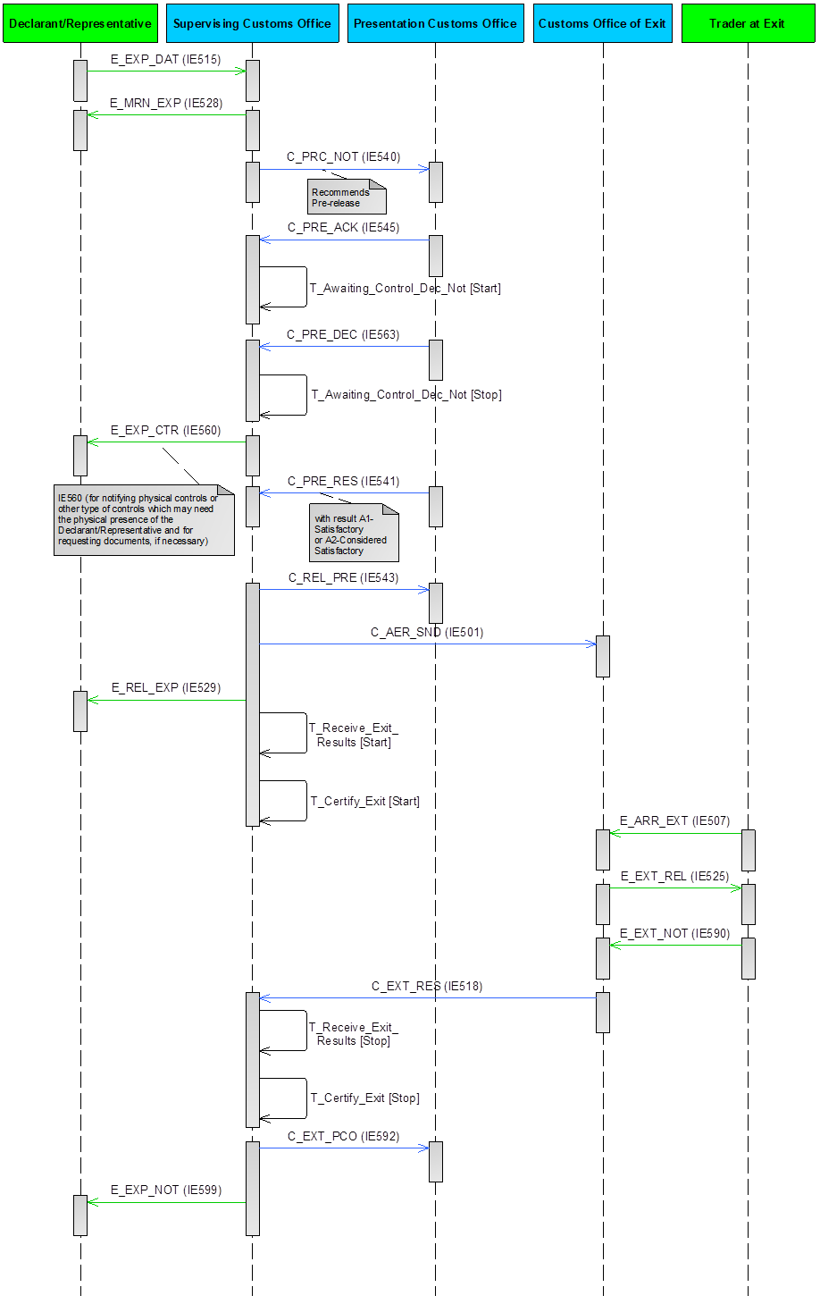

Figure 23: E-EXP-CCE-A-001 SCO recommends pre-release - Satisfactory/considered satisfactory control results at PCO

##### E-EXP-CCE-A-002 SCO recommends pre-release - Unsatisfactory control results at PCO

In this scenario (Figure 24), after receiving the ‘Pre-release/Control Notification’ C_PRC_NOT (IE540) recommending Pre-release from the Supervising Customs Office, the Presentation Customs Office decides to perform controls, but the control results are unsatisfactory. A pre-requisite for Centralised Clearance is that the Declarant/Representative is AEO certified.

More specifically, the current scenario starts identically to the E-EXP-CCE-M-001 SCO recommends pre-release - No controls at SCO and PCO up to **[Step 4]**. That is, **[Step 1]** until **[Step 4]** are the same as E-EXP-CCE-M-001 SCO recommends pre-release - No controls at SCO and PCO.

**[Step 5]** Upon the reception of the ‘Pre-release/Control Acknowledgement’ C_PRE_ACK (IE545) from the Presentation Customs Office, the AES at the Supervising Customs Office initiates the Timer to Receive Control Notification from PCO (T_Awaiting_Control_Dec_Not) to expire at the time limit for receiving the control decision from the Presentation Customs Office. The state of the movement at the Supervising Customs Office is updated to “Awaiting for PCO Control Decision”.

If a ‘Control Decision from Presentation Customs Office’ C_PRE_DEC (IE563) is not received until a specified time (a configurable amount of time) before the expiration of the Timer to Receive Control Notification from PCO (T_Awaiting_Control_Dec_Not), then the Supervising Customs Office sends to the Presentation Customs Office a ‘Reminder for Control Decision’ C_CTR_REM (IE564). In such case, the time sequence diagram is similar to the current scenario, see Figure 24 below. The only difference (compared to the current scenario) is that the Supervising Customs Office also sends to the Presentation Customs Office a ‘Reminder for Control Decision’ C_CTR_REM (IE564), prior receiving the ‘Control Decision from Presentation Customs Office’ C_PRE_DEC (IE563)."

**[Step 6]** The AES at the Presentation Customs Office interfaces with the national risk analysis systems of the Member States to request a Risk Analysis. According to this scenario, the Presentation Customs Office decides to perform controls, hence the AES at the Presentation Customs Office sends to the AES at the Supervising Customs Office a ‘Control Decision from Presentation Customs Office’ C_PRE_DEC (IE563) indicating this decision. The state of the movement at the Presentation Customs Office is updated to “Under Control”.

**[Step 7]** Upon receiving the Customs Office a ‘Control Decision from Presentation Customs Office’ C_PRE_DEC (IE563) indicating the decision of the Presentation Customs Office for performing controls, the AES at the Supervising Customs Office stops the Timer to Receive Control Notification from PCO (T_Awaiting_Control_Dec_Not).

**[Step 8]** The AES at the Supervising Customs Office notifies the Declarant/Representative, about the upcoming activities (physical controls or other type of controls which may need the physical presence of the Declarant/Representative) and for requesting documents19, if necessary, via an ‘Export Control Decision Notification’ E_EXP_CTR (IE560). The state of the movement at the Supervising Customs Office is updated to “Under Control”20.

**[Step 9]** Subsequently, the Presentation Customs Office performs the necessary controls and the Customs Officer registers the unsatisfactory control results at the Presentation Customs Office. Next, the AES at the Presentation Customs Office sends the ‘Control Results from Presentation Customs Office’ C_PRE_RES (IE541 with Control Result Code equal to “B1: Unsatisfactory”) to the AES at the Supervising Customs Office.

The AES at the Supervising Customs Office receives the ‘Control Results from Presentation Customs Office’ C_PRE_RES (IE541 with Control Result Code equal to “B1: Unsatisfactory”) from the AES at the Presentation Customs Office.

**[Step 10]** The AES at the Supervising Customs Office notifies the AES at the Presentation Customs Office that the release of the goods is rejected via a ‘Release Rejection Notification’ C_PRE_REJ (IE542). The state of the movement at the Supervising Customs Office is updated to “Not Released for Export”, which is a final state.

After receiving the ‘Release Rejection Notification’ C_PRE_REJ (IE542) from the Supervising Customs Office, the AES at the Presentation Customs Office also updates the state of the movement to “Not Released for Export” (final state).

**[Step 11]** Finally,the AES at the Supervising Customs Office also informs the Declarant/Representative about the release rejection by sending an ‘Export No Release’ E_EXP_NRL (IE551).

The remaining steps of the E-EXP-CCE-M-001 SCO recommends pre-release - No controls at SCO and PCO ([Step 5] until [Step 21]) are not applicable, since the current scenario has terminated in [Step 11] above.

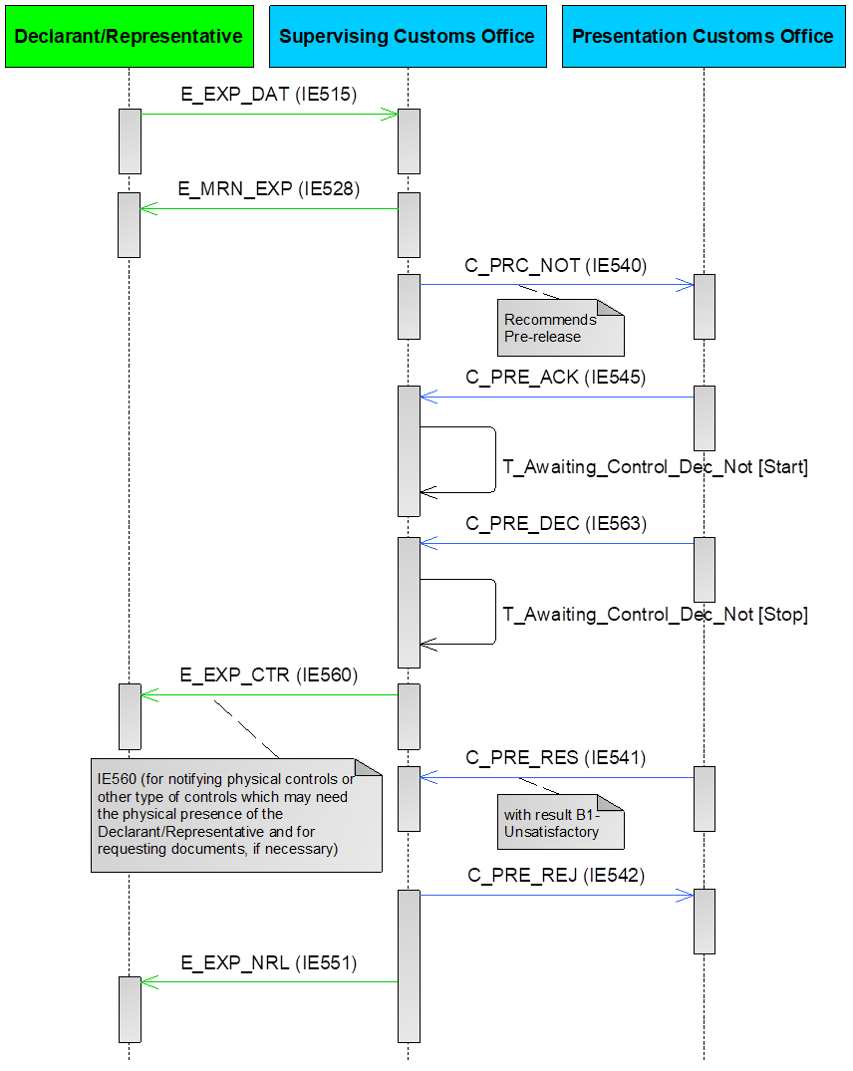

Figure 24: E-EXP-CCE-A-002 SCO recommends pre-release - Unsatisfactory control results at PCO

##### E-EXP-CCE-E-001 SCO recommends pre-release – Expiry of timer for receiving control decision from PCO

In this case (Figure 25), after the ‘Pre-release/Control Notification’ C_PRC_NOT (IE540) recommending Pre-release from the Supervising Customs Office, the timer for receiving control decision expires, before the Presentation Customs Office has sent a ‘Control Decision from Presentation Customs Office’ C_PRE_DEC (IE563). A pre-requisite for Centralised Clearance is that the Declarant/Representative is AEO certified.

More specifically, the current scenario starts identically to the E-EXP-CCE-M-001 SCO recommends pre-release - No controls at SCO and PCO up to **[Step 4]**. That is, **[Step 1]** until **[Step 4]** are the same as in E-EXP-CCE-M-001 SCO recommends pre-release - No controls at SCO and PCO.

**[Step 5]** Upon the reception of the ‘Pre-release/Control Acknowledgement’ C_PRE_ACK (IE545) from the Presentation Customs Office, the AES at the Supervising Customs Office initiates the Timer to Receive Control Notification from PCO (T_Awaiting_Control_Dec_Not) to expire at the time limit for receiving the control decision from the Presentation Customs Office. The state of the movement at the Supervising Customs Office is updated to “Awaiting for PCO Control Decision”.

**[Step 6]** According to this scenario, a ‘Control Decision from Presentation Customs Office’ C_PRE_DEC (IE563) is not received until a specified time (a configurable amount of time) before the expiration of the Timer to Receive Control Notification from PCO (T_Awaiting_Control_Dec_Not), therefore the AES at the Supervising Customs Office sends to the AES at the Presentation Customs Office a ‘Reminder for Control Decision’ C_CTR_REM (IE564).

**[Step 7]** Additionally, the Timer to Receive Control Notification from PCO (T_Awaiting_Control_Dec_Not) expires, before the AES at the Presentation Customs Office has sent a Control Notification to ‘Supervising Customs Office’ C_PRE_DEC (IE563).

**[Step 8]** In this case, the Supervising Customs Office takes the decision (either manually or automatically) to release the goods for export. Therefore, the AES at the Supervising Customs Office informs the AES at the Presentation Customs Office that the goods have been released for export via a ‘Release Notification to Presentation Customs Office’ C_REL_PRE (IE543).

The AES at the Presentation Customs Office receives the ‘Release Notification’ C_REL_PRE (IE543) from the AES at the Supervising Customs Office and changes the state of the movement to “Goods Released for Export”.

**[Step 9]** In parallel, the AES at the Supervising Customs Office sends to the AES of the Customs Office of Exit (Declared) an AER C_AER_SND (IE501) with Control Result Code equal to “A2: Considered Satisfactory”.

After receiving the AER C_AER_SND (IE501) with Control Result Code equal to “A2: Considered Satisfactory”, the AES at the Customs Office of Exit sets the state of the movement at the Customs Office of Exit to “AER Created”.

**[Steps 10 until 21]** These steps are the same as the steps **[Step 10]** until **[Step 21]** of E-EXP-CCE-M-001 SCO recommends pre-release - No controls at SCO and PCO, respectively.



Figure 25: E-EXP-CCE-E-001 SCO recommends pre-release – Expiry of timer for receiving control decision from PCO

##### E-EXP-CCE-A-003 SCO recommends control at PCO – Satisfactory/Considered satisfactory control results at PCO

In the current scenario, the Supervising Customs Office decides to recommend controls at the Presentation Customs Office and satisfactory/considered satisfactory control results are received from the Presentation Customs Office. A pre-requisite for Centralised Clearance is that the Declarant/Representative is AEO certified.

More specifically, the current scenario starts identically to the E-EXP-CFL-M-001 Core flow up to **[Step2]**. That is, **[Step1]** until **[Step2]** are the same as E-EXP-CFL-M-001 Core flow. It shall be highlighted that in the scenarios of Centralised Clearance for Export, the Supervising Customs Office is the Customs Office of Export.

**[Step 3]** The AES at Supervising Customs Office identifies that the ‘Export Declaration’ E_EXP_DAT (IE515) has been lodged under the Centralised Clearance procedure. According to this scenario (depicted in Figure 26 below), the Supervising Customs Office decides to request documents during the documentary controls at the Supervising Customs Office. Thus, the AES at the Supervising Customs Office sends to the Declarant/Representative an ‘Export Control Decision Notification’ E_EXP_CTR (IE560) in order to request documents as part of documentary controls. The state of the movement at the Supervising Customs Office changes to “Under Control” [22].

As the documentary controls take place and the control results are satisfactory, the Customs Officer registers the satisfactory control results at the Supervising Customs Office (the case that documentary controls take place and the control results are unsatisfactory is described in a different scenario, see III.4.1.3.9 below). It is possible, the documentary controls at the Supervising Customs Office not to be completed yet. In such case, the Supervising Customs Office will inform the Presentation Customs Office that controls are still ongoing at the Supervising Customs Office, via the ‘Pre-release/Control Notification’ C_PRC_NOT (IE540) (see [Step 4] below).

**[****Step 4]** According to the current scenario, the Supervising Customs Office decides to recommend controls at the Presentation Customs Office. Due to this, the AES at the Supervising Customs Office sends a ‘Pre-release/Control Notification’ C_PRC_NOT (IE540) recommending Control to the Presentation Customs Office.

**[Step 5]** After receiving the ‘Pre-release/Control Notification’ C_PRC_NOT (IE540) recommending Control from the Supervising Customs Office, the state of the movement at the Presentation Customs Office is set to “Awaiting for PCO Control Decision”. Then, the Presentation Customs Office automatically sends a ‘Pre-release/Control Acknowledgement’ C_PRE_ACK (IE545) to the AES at the Supervising Customs Office.

**[Step 6]** Upon the reception of the ‘Pre-release/Control Acknowledgement’ C_PRE_ACK (IE545) from the Presentation Customs Office, the AES at the Supervising Customs Office initiates the Timer to Receive Control Notification from PCO (T_Awaiting_Control_Dec_Not) to expire at the time limit for receiving the control decision from the Presentation Customs Office.

If a ‘Control Decision from Presentation Customs Office’ C_PRE_DEC (IE563) is not received until a specified time (a configurable amount of time) before the expiration of the Timer to Receive Control Notification from PCO (T_Awaiting_Control_Dec_Not), then the Supervising Customs Office sends to the Presentation Customs Office a ‘Reminder for Control Decision’ C_CTR_REM (IE564).

**[Step 7]** The AES at the Presentation Customs Office interfaces with the national risk analysis systems of the Member States to request a Risk Analysis. According to this scenario, the Presentation Customs Office decides to perform controls, hence the AES at the Presentation Customs Office sends to the AES at the Supervising Customs Office a ‘Control Decision from Presentation Customs Office’ C_PRE_DEC (IE563) indicating this decision. The state of the movement at the Presentation Customs Office is updated to “Under Control”.

**[Step 8]** Upon receiving the ‘Control Decision from Presentation Customs Office’ C_PRE_DEC (IE563) indicating the decision of the Presentation Customs Office for performing controls, the AES at the Supervising Customs Office stops the Timer to Receive Control Notification from PCO (T_Awaiting_Control_Dec_Not).

**[Step 9]** As the Presentation Customs Office decides to perform physical controls or other type of controls which may need the physical presence of the Declarant/Representative and for requesting documents, a new ‘Export Control Decision Notification’ E_EXP_CTR (IE560) shall be sent to Declarant/Representative from Supervising Customs Office[23]. The state of the movement at the Supervising Customs Office remains “Under Control”.[24]

**[Step 10]** Subsequently, the Presentation Customs Office performs the necessary controls and the Customs Officer registers the satisfactory control results at the Presentation Customs Office. In case of the Presentation Customs Office is not able to perform the necessary controls, the control results are considered satisfactory. Next, the Presentation Customs Office sends the ‘Control Results from Presentation Customs Office’ C_PRE_RES (IE541 with Control Result Code equal to “A1: Satisfactory:” or “A2: Considered Satisfactory”[25]) to the Supervising Customs Office.

The AES at the Supervising Customs Office receives the ‘Control Results from Presentation Customs Office’ C_PRE_RES (IE541 with Control Result Code equal to “A1: Satisfactory:” or “A2: Considered Satisfactory”) from the AES at the Presentation Customs Office.

**[Step 11]** This step is the same as the **[Step 8]** of the E-EXP-CCE-M-001 SCO recommends pre-release - No controls at SCO and PCO.

**[Step 12]** The AES at the Supervising Customs Office sends to the AES of the Customs Office of Exit (Declared) an AER C_AER_SND (IE501) with Control Result Code equal to “A1: Satisfactory” or “A2: Considered Satisfactory”.

After receiving the AER C_AER_SND (IE501) with Control Result Code equal to “A1: Satisfactory” or “A2: Considered Satisfactory”, the AES at the Customs Office of Exit sets the state of the movement at the Customs Office of Exit to “AER Created”.

**[Steps 13 until 24]** These steps are the same as the steps **[Step 10]** until **[Step 21]** of the E-EXP-CCE-M-001 SCO recommends pre-release - No controls at SCO and PCO, respectively.

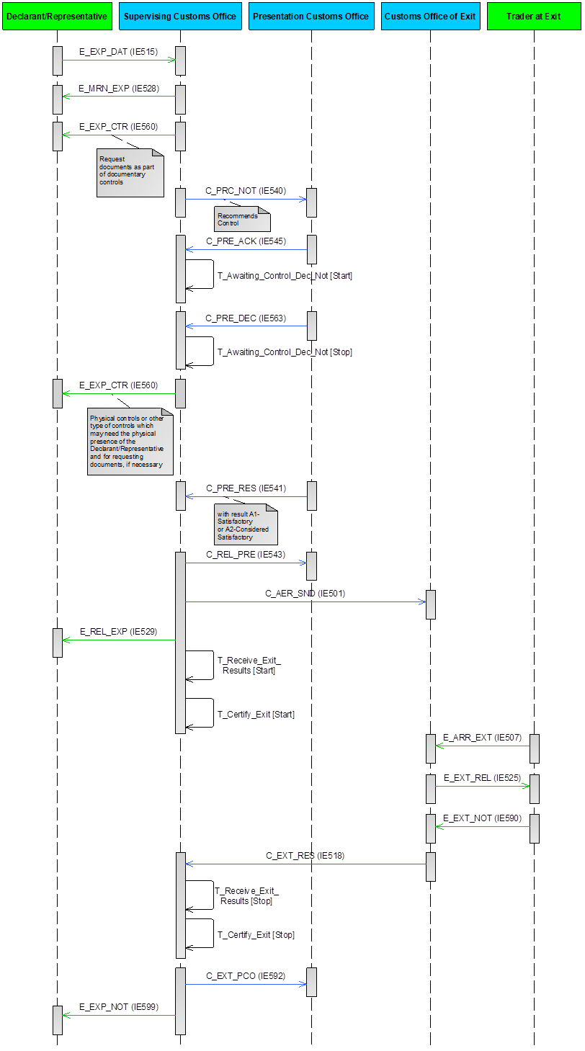

Figure 26: E-EXP-CCE-A-003 SCO recommends control at PCO – Satisfactory/Considered satisfactory control results at PCO

##### E-EXP-CCE-A-004 SCO recommends control at PCO - Unsatisfactory control results at PCO

In the current scenario, the Supervising Customs Office decides that controls from the Presentation Customs Office are required, but unsatisfactory control results are received from the Presentation Customs Office. A pre-requisite for Centralised Clearance is that the Declarant/Representative is AEO certified.

More specifically, the current scenario starts identically to the E-EXP-CFL-M-001 Core flow up the **[Step 2]**. That is, **[Step 1]** until **[Step 2]** are the same as E-EXP-CFL-M-001 Core flow. It shall be highlighted that in the scenarios of Centralised Clearance for Export, the Supervising Customs Office is the Customs Office of Export.

**[Step 3]** The AES at Supervising Customs Office identifies that the ‘Export Declaration’ E_EXP_DAT (IE515) has been lodged under the Centralised Clearance procedure. According to this scenario (depicted in Figure 27 below), Supervising Customs Office decides to request documents during the documentary controls at the Supervising Customs Office. Thus, the AES at the Supervising Customs Office sends to the Declarant/Representative an ‘Export Control Decision Notification’ E_EXP_CTR (IE560) in order to request documents as part of documentary controls. The state of the movement at the Supervising Customs Office changes to “Under Control”22.

At this point, documentary controls may be performed at the Supervising Customs Office if so decided. In case documentary controls take place and the control results are satisfactory, the Customs Officer registers the satisfactory control results at the Supervising Customs Office (the case that documentary controls take place and the control results are unsatisfactory is described in a different scenario, see III.4.1.3.9 below). It is possible, the documentary controls at the Supervising Customs Office not to be completed yet. In such case, the Supervising Customs Office will inform the Presentation Customs Office that controls are still ongoing at the Supervising Customs Office, via the ‘Pre-release/Control Notification’ C_PRC_NOT (IE540) (see [Step 4] below).

**[****Step 4]** According to the current scenario, the Supervising Customs Office decides to recommend controls at the Presentation Customs Office. Due to this, the AES at the Supervising Customs Office sends a ‘Pre-release/Control Notification’ C_PRC_NOT (IE540) recommending Control to the Presentation Customs Office.

**[Step 5]** After receiving the ‘Pre-release/Control Notification’ C_PRC_NOT (IE540) recommending Control from the Supervising Customs Office, the state of the movement at the Presentation Customs Office is set to “Awaiting for PCO Control Decision”. Then, the Presentation Customs Office automatically sends a ‘Pre-release/Control Acknowledgement’ C_PRE_ACK (IE545) to the AES at the Supervising Customs Office.

**[Step 6]** Upon the reception of the ‘Pre-release/Control Acknowledgement’ C_PRE_ACK (IE545) from the Presentation Customs Office, the AES at the Supervising Customs Office initiates the Timer to Receive Control Notification from PCO (T_Awaiting_Control_Dec_Not) to expire at the time limit for receiving the control decision from the Presentation Customs Office.

If a ‘Control Decision from Presentation Customs Office’ C_PRE_DEC (IE563) is not received until a specified time (a configurable amount of time) before the expiration of the Timer to Receive Control Notification from PCO (T_Awaiting_Control_Dec_Not), then the Supervising Customs Office sends to the Presentation Customs Office a ‘Reminder for Control Decision’ C_CTR_REM (IE564). In such case, the time sequence diagram is similar to the current scenario, see Figure 27 below. The only difference (compared to the current scenario) is that the Supervising Customs Office also sends to the Presentation Customs Office a ‘Reminder for Control Decision’ C_CTR_REM (IE564), prior receiving the ‘Control Decision from Presentation Customs Office’ C_PRE_DEC (IE563)."

**[Step 7]** The AES at the Presentation Customs Office interfaces with the national risk analysis systems of the Member States to request a Risk Analysis. According to this scenario, the Presentation Customs Office decides to perform controls, hence the AES at the Presentation Customs Office sends to the AES at the Supervising Customs Office a ‘Control Decision from Presentation Customs Office’ C_PRE_DEC (IE563) indicating this decision. The state of the movement at the Presentation Customs Office is updated to “Under Control”.

**[Step 8]** Upon receiving the ‘Control Decision from Presentation Customs Office’ C_PRE_DEC (IE563) indicating the decision of the Presentation Customs Office for performing controls, the AES at the Supervising Customs Office stops the Timer to Receive Control Notification from PCO (T_Awaiting_Control_Dec_Not).

**[Step 9]** As the Presentation Customs Office decides on physical controls or other type of controls which may need the physical presence of the Declarant/Representative and for requesting documents, a new ‘Export Control Decision Notification’ E_EXP_CTR (IE560) shall be sent to Declarant/Representative from Supervising Customs Office23. The state of the movement at the Supervising Customs Office remains “Under Control”24.

**[Step 10]** Subsequently, the Presentation Customs Office performs the necessary controls and the Customs Officer registers the unsatisfactory control results at the Presentation Customs Office. Next, the Presentation Customs Office sends the ‘Control Results from Presentation Customs Office’ C_PRE_RES (IE541 with Control Result Code equal to “B1: Unsatisfactory”) to the Supervising Customs Office.

The AES at the Supervising Customs Office receives the ‘Control Results from Presentation Customs Office’ C_PRE_RES (IE541 with Control Result Code equal to “B1: Unsatisfactory”) from the AES at the Presentation Customs Office.

**[Step 11]** The AES at the Supervising Customs Office notifies the AES at the Presentation Customs Office that the release of the goods is rejected via a ‘Release Rejection Notification’ C_PRE_REJ (IE542). The state of the movement at the Supervising Customs Office is updated to “Not Released for Export”, which is a final state.

After receiving the ‘Release Rejection Notification’ C_PRE_REJ (IE542) from the Supervising Customs Office, the AES at the Presentation Customs Office also updates the state of the movement to “Not Released for Export” (final state).

**[Step 12]** Finally,the AES at the Supervising Customs Office also informs the Declarant/Representative about the release rejection by sending an ‘Export No Release’ E_EXP_NRL (IE551).

The remaining steps of the E-EXP-CCE-M-001 SCO recommends pre-release - No controls at SCO and PCO ([Step 13] until [Step 22]) are not applicable, since the current scenario has terminated in [Step 11] above.

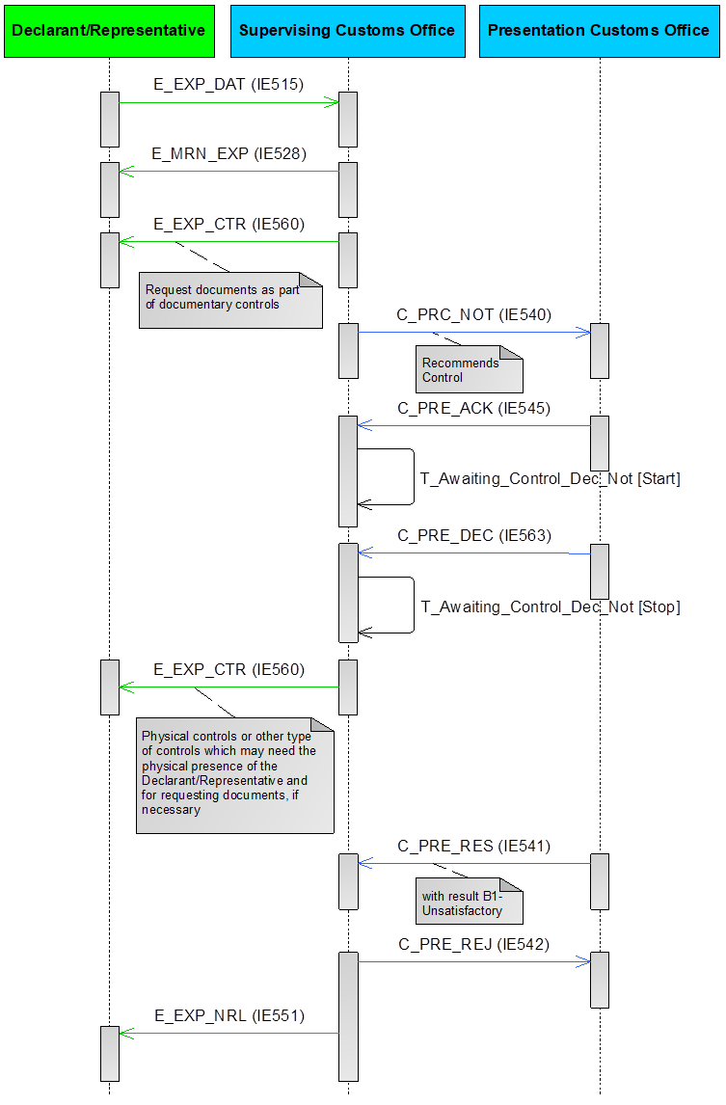

Figure 27: E-EXP-CCE-A-004 SCO recommends control at PCO - Unsatisfactory control results at PCO

##### E-EXP-CCE-E-002 SCO recommends control at PCO - PCO decides not to perform any control

In the current scenario, the Supervising Customs Office decides to recommend controls at the Presentation Customs Office, but the Presentation Customs Office decides not to perform any control. A pre-requisite for Centralised Clearance is that the Declarant/Representative is AEO certified.

More specifically, the current scenario starts identically to the E-EXP-CFL-M-001 Core flow up to the **[Step 2]**. That is, **[Step 1]** until **[Step 2]** are the same as E-EXP-CFL-M-001 Core flow. It shall be highlighted that in the scenarios of Centralised Clearance for Export, the Supervising Customs Office is the Customs Office of Export.

**[Step 3]** The AES at Supervising Customs Office identifies that the ‘Export Declaration’ E_EXP_DAT (IE515) has been lodged under the Centralised Clearance procedure. According to this scenario (depicted in Figure 28 below), the Supervising Customs Office decides to request documents during the documentary controls at the Supervising Customs Office. Thus, the AES at the Supervising Customs Office sends to the Declarant/Representative an ‘Export Control Decision Notification’ E_EXP_CTR (IE560) in order to request documents as part of documentary controls. The state of the movement at the Supervising Customs Office changes to “Under Control”22.

As the documentary controls take place and the control results are satisfactory, the Customs Officer registers the satisfactory control results at the Supervising Customs Office (the case that documentary controls take place and the control results are unsatisfactory is described in a different scenario, see III.4.1.3.9 below). It is possible, the documentary controls at the Supervising Customs Office not to be completed yet. In such case, the Supervising Customs Office will inform the Presentation Customs Office that controls are still ongoing at the Supervising Customs Office, via the ‘Pre-release/Control Notification’ C_PRC_NOT (IE540) (see [Step 4] below).

**[****Step 4]** According to the current scenario, the Supervising Customs Office decides to recommend controls at the Presentation Customs Office. Due to this, the AES at the Supervising Customs Office sends a ‘Pre-release/Control Notification’ C_PRC_NOT (IE540) recommending Control to the Presentation Customs Office.

**[Step 5]** After receiving the ‘Pre-release/Control Notification’ C_PRC_NOT (IE540) recommending Control from the Supervising Customs Office, the state of the movement at the Presentation Customs Office is set to “Awaiting for PCO Control Decision”. Then, the Presentation Customs Office automatically sends a ‘Pre-release/Control Acknowledgement’ C_PRE_ACK (IE545) to the AES at the Supervising Customs Office.

**[Step 6]** Upon the reception of the ‘Pre-release/Control Acknowledgement’ C_PRE_ACK (IE545) from the Presentation Customs Office, the AES at the Supervising Customs Office initiates the Timer to Receive Control Notification from PCO (T_Awaiting_Control_Dec_Not) to expire at the time limit for receiving the control decision from the Presentation Customs Office.

If a ‘Control Decision from Presentation Customs Office’ C_PRE_DEC (IE563) is not received until a specified time (a configurable amount of time) before the expiration of the Timer to Receive Control Notification from PCO (T_Awaiting_Control_Dec_Not), then the Supervising Customs Office sends to the Presentation Customs Office a ‘Reminder for Control Decision’ C_CTR_REM (IE564).

**[Step 7]** The AES at the Presentation Customs Office interfaces with the national risk analysis systems of the Member States to request a Risk Analysis. According to this scenario, the Presentation Customs Office decides not to perform any control, hence the Presentation Customs Office sends to the Supervising Customs Office a ‘Control Decision from Presentation Customs Office’ C_PRE_DEC (IE563) indicating this decision.

**[Step 8]** Upon receiving the ‘Control Decision from Presentation Customs Office’ C_PRE_DEC (IE563) indicating the decision of the Presentation Customs Office for not performing any control, the AES at the Supervising Customs Office stops the Timer to Receive Control Notification from PCO (T_Awaiting_Control_Dec_Not).

**[Step 9]** In this case, the Supervising Customs Office takes the decision (either manually or automatically) to release the goods for export. Therefore, the AES at the Supervising Customs Office informs the AES at the Presentation Customs Office that the goods have been released for export via a ‘Release Notification to Presentation Customs Office’ C_REL_PRE (IE543).

The AES at the Presentation Customs Office receives the ‘Release Notification to Presentation Customs Office’ C_REL_PRE (IE543) from the AES at the Supervising Customs Office and changes the state of the movement to “Goods Released for Export”.

**[Step 10]** In parallel, the AES at the Supervising Customs Office sends to the AES of the Customs Office of Exit (Declared) an AER C_AER_SND (IE501) with Control Result Code equal to “A2: Considered Satisfactory”.

After receiving the AER C_AER_SND (IE501) with Control Result Code equal to “A2: Considered Satisfactory”, the AES at the Customs Office of Exit sets the state of the movement at the Customs Office of Exit to “AER Created”.

**[Steps 11 until 22]** These steps are the same as the steps **[Step 10]** until **[Step 21]** of E-EXP-CCE-M-001 SCO recommends pre-release - No controls at SCO and PCO, respectively.

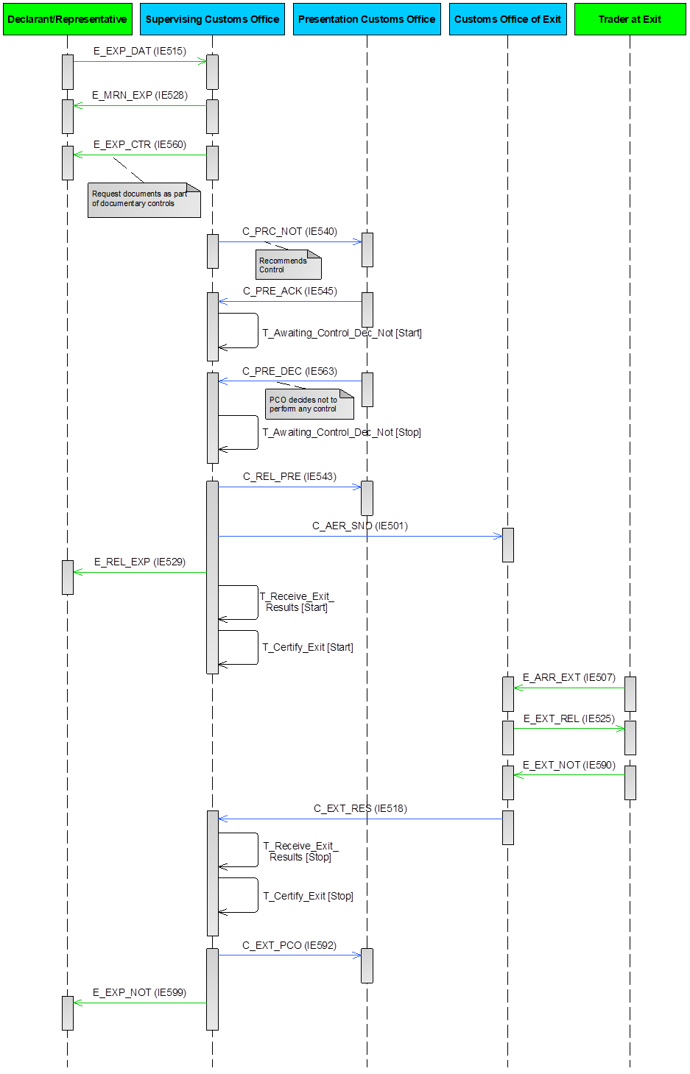

Figure 28: E-EXP-CCE-E-002 SCO recommends control at PCO - PCO decides not to perform any control

##### E-EXP-CCE-E-003 SCO recommends control at PCO - Expiry of timer for receiving control decision from PCO

In the current scenario, the Supervising Customs Office decides to recommend controls at the Presentation Customs Office, but the timer for receiving control decision expires, before the Presentation Customs Office has sent a ‘Control Decision from Presentation Customs Office’ C_PRE_DEC (IE563). A pre-requisite for Centralised Clearance is that the Declarant/Representative is AEO certified.

More specifically, the current scenario starts identically to the E-EXP-CFL-M-001 Core flow up the **[Step 2]**. That is, **[Step 1]** until **[Step 2]** are the same as in E-EXP-CFL-M-001 Core flow. It shall be highlighted that in the scenarios of Centralised Clearance for Export, the Supervising Customs Office is the Customs Office of Export.

**[Step 3]** The AES at Supervising Customs Office identifies that the ‘Export Declaration’ E_EXP_DAT (IE515) has been lodged under the Centralised Clearance procedure. According to this scenario (depicted in Figure 29 below), the Supervising Customs Office decides to request documents during the documentary controls at the Supervising Customs Office. Thus, the AES at the Supervising Customs Office sends to the Declarant/Representative an ‘Export Control Decision Notification’ E_EXP_CTR (IE560) in order to request documents as part of documentary controls. The state of the movement at the Supervising Customs Office changes to “Under Control”22.

As the documentary controls take place and the control results are satisfactory, the Customs Officer registers the satisfactory control results at the Supervising Customs Office (the case that documentary controls take place and the control results are unsatisfactory is described in a different scenario, see III.4.1.3.9 below). It is possible, the documentary controls at the Supervising Customs Office not to be completed yet. In such case, the Supervising Customs Office will inform the Presentation Customs Office that controls are still ongoing at the Supervising Customs Office, via the ‘Pre-release/Control Notification’ C_PRC_NOT (IE540) (see [Step 4] below).

**[****Step 4]** According to the current scenario, the Supervising Customs Office decides to recommend controls at the Presentation Customs Office. Due to this, the AES at the Supervising Customs Office sends a ‘Pre-release/Control Notification’ C_PRC_NOT (IE540) recommending Control to the Presentation Customs Office.

**[Step 5]** After receiving the ‘Pre-release/Control Notification’ C_PRC_NOT (IE540) recommending Control from the Supervising Customs Office, the state of the movement at the Presentation Customs Office is set to “Awaiting for PCO Control Decision”. Then, the Presentation Customs Office automatically sends a ‘Pre-release/Control Acknowledgement’ C_PRE_ACK (IE545) to the AES at the Supervising Customs Office.

**[Step 6]** Upon the reception of the ‘Pre-release/Control Acknowledgement’ C_PRE_ACK (IE545) from the Presentation Customs Office, the AES at the Supervising Customs Office initiates the Timer to Receive Control Notification from PCO (T_Awaiting_Control_Dec_Not) to expire at the time limit for receiving the control decision from the Presentation Customs Office.

**[Step 7]** According to this scenario, a ‘Control Decision from Presentation Customs Office’ C_PRE_DEC (IE563) is not received until a specified time (a configurable amount of time) before the expiration of the Timer to Receive Control Notification from PCO (T_Awaiting_Control_Dec_Not), therefore the AES at the Supervising Customs Office sends to the AES at the Presentation Customs Office a ‘Reminder for Control Decision’ C_CTR_REM (IE564).

**[Step 8]** Additionally, the Timer to Receive Control Notification from PCO (T_Awaiting_Control_Dec_Not) expires before the AES at the Presentation Customs Office has sent a ‘Control Decision from Presentation Customs Office’ C_PRE_DEC (IE563).

**[Step 9]** In this case, the Supervising Customs Office takes the decision (either manually or automatically) to release the goods for export. Therefore, the AES at the Supervising Customs Office informs the AES at the Presentation Customs Office that the goods have been released for export via a ‘Release Notification to Presentation Customs Office’ C_REL_PRE (IE543).

The AES at the Presentation Customs Office receives the ‘Release Notification to Presentation Customs Office’ C_REL_PRE (IE543) from the AES at the Supervising Customs Office and changes the state of the movement to “Goods Released for Export”.

**[Step 10]** In parallel, the AES at the Supervising Customs Office sends to the AES of the Customs Office of Exit (Declared) an AER C_AER_SND (IE501) with Control Result Code equal to “A2: Considered Satisfactory).

After receiving the AER C_AER_SND (IE501) with Control Result Code equal to “A2: Considered Satisfactory”, the AES at the Customs Office of Exit sets the state of the movement at the Customs Office of Exit to “AER Created”.

**[Steps 11 until 22]** These steps are the same as the steps **[Step 10]** until **[Step 21]** of the E-EXP-CCE-M-001 SCO recommends pre-release - No controls at SCO and PCO, respectively.

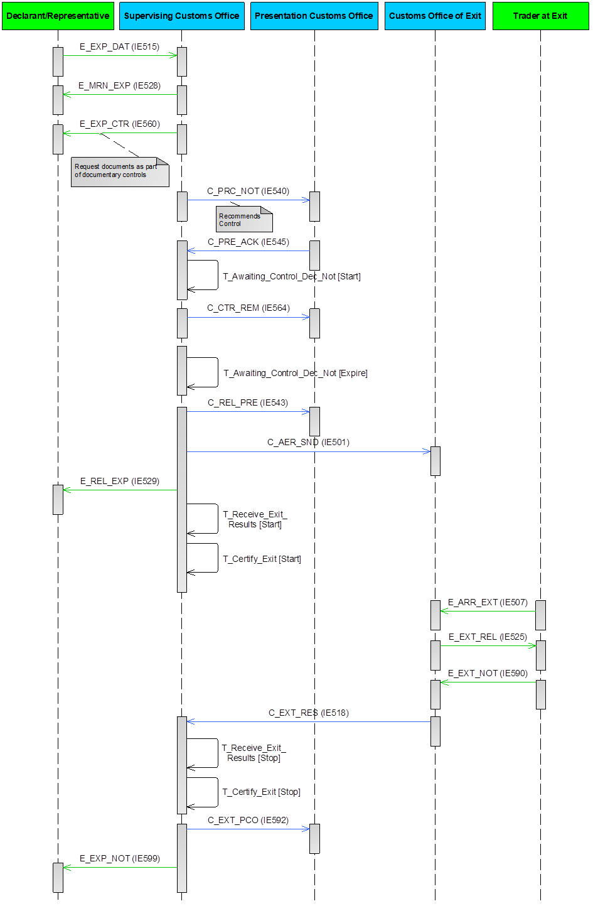

Figure 29: E-EXP-CCE-E-003 SCO recommends control at PCO - Expiry of timer for receiving control decision from PCO

##### E-EXP-CCE-A-005 Unsatisfactory documentary control results at SCO

In the current scenario, the results of the documentary controls at the Supervising Customs Office are deemed unsatisfactory. A pre-requisite for Centralised Clearance is that the Declarant/Representative is AEO certified.

More specifically, the current scenario starts identically to the E-EXP-CFL-M-001 Core flow up to **[Step 2]**. That is, **[Step 1]** until **[Step 2]** are the same as E-EXP-CFL-M-001 Core flow. It shall be highlighted that in the scenarios of Centralised Clearance for Export, the Supervising Customs Office is the Customs Office of Export.

**[Step 3]** The AES at Supervising Customs Office identifies that the ‘Export Declaration’ E_EXP_DAT (IE515) has been lodged under the Centralised Clearance procedure. According to this scenario (depicted in Figure 30), the Supervising Customs Office decides to request documents during the documentary controls at the Supervising Customs Office. Thus, the AES at the Supervising Customs Office sends to the Declarant/Representative an ‘Export Control Decision Notification’ E_EXP_CTR (IE560) in order to request documents as part of documentary controls. The state of the movement at the Supervising Customs Office changes to “Under Control”22.

**[Step 4**] At this point, documentary controls are performed at the Supervising Customs Office, since they were decided, and the control results are deemed unsatisfactory. The Customs Officer registers the unsatisfactory control results at the Supervising Customs Office. Due to this, the AES at the Supervising Customs Office sends a ‘Pre-release/Control Notification’ C_PRC_NOT (IE540) to the Presentation Customs Office indicating the release rejection of the goods and also containing the unsatisfactory documentary control results of the Supervising Customs Office. The state of the movement at the Supervising Customs Office is updated to “Not Released for Export”, which is a final state.

**[Step 5]** In parallel, the AES at the Supervising Customs Office also informs the Declarant/Representative about the release rejection by sending an ‘Export No Release’ E_EXP_NRL (IE551).

**[Step 6]** Afterreceiving the ‘Pre-release/Control Notification’ C_PRC_NOT (IE540) indicating the release rejection from the Supervising Customs Office, the Presentation Customs Office automatically sends a ‘Pre-release/Control Acknowledgement’ C_PRE_ACK (IE545) to the AES at the Supervising Customs Office. The state of the movement at the Presentation Customs Office is updated to “Not Released for Export”, which is a final state.

The remaining steps of the E-EXP-CCE-M-001 SCO recommends pre-release - No controls at SCO and PCO ([Step 7] until [Step 21]) are not applicable, since the current scenario has terminated in [Step 6] above.

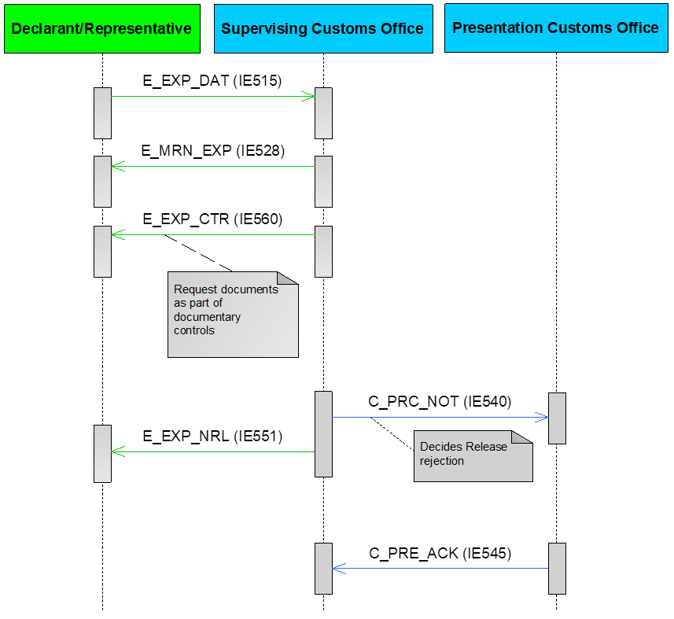

Figure 30: E-EXP-CCE-A-005 Unsatisfactory documentary control results at SCO

##### E-EXP-CCE-A-006 Declaration amendment accepted under centralised clearance

The conditions under which a declaration amendment request can be sent are described in section III.5.1.1. It is worth noting that multiple declaration amendments (‘Export Declaration Amendment’ E_EXP_AMD (IE513)) can be sent to the Supervising Customs Office of Export, as long as those conditions are fulfilled.

More specifically, the current scenario (Figure 31) starts identically to the E-EXP-CFL-M-001 Core flow up to **[Step 2]**. That is, **[Step 1]** until **[Step 2]** are the same as E-EXP-CFL-M-001 Core flow. It shall be highlighted that in the scenarios of Centralised Clearance for Export, the Supervising Customs Office is the Customs Office of Export.

**[Step 3]** The Declarant/Representative, who sent the initial declaration, sends an ‘Export Declaration Amendment’ E_EXP_AMD (IE513) to the AES at the Supervising Customs Office, in the time period between the declaration acceptance and the release for export, while the movement state is “Accepted” (either in case the amendment request is accepted or rejected).

**[Step 4]** After validating and accepting the ‘Export Declaration Amendment’ E_EXP_AMD (IE513), the AES at the Supervising Customs Office sends an ‘Export Declaration Amendment Acceptance’ E_EXP_AAC (IE504) to the Declarant/Representative. The state of the movement remains to “Accepted”.

**[Steps 5 until 23]** These steps are the same as the steps **[Step 3]****[26]** until **[Step 21]** of the E-EXP-CCE-M-001 SCO recommends pre-release - No controls at SCO and PCO, respectively. In this case, the AES at the Supervising Customs Office will send to the AES at the Presentation Customs Office a ‘Pre-release/Control Notification’ C_PRC_NOT (IE540) containing the amended Export Declaration data, following the successful declaration amendment.

It shall be noted that if the Declarant/Representative sends an ‘Export Declaration Amendment’ E_EXP_AMD (IE513), which is rejected by the Supervising Customs Office due to errors, then the AES at the Supervising Customs Office sends a ‘Rejection from Office of Export’ E_EXP_REJ (IE556) to the Declarant/Representative. In this case, the state of the movement at the Supervising Customs Office remains as “Accepted”. Then, the following cases are possible:

* The Declarant/Representative may send a new amendment (‘Export Declaration Amendment’ E_EXP_AMD (IE513)), in which case the flow shall continue as per **[Step 3]** of the current scenario E-EXP-CCE-A-006 Declaration amendment accepted under centralised clearance; OR
* The Declarant/Representative does not send a new amendment request (‘Export Declaration Amendment’ E_EXP_AMD (IE513)), in which case the the initial export declaration remains valid and the flow continues from **[Step 3]** of the E-EXP-CCE-M-001 SCO recommends pre-release - No controls at SCO and PCO.



Figure 31: E-EXP-CCE-A-006 Declaration amendment accepted under centralised clearance

#### Declaration Invalidation

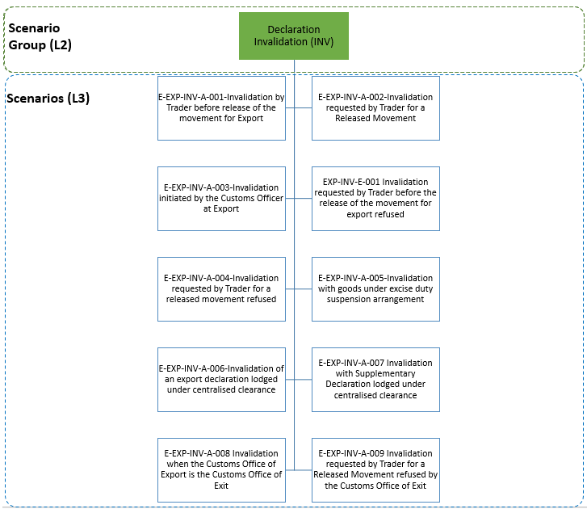

Figure 32: Declaration Invalidation scenarios

The current section describes export declaration invalidation functionality. The scenarios can be categorised in the following major groupings:

* Handling of the export declaration invalidation before the goods release for export which includes the cases where:
* the invalidation request initiated by the Declarant/Representative is found valid at AES of Customs Office of Export (E-EXP-INV-A-001 Invalidation by Trader before release of the movement for Export);
* the invalidation request initiated by the Declarant/Representative is found invalid at AES of Customs Office of Export, hence it is rejected (E-EXP-INV-E-001 Invalidation requested by Trader before the release of the movement for export refused).
* Handling of the export declaration invalidation after the goods release for export which includes the cases:
* the invalidation request initiated by the Declarant/Representative is found valid at AES of Customs Office of Export and AES at the Customs Office of Exit replies positively to the invalidation notification (E-EXP-INV-A-002 Invalidation requested by Trader for a Released Movement);
* the invalidation request initiated by the Customs Officer is valid and AES at the Customs Office of Exit replies positively to the invalidation notification (E-EXP-INV-A-003 Invalidation initiated by the Customs Officer at Export);
* the invalidation request initiated by the Declarant/Representative is found invalid at AES of Customs Office of Export, hence it is rejected (E-EXP-INV-A-004 Invalidation requested by Trader for a released movement refused);
* the invalidation request initiated by the Declarant/Representative is found valid at AES of Customs Office of Export, but AES at the Customs Office of Exit replies negatively to the invalidation notification, hence it is rejected (E-EXP-INV-A-009 Invalidation requested by Trader for a Released Movement refused by the Customs Office of Exit).
* Export declaration invalidation when the goods are under excise duty suspension arrangement (E-EXP-INV-A-005 Invalidation with goods under excise duty suspension arrangement);
* Invalidation of an export declaration lodged under centralised clearance (E-EXP-INV-A-006 Invalidation of an export declaration lodged under centralised clearance) and invalidation with Supplementary Declaration lodged under centralised clearance (E-EXP-INV-A-007 Invalidation with Supplementary Declaration lodged under centralised clearance);
* Invalidation of an export declaration when the Customs Office of Export is the Customs Office of Exit (E-EXP-INV-A-008 Invalidation when the Customs Office of Export is the Customs Office of Exit).

##### E-EXP-INV-A-001 Invalidation by Trader before release of the movement for Export

Figure 33 displays the scenario in which the Declarant/Representative decides to invalidate an Export Declaration after the declaration had been accepted and before the movement is released at the Customs Office of Export.

The flow continues up until **[****Step 3****]** of the E-EXP-CFL-M-001 Core flow scenario. That is, **[**Step 1**]** until **[**Step 2**]** are the same as in E-EXP-CFL-M-001 Core flow. In this case, the Customs Officer at the Customs Office of Export decides not to control the goods and therefore the export movement can be released for export **[Step 3]**.

At this point the Declarant/Representative decides to invalidate the Export Declaration and submits an invalidation request via an ‘Export Invalidation Request’ E_EXP_INV (IE514) message **[Step 4]**.

AES at the Customs Office of Export verifies that the invalidation request is valid. Hence, AES at the Customs Office of Export proceeds with the invalidation of the Export Declaration and informs the Declarant/Representative via an ‘Export Invalidation Decision’ E_EXP_DEC (IE509) message. The movement state is set to “Invalidated”, which is the final state **[Step 5]**.

The remaining steps of E-EXP-CFL-M-001 Core flow ([Step 3] until [Step 15]) are not applicable, since [Step 5] above is the final step.



Figure 33: E-EXP-INV-A-001 Invalidation by Trader before release of the movement for Export

##### E-EXP-INV-A-002 Invalidation requested by Trader for a Released Movement

Figure 34 displays the scenario in which the Declarant/Representative decides to invalidate an Export Declaration after the movement has been released at the Customs Office of Export.

The flow continues up until **[****Step 8****]** of the E-EXP-CFL-M-001 Core flow scenario. That is, **[**Step 1**]** until **[**Step 7**]** are the same as in E-EXP-CFL-M-001 Core flow. In this case, the Declarant/Representative decides to invalidate the Export Declaration for movement that has been released for export (the movement state at the Customs Office of Export is set to either “Goods Released for Export” or “Diversion Accepted”). Thus, the Declarant/Representative submits an invalidation request via an ‘Export Invalidation Request’ E_EXP_INV (IE514) message. It is strongly recommended to use the status check mechanism (E-EXP-EMS-M-001 Status request/response) before the invalidation process, in order the Customs Office of Export to be aware of the state at the Customs Office of Exit, before sending the ‘Export Invalidation Notification’ C_INV_EXP (IE510) message **[Step 8]**.

**[Step 9]** AES at the Customs Office of Export verifies that the invalidation request is valid. Hence, AES at the Customs Office of Export sends to AES at the Customs Office of Exit an ‘Export Invalidation Notification’ C_INV_EXP (IE510) message.

**[Step 10]** AES at the Customs Office of Exit replies positively to the invalidation notification via an ‘Invalidation Acknowledgement’ C_INV_ACK (IE591)[27].

**[Step 11]** AES at the Customs Office of Export informs the Declarant/Representative about the declaration invalidation via an ‘Export Invalidation Decision’ E_EXP_DEC (IE509) message. The movement state at the Customs Office of Export is set to “Invalidated”.

Following the declaration invalidation, all active timers related to the movement are stopped. This is the final state and flow ends here. The remaining steps of E-EXP-CFL-M-001 Core flow ([Step 8] until [Step 15]) are not applicable, since [Step 11] above is the final step.



Figure 34: E-EXP-INV-A-002 Invalidation requested by Trader for a Released Movement

##### E-EXP-INV-A-003 Invalidation initiated by the Customs Officer at Export

Figure 35 displays the scenario in which the Customs Officer decides to invalidate an Export Declaration after the movement is released at the Customs Office of Export. The Customs Officer may initiate the invalidation process either:

* Due to reasons resulting from the enquiry process (i.e. when the Time Limit to Receive Alternative Evidence (T_Receive_Alternative_Evidence) expires before the Declarant/Representative has sent an ‘Information on Non-Exited Export’ E_EXT_RSP (IE583), see E-EXP-ENQ-A-002 Expiry of timer to receive exit results - Invalidation after expiry of time limit to receive Alternative Evidence);
* In the exceptional situation where the Declarant/Representative has decided to invalidate the Export declaration, but he/she is not able to initiate the invalidation process by electronic means, so the Customs Officer initiates the invalidation process on his/her behalf.

The flow continues up until **[****Step 8****]** of the E-EXP-CFL-M-001 Core flow scenario. That is, **[**Step 1**]** until **[**Step 7**]** are the same as in E-EXP-CFL-M-001 Core flow. At this point the Customs Officer at the Customs Office of Export decides to invalidate the Export Declaration for a movement that has been released for export (the movement state at the Customs Office of Export is set to either “Goods Released for Export” or “Diversion Accepted”) **[Step 8]**.

**[Step 9]** AES atthe Customs Office of Export sends to AES the Customs Office of Exit an ‘Export Invalidation Notification’ C_INV_EXP (IE510) message. It is strongly recommended to use the status check mechanism (E-EXP-EMS-M-001 Status request/response) before the invalidation process, in order the Customs Office of Export to be aware of the state at the Customs Office of Exit, before sending the ‘Export Invalidation Notification’ C_INV_EXP (IE510) message.

**[Step 10]** AES at the Customs Office of Exit replies positively to the invalidation notification via an ‘Invalidation Acknowledgement’ C_INV_ACK (IE591).)27.

**[Step 11]** AES at the Customs Office of Export informs the Declarant/Representative about the declaration invalidation via an ‘Export Invalidation Decision’ E_EXP_DEC (IE509) message. The movement state at the Customs Office of Export is set to “Invalidated”.

Following the declaration invalidation, all active timers related to the movement are stopped. This is the final state and flow ends here. The remaining steps of E-EXP-CFL-M-001 Core flow ([Step 8] until [Step 15]) are not applicable, since [Step 11] above is the final step.



Figure 35: E-EXP-INV-A-003 Invalidation initiated by the Customs Officer at Export

##### E-EXP-INV-E-001 Invalidation requested by Trader before the release of the movement for export refused

Figure 36 displays the scenario in which the Declarant/Representative decides to invalidate an Export Declaration before the movement is released at the Customs Office of Export. In this scenario, the invalidation request is rejected by AES at the Customs Office of Export.

The flow continues up until **[****Step 3****]** of the E-EXP-CFL-M-001 Core flow scenario. That is, **[**Step 1**]** until **[**Step 2**]** are the same as in E-EXP-CFL-M-001 Core flow. In this case, the Customs Officer at the Customs Office of Export decides not to control the goods and therefore the export movement can be released for export **[Step 3]**.

At this point the Declarant/Representative decides to invalidate the Export Declaration and submits an invalidation request via an ‘Export Invalidation Request’ E_EXP_INV (IE514) message **[Step 4]**.

**[Step 5]** In this case,AES at the Customs Office of Export identifies that the invalidation request is invalid. Hence, AES at the Customs Office of Export informs the Declarant/Representative of the declaration invalidation rejection via ‘Rejection from Office of Export’ E_EXP_REJ (IE556) and the movement state remains as is.

Since the invalidation request has been rejected, the initial export declaration remains valid and the flow may continue from [Step 3] of E-EXP-CFL-M-001 Core flow scenario.



Figure 36: E-EXP-INV-E-001 Invalidation requested by Trader before the release of the movement for export refused

##### E-EXP-INV-A-004 Invalidation requested by Trader for a released movement refused

Figure 37 displays the scenario in which the Declarant/Representative decides to invalidate an Export Declaration after the movement has been released at the Customs Office of Export. In this scenario, the invalidation request is rejected by AES at the Customs Office of Export.

The flow continues up until **[****Step 8****]** of the E-EXP-CFL-M-001 Core flow scenario. That is, **[**Step 1**]** until **[**Step 7**]** are the same as in E-EXP-CFL-M-001 Core flow. In this case, the Declarant/Representative decides to invalidate the Export Declaration for a movement that has been released for export (the movement state at the Customs Office of Export is set to either “Goods Released for Export” or “Diversion Accepted”). Thus, the Declarant/Representative submits an invalidation request via an ‘Export Invalidation Request’ E_EXP_INV (IE514) message. **[Step 8]**.

**[Step 9]** In this case,AES at the Customs Office of Export identifies that the invalidation request is invalid. Hence, AES at the Customs Office of Export informs the Declarant/Representative of the declaration invalidation rejection via ‘Rejection from Office of Export’ E_EXP_REJ (IE556) and the movement state remains as is.

Since the invalidation request has been rejected, the initial export declaration remains valid and the flow may continue from [Step 8] of E-EXP-CFL-M-001 Core flow scenario.



Figure 37: E-EXP-INV-A-004 Invalidation requested by Trader for a released movement refused

##### E-EXP-INV-A-005 Invalidation with goods under excise duty suspension arrangement

The scenario adopts the flow of the scenarios listed below with one differentiation, which can be applied if the declared goods are under excise duty suspension arrangement:

* E-EXP-INV-A-002 Invalidation requested by Trader for a Released Movement;
* E-EXP-INV-A-003 Invalidation initiated by the Customs Officer at Export;
* E-EXP-ENQ-A-002 Expiry of timer to receive exit results - Invalidation after expiry of time limit to receive Alternative Evidence.

In the end of each scenario, after the communication of the declaration invalidation to the Customs Office of Exit and the positive reply to the invalidation notification from the Customs Office of Exit, the Customs Office of Export communicates the declaration invalidation to the EMCS of the Member State of Export via an ‘Invalidation Notification to MSA of Export’ N_INV_NOT (IE536) message (valid for each and every bullet point below in this chapter).

No additional confirmation from the EMCS of the Member State of Export via an 'Invalidation Acknowledgment' C_INV_ACK (IE591) is foreseen. The rest of the scenarios flow remains as is.

The movement state the Customs Office of Export from one of the following: “Accepted”, “Goods Released for Export” or “Diversion Accepted”, is set to “Invalidated”.

##### E-EXP-INV-A-006 Invalidation of an export declaration lodged under centralised clearance

The scenario adopts the flow of the scenarios listed below with one differentiation, which can be applied if the Export Declaration is lodged under centralised clearance:

* E-EXP-INV-A-002 Invalidation requested by Trader for a Released Movement;
* E-EXP-INV-A-003 Invalidation initiated by the Customs Officer at Export;
* E-EXP-ENQ-A-002 Expiry of timer to receive exit results - Invalidation after expiry of time limit to receive Alternative Evidence.

In the end of each scenario, after the communication of the declaration invalidation to the Customs Office of Exit and the positive reply to the invalidation notification from the Customs Office of Exit, the Supervising Customs Office communicates the declaration invalidation to the Presentation Customs Office via an ‘Export Invalidation Notification’ C_INV_EXP (IE510) message.

No additional confirmation from the Presentation Customs Office via an 'Invalidation Acknowledgment' C_INV_ACK (IE591) is foreseen. The rest of the scenarios flow remains as is.

It is strongly recommended to use the status check mechanism (E-EXP-EMS-M-001 Status request/response) before the invalidation process, in order the Supervising Customs Office to be aware of the state at the Customs Office of Exit, before sending the ‘Export Invalidation Notification’ C_INV_EXP (IE510) message.

The movement state the Supervising Customs Office from one of the following: “Accepted”, “Goods Released for Export” or “Diversion Accepted” or “Under Exit Confirmation Request”, is set to “Invalidated”.

##### E-EXP-INV-A-007 Invalidation with Supplementary Declaration lodged under centralised clearance

The scenario adopts the flow of the scenarios listed below with one differentiation:

* E-EXP-INV-A-002 Invalidation requested by Trader for a Released Movement;
* E-EXP-INV-A-003 Invalidation initiated by the Customs Officer at Export;
* E-EXP-ENQ-A-002 Expiry of timer to receive exit results - Invalidation after expiry of time limit to receive Alternative Evidence.

In this case the Declarant/Representative has previously submitted a Simplified Declaration for which the waiver does not apply, the Simplified Declaration was afterwards accepted, and the goods have been released for Export under Centralised Clearance.

The movement state for the Export Declaration at the Supervising Customs Office is set to either “Goods Released for Export” or “Diversion Accepted”.

In this case, after the communication of the declaration invalidation to the Customs Office of Exit and the positive reply to the invalidation notification from the Customs Office of Exit, the Supervising Customs Office communicates the declaration invalidation to the Presentation Customs Office via an ‘Export Invalidation Notification’ C_INV_EXP (IE510) message.

No additional confirmation from the Presentation Customs Office via an 'Invalidation Acknowledgment' C_INV_ACK (IE591) is foreseen. The rest of the scenarios flow remains as is.

It is strongly recommended to use the status check mechanism (E-EXP-EMS-M-001 Status request/response) before the invalidation process, in order the Supervising Customs Office to be aware of the state at the Customs Office of Exit, before sending the ‘Export Invalidation Notification’ C_INV_EXP (IE510) message.

The movement state for the Export Declaration at the Supervising Customs Office is now set to “Invalidated”.

##### E-EXP-INV-A-008 Invalidation when the Customs Office of Export is the Customs Office of Exit

The scenario adopts the flow of the scenarios listed below with one differentiation, which can be applied if the Customs Office of Export is the same as the Customs Office of Exit:

* E-EXP-INV-A-002 Invalidation requested by Trader for a Released Movement;
* E-EXP-INV-A-003 Invalidation initiated by the Customs Officer at Export;
* E-EXP-ENQ-A-002 Expiry of timer to receive exit results - Invalidation after expiry of time limit to receive Alternative Evidence.

In the end of each scenario, the communication of the declaration invalidation to the Customs Office of Exit will not be performed. The rest of the scenarios flow remains as is.

The movement state the Customs Office of Export being from one of the following: “Accepted”, “Goods Released for Export” or “Diversion Accepted”, is set to “Invalidated”.

##### E-EXP-INV-A-009 Invalidation requested by Trader for a Released Movement refused by the Customs Office of Exit

Figure 38 displays the scenario in which the Declarant/Representative decides to invalidate an Export Declaration after the movement has been released at the Customs Office of Export. According to this scenario, the Customs Office of Exit refuses the invalidation request.

The flow continues up until **[****Step 8****]** of the E-EXP-CFL-M-001 Core flow. That is, **[**Step 1**]** until **[**Step 7**]** are the same as in E-EXP-CFL-M-001 Core flow. In this case, the Declarant/Representative decides to invalidate the Export Declaration for a movement that has been released for export (the movement state at the Customs Office of Export is set to either “Goods Released for Export” or “Diversion Accepted”). Thus, the Declarant/Representative submits an invalidation request via an ‘Export Invalidation Request’ E_EXP_INV (IE514) message **[Step 8]**.

**[Step 9]** AES at the Customs Office of Export verifies that the invalidation request is valid. Hence, AES at the Customs Office of Export sends to the AES at the Customs Office of Exit an ‘Export Invalidation Notification’ C_INV_EXP (IE510) message. It is strongly recommended to use the status check mechanism (E-EXP-EMS-M-001 Status request/response) before the invalidation process, in order the Customs Office of Export to be aware of the state at the Customs Office of Exit, before sending the ‘Export Invalidation Notification’ C_INV_EXP (IE510) message.

**[Step 10]** AES at the Customs Office of Exit replies negatively to the invalidation notification via an ‘Invalidation Acknowledgement’ C_INV_ACK (IE591)27 due to the fact that the invalidation cannot be performed from the current movement state at the Customs Office of Exit[28],[29]. The movement state at the Customs Office of Exit remains as is.

**[Step 11]** The Customs Office of Export informs the Declarant/Representative about the declaration invalidation rejection via an ‘Rejection from Office of Export’ E_EXP_REJ (IE556) message. The movement state at the Customs Office of Export remains as is.

It shall be noted that a similar flow can apply when the Invalidation is initiated by the Customs Officer at Export (as per the scenario E-EXP-INV-A-003 Invalidation initiated by the Customs Officer at Export). That is, in case the Customs Office of Exit replies negatively to the invalidation notification (which was initiated by the Customs Officer at Export) via an ‘Invalidation Acknowledgement’ C_INV_ACK (IE591), the Customs Office of Export will inform the Declarant/Representative about the declaration invalidation rejection via an ‘Rejection from Office of Export’ E_EXP_REJ (IE556) and the movement state will remain as is.

Since the invalidation request has been rejected, the initial export declaration remains valid and the flow may continue from [Step 8] of E-EXP-CFL-M-001 Core flow scenario.



Figure 38: E-EXP-INV-A-009 Invalidation requested by Trader for a released movement refused by the Customs Office of Exit

#### Simplified and Supplementary Declaration

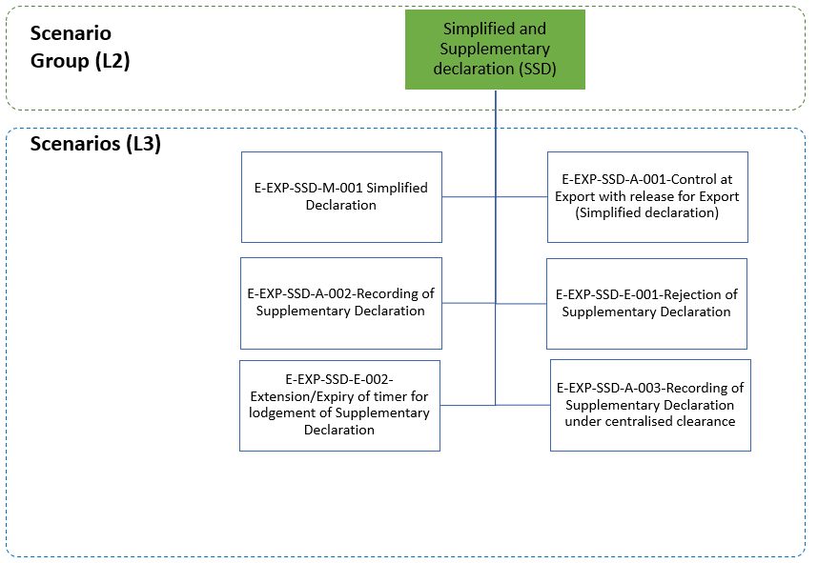

Figure 39: Simplified and Supplementary Declaration specific scenarios

The current section describes the scenarios concerning the Simplified and Supplementary Declaration.

In these scenarios, the Declarant/Representative submits, under a customs procedure, a Simplified Export Declaration (omitting certain declaration particulars) for which the waiver for the Supplementary Declaration does not apply. Therefore, a Supplementary Declaration will have to be lodged.

In continuation to this, the Declarant/Representative submits a Supplementary Declaration containing the missing declaration particulars of the corresponding Simplified Declaration. The Simplified Declaration and the Supplementary Declaration have a one-to-one relationship.

##### E-EXP-SSD-M-001 Simplified Declaration

The current scenario (Figure 40) starts identically to the E-EXP-CFL-M-001 Core flow up to [Step 3]. That is, [Step 1] until [Step 3]are the same as E-EXP-CFL-M-001 Core flow. More specifically, in this scenario, the Declarant/Representative submits a Simplified Export Declaration (IE515 with Additional declaration type equal to “B” or “C” or “E” or “F”). From the [Step 1] of the E-EXP-CFL-M-001 Core flow scenario, the AES knows that the ‘Export Declaration’ E_EXP_DAT (IE515) is Simplified and that the waiver for the Supplementary Declaration does not apply, therefore a Supplementary Declaration will have to be lodged.

**[Step 4]** AES at the Customs Office of Export initiates the Timer for Lodgement of Supplementary Declaration (T_Lodgement_Supplementary_Declaration).

**[Steps 5 until 16]** These steps are the same as the steps [Step 4] until [Step 15] of the E-EXP-CFL-M-001 Core flow, respectively.



Figure 40: E-EXP-SSD-M-001 Simplified Declaration

##### E-EXP-SSD-A-001 Control at Export with release for Export (Simplified Declaration)

The current scenario (Figure 41) starts identically to the E-EXP-CFL-M-001 Core flow up to [Step 2]. That is, [Step 1] until [Step 2]are the same as E-EXP-CFL-M-001 Core flow. More specifically, in this scenario, the Declarant/Representative submits a Simplified Export Declaration (IE515 with Additional declaration type equal to “B” or “C” or “E” or “F”). From the [Step 1] of the E-EXP-CFL-M-001 Core flow scenario, the AES knows that the ‘Export Declaration’ E_EXP_DAT (IE515) is Simplified and that the waiver for the Supplementary Declaration does not apply, therefore a Supplementary Declaration will have to be lodged.

**[Step 3]** In this case, the Customs Officer at the Customs Office of Export decides to control the goods. Thus, the Customs Office of Export sends an ‘Export Control Decision Notification’ E_EXP_CTR (IE560) to the Declarant/Representative in order to inform him/ her of the upcoming control activities and the movement state is set to “Under Control”. According to the current scenario, the Customs Officer registers satisfactory control results.

**[Step 4]** The Timer for Lodgement of Supplementary Declaration (T_Lodgement_Supplementary_Declaration) starts at this point.

**[Steps 5 until 16]** These steps are the same as the steps [Step 4] until [Step 15] of the E-EXP-CFL-M-001 Core flow, respectively.



Figure 41: E-EXP-SSD-A-001 Control at Export with release for Export (Simplified Declaration)

##### E-EXP-SSD-A-002 Recording of Supplementary Declaration

The present scenario (Figure 42) starts with the Declarant/Representative previously submitting a Simplified Declaration (IE515 with Additional declaration type equal to “B” or “C” or “E” or “F”) for which the waiver does not apply. The Simplified Declaration was accepted, and the goods have been released for Export. The movement states under which a Supplementary Declaration can be lodged are the following: “Goods Released for Export”, “Diversion Accepted”, “Under Exit Confirmation Request”, or “Exported”.

**[Step 1]** The Declarant/Representative submits a Supplementary Declaration via an ‘Export Declaration’ E_EXP_DAT (IE515) message (with Additional declaration type equal to “X” or “Y”) to the Customs Office of Export within the defined time limit. The Simplified Declaration and the Supplementary Declaration have a one-to-one relationship.

**[Step 2]** After a successful validation of the Supplementary Declaration, the movement state remains as is and the Timer for Lodgement of Supplementary Declaration (T_Lodgement_Supplementary_Declaration) stops.

The validation process includes the verification that the MRN of Supplementary Declaration matches the MRN of the corresponding Simplified Declaration but not the LRN verification, since the LRN of the Supplementary Declaration IE515 might not be the same as the Simplified Declaration LRN. Therefore, the MRN declared as Previous Document (IE515.PREVIOUS DOCUMENT.Reference number) in the Supplementary Declaration must be the MRN of the Simplified Declaration.

AES at the Customs Office of Export reconciles the data of the Simplified Declaration and the Supplementary Declaration. The Export Declaration now holds the full content of the Simplified Declaration and the Supplementary Declaration.

The recording of Supplementary Declaration under Centralised Clearance is allowed as described in the scenario E-EXP-SSD-A-003 Recording of Supplementary Declaration under centralised clearance.



Figure 42: E-EXP-SSD-A-002 Recording of Supplementary Declaration

##### E-EXP-SSD-E-001 Rejection of Supplementary Declaration

This scenario (Figure 43) starts with the Declarant/Representative previously submitting a Simplified Declaration for which the waiver does not apply. The Simplified Declaration was accepted, and the goods have been released for Export.

**[Step 1]** The Declarant/Representative submits a Supplementary Declaration via an ‘Export Declaration’ E_EXP_DAT (IE515) message (with Additional declaration type equal to “X” or “Y”) to the Customs Office of Export within the defined time limit.

After an unsuccessful validation of the Supplementary Declaration, AES rejects the Supplementary Declaration and the movement state remains as is.

**[Step 2]** Sequentially, the Customs Office of Export sends to the Declarant/Representative a ‘Rejection from Office of Export’ E_EXP_REJ (IE556) message that the Supplementary Declaration is rejected, giving the reason for rejection. This is the final step.



Figure 43: E-EXP-SSD-E-001 Rejection of Supplementary Declaration

##### E-EXP-SSD-E-002 Extension/Expiry of the timer for lodgement of Supplementary Declaration

The current scenario (Figure 44) starts with the Declarant/Representative previously submitting a Simplified Declaration for which the waiver does not apply. The Simplified Declaration was accepted, and the goods have been released for Export.

**[Step 1]** The Customs Officer at the Customs Office of Export decides to extend the Timer for Lodgement of Supplementary Declaration (T_Lodgement_Supplementary_Declaration) before the timer expiration.

**[Step 2]** Afterwards, the Customs Office of Export informs the Declarant/Representative about the time limit extension via an ‘Expiry of Timer for Supplementary Declaration Notification’ E_TMR_SUP (IE531) message.

**[Step 3]** Since the Declarant/Representative does not submit a Supplementary Declaration to the Customs Office of Export within the defined time limit, the Timer for Lodgement of Supplementary Declaration (T_Lodgement_Supplementary_Declaration) expires.

**[Step 4]** The Customs Office of Export informs the Declarant/Representative about the timer expiration via an ‘Expiry of Timer for Supplementary Declaration Notification’ E_TMR_SUP (IE531) message.

It may be a case the flow to continue as per **[****Step 1****]** until **[**Step 2**]** of scenario E-EXP-SSD-A-002 Recording of Supplementary Declaration.

**[Step 5]** The Customs Officer at the Customs Office of Export may decide to extend the Timer for Lodgement of Supplementary Declaration (T_Lodgement_Supplementary_Declaration) after the timer expiration. In this case, the Customs Office of Export will inform the Declarant/Representative about the time limit extension via an ‘Expiry of Timer for Supplementary Declaration Notification’ E_TMR_SUP (IE531) message **[Step 6]**. Figure 44 shows this case, which is an optional step.

The Extension/Expiry of timer for lodgement of Supplementary Declaration can similarly happen in case of Supplementary Declaration under Centralised Clearance (in the scenarios of Centralised Clearance for Export, the Supervising Customs Office is the Customs Office of Export). In such case and provided that the Customs Officer at the Customs Office of Export decides to extend the Timer for Lodgement of Supplementary Declaration (T_Lodgement_Supplementary_Declaration), the flow continues as per **[Step 1]** of scenario E-EXP-SSD-A-003 Recording of Supplementary Declaration under centralised clearance.



Figure 44: E-EXP-SSD-E-002 Expiry of timer for lodgement of Supplementary Declaration

##### E-EXP-SSD-A-003 Recording of Supplementary Declaration under centralised clearance

The present scenario (Figure 45) starts with the Declarant/Representative previously submitting a Simplified Declaration for which the waiver does not apply. The Simplified Declaration was accepted, and the goods have been released for Export under Centralised Clearance. The movement states under which a Supplementary Declaration can be lodged are the following: “Goods Released for Export”, “Diversion Accepted”, “Under Exit Confirmation Request”, or “Exported”.

**[****Step 1]** The Declarant/Representative submits a ‘Supplementary Declaration via an Export Declaration’ E_EXP_DAT (IE515) message (with Additional declaration type equal to “X” or “Y”) to the Supervising Customs Office (in the scenarios of Centralised Clearance for Export, the Supervising Customs Office is the Customs Office of Export) within the defined time limit. The Simplified Declaration and the Supplementary Declaration have a one-to-one relationship.

**[Step 2]** After a successful validation of the Supplementary Declaration, the movement state remains as is and the Timer for Lodgement of Supplementary Declaration (T_Lodgement_Supplementary_Declaration) stops.

The validation process includes the verification that the MRN of Supplementary Declaration matches the MRN of the corresponding Simplified Declaration but not the LRN verification, since the LRN of the Supplementary Declaration IE515 might not be the same as the Simplified Declaration LRN. Therefore, the MRN declared as Previous Document (IE515.PREVIOUS DOCUMENT.Reference number) in the Supplementary Declaration must be the MRN of the Simplified Declaration.

AES at the Supervising Customs Office reconciles the data of the Simplified Declaration and the Supplementary Declaration. The Export Declaration now holds the full content of the Simplified Declaration and the Supplementary Declaration.

**[Step 3]** The Supervising Customs Office communicates the reconciled data of the Simplified Declaration and the Supplementary Declaration to the Presentation Customs Office via a ‘Matched Data Declaration’ C_MAT_DAT (IE533) message (IE533 is the result of the reconciliation data and holds the MRN of the Simplified Declaration).

|  |
| --- |
| ! It shall be highlighted that the Presentation Customs Office is responsible for reporting for statistical purposes. The Supervising Customs Office does not provide information to the Statistical Office for the goods exported using Centralised Clearance. |



Figure 45: E-EXP-SSD-A-003 Recording of Supplementary Declaration under centralised clearance

#### Goods under Excise duty suspension arrangement

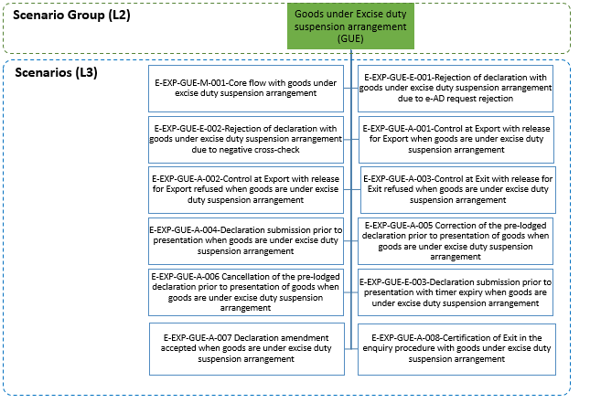

Figure 46: Goods under Excise duty suspension arrangement specific scenarios

The current section describes the handling of an Export Declaration with goods under excise duty suspension. It shall be clarified that the scenario of invalidating an Export Declaration with goods under excise duty suspension is described in E-EXP-INV-A-005 Invalidation with goods under excise duty suspension arrangement.

##### E-EXP-GUE-M-001 Core flow with goods under excise duty suspension arrangement

**[Step 1]** Similarly to the E-EXP-CFL-M-001 Core flow, the present scenario (Figure 47) starts with the Declarant/Representative submitting an ‘Export Declaration’ E_EXP_DAT (IE515) to the Customs Office of Export.

After a successful validation of the Export Declaration, the AES at the Customs Office of Export checks and realises that the ‘Export Declaration’ E_EXP_DAT (IE515) contains Excise Goods (that belong to the MUST[30] or MAY[31] CN Code list) for which ARC (Administrative Reference Code) and UBR (Body Record Unique Reference) are provided (hence interface with EMCS is applicable).

In the case of an ‘Export Declaration’ E_EXP_DAT (IE515) having the Commodity Code in the MUST CN list but not having any reference to the e-AD (by ARC and UBR), the automatic process should be re-directed for a manual decision by the Customs Officer that will case by case either accept the Export Declaration without reference to e-AD or reject it. An example of acceptable export declarations for goods in the MUST CN list but not having reference to e-AD is the direct export of excise goods already released for consumption (“duty paid”). The same mechanism is also recommended to be applied for national EMCS movements (where the MSA of Dispatch = MSA of Export) and also for the direct exports (where the MSA of Export = MS of Exit).

Until the Export Declaration acceptance, AES uses LRN as a key in all external and national domain information exchanges (IE515, IE519, IE513, IE514, IE511, IE504, IE509, IE556). Following the Export Declaration acceptance, MRN will be used instead of LRN10.

**[Step 2]** The ‘Export Declaration’ E_EXP_DAT (IE515) may contain Goods Items (e-AD Bodies) from multiple e-ADs (IE801 messages).[32] Thus, the AES at the Customs Office of Export requests the corresponding e-AD(s) from the EMCS at the Member State of Export via one or multiple ‘e-AD Request’ N_EAD_REQ (IE532) message(s)[33].

Amendment of an ‘Export Declaration’ E_EXP_DAT (IE515) containing goods under Excise duty suspension arrangement (having reference to the e-AD by ARC and UBR number) can be accepted only before the movement was released for export, as described in E-EXP-GUE-A-007 Declaration amendment accepted when goods are under excise duty suspension arrangement. In such case, after an amendment request is submitted and is validated at the Customs Office of Export, the Customs Office of Export requests the corresponding modified or new e-AD(s) from the EMCS at the Member State of Export via new ‘e-AD Request’ N_EAD_REQ (IE532) message(s) and the ‘cross-check’ against EMCS (see **[Step 4]**) is performed again). In case the ‘Export Declaration’ E_EXP_DAT (IE515) was submitted prior to presentation, when goods are under Excise duty suspension arrangement, it is also allowed to correct the declaration under the same conditions, but before receiving the ‘Export Presentation Notification’ E_PRE_NOT (IE511), as described in E-EXP-GUE-A-005 Correction of the pre-lodged declaration prior to presentation of goods when goods are under excise duty suspension arrangement.

**[Step 3]** The EMCS at the Member State of Export accepts the e-AD Request(s) and sends to the AES at the Customs Office of Export the requested ‘e-AD’ N_EAD_VAL (IE801)[34] message(s).

**[****Step 4]** After receiving the requested ‘e-AD’ N_EAD_VAL (IE801) message(s), the AES at the Customs Office of Export performs a cross-checking[35] between the Export Declaration and the concerned e-ADs in order to verify their consistency. According to the current scenario, the cross-checking is found successful, hence the AES at the Customs Office of Export allocates a Master Reference Number (MRN) to the ‘Export Declaration’ E_EXP_DAT (IE515). Then, the AES at the Customs Office of Export informs the Declarant/Representative of the Export Declaration acceptance and the MRN assignment via an ‘Export MRN Allocated’ E_MRN_EXP (IE528) message and the state of the movement is updated to “Accepted”.

**[Step 5]** The AES at the Customs Office of Export communicates the Export Declaration acceptance to the EMCS at the Member State of Export via an ‘Export Declaration Acceptance Notification to MSA of Export’ N_MSA_ACC (IE539)[36].

**[****Step 6]** Subsequently, the movement is released for export and the AES at the Customs Office of Export sends to the AES of the Customs Office of Exit (Declared) an AER C_AER_SND (IE501) with Control Result Code equal to “A2: Considered Satisfactory”.

After receiving the AER C_AER_SND (IE501) with Control Result Code equal to “A2: Considered Satisfactory”, the AES at the Customs Office of Exit interfaces with the national risk analysis systems of the Member States to request a Risk Analysis. The state of the movement at the Customs Office of Exit is set to “AER Created”.

**[Step 7]** The AES at the Customs Office of Export also sends to the Declarant/Representative the ‘Release for Export’ E_REL_EXP (IE529).

**[Step 8]** In parallel,the AES at the Customs Office of Export communicates the release for export to the EMCS at the Member State of Export via a ‘Release for Export Notification to MSA of Export’ N_REL_DES (IE535)[37].

**[Step 9]** The AES at the Customs Office of Export initiates the T_Receive_Exit_Results timer to expire at the time limit for receiving the ‘Exit Results’ C_EXT_RES (IE518) from the Customs Office of Exit.

**[Step 10]** The AES at the Customs Office of Export also initiates the T_Certify_Exit timer to expire at the time limit for certifying exit.

**[Step 11]** Upon the arrival of the consignment at the Customs Office of Exit, the Trader at Exit sends an ‘Arrival at Exit’ E_ARR_EXT (IE507) to the AES at the Customs Office of Exit and requests that the goods are allowed to leave immediately the European Union Customs Territory.

After verifying that the ‘Arrival at Exit’ E_ARR_EXT (IE507) is valid and that the AER C_AER_SND (IE501) is available at the Customs Office of Exit, the AES at the Customs Office of Exit updates the state of the movement to “Goods Presented at Exit”.

**[Step 12]** Following this and based on the Risk Analysis results, the Customs Officer at the Customs Office of Exit decides to perform control on the goods (considering that the Export Declaration concerns Excise goods).

The AES at the Customs Office of Exitinforms the Trader at Exit that the Custom Authorities are intended to examine the goods via an ‘Exit Control Decision Notification’ E_EXT_CTR (IE561) message and the state of the movement at the Customs Office of Exit is updated to “Under Control”.

The Customs Office of Exit performs the necessary controls and the Customs Officer registers the positive control results (no or minor discrepancies are found) at the Customs Office of Exit.

**[Step 13]** The AES at the Customs Office of Exit verifies that the Trader at Exit had requested the immediate release of the goods. Consequently, the AES at the Customs Office of Exit sends an ‘Exit Release Notification’ E_EXT_REL (IE525) to the Trader at Exit for informing him/her of the release. The state of the movement at the Customs Office of Exit is updated to “Goods Released for Immediate Leave”.

**[Step 14]** When the consignment has left the European Union Customs Territory, the Trader at Exit notifies the Customs Office of Exit that the goods have exited via an ‘Exit Notification’ E_EXT_NOT (IE590). The state of the movement at the Customs Office of Exit is updated to “Exited”.

**[Step 15]** The AES at the Customs Office of Exit sends to the AES at the Customs Office of Export the ‘Exit Results’ C_EXT_RES (IE518), in order to confirm the exit of the consignment.

**[Step 16]** After receiving the ‘Exit Results’ C_EXT_RES (IE518) and verifying that they are positive, the AES at the Customs Office of Export stops the T_Receive_Exit_Results timer. The state of the movement at the Customs Office of Export is updated to “Exported” which is final state.

**[Step 17]** In addition, due to the receipt of the ‘Exit Results’ C_EXT_RES (IE518), the AES at the Customs Office of Export stops the T_Certify_Exit timer.

**[Step 18]** Then, the AES at the Customs Office of Export sends to the Declarant/Representative an ‘Export Notification’ C_EXP_NOT (IE599) in order to notify him/her that the movement has successfully exited the European Union Customs Territory providing all the export details.

**[Step 19]** Finally, the AES at the Customs Office of Export notifies the EMCS at the Member State of Export about the goods exit, via an ‘Exit Results to MSA of Export’ N_EXT_MSA (IE598).





Figure 47: E-EXP-GUE-M-001 Core flow with goods under excise duty suspension arrangement

##### E-EXP-GUE-E-001 Rejection of declaration with goods under excise duty suspension arrangement due to e-AD request rejection

In the present scenario (see Figure 48) the AES at the Customs Office of Export rejects the ‘Export Declaration’ E_EXP_DAT (IE515), due the receipt of e-AD Request Rejections from the EMCS the Member State of Export.

More specifically, the current scenario starts identically to the E-EXP-GUE-M-001 Core flow with goods under excise duty suspension arrangement up to **[Step 2]**. That is, **[Step 1]** and **[Step 2]** are the same as in E-EXP-GUE-M-001 Core flow with goods under excise duty suspension arrangement.

**[Step 3]** According to this scenario, the EMCS at the Member State of Export rejects the e-AD Request(s) and communicates the ‘e-AD Request Rejection’ N_EAD_REJ (IE8xx)34 message(s)to the AES at the Customs Office of Export.

**[Step 4]** After receivingthe ‘e-AD Request Rejection’ N_EAD_REJ (IE8xx) message(s),the AES at the Customs Office of Export rejects the ‘Export Declaration’ E_EXP_DAT (IE515) and sends to the Declarant/Representative a ‘Rejection from Office of Export’ E_EXP_REJ (IE556) proving the reason for rejection.

When an ‘Export Declaration’ E_EXP_DAT (IE515) is rejected, the state of the movement sets/changes to “Rejected” (final state).When an ‘Export Declaration’ E_EXP_DAT (IE515) has been rejected, the normal way of proceeding is to send a new Export Declaration that is acceptable.

The remaining steps of the E-EXP-GUE-M-001 Core flow with goods under excise duty suspension arrangement ([Step 5] until [Step 19]) are not applicable, since the current scenario has terminated in [Step 4] above.



Figure 48: E-EXP-GUE-E-001 Rejection of declaration with goods under excise duty suspension arrangement due to e-AD request rejectionE-EXP-GUE-M-001 Core flow with goods under excise duty suspension arrangement

##### E-EXP-GUE-E-002 Rejection of declaration with goods under excise duty suspension arrangement due to negative cross-check

In this scenario (Figure 49) the AES at the Customs Office of Export rejects the ‘Export Declaration’ E_EXP_DAT (IE515), due the negative cross-checking6 between the Export Declaration and the concerned e-ADs.

More specifically, the current scenario starts identically to the E-EXP-GUE-M-001 Core flow with goods under excise duty suspension arrangement up the **[Step 3]**. That is, **[Step 1]** until **[Step 3]**are the same as the E-EXP-GUE-M-001 Core flow with goods under excise duty suspension arrangement.

**[Step 4]** After receiving the requested ‘e-AD’ N_EAD_VAL (IE801) message(s), the AES at the Customs Office of Export performs a cross-checking between the Export Declaration and the concerned e-ADs in order to verify their consistency. According to the current scenario, the cross-checking is found unsuccessful, hence the AES at the Customs Office of Export communicates to the EMCS at the Member State of Export, the negative cross-check result, via an ‘e-AD Negative Cross Check Result’ N_EAD_RES (IE537)[38].

**[Step 5]** Then, the AES at the Customs Office of Export rejects the ‘Export Declaration’ E_EXP_DAT (IE515) and sends to the Declarant/Representative a proving the reason for rejection.

When an ‘Export Declaration’ E_EXP_DAT (IE515) is rejected, the state of the movement sets/changes to “Rejected” (final state). When an ‘Export Declaration’ E_EXP_DAT (IE515) has been rejected, the normal way of proceeding is to send a new Export Declaration that is acceptable.).

The remaining steps of the E-EXP-GUE-M-001 Core flow with goods under excise duty suspension arrangement ([Step 6] until [Step 19])are not applicable, since the current scenario has terminated in [Step 5] above.



Figure 49: E-EXP-GUE-E-002 Rejection of declaration with goods under excise duty suspension arrangement due to negative cross-check

##### E-EXP-GUE-A-001 Control at Export with release for Export when goods are under excise duty suspension arrangement

In the present scenario (Figure 50), before the release for export, the Customs Office of Export performs controls for the goods under excise duty suspension arrangement and the control result is found positive.

More specifically, the current scenario starts identically to the E-EXP-GUE-M-001 Core flow with goods under excise duty suspension arrangement up to the **[Step 5]**. That is, **[Step 1]** until **[Step 5]** are the same as the E-EXP-GUE-M-001 Core flow with goods under excise duty suspension arrangement.

**[Step 6]** According to this scenario, before release for export, the Customs Office of Export decides to perform controls for the goods under excise duty suspension arrangement. Thus, the AES at the Customs Office of Export notifies the Declarant/Representative, about the upcoming control activities (and for requesting documents, if necessary), via an ‘Export Control Decision Notification’ E_EXP_CTR (IE560). The state of the movement at the Customs Office of Export is updated to “Under Control”.

**[Step 7]** Subsequently, the Customs Office of Export performs the necessary controls and the Customs Officer registers the satisfactory control results at the AES at the Customs Office of Export. In case the Customs Office of Export is not able to perform the necessary controls, the control results are considered satisfactory. Then, the AES at the Customs Office of Export sends to the AES of the Customs Office of Exit (Declared) an AER C_AER_SND (IE501) with Control Result Code equal to “A1: Satisfactory” or “A2: Considered Satisfactory”.[39]

After receiving the AER C_AER_SND (IE501) with Control Result Code equal to “A1: Satisfactory” or “A2: Considered Satisfactory”, the AES at the Customs Office of Exit sets the state of the movement at the Customs Office of Exit to “AER Created”.

**[Steps 8 until 20]** These steps are the same as the steps **[Step 7]** until **[Step 19]** of the E-EXP-GUE-M-001 Core flow with goods under excise duty suspension arrangement, respectively.

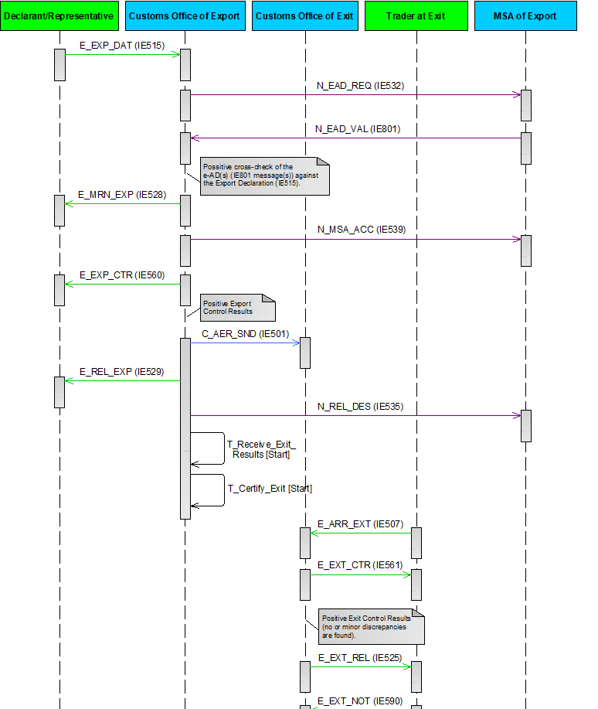



Figure 50: E-EXP-GUE-A-001 Control at Export with release for Export when goods are under excise duty suspension arrangement

##### E-EXP-GUE-A-002 Control at Export with release for Export refused when goods are under excise duty suspension arrangement

In this scenario (Figure 51), before the release for export, the Customs Office of Export performs controls for the goods under excise duty suspension arrangement and the control result is found negative.

More specifically, the current scenario starts identically to E-EXP-GUE-M-001 Core flow with goods under excise duty suspension arrangement up to **[Step** **5]**. That is, **[Step 1]** until **[Step 5]** are the same as in E-EXP-GUE-M-001 Core flow with goods under excise duty suspension arrangement.

**[Step 6]** According to this scenario, before release for export, the Customs Office of Export decides to perform controls for the goods under excise duty suspension arrangement. Thus, the AES at the Customs Office of Export notifies the Declarant/Representative about the upcoming control activities (and for requesting documents, if necessary), via an ‘Export Control Decision Notification’ E_EXP_CTR (IE560). The state of the movement at the Customs Office of Export is updated to “Under Control”.

**[Step 7]** Subsequently, the Customs Office of Export performs the necessary controls and the Customs Officer registers the unsatisfactory control results at the AES at the Customs Office of Export. The Customs Officer at the Customs Office of Export decides that the consignment cannot be released for Export. Thus, the AES at Customs Office of Export communicates the ‘Non-Release for Export Notification to MSA of Export’ N_NON_DES (IE534)[40] to the EMCS at the MSA of Export. The state of the movement at the Customs Office of Export is updated to “Not Released for Export”, which is a final state.

**[Step 8]** The AES at the Customs Office of Export also informs the Declarant/Representative about the release rejection by sending an ‘Export No Release’ E_EXP_NRL (IE551).

The remaining steps of the E-EXP-GUE-M-001 Core flow with goods under excise duty suspension arrangement ([Step 9] until [Step 19]) are not applicable, since the current scenario has terminated in [Step 8] above.



Figure 51: E-EXP-GUE-A-002 Control at Export with release for Export refused when goods are under excise duty suspension arrangement

##### E-EXP-GUE-A-003 Control at Exit with release for Exit refused when goods are under excise duty suspension arrangement

In the scenario (Figure 52), before the release for exit, the Customs Office of Exit performs controls for the goods under excise duty suspension arrangement and the control result is found negative.

More specifically, the current scenario starts identically to the E-EXP-GUE-M-001 Core flow with goods under excise duty suspension arrangement up the **[Step 11]**. That is, **[Step 1]** until **[Step 11]** are the same as the E-EXP-GUE-M-001 Core flow with goods under excise duty suspension arrangement.

**[Step 12]** Following this and based on the Risk Analysis results, the Customs Officer at the Customs Office of Exit decides to perform control on the goods (considering that the Export Declaration concerns Excise goods).

The AES at the Customs Office of Exitinforms the Trader at Exit that the Custom Authorities are intended to examine the goods via an ‘Exit Control Decision Notification’ E_EXT_CTR (IE561) message and the state of the movement at the Customs Office of Exit is updated to “Under Control”.

According to the current scenario, the Customs Office of Exit performs the necessary controls and the Customs Officer registers the negative control results (major discrepancies are found) at the Customs Office of Exit.

**[Step 13]** As a result, the consignment cannot leave the European Union Customs Territory, hence the AES at the Customs Office of Exit communicates to the AES at the Customs Office of Export the negative control results via an ‘Exit Results’ C_EXT_RES (IE518) with Control Result Code equal to “B1: Unsatisfactory”.

**[Step 14]** In addition, the AES at the Customs Office of Exit sends an ‘Exit Release Rejection’ E_EXT_REJ (IE522) to the Trader at Exit for notifying him/her that the goods are not allowed to Exit the European Union Customs Territory. The movement stops without prejudice of any subsequent measure to be taken. The state of the movement at the Customs Office of Exit is updated to “Goods not Allowed to Exit” which is a final state.

**[Step 15]** After receiving the negative control results via an ‘Exit Results’ C_EXT_RES (IE518) with Control Result Code equal to “B1: Unsatisfactory” from the AES at the Customs Office of Exit, the AES at the Customs Office of Export stops the T_Receive_Exit_Results timer. The state of the movement at the Customs Office of Export is updated to “Export Stopped, Discrepancies at Exit” which is final state.

**[Step 16]** This step is the same as the **[Step 17]** of the E-EXP-GUE-M-001 Core flow with goods under excise duty suspension arrangement.

**[Step 17]** Then, the AES at the Customs Office of Export notifies the EMCS at the Member State of Export about the non-exit of the goods, via an ‘Exit Results to MSA of Export’ N_EXT_MSA (IE598)[41] with negative exit control results).

**[Step 18]** Finally, the AES at the Customs Office of Export sends to the Declarant/Representative an ‘Export Notification’ E_EXP_NOT (IE599) in order to notify him/her about the non-exit of the goods.

The [Step 19] of the E-EXP-GUE-M-001 Core flow with goods under excise duty suspension arrangement is not applicable, since the current scenario has terminated in [Step 18] above.



Figure 52: E-EXP-GUE-A-003 Control at Exit with release for Exit refused when goods are under excise duty suspension arrangement

##### E-EXP-GUE-A-004 Declaration submission prior to presentation when goods are under excise duty suspension arrangement

In the present scenario (Figure 53) the Declarant/Representative submits an ‘Export Declaration’ E_EXP_DAT (IE515) to the AES at the Customs Office of Export, before the presentation of the goods (under excise duty suspension arrangement). According to the current scenario, the Declarant/Representative submits the ‘Export Presentation Notification’ E_PRE_NOT (IE511) within the defined time limit.

More specifically, the current scenario starts identically to the E-EXP-GUE-M-001 Core flow with goods under excise duty suspension arrangement up to the **[Step 3]**. That is, **[Step 1]** until **[Step 3]** are the same as in the E-EXP-GUE-M-001 Core flow with goods under excise duty suspension arrangement.

**[Step 4]** After receiving the requested ‘e-AD’ N_EAD_VAL (IE801) message(s), the AES at the Customs Office of Export performs a cross-checking between the Export Declaration and the concerned e-ADs in order to verify their consistency. According to the current scenario, the cross-checking is found successful.

At this point, the AES at the Customs Office of Export identifies that the ‘Export Declaration’ E_EXP_DAT (IE515) was submitted prior to the goods presentation to the Customs Office of Export, hence the state of the movement is set to “Registered and Waiting for Presentation of Goods”. In addition, the AES at the Customs Office of Export initiates the Timer Awaiting for Export Presentation Notification (T_Awaiting_Export_Presentation_Notification) to expire at the time limit for receiving the ‘Export Presentation Notification’ E_PRE_NOT (IE511) from the Declarant/Representative.

Until the successful presentation of the goods and the Export Declaration acceptance, AES uses LRN as a key in all external and national domain information exchanges (IE515, IE519, IE513, IE514, IE511, IE504, IE509, IE556). Following the Export Declaration acceptance, MRN will be used instead of LRN10.

**[****Step 5]** The Declarant/Representative submits an ‘Export Presentation Notification’ E_PRE_NOT (IE511) to the AES at the Customs Office of Export, within the defined time limit.

**[****Step 6]** AES at the Customs Office of Export validates successfully the ‘Export Presentation Notification’ E_PRE_NOT (IE511) and the Timer Awaiting for Export Presentation Notification (T_Awaiting_Export_Presentation_Notification) stops. In addition, based on the information contained in the ‘Export Presentation Notification’ E_PRE_NOT (IE511), AES at the Customs Office of Export re-validates the Export Declaration information (considering the ‘Export Declaration’ E_EXP_DAT (IE515) and any latest ‘Export Declaration Amendment’ E_EXP_AMD (IE513)) and ensures the validity of the reference data.

**[****Step 7]** After re-validating successfully the Export Declaration information (considering the ‘Export Declaration’ E_EXP_DAT (IE515) and any latest ‘Export Declaration Amendment’ E_EXP_AMD (IE513)), the AES at the Customs Office of Export requests again the corresponding e-AD(s) from the EMCS at the Member State of Export via one or multiple ‘e-AD Request’ N_EAD_REQ (IE532) message(s). The state of the movement at the Customs Office of Export remains as “Registered and Waiting for Presentation of Goods”.

**[Step 8]** The EMCS at the Member State of Export accepts the e-AD request(s) and sends to the AES at the Customs Office of Export the requested e-AD N_EAD_VAL (IE801) message(s).

**[****Step 9]** After receiving the requested ‘e-AD’ N_EAD_VAL (IE801) message(s), the AES at the Customs Office of Export performs again a cross-checking between the Export Declaration and the concerned e-ADs, in order to verify their consistency. According to the current scenario, the cross-checking is found successful, hence the AES at the Customs Office of Export informs the Declarant/Representative of the Export Declaration acceptance and the MRN assignment via an ‘Export MRN Allocated’ E_MRN_EXP (IE528) message and the state of the movement at the Customs Office of Export is updated to “Accepted”.

**[Steps 10 until 24]** These steps are the same as the steps **[Step 5]** until **[Step 19]** of the E-EXP-GUE-M-001 Core flow with goods under excise duty suspension arrangement, respectively.

It shall be noted that:

* If the AES at the Customs Office of Export identifies (during the [Step 6] of the current scenario E-EXP-GUE-A-004 Declaration submission prior to presentation when goods are under excise duty suspension arrangement) that the ‘Export Presentation Notification’ E_PRE_NOT (IE511) is invalid, then the Customs Office of Export responds to the Declarant/Representative with a ‘Rejection from Office of Export’ E_EXP_REJ (IE556) and the movement state remains as is. Following this, the Declarant/Representative has to send a new ‘Export Presentation Notification’ E_PRE_NOT (IE511) within the defined time limit and the flow continues as per [Step 5] of the current scenario E-EXP-GUE-A-004 Declaration submission prior to presentation when goods are under excise duty suspension arrangement;
* Following the reception of the ‘Export Presentation Notification’ E_PRE_NOT (IE511) (as part of the [Step 6] of the current scenario E-EXP-GUE-A-004 Declaration submission prior to presentation when goods are under excise duty suspension arrangement), the pre-lodged Export Declaration can be rejected in the following cases:
* The re-validation of the Export Declaration information (considering the ‘Export Declaration’ E_EXP_DAT (IE515) and any latest ‘Export Declaration Amendment’ E_EXP_AMD (IE513)) which is performed a part of [Step 6] of the current scenario (E-EXP-GUE-A-004 Declaration submission prior to presentation when goods are under excise duty suspension arrangement) is found unsuccessful (i.e. reference data are not valid); OR
* The EMCS at the Member State of Export rejects the e-AD Request(s) (that the Customs Office of Export has sent to the Member State of Export as part of [Step 7] of the current scenario E-EXP-GUE-A-004 Declaration submission prior to presentation when goods are under excise duty suspension arrangement) and communicates the ‘e-AD Request Rejection’ N_EAD_REJ (IE8xx) to the AES at the Customs Office of Export; OR
* The cross-checking between the Export Declaration and the concerned e-ADs (performed as part of [Step 9] of the current scenario E-EXP-GUE-A-004 Declaration submission prior to presentation when goods are under excise duty suspension arrangement) is found unsuccessful at the AES of the Customs Office of Export (in this case, the Customs Office of Export communicates to the EMCS at the Member State of Export, the negative cross-check result, via an ‘e-AD Negative Cross Check Result’ N_EAD_RES (IE537)).

When the pre-lodged Export Declaration is rejected, AES at the Customs Office of Export sends to the Declarant/Representative a ‘Rejection from Office of Export’ E_EXP_REJ (IE556) giving the reason for rejection. The state of the movement changes to “Rejected” which is a final state and the scenario stops here.When an Export Declaration has been rejected, the normal way of proceeding is the Declarant/Representative to send a new Export Declaration’ E_EXP_DAT (IE515).

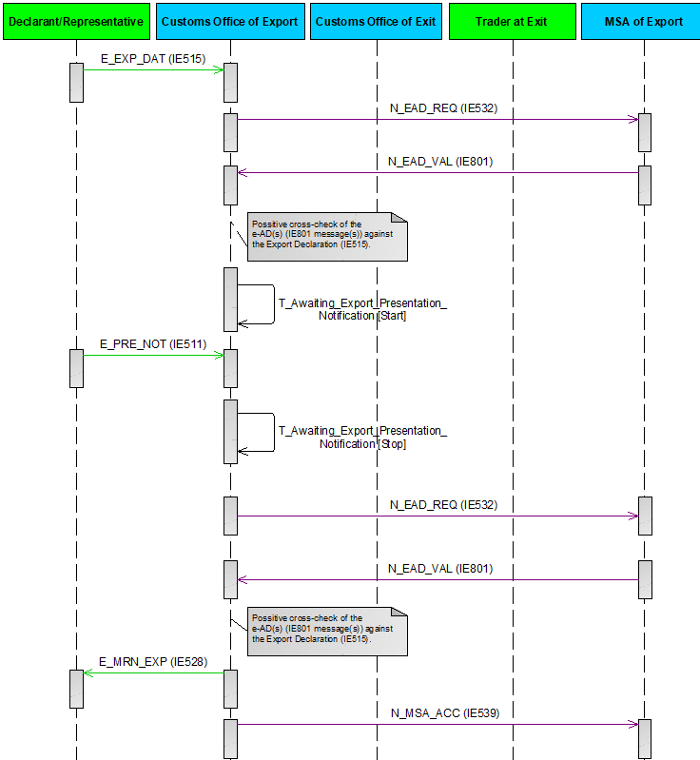

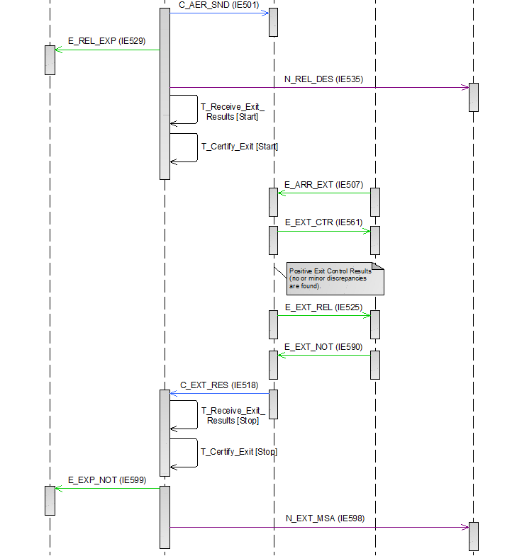

Figure 53: E-EXP-GUE-A-004 Declaration submission prior to presentation when goods are under excise duty suspension arrangement

##### E-EXP-GUE-A-005 Correction of the pre-lodged declaration prior to presentation of goods when goods are under excise duty suspension arrangement

In the present scenario (Figure 54) the Declarant/Representative submits an ‘Export Declaration’ E_EXP_DAT (IE515) to the AES at the Customs Office of Export, before the presentation of the goods (under excise duty suspension arrangement). Following this, the Declarant/Representative decides to correct the pre-lodged declaration by submitting an ‘Export Declaration Amendment’ E_EXP_AMD (IE513) to the AES at the Customs Office of Export.

Correction(s) of a Declaration submitted prior to presentation, when goods are under excise duty suspension arrangement, can be requested by the Declarant/Representative before submitting the ‘Export Presentation Notification’ E_PRE_NOT (IE511) to the Customs Office of Export and before the Timer Awaiting for Export Presentation Notification (T_Awaiting_Export_Presentation_Notification) expires. The correction is accepted at the Customs Office of Export only if positive cross-checking result against the respective ‘e-AD’ N_EAD_VAL (IE801) message(s) received from the Member State of Export is obtained.

More specifically, the current scenario starts identically to the E-EXP-GUE-M-001 Core flow with goods under excise duty suspension arrangement up to **[Step 3]**. That is, **[Step 1]** until **[Step 3]** are the same as the E-EXP-GUE-M-001 Core flow with goods under excise duty suspension arrangement.

**[Step 4]** After receiving the requested ‘e-AD’ N_EAD_VAL (IE801) message(s), the AES at the Customs Office of Export performs a cross-checking between the Export Declaration and the concerned e-ADs in order to verify their consistency. According to the current scenario, the cross-checking is found successful.

At this point, the AES at the Customs Office of Export identifies that the ‘Export Declaration’ E_EXP_DAT (IE515) was submitted prior to the goods presentation to the Customs Office of Export, hence the state of the movement is set to “Registered and Waiting for Presentation of Goods”. In addition, the AES at the Customs Office of Export initiates the Timer Awaiting for Export Presentation Notification (T_Awaiting_Export_Presentation_Notification) to expire at the time limit for receiving the ‘Export Presentation Notification’ E_PRE_NOT (IE511) from the Declarant/Representative.

Until the successful presentation of the goods and the Export Declaration acceptance, AES uses LRN as a key in all external and national domain information exchanges (IE515, IE519, IE513, IE514, IE511, IE504, IE509, IE556). Following the Export Declaration acceptance, MRN will be used instead of LRN10.

**[Step 5]** Following this, the Declarant/Representative decides to correct the pre-lodged Export Declaration and therefore he/she submits an ‘Export Declaration Amendment’ E_EXP_AMD (IE513) to the AES at the Customs Office of Export.

**[****Step 6]** After receiving and validating successfully the ‘Export Declaration Amendment’ E_EXP_AMD (IE513), the AES at the Customs Office of Export requests the corresponding corrected or new e-AD(s) from the EMCS at the Member State of Export, via one or multiple ‘e-AD Request’ N_EAD_REQ (IE532) message(s).

**[Step 7]** The EMCS at the Member State of Export accepts the corrected/new e-AD Request(s) and sends to the AES at the Customs Office of Export the requested corrected/new ‘e-AD’ N_EAD_VAL (IE801) message(s).

**[****Step 8]** After receiving the requested corrected/new ‘e-AD’ N_EAD_VAL (IE801) message(s), the AES at the Customs Office of Export performs a cross-checking between the requested to be corrected Export Declaration and the concerned e-ADs, in order to verify their consistency. According to the current scenario, the cross-checking is found successful, hence the AES at the Customs Office of Export accepts the corrections to the pre-lodged ‘Export Declaration’ E_EXP_DAT (IE515) and then sends an ‘Export Declaration Amendment Acceptance’ E_EXP_AAC (IE504) to the Declarant/Representative. The movement state remains as “Registered and Waiting for Presentation of Goods” and the Timer Awaiting for Export Presentation Notification (T_Awaiting_Export_Presentation_Notification) is not affected.

**[****Step 9]** The Declarant/Representative submits an ‘Export Presentation Notification’ E_PRE_NOT (IE511) to the AES at the Customs Office of Export, within the defined time limit.

**[****Step 10]** AES at the Customs Office of Export validates successfully the ‘Export Presentation Notification’ E_PRE_NOT (IE511) and the Timer Awaiting for Export Presentation Notification (T_Awaiting_Export_Presentation_Notification) stops. In addition, based on the information contained in the ‘Export Presentation Notification’ E_PRE_NOT (IE511), AES at the Customs Office of Export re-validates the Export Declaration information (considering the ‘Export Declaration’ E_EXP_DAT (IE515) and any latest ‘Export Declaration Amendment’ E_EXP_AMD (IE513)) and ensures the validity of the reference data.

**[****Step 11]** After re-validating successfully the Export Declaration information (considering the ‘Export Declaration’ E_EXP_DAT (IE515) and any latest ‘Export Declaration Amendment’ E_EXP_AMD (IE513)), the AES at the Customs Office of Export requests again the corresponding e-AD(s) from the EMCS at the Member State of Export via one or multiple ‘e-AD Request’ N_EAD_REQ (IE532) message(s). The state of the movement at the Customs Office of Export remains as “Registered and Waiting for Presentation of Goods”.

**[Step 12]** The EMCS at the Member State of Export accepts the e-AD request(s) and sends to the AES at the Customs Office of Export the requested e-AD N_EAD_VAL (IE801) message(s).

**[****Step 13]** After receiving the requested ‘e-AD’ N_EAD_VAL (IE801) message(s), the AES at the Customs Office of Export performs again a cross-checking between the Export Declaration and the concerned e-ADs, in order to verify their consistency. According to the current scenario, the cross-checking is found successful, hence the AES at the Customs Office of Export informs the Declarant/Representative of the Export Declaration acceptance and the MRN assignment via an ‘Export MRN Allocated’ E_MRN_EXP (IE528) message and the state of the movement at the Customs Office of Export is updated to “Accepted”.

**[Steps 14 until 28]** These steps are the same as the steps **[Step 5]** until **[Step 19]** of the E-EXP-GUE-M-001 Core flow with goods under excise duty suspension arrangement, respectively.

It shall be noted that if the received correction request ‘Export Declaration Amendment’ E_EXP_AMD (IE513) is found invalid or it is not accepted by the Customs Office of Export, then the AES at the Customs Office of Export sends a correction rejection via a ‘Rejection from Office of Export’ E_EXP_REJ (IE556) to the Declarant/Representative. In this case, the state of the movement at the Customs Office of Export remains as “Registered and Waiting for Presentation of Goods”. Then, the following cases are possible:

* The Declarant/Representative sends a new correction request (‘Export Declaration Amendment’ E_EXP_AMD (IE513)) and the flow continues as per **[Ste****p 6]** of the current scenario E-EXP-GUE-A-005 Correction of the pre-lodged declaration prior to presentation of goods when goods are under excise duty suspension arrangement; OR
* The Declarant/Representative does not send a new correction request (‘Export Declaration Amendment’ E_EXP_AMD (IE513)), in which case the initial export declaration remains valid and the flow continues from [Step 5] of the E-EXP-GUE-A-004 Declaration submission prior to presentation when goods are under excise duty suspension arrangement.

More specifically, the AES at the Customs Office of Export will reject/not accept the correction request and will consequently send a ‘Rejection from Office of Export’ E_EXP_REJ (IE556) to the Declarant/Representative, in the following cases:

* The ‘Export Declaration Amendment’ E_EXP_AMD (IE513) (received in **[Step 5]** of the current scenario E-EXP-GUE-A-005 Correction of the pre-lodged declaration prior to presentation of goods when goods are under excise duty suspension arrangement) is found invalid (due to errors) at the AES of Customs Office of Export; OR
* The EMCS at the Member State of Export rejects the e-AD Request(s) (that the Customs Office of Export has sent to the Member State of Export as part of **[Step 6]** of the current scenario E-EXP-GUE-A-005 Correction of the pre-lodged declaration prior to presentation of goods when goods are under excise duty suspension arrangement) and communicates the ‘e-AD Request Rejection’ N_EAD_REJ (IE8xx) to the AES at the Customs Office of Export; OR
* The cross-checking between the requested to be corrected Export Declaration and the concerned e-ADs (performed as part of **[Step** **8]** of this scenario E-EXP-GUE-A-005 Correction of the pre-lodged declaration prior to presentation of goods when goods are under excise duty suspension arrangement) is found unsuccessful at the AES of the Customs Office of Export (in this case, the Customs Office of Export communicates to the EMCS at the Member State of Export, the negative cross-check result, via an ‘e-AD Negative Cross Check Result’ N_EAD_RES (IE537)).

In addition, it shall be noted that:

* If the AES at the Customs Office of Export identifies (during the [Step 10] of the current scenario E-EXP-GUE-A-005 Correction of the pre-lodged declaration prior to presentation of goods when goods are under excise duty suspension arrangement) that the ‘Export Presentation Notification’ E_PRE_NOT (IE511) is invalid, then the Customs Office of Export responds to the Declarant/Representative with a ‘Rejection from Office of Export’ E_EXP_REJ (IE556) and the movement state remains as is. Following this, the Declarant/Representative has to send a new ‘Export Presentation Notification’ E_PRE_NOT (IE511) within the defined time limit and the flow continues as per [Step 9] of the current scenario E-EXP-GUE-A-005 Correction of the pre-lodged declaration prior to presentation of goods when goods are under excise duty suspension arrangement;
* Following the reception of the ‘Export Presentation Notification’ E_PRE_NOT (IE511) (as part of the [Step 10] of the current scenario E-EXP-GUE-A-005 Correction of the pre-lodged declaration prior to presentation of goods when goods are under excise duty suspension arrangement), the pre-lodged Export Declaration can be rejected in the following cases:
* The re-validation of the Export Declaration information (considering the ‘Export Declaration’ E_EXP_DAT (IE515) and any latest ‘Export Declaration Amendment’ E_EXP_AMD (IE513)) which is performed as part of the [Step 10] of the current scenario (E-EXP-GUE-A-005 Correction of the pre-lodged declaration prior to presentation of goods when goods are under excise duty suspension arrangement) is found unsuccessful (i.e. reference data are not valid); OR
* The EMCS at the Member State of Export rejects the e-AD Request(s) (that the Customs Office of Export has sent to the Member State of Export as part of [Step 11] of the current scenario E-EXP-GUE-A-005 Correction of the pre-lodged declaration prior to presentation of goods when goods are under excise duty suspension arrangement) and communicates the ‘e-AD Request Rejection’ N_EAD_REJ (IE8xx) to the AES at the Customs Office of Export; OR
* The cross-checking between the Export Declaration and the concerned e-ADs (performed as part of [Step 13] of the current scenario E-EXP-GUE-A-005 Correction of the pre-lodged declaration prior to presentation of goods when goods are under excise duty suspension arrangement) is found unsuccessful at the AES of the Customs Office of Export (in this case, the Customs Office of Export communicates to the EMCS at the Member State of Export, the negative cross-check result, via an ‘e-AD Negative Cross Check Result’ N_EAD_RES (IE537)).

When the pre-lodged Export Declaration is rejected, AES at the Customs Office of Export sends to the Declarant/Representative a ‘Rejection from Office of Export’ E_EXP_REJ (IE556) giving the reason for rejection. The state of the movement changes to “Rejected” which is a final state and the scenario stops here.When an Export Declaration has been rejected, the normal way of proceeding is the Declarant/Representative to send a new Export Declaration’ E_EXP_DAT (IE515).

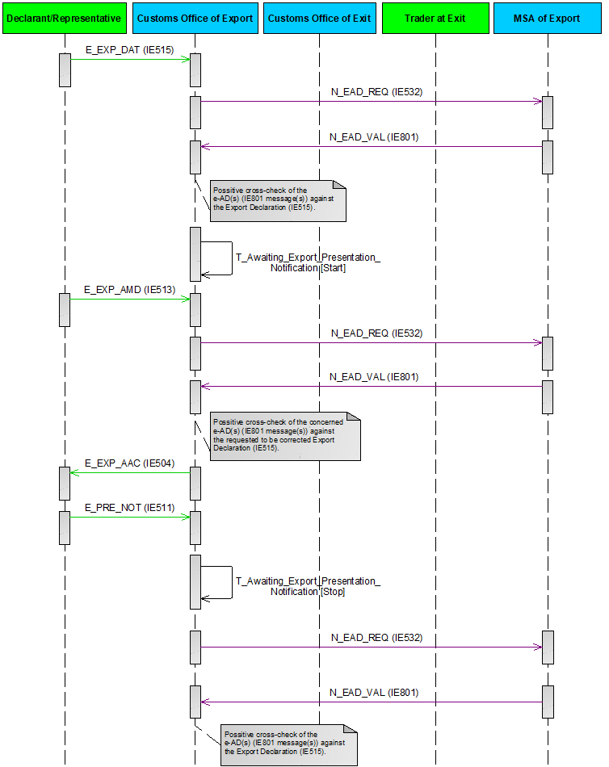

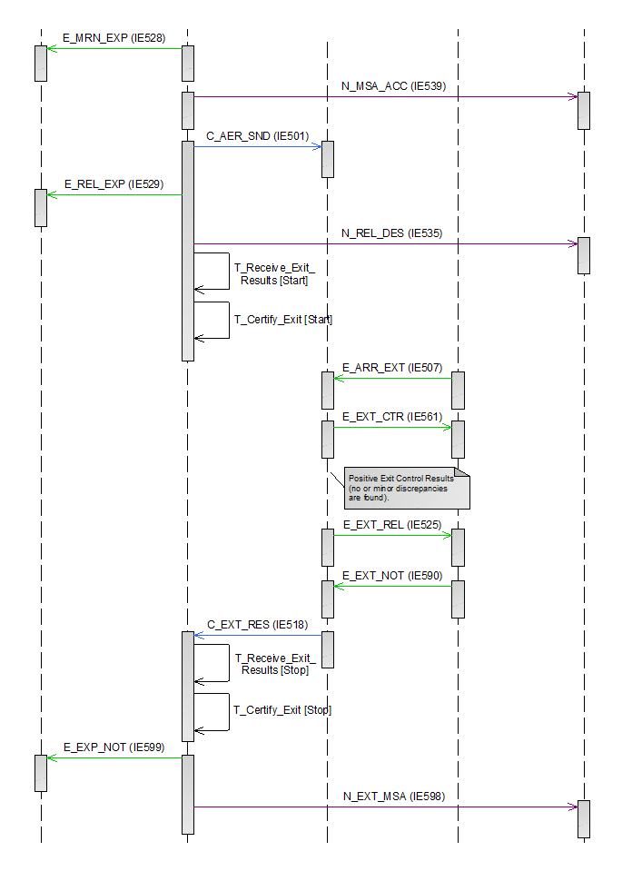

Figure 54: E-EXP-GUE-A-005 Correction of the pre-lodged declaration prior to presentation of goods when goods are under excise duty suspension arrangement

##### E-EXP-GUE-A-006 Cancellation of the pre-lodged declaration prior to presentation of goods when goods are under excise duty suspension arrangement

In the present scenario (Figure 55) the Declarant/Representative submits an ‘Export Declaration’ E_EXP_DAT (IE515) to the AES at the Customs Office of Export, before the presentation of the goods (under excise duty suspension arrangement). Following this, the Declarant/Representative decides to cancel the pre-lodged declaration by submitting an ‘Export Invalidation Request’ E_EXP_INV (IE514) to the AES at the Customs Office of Export.

More specifically, the current scenario starts identically to the E-EXP-GUE-M-001 Core flow with goods under excise duty suspension arrangement up to **[Step 3]**. That is, **[Step 1]** until **[Step 3]** are the same as the E-EXP-GUE-M-001 Core flow with goods under excise duty suspension arrangement.

**[Step 4]** After receiving the requested ‘e-AD’ N_EAD_VAL (IE801) message(s), the AES at the Customs Office of Export performs a cross-checking between the Export Declaration and the concerned e-ADs in order to verify their consistency. According to the current scenario, the cross-checking is found successful.

At this point, the AES at the Customs Office of Export identifies that the ‘Export Declaration’ E_EXP_DAT (IE515) was submitted prior to the goods presentation to the Customs Office of Export, hence the state of the movement is set to “Registered and Waiting for Presentation of Goods”. In addition, the AES at the Customs Office of Export initiates the Timer Awaiting for Export Presentation Notification (T_Awaiting_Export_Presentation_Notification) to expire at the time limit for receiving the ‘Export Presentation Notification’ E_PRE_NOT (IE511) from the Declarant/Representative.

Until the successful presentation of the goods and the Export Declaration acceptance, AES uses LRN as a key in all external and national domain information exchanges (IE515, IE519, IE513, IE514, IE511, IE504, IE509, IE556). Following the Export Declaration acceptance, MRN will be used instead of LRN10.

**[Step 5]** In the present scenario, the Declarant/Representative decides to cancel the pre-lodged Export Declaration and therefore he/she submits an ‘an ‘Export Invalidation Request’ E_EXP_INV (IE514) to the AES at the Customs Office of Export.

**[Step 6]** The Customs Office of Export examines the request and takes a positive decision to cancel the pre-lodged declaration and informs the Declarant/Representative via an ‘Export Invalidation Decision’ E_EXP_DEC (IE509). The movement state is updated to “Cancelled” which is a final state.

**[Step 7]** The Timer Awaiting for Export Presentation Notification (T_Awaiting_Export_Presentation_Notification) stops.

The remaining steps of the E-EXP-GUE-M-001 Core flow with goods under excise duty suspension arrangement are not applicable, since the current scenario has terminated in [Step 7] above.



Figure 55: E-EXP-GUE-A-006 Cancellation of the pre-lodged declaration prior to presentation of goods when goods are under excise duty suspension arrangement

##### E-EXP-GUE-E-003 Declaration submission prior to presentation with timer expiry when goods are under excise duty suspension arrangement

In the present scenario (Figure 56) the Declarant/Representative submits an ‘Export Declaration’ E_EXP_DAT (IE515) to the AES at the Customs Office of Export, before the presentation of the goods (under excise duty suspension arrangement). According to the current scenario, the Declarant/Representative does not submit the ‘Export Presentation Notification’ E_PRE_NOT (IE511) within the defined time limit.

More specifically, the current scenario starts identically to the E-EXP-GUE-M-001 Core flow with goods under excise duty suspension arrangement up the **[Step 3]**. That is, **[Step 1]** until **[Step 3]** are the same as the E-EXP-GUE-M-001 Core flow with goods under excise duty suspension arrangement.

**[Step 4]** After receiving the requested ‘e-AD’ N_EAD_VAL (IE801) message(s), the AES at the Customs Office of Export performs a cross-checking between the Export Declaration and the concerned e-ADs in order to verify their consistency. According to the current scenario, the cross-checking is found successful.

At this point, the AES at the Customs Office of Export identifies that the ‘Export Declaration’ E_EXP_DAT (IE515) was submitted prior to the goods presentation to the Customs Office of Export, hence the state of the movement is set to “Registered and Waiting for Presentation of Goods”. In addition, the AES at the Customs Office of Export initiates the Timer Awaiting for Export Presentation Notification (T_Awaiting_Export_Presentation_Notification) timer to expire at the time limit for receiving the ‘Export Presentation Notification’ E_PRE_NOT (IE511) from the Declarant/Representative.

Until the successful presentation of the goods and the Export Declaration acceptance, AES uses LRN as a key in all external and national domain information exchanges (IE515, IE519, IE513, IE514, IE511, IE504, IE509, IE556). Following the Export Declaration acceptance, MRN will be used instead of LRN10.

**[Step 5]** According to the current scenario, an ‘Export Presentation Notification’ E_PRE_NOT (IE511) is not received within the defined time limit, hence the Timer Awaiting for Export Presentation Notification (T_Awaiting_Export_Presentation_Notification) expires.

**[Step 6]** The AES at the Customs Office of Export rejects the ‘Export Declaration’ E_EXP_DAT (IE515) and sends to the Declarant/Representative a ‘Rejection from Office of Export’ E_EXP_REJ (IE556) proving the reason for rejection. The state of the movement at the Customs Office of Export changes to “Rejected” (final state).

**[Step 7]** Finally, the AES at the Customs Office of Export communicates to the EMCS at the Member State of Export the rejection of the Export Declaration via an ‘Export Declaration Rejection Notification to MSA of Export’ N_EXP_REJ (IE519).

The remaining steps of the E-EXP-GUE-M-001 Core flow with goods under excise duty suspension arrangement ([Step 8] until [Step 19]) are not applicable, since the current scenario has terminated in [Step 7] above.



Figure 56: E-EXP-GUE-E-003 Declaration submission prior to presentation with timer expiry when goods are under excise duty suspension arrangement

##### E-EXP-GUE-A-007 Declaration amendment accepted when goods are under excise duty suspension arrangement

Amendment(s) of a declaration containing goods under excise duty suspension arrangement can be requested only before the movement was released for export. In such case, after an amendment request (‘Export Declaration Amendment’ E_EXP_AMD (IE513)) is submitted and is validated at the Customs Office of Export, a new ‘e-AD Request’ N_EAD_REQ (IE532) message(s) is sent from the Customs Office of Export to the Member State of Export. The amendment request is accepted at the Customs Office of Export only if positive cross-checking result against the respective ‘e-AD’ N_EAD_VAL (IE801) message(s) received from the Member State of Export is obtained.

Figure 57 shows the scenario where an ‘Export Declaration Amendment’ E_EXP_AMD (IE513) is accepted at the Customs Office of Export, when goods are under excise duty suspension arrangement. More specifically, the current scenario starts identically to the E-EXP-GUE-M-001 Core flow with goods under excise duty suspension arrangement up the **[Step 5]**. That is, **[Step 1]** until **[Step 5]** are the same as the E-EXP-GUE-M-001 Core flow with goods under excise duty suspension arrangement.

**[Step 6]** In this present scenario, the Declarant/Representative, who sent the initial declaration, sends an ‘Export Declaration Amendment’ E_EXP_AMD (IE513) to the AES at the Customs Office of Export, in the time period between the declaration acceptance and the release for export (while the movement state is in the “Accepted” state).

**[****Step 7]** After receiving and validating successfully the ‘Export Declaration Amendment’ E_EXP_AMD (IE513), the AES at the Customs Office of Export requests the corresponding modified or new e-AD(s) from the EMCS at the Member State of Export via one or multiple ‘e-AD Request’ N_EAD_REQ (IE532) message(s). The state of the movement at the Customs Office of Export remains as “Accepted”.

**[Step 8]** The EMCS at the Member State of Export accepts the modified/new e-AD request(s) and sends to the AES at the Customs Office of Export the requested modified/new e-AD N_EAD_VAL (IE801) message(s).

**[Step 9]** After receiving the requested modified/new e-AD N_EAD_VAL (IE801) message(s), the AES at the Customs Office of Export performs a cross-checking between the requested to be amended Export Declaration and the concerned e-ADs in order to verify their consistency. According to the current scenario, the cross-checking is found successful, hence the AES at the Customs Office of Export accepts the modifications to the ‘Export Declaration’ E_EXP_DAT (IE515) and the state of the movement remains as “Accepted”. Then, the AES at the Customs Office of Export informs the Declarant/Representative of the Export Declaration acceptance via an ‘Export Declaration Amendment Acceptance’ E_EXP_AAC (IE504) message.

**[Step 10]** The AES at the Customs Office of Export communicates the Export Declaration acceptance to the EMCS at the Member State of Export via an ‘Export Declaration Acceptance Notification to MSA of Export’ N_MSA_ACC (IE539).

**[Steps 11 until 24]** These steps are the same as the steps **[Step 6]** until **[Step 19]** of the E-EXP-GUE-M-001 Core flow with goods under excise duty suspension arrangement, respectively.

It shall be noted that if the received amendment request ‘Export Declaration Amendment’ E_EXP_AMD (IE513) is found invalid or it is not accepted by the Customs Office of Export, then the AES at the Customs Office of Export sends a ‘Rejection from Office of Export’ E_EXP_REJ (IE556) to the Declarant/Representative. In this case, the state of the movement at the Customs Office of Export remains as “Accepted”. Then, the following cases are possible:

* The Declarant/Representative may send a new amendment request (‘Export Declaration Amendment’ E_EXP_AMD (IE513)), in which case the flow shall continue as per **[Step 7]** of the current scenario E-EXP-GUE-A-007 Declaration amendment accepted when goods are under excise duty suspension arrangement; OR
* The Declarant/Representative does not send a new amendment request (‘Export Declaration Amendment’ E_EXP_AMD (IE513)), in which case the the initial export declaration remains valid and the flow continues from [Step 6] of the E-EXP-GUE-M-001 Core flow with goods under excise duty suspension arrangement.

More specifically, the AES at the Customs Office of Export will reject/not accept the amendment request and will consequently send a ‘Rejection from Office of Export’ E_EXP_REJ (IE556) to the Declarant/Representative, in the following cases:

* The ‘Export Declaration Amendment’ E_EXP_AMD (IE513) (received in **[Step 6]**of the current scenario E-EXP-GUE-A-007 Declaration amendment accepted when goods are under excise duty suspension arrangement) is found invalid (due to errors) at the AES of Customs Office of Export; OR
* The EMCS at the Member State of Export rejects the e-AD Request(s) (that the Customs Office of Export has sent to the Member State of Export as part of **[Step 7]** of the current scenario E-EXP-GUE-A-007 Declaration amendment accepted when goods are under excise duty suspension arrangement) and communicates the ‘e-AD Request Rejection’ N_EAD_REJ (IE8xx) to the AES at the Customs Office of Export; OR
* The cross-checking between the requested to be amended Export Declaration and the concerned e-ADs (performed as part of **[Step 9]** of this scenario E-EXP-GUE-A-007 Declaration amendment accepted when goods are under excise duty suspension arrangement) is found unsuccessful at the AES of the Customs Office of Export (in this case, the Customs Office of Export may also communicate to the EMCS at the Member State of Export, the negative cross-check result, via an ‘e-AD Negative Cross Check Result’ N_EAD_RES (IE537)).





Figure 57: E-EXP-GUE-A-007 Declaration amendment accepted when goods are under excise duty suspension arrangement

##### E-EXP-GUE-A-008 Certification of Exit in the enquiry procedure with goods under excise duty suspension arrangement

The scenario adopts the flow of the scenarios listed below with one differentiation, which can be applied if the declared goods are under excise duty suspension arrangement:

* E-EXP-ENQ-M-001 Expiry of time limit to receive exit results - Exit Results received after Enquiry Procedure;
* E-EXP-ENQ-A-001 Expiry of time limit to receive exit results – Confirmation of exit by Alternative Evidence (Enquiry information code: “Exited-Alternative Evidence”);
* E-EXP-ENQ-A-005 Expiry of time limit to receive exit results after international diversion occurred - Exit Results received after Enquiry Procedure;
* E-EXP-ENQ-A-006 Trader sends Enquiry Information on his/her own initiative (Enquiry information code: “Exited-Alternative Evidence” or “Exited-No Alternative Evidence”) - Exit Results received after Enquiry Procedure;
* E-EXP-ENQ-A-007 Trader sends Enquiry Information on his/her own initiative (Enquiry information code: “Exited-Alternative Evidence”) - Confirmation of exit by Alternative Evidence.

In the end of each scenario, after the communication of the goods exit to the Declarant/Representative, the Customs Office of Export communicates the goods exit to the EMCS of the Member State of Export via an ‘Exit Results to MSA of Export’ N_EXT_MSA (IE598). The rest of the scenarios flow remains as is.

#### Exit specific scenarios

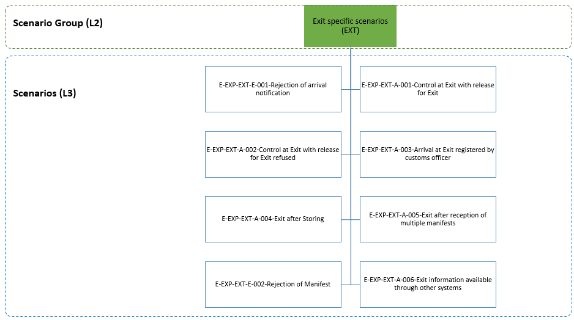

Figure 58: Exit specific scenarios

The current section describes exit specific scenarios of a standard Export process. The scenarios can be categorised in the following major groupings:

* The handling of controls at the Customs Office of Exit;
* the handling of the arrival at exit notification;
* the exit formalities when the goods are stored prior to their exit;
* the handling of exit notification provided by another system.

##### E-EXP-EXT-E-001 Rejection of arrival notification

Figure 59 displays the scenario in which a declaration is accepted at the Customs Office of Export and the export movement information is forwarded to the Customs Office of Exit (Declared).

The flow continues up until **[St****ep 8]** of the E-EXP-CFL-M-001 Core flow scenario. That is, **[**Step 1**]** until **[**Step 7**]** are the same as in E-EXP-CFL-M-001 Core flow. In this case, after the reception of the arrival notification by the Customs Office of Exit via an ‘Arrival at Exit’ E_ARR_EXT (IE507) message, the validation of the message is not successful due to inconsistencies or functional errors detected **[Step 8].**

**[Step 9]** The reason of the rejection of the arrival notification message is communicated to the Trader at Exit via a ‘Rejection from Office of Exit’ E_EXT_REJ (IE557) message and the movement state at the Customs Office of Exit remains as “AER Created”.

The remaining steps of E-EXP-CFL-M-001 Core flow ([Step 8] until [Step 15]) are not applicable, since [Step 9] above is the final step.



Figure 59: E-EXP-EXT-E-001 Rejection of arrival notification

##### E-EXP-EXT-A-001 Control at Exit with release for Exit

Figure 60 displays the scenario in which the Customs Officer at the Customs Office of Exit decides to control the goods of the movement and the consignment is finally allowed to leave the European Union Customs Territory.

The flow continues up until **[Step 9]** of the E-EXP-CFL-M-001 Core flow scenario. That is, **[**Step 1**]** until **[**Step 8**]** are the same as in E-EXP-CFL-M-001 Core flow.

There is the possibility for the Trader at Exit to inform via ‘Arrival at Exit’ E_ARR_EXT (IE507) about any detected differences and any additional information (Goods measure, Packaging, Transport Equipment, Transport Document and UCR) at arrival for consideration to the Customs Office of Exit.

In this case, after the presentation of goods at the Customs Office of Exit, the Customs Officer decides to control the goods.

The Trader at Exit is informed that the Custom Authorities are intended to examine the goods via an ‘Exit Control Decision Notification’ E_EXT_CTR (IE561) message and the movement state at the Customs Office of Exit is set to “Under Control” **[Step 9].**

After the control is done, the Customs Officer registers the satisfactory control results into the system. The movement state at the Customs Office of Exit is set to “Goods Ready to be Released”.

**[Steps 10 until 15**] The scenario continues as per [**Step** **10**] until **[**Step 15**]** of the E-EXP-CFL-M-001 Core flow scenario.

Note: It might also be the case that the Trader at Exit informs via ‘Exit Notification’ E_EXT_NOT (IE590) about any detected differences and any additional information (Goods measure, Packaging and Transport Equipment) for the goods that finally exited.

Finally, the Customs Office of Exit shall inform the Customs Office of Export via Exit Results C_EXT_RES (ΙΕ518) message for any reported differences and additional information by Trader at Exit via ‘Arrival at Exit’ E_ARR_EXT (IE507) or ‘Exit Notification’ E_EXT_NOT (IE590).



Figure 60: E-EXP-EXT-A-001 Control at Exit with release for Exit

##### E-EXP-EXT-A-002 Control at Exit with release for Exit refused

Figure 61 displays the scenario in which the Customs Officer at the Customs Office of Exit decides to control the goods of the movement. The consignment is not allowed to leave the European Union Customs Territory as major discrepancies are found.

The flow continues up until **[Ste****p 9]** of the E-EXP-CFL-M-001 Core flow scenario. That is, **[**Step 1**]** until **[**Step 8**]** are the same as in E-EXP-CFL-M-001 Core flow. In this case, after the presentation of goods at the Customs Office of Exit, the Customs Officer decides to control the goods.

The Trader at Exit is informed that the Custom Authorities are intended to examine the goods via an ‘Exit Control Decision Notification’ E_EXT_CTR (IE561) message and the movement state at the Customs Office of Exit is set to “Under Control” **[Step 9].**

During the control of the goods, major discrepancies are found and registered into the system.

**[Step 10]** As a result, the consignment cannot leave the European Union Customs Territory and the control results are communicated to the Customs Office of Export via an Exit Results C_EXT_RES (ΙΕ518) message.

**[Step 11]** The Trader at Exit is notified via an ‘Exit Release Rejection’ E_EXT_REJ (IE522) message that the goods are not allowed to Exit the European Union Customs Territory and the movement stops without prejudice of any subsequent measure to be taken. The movement state at the Customs Office of Exit is set to “Goods not Allowed to Exit”.

AES identifies that the exit control results are found negative. The movement state at the Customs Office of Export is set to “Export Stopped, Discrepancies at Exit” and the Time Limit to Receive Exit Results (T_Receive_Exit_Results) and Time Limit to Certify Exit [T_Certify_Exit] timers stop at this point **[Step 12]**.

**[Step 12]** Finally, the Customs Office of Export notifies via an ‘Export Notification’ E_EXP_NOT (IE599) message the Declarant/Representative that the goods are not allowed to Exit the European Union Customs Territory providing all the export details.

The remaining steps of E-EXP-CFL-M-001 Core flow are not applicable, since [Step 12] above is the final step.



Figure 61: E-EXP-EXT-A-002 Control at Exit with release for Exit refused

##### E-EXP-EXT-A-003 Arrival at Exit registered by customs officer

Figure 62 displays the scenario in which a Customs Officer registers the arrival at Exit at the Customs Office of Exit.

The flow continues up until [Step 8] of the E-EXP-CFL-M-001 Core flow scenario. That is, [Step 1] until [Step 7] are the same as in E-EXP-CFL-M-001 Core flow. In this case, following the communication of the export movement information to the Customs Office of Exit, a Customs Officer will register the arrival at exit at the Customs Office of Exit instead of the communication of an arrival at exit by the Trader at Exit (the movement state at the Customs Office of Exit will be set to “Goods Presented at Exit”) **[Step 8]**.

**[Step 9 until 15]** The scenario continues with [Step 9] until [Step 15] of the E-EXP-CFL-M-001 Core flow scenario.

Note: There is the possibility for the Customs Officer at the Customs Office of Exit to register any detected differences and any additional information (Goods measure, Packaging, Transport Equipment, Transport Document and UCR) with the arrival at exit.

It might also be the case that the Trader at Exit informs via ‘Exit Notification’ E_EXT_NOT (IE590) about any detected differences and any additional information (Goods measure, Packaging and Transport Equipment) for the goods that finally exited.

Finally, the Customs Office of Exit shall inform the Customs Office of Export via Exit Results C_EXT_RES (ΙΕ518) message for any reported differences and additional information by Trader at Exit via ‘Arrival at Exit’ E_ARR_EXT (IE507) or ‘Exit Notification’ E_EXT_NOT (IE590).



Figure 62: E-EXP-EXT-A-003 Arrival at Exit registered by customs officer

##### E-EXP-EXT-A-004 Exit after Storing

Figure 63 displays the scenario in which the goods are stored prior to their exit from the European Union Customs Territory. No control procedures are initiated by the Customs Officer in this scenario.

The flow continues up until **[Step 8]** of the E-EXP-CFL-M-001 Core flow scenario. That is, **[**Step 1**]** until **[**Step 7**]** are the same as in E-EXP-CFL-M-001 Core flow. In this case, the arrival notification is received by the Customs Office of Exit via an ‘Arrival at Exit’ E_ARR_EXT (IE507) message, indicating that the goods will be stored prior their exit (the movement state at the Customs Office of Exit is set to “Goods Presented at Exit”) **[Step 8].**

The Customs Officer at Exit taking into account the results of risk analysis recommendation, decides not to control the goods (the movement state at the Customs Office of Exit is set to “Goods Ready to be Released”).

**[Step 9]** An ‘Exit Release Notification’ E_EXT_REL (IE525) message is sent notifying the Trader at Exit that the goods are allowed to be stored prior their exit.

**[Step 10]** The exiting process of the goods being in the “Goods Held for Storing” state is initiated by the submission of a manifest via a ‘Manifest Presentation’ E_MAN_PRE (IE547) message from the Trader at Exit. In the present scenario, it is assumed that the manifest lists all the stored goods of the export movement (meaning all items belonging to the corresponding MRN) intended to leave the European Union Customs Territory on a given mean of transport.

**[Step 11]** The Customs Office of Exit upon the reception of the message checks its validity and confirms its successful acceptance to the Trader at Exit via a ‘Manifest Validation’ E_MAN_VAL (IE548) message. The movement state at the Customs Office of Exit is set to “Goods Released for Immediate Leave”.

**[Steps 12 until 16]** The scenario continues with steps **[****Step 11****]** until **[**Step 15**]** of the E-EXP-CFL-M-001 Core flow.



Figure 63: E-EXP-EXT-A-004 Exit after Storing

##### E-EXP-EXT-A-005 Exit after reception of multiple manifests

Figure 64depicts the process of a movement exiting via multiple manifests after it is held for storing.

The flow continues up until **[****St****ep** **10****]** of scenario E-EXP-EXT-A-004 Exit after Storing. That is, **[**Step 1**]** until **[**Step 9**]** are the same as in E-EXP-EXT-A-004 Exit after Storing. However, in this scenario it is assumed that the initial manifest covers only part of the goods items of the movement [**Step 10**]. The Customs Office of Exit upon the reception of the manifest checks its validity and confirms its successful acceptance via a ‘Manifest Validation’ E_MAN_VAL (IE548) message **[Step 11]**. The state of the movement at the Customs Office of Exit changes to “Goods Released for Immediate Leave (Partial)”.

After the specific goods items of the movement (as indicated in the initial manifest) have exited, the Trader at Exit indicates the fact to the Office of Exit via an ‘Exit Notification’ E_EXT_NOT (IE590) message and the state of the movement at the Customs Office of Exit is set to “Partially Exited” **[Step 12]**.

A second (or more) manifest(s) can follow covering the remaining (or part of the remaining) goods items of the stored movement **[Steps 10-12]**. However, the state of the movement at the Customs Office of Exit remains to “Partially Exited”. It is only when the final ‘Exit Notification’ E_EXT_NOT (IE590) message is received confirming the exiting of the last manifest (covering all the remaining goods items of the movement) that the movement state at the Customs Office of Exit is set to “Exited”.

**[Steps 13 until 16]** The scenario continues with steps **[****Ste****p 11****]** until [Step 15] of the E-EXP-CFL-M-001 Core flow.





Figure 64: E-EXP-EXT-A-005 Exit after reception of multiple manifests

##### E-EXP-EXT-E-002 Rejection of Manifest

Figure 65 displays the scenario in which the goods are stored prior to their exit and the manifest is rejected and the goods are not allowed to exit from the European Union Customs Territory.

The flow continues up to**[****Step 10****]** of scenario E-EXP-EXT-A-004 Exit after Storing. That is, **[**Step 1**]** until [Step 10] are the same as in E-EXP-EXT-A-004 Exit after Storing. The Customs Office of Exit upon the reception of the message checks its validity and rejects it. The Trader at Exit is notified via a ‘Manifest Validation’ E_MAN_VAL (IE548) message **[Step 11].**

Unless the Trader at Exit amends the manifest successfully, the movement remains at the same state (“Goods Held for Storing”) waiting for a valid manifest to be submitted. For this scenario, the remaining steps of E-EXP-EXT-A-004 Exit after Storing ([Step 12] until [Step 16] are not applicable, since [Step 11] is the final step.



Figure 65: E-EXP-EXT-E-002 Rejection of Manifest

##### E-EXP-EXT-A-006 Exit information available through other systems

As the exact implementation can differ based on the arrangements between the National Customs Authority and the Commercial/Port Authority, this scenario is depicted for information only with the purpose to register monitoring and processing of the exit of the goods using the Commercial or Port or Transport System.

Figure 66 displays the scenario in which a declaration is accepted at the Customs Office of Export and the exit information is available to the Customs Office of Exit through the Commercial or Port or Transport System linked to the declaration.

The flow continues up until **[Step 11]** of the E-EXP-CFL-M-001 Core flow scenario. That is, **[**Step 1**]** until **[**Step 10**]** are the same as in E-EXP-CFL-M-001 Core flow. In this case, after the communication of an ‘Exit Release Notification’ E_EXT_REL (IE525) message to the Trader at Exit informing him/ her that the goods can be immediately released (movement state at the Customs Office of Exit is set to “Goods Released for Immediate Leave”), the Customs Office of Exit receives the information that the goods have exited through the Commercial or Port or Transport System linked to the export declaration and the movement state at the Customs Office of Exit is set to “Exited” **[Step 11].**

**[Step 12 until 15]** The scenario continues as per **[Ste****p 12]** until **[**Step 15**]** of the E-EXP-CFL-M-001 Core flow.



Figure 66: E-EXP-EXT-A-006 Exit information available through other systems

#### Export Followed by Transit

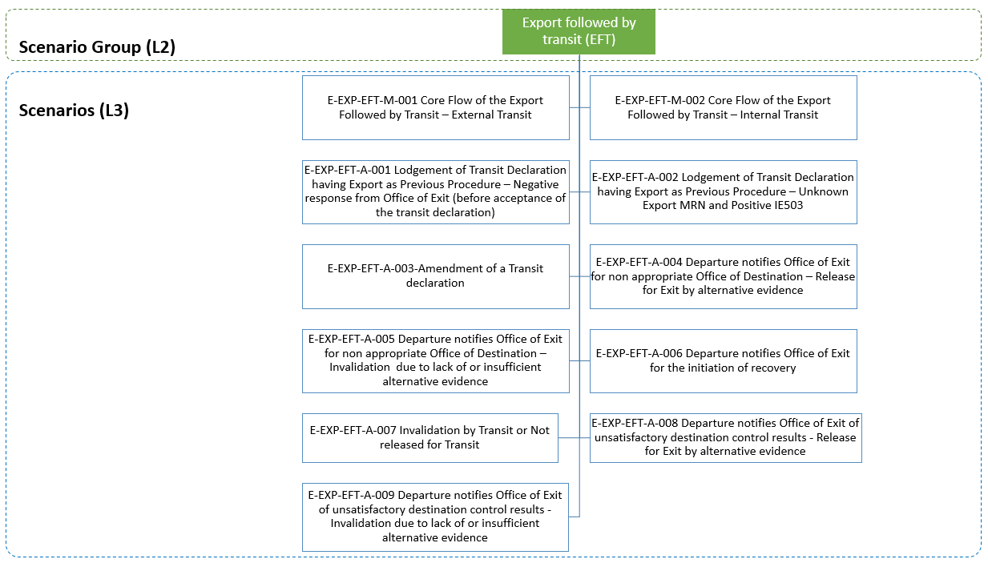

Figure 67: Export Followed by Transit specific scenarios

There are cases when an export is followed by a transit procedure. In that case, AES needs to interface with NCTS:

* The IE190 that is sent from the Customs Office of Departure to the Customs Office of Exit to verify/allocate the export MRNs that are referenced in the transit declaration includes the field Transit Declaration type which indicates if the transit operation is an internal or external one.
* When the goods are released for export and then the external transit procedure follows, the Customs Office of Exit shall be the Customs Office of Departure of the transit operation (Article 329 (5) UCC IA [A2])[42];
* In case of internal transit, the Customs Office of Exit shall be the Customs Office of Departure, if the Office of Destination is situated either:
  + in a common transit country (Article 329 (6) UCC IA [A2]), or
  + at the border of the Customs territory of the Union and the goods are taken out of that Customs territory, after having passed through a country or territory outside the Customs territory of Union (Article 329 (6) UCC IA [A2]).

The export followed by transit scenario is triggered when at least one (1) Export MRN is referenced into the previous documents data group of the transit declaration. Specifically, these Export MRNs should be declared by the Holder of the Transit Procedure into the Previous Document data group under the House Consignment data group of the transit declaration.

On the other hand, each House Consignment data group into the transit declaration data corresponds to the full details of only one (1) Export Movement. The interface between NCTS and AES validates the existence of the referenced export MRNs into the transit movement. No other information (e.g. goods items details) is validated between NCTS and AES. However, other validations are also taking place in AES such as the status of the Export Movement is appropriate so that it can be referenced as previous procedure into a Transit Movement. Moreover, one (1) transit declaration can contain more than one (1) export MRNs, but one (1) export MRN cannot be referenced in more than one (1) transit declarations.

Following this, communication between NCTS and AES is taking place by NCTS sending for validation the ‘Transit Presentation Notification’ N_XFT_REQ (IE190) message to the Office of Exit before the acceptance of the transit declaration. One specialised ‘Transit Presentation Notification’ N_XFT_REQ (IE190) message is sent containing all Export MRNs referenced in the transit declaration.

When AES receives the ‘Transit Presentation Notification’ N_XFT_REQ (IE190) message, it conducts all the validation checks and returns one ‘Transit Presentation Notification Response’ N_XFT_RSP (IE191) message back to NCTS. Depending on the response being negative or positive, NCTS acts accordingly.

The validations to be performed as part of the cross-checking that is provided by the AES at the Office of Exit are classified according to their optionality (Minimum-Mandatory, Extended-Recommended, Excise-Specific), as follows:

* **Minimum-Mandatory**: MRN existence and appropriate state (at the Office of Exit);
* **Extended-Recommended**: The same Commodity Code (between Transit Declaration and Export Declaration for the requested export MRN);
* **Excise-Specific** (in addition to the abovementioned checks):
  + ARC+UBR;
  + CN Code (in case the Extended-Recommended check is not enabled);
  + Net mass;
  + Supplementary units (not mandatory cross-check).

In case that a transit declaration is lodged under simplified procedure, then additionally to the above checks, the location of goods declared in the transit declaration/authorisation (ACR) is validated against the location data registered at the Office of Exit.

In case of positive response from AES, NCTS accepts the transit declaration and allocates an MRN to the transit movement. The Holder of the Transit Procedure is notified with the ‘MRN Allocated’ E_MRN_ALL (IE028) message. Following this, the ‘Transit Presentation Notification’ N_XFT_REQ (IE190) message is sent again to the Office of Exit to allocate the Export MRNs for the transit declaration in the Office of Exit. Then, the Office of Exit acknowledges with a positive ‘Transit Presentation Notification Response’ N_XFT_RSP (IE191) message to NCTS and the transit movement with the export MRNs can continue its usual process. On the other hand, in case of negative response from AES, the transit declaration is rejected and the ‘Declaration Rejected’ E_DEC_REJ (IE056) message is communicated to the Holder of the Transit Procedure.

Finally, in case of internal transit, the Office of Departure validates the ‘appropriateness’ of the Declared Office of Destination at first during the validation process of the transit declaration. An ‘appropriate’ Office of Destination is considered that Office that either:

* Belongs to an EU MS and has the role ‘EXT-Office of Exit’; or
* Belongs to a Common Transit Convention country (i.e. that operates in NCTS).

The ‘appropriateness’ of the Office of Destination is checked by the Office of Departure:

* Firstly, during the validation of the transit declaration but before the allocation of the MRN to the transit movement, and
* Lastly, when the Office of Departure receives the ‘Arrival Advice’ C_ARR_ADV (IE006) message from the Office of Destination.

The reason that the ‘appropriateness’ of the Office of Destination is checked by the Office of Departure is to suitably inform the AES system with the ‘Destination Control Results to AES’ N_DES_CON (IE042) message (i.e. ‘Appropriate Office of Destination’ is equal to ‘0-No’ or ‘1-Yes’ in the ‘Destination Control Results to AES’ N_DES_CON (IE042) message).

The scenarios below describe this interface between NCTS and AES at the National Domain.

##### Core flow of the Export Followed by Transit

###### E-EXP-EFT-M-001 Core Flow of the Export Followed by Transit – External Transit

When external transit follows export (the transit procedure is either “T”, “T1” or “TIR”) and the movement is released for transit, NCTS notifies AES with the ‘Destination Control Results to AES’ N_DES_CON (IE042) message. When AES receives this message, the exit control results are directly communicated to the Office of Export with the ‘Exit Results’ C_EXT_RES (IE518) message and that finalises the export movement. It is noted that even though any further interaction with AES is finished, the NCTS operation completes when the ‘Destination control results’ C_DES_CON (IE018) message is sent to the Office of Departure from the Office of Destination.

Figure 68 displays the scenario in which an external transit procedure takes place between the goods release for export and the goods exit.

The scenario starts identically to the E-EXP-CFL-M-001 Core flow scenario up to **[Step** **7]**. That is, **[**Step 1**]** until **[**Step 7**]** are in E-EXP-CFL-M-001 Core flow. The Customs Office of Export communicates the release for export via an AER C_AER_SND (IE501) message to the Customs Office of Exit.

**[Step 8]** The Customs Office of Exit will now receive a ‘Transit Presentation Notification’ N_XFT_REQ (IE190) by the Customs Office of Departure as an initial cross-check to validate the Export MRN(s). Upon reception of the ‘Transit Presentation Notification’ N_XFT_REQ (IE190) message, the Office of Exit verifies (cross check) that the referenced Export MRN(s) exist and are in appropriate state (i.e. AER Created, Goods Presented at Exit, Goods Ready to be Released)[43].

**[Step 9]** The Customs Office of Exit replies positively to the Customs Office of Departure by sending a positive ‘Transit presentation Notification response’ N_XFT_RSP (IE191).

Note: Upon reception of a positive ‘Transit presentation Notification response’ N_XFT_RSP (IE191) message, the Office of Departure communicates the Transit MRN to the Holder of the Transit Procedure with the ‘MRN Allocated’ E_MRN_ALL (IE028) message and the state at the Office of Departure is set to Accepted.

**[****Step 10]** The Customs Office of Exit receives a new ‘Transit Presentation Notification’ N_XFT_REQ (IE190) by the Customs Office of Departure as allocation request of the transit MRN to the Export MRN(s) since the transit declaration has now been accepted.  
AES at the Office of Exit allocates the Transit MRN for the specific Export MRN(s).

**[Step 11]** The Customs Office of Exit replies positively to the Customs Office of Departure by sending a positive ‘Transit Presentation Notification Response’ N_XFT_RSP (IE191). The movement state is set to “Goods Presented at Transit” at the Customs Office of Exit.

**[****Step 12]** The Customs Office of Departure sends positive Destination Control Results via the ‘Destination Control Results to AES’ N_DES_CON (IE042) to the Customs Office of Exit, indicating the release for transit of the external transit procedure and so the consignment is considered that left the European Union Customs Territory.

The Customs Office of Exit confirms the exit of the consignment to the Customs Office of Export via an Exit Results C_EXT_RES (ΙΕ518) message and the movement state at the Office of Exit is set to “Exited”.

**[Step 13 until 15]** The scenario continues as per **[St****ep 13]** until **[**Step 15**]** of the E-EXP-CFL-M-001 Core flow.

Note: When excise goods are referenced in an export declaration and transit is the procedure that follows export, then only external transit procedure can be used.



Figure 68: E-EXP-EFT-M-001 Core Flow of the Export Followed by Transit – External Transit

###### E-EXP-EFT-M-002 Core Flow of the Export Followed by Transit – Internal Transit

In contrast with what happens for the external transit, when internal transit follows export (the transit procedure is either “T2” or “T2F”), the Office of Departure notifies the Office of Exit with the ‘Destination Control Results to AES’ N_DES_CON (IE042) message, when the Office of Departure receives the ‘Destination control results’ C_DES_CON (IE018) message from the Office of Destination. For the analysis of this scenario, the assumption is that satisfactory control results are included into the ‘Destination control results’ C_DES_CON (IE018) message. In that case, the exit control results also contain a satisfactory control result code (i.e. starting with ‘A’), and the Office of Export is notified with the ‘Exit Results’ C_EXT_RES (IE518) from the Office of Exit. The latter finalises the export movement.

Figure 69 displays the scenario in which an internal transit procedure takes place between the goods release for export and the goods exit.

The scenario starts identically to the E-EXP-CFL-M-001 Core flow scenario up the point **[Step 7]****.** That is, **[**Step 1**]** until **[**Step 7**]** are in E-EXP-CFL-M-001 Core flow. The Customs Office of Export communicates the release for export via an AER C_AER_SND (IE501) message to the Customs Office of Exit.

**[Step 8]** The Customs Office of Exit will now receive a ‘Transit Presentation Notification’ N_XFT_REQ (IE190) by the Customs Office of Departure as an initial cross-check[44] to validate the Export MRN(s). Upon reception of the ‘Transit Presentation Notification’ N_XFT_REQ (IE190) message, the Office of Exit verifies that the referenced Export MRN(s) exist and are in appropriate state (i.e. AER Created, Goods Presented at Exit, Goods Ready to be Released).

**[Step 9]** The Customs Office of Exit replies positively to the Customs Office of Departure by sending a positive ‘Transit Presentation Notification Response’ N_XFT_RSP (IE191).

Note: Upon reception of a positive ‘Transit Presentation Notification Response’ N_XFT_RSP (IE191) message, the Office of Departure communicates the Transit MRN to the Holder of the Transit Procedure with the ‘MRN Allocated’ E_MRN_ALL (IE028) message and the state at the Office of Departure is set to Accepted.

**[****Step 10]** The Customs Office of Exit receives a new ‘Transit Presentation Notification’ N_XFT_REQ (IE190) by the Customs Office of Departure as allocation request of the transit MRN to the Export MRN(s) since the transit declaration has now been accepted.  
AES at the Office of Exit allocates the Transit MRN for the specific Export MRN(s).

**[****Step 11]** The Customs Office of Exit replies positively to the Customs Office of Departure by sending a positive ‘Transit Presentation Notification Response’ N_XFT_RSP (IE191). The movement state is set to “Goods Presented at Transit” at the Customs Office of Exit.

**[****Step 12]** When the Office of Departure sends the ‘Destination Control Results to AES’ N_DES_CON (IE042) message to the Office of Exit indicating the destination control results for each referenced export MRN(s) in the transit declaration.

Upon reception of the ‘Destination Control Results to AES’ N_DES_CON (IE042) message, the Office of Exit will generate and send to the AES at the Office of Export, an instance of the ‘Exit Results’ C_EXT_RES (IE518) for each referenced Export MRN in the N_DES_CON (IE042).

It is noted that the N_DES_CON (IE042) message incorporates the information from the Office of Departure whether the Office of Destination is at border or not (flag “Appropriate Office of Destination” (Yes/No));

In case that the flag “Appropriate Office of Destination” = 0 – No (i.e. non-appropriate Office of Destination), the AES at the Office of Exit will generate and send to the AES at the Office of Export, an instance of the ‘Exit Results’ C_EXT_RES (IE518) for each referenced Export MRN in the N_DES_CON (IE042) indicating the value ‘B2’ in the Control result code. This code will be used to signal a non-appropriate Office of Destination provided that the destination control results in IE018 are satisfactory (‘A1’, ‘A4’). Please see section III.4.1.8.5. It is emphasised that in such a case the Office of Export would demand alternative evidence for the finalisation of the export operation.

**[Step 13 until 15]** The scenario continues as per **[Step 13]** until **[**Step 15**]** of the E-EXP-CFL-M-001 Core flow.



Figure 69: E-EXP-EFT-M-002 Core Flow of the Export Followed by Transit – Internal Transit

##### Validate transit declaration before acceptance

When the goods are released for export and have arrived at the Office of Exit, a transit declaration is lodged at the same Customs Office of Exit that becomes Customs Office of Departure with the ‘Declaration data’ E_DEC_DAT (IE015) message. The declaration data message contains one or more Export MRNs in the previous documents data group. Following this, communication between NCTS and AES is taking place by NCTS sending for validation the ‘Transit Presentation Notification’ N_XFT_REQ (IE190) message to the Office of Exit before the acceptance of the transit declaration. One ‘Transit Presentation Notification’ N_XFT_REQ (IE190) message is sent containing all Export MRNs referenced in the transit declaration.

When AES receives the ‘Transit Presentation Notification’ N_XFT_REQ (IE190) message, it conducts all the validation checks and returns one ‘Transit Presentation Notification Response’ N_XFT_RSP (IE191) message back to NCTS. Depending on the response being negative or positive, NCTS acts accordingly. In case of positive response from AES, NCTS accepts the transit declaration and allocates an MRN to the transit movement. The Holder of the Transit Procedure is notified with the ‘MRN Allocated’ E_MRN_ALL (IE028) message. Following this, the ‘Transit Presentation Notification’ N_XFT_REQ (IE190) message is sent again to the Office of Exit to allocate the Export MRNs for the transit declaration in the Office of Exit. Then, the Office of Exit acknowledges with a positive ‘Transit Presentation Notification Response’ N_XFT_RSP (IE191) message to NCTS and the transit movement with the export MRNs can continue its usual process. On the other hand, in case of negative response from AES, the transit declaration is rejected and the ‘Declaration Rejected’ E_DEC_REJ (IE056) message is communicated to the Holder of the Transit Procedure.

###### E-EXP-EFT-A-001 Lodgement of Transit Declaration having Export as Previous Procedure – Negative response from Office of Exit (before acceptance of the transit declaration)

This scenario describes the case when the Office of Departure requests the Office of Exit to perform an initial cross check of the Export MRNs referenced in the transit declaration by sending the ‘Transit Presentation Notification’ N_XFT_REQ (IE190) message. However, the Office of Exit responds with a negative ‘Transit Presentation Notification Response’ N_XFT_RSP (IE191) message (e.g. the referenced export MRN is not in appropriate state or it unknown to the Office of Exit. In this case the IE502/IE503 mechanism will be used with a negative IE503 response). In that case, the process stops in NCTS and the transit declaration is rejected by sending the ‘Declaration Rejected’ E_DEC_REJ (IE056) message to the Holder of the Transit Procedure. No notification is sent to the Office of Exit. AES at the Office of Exit does not perform any further action.

###### E-EXP-EFT-A-002 Lodgement of Transit Declaration having Export as Previous Procedure – Unknown Export MRN and Positive IE503

This scenario describes the case when the Office of Departure performs an initial cross check of the Export MRNs referenced in the transit declaration by sending the ‘Transit Presentation Notification’ N_XFT_REQ (IE190) message to the Office of Exit for validation purposes. However, these Export MRNs are unknown to the Office of Exit. As a result, the Customs Office of Exit (Actual) sends the ‘Declaration Request Export’ C_EXP_REQ (IE502) to the relevant Office(s) of Export for each of these unknown Export MRNs.

Upon reception of all positive AER Response C_AER_RSP (IE503) from each relevant Office of Export, the Customs Office of Exit (Actual) prepares and sends a ‘Transit Presentation Notification Response’ N_XFT_RSP (IE191) message to the Office of Departure. In that case, the process continues by having the Office of Departure to allocate the Export MRNs with the Transit MRN (by exchanging the IE190/IE191 messages with the Customs Office of Exit (Actual)) and to continue its normal business process after the acceptance of the transit declaration.

Figure 70 depicts the scenario which starts identically to the E-EXP-CFL-M-001 Core flow scenario up the point **[Step 7]**. That is, **[**Step 1**]** until **[**Step 7**]** are in E-EXP-CFL-M-001 Core flow. The Customs Office of Export communicates the release for export via an AER C_AER_SND (IE501) message to the Customs Office of Exit (Declared).

**[Step 8]** The Customs Office of Exit (Actual) will now receive a ‘Transit Presentation Notification’ N_XFT_REQ (IE190) by the Customs Office of Departure as an initial cross-check to validate the Export MRN(s). Upon reception of the ‘Transit Presentation Notification’ N_XFT_REQ (IE190) message, the Customs Office of Exit (Actual) verifies that the referenced Export MRN(s) exist and are in appropriate state (i.e. AER Created, Goods Presented at Exit, Goods Ready to be Released). However, in this scenario the referenced export MRN(s) cannot be located (i.e. they are unknown to the Customs Office of Exit (Actual)).

**[Step 9]** The Customs Office of Exit (Actual) sends the ‘Declaration Request Export’ C_EXP_REQ (IE502) message to the Office(s) of Export (i.e. one separate message for each Export MRN).

**[Step 10]** Upon reception of the ‘Declaration Request Export’ C_EXP_REQ (IE502) message, the Office of Export retrieves the requested MRN and sends a positive ‘AER Response’ C_AER_RSP (IE503) back to the Customs Office of Exit (Actual).

**[Step 11]** The Office of Export also notifies the Customs Office of Exit (Declared) with the ‘Forwarded Arrival Advice’ C_ARR_FWD (IE524) message.

**[Step 12]** After the Customs Office of Exit (Actual) collects all positive ‘AER Response’ C_AER_RSP (IE503) messages[45],[46] from the Office(s) of Export that were referenced in the received N_XFT_REQ (IE190), it produces a positive ‘Transit Presentation Notification Response’ N_XFT_RSP (IE191) message and sends it to the Office of Departure. The movement state of the referenced export MRN(s) is set to “Goods Presented at Transit” at the Customs Office of Exit (Actual).

**[Step 13 until 18]** The scenario continues as per **[****Step** **10****]** until **[**Step 13 until 15**]** of the E-EXP-EFT-M-001 Core Flow of the Export Followed by Transit – External Transit or as per **[****Step** **10****]** until **[**Step 13 until 15**]** of the E-EXP-EFT-M-002 Core Flow of the Export Followed by Transit – Internal Transit, respectively.



Figure : E-EXP-EFT-A-002 Lodgement of Transit Declaration having Export as Previous Procedure – Unknown Export MRN and Positive IE503

##### Amendment of a Transit declaration

The below scenarios describe what happens when amendment of the transit declaration (after acceptance) having export as previous procedure is requested by the Holder of the Transit Procedure. In that case, if changes into the previous documents of the transit declaration exist and provided that the amendment request from the Holder of the Transit Procedure is valid, the NCTS at the Office of Departure contacts the AES at the Office of Exit to validate the Export MRNs. This check is conducted with the ‘Transit Presentation Notification’ N_XFT_REQ (IE190) message. If positive ‘Transit Presentation Notification Response’ N_XFT_RSP (IE191) is returned from the Office of Exit, then the transit declaration continues its normal processing with the amended data. However, if negative ‘Transit Presentation Notification Response’ N_XFT_RSP (IE191) is returned from the Office of Exit, then NCTS notifies the Holder of the Transit Procedure via the ‘Notification to amend Declaration’ E_AMD_NOT (IE022) message to submit an updated amendment request. The process can only continue if the amended data on the Export MRNs is validated from AES when the Office of Departure receives a positive ‘Transit Presentation Notification Response’ N_XFT_RSP (IE191) message.

###### E-EXP-EFT-A-003 Amendment of a Transit declaration

This scenario (Figure 71) examines what happens when a positive response is returned from the Office of Exit due to the amendment of the Export MRNs referenced in the transit declaration.

The scenario starts with **[**Step 1**]** up to **[****Step 11****]** of the E-EXP-EFT-M-001 Core Flow of the Export Followed by Transit – External Transit or with **[**Step 1**]** up to **[****Ste****p 11****]** of the E-EXP-EFT-M-002 Core Flow of the Export Followed by Transit – Internal Transit.

**[Step 12]** AES at the Office of Exit receives a new ‘Transit Presentation Notification’ N_XFT_REQ (IE190) message (Transit Indicator Flag is set to ‘Amendment of Export MRNs referenced in Transit Declaration’) containing all the Export MRNs that exist into the Previous Documents of the amended transit declaration.

**[Step 13]** AES at the Office of Exit de-allocates all the export MRN(s) that were initially correlated with the transit declaration (before its amendment) and are not referenced in the amended one. For those export MRNs, the transition to their previous state (“AER Created”, “Goods Presented at Exit” or “Goods Ready to be Released”) before the transition to “Goods Presented at Transit” is performed.

For all the other (if any) export MRNs referenced in the amended transit declaration, the state is set to “Goods Presented at Transit”. In this scenario it is assumed that any new export MRNs that are referenced in the amended transit declaration are located at the office of exit and they are in appropriate state (i.e. AER Created, Goods Presented at Exit, Goods Ready to be Released). Finally, AES at the Office of Exit prepares and sends a positive ‘Transit Presentation Notification Response’ N_XFT_RSP (IE191) to the Office of Departure.

**[Steps 14 until 17]** The scenario continues as per **[****Step 12****]** until[Step 13 until 15] of the E-EXP-EFT-M-001 Core Flow of the Export Followed by Transit – External Transit or as per **[****Step 12****]** until **[**Step 13 until 15] of the E-EXP-EFT-M-002 Core Flow of the Export Followed by Transit – Internal Transit.





Figure : E-EXP-EFT-A-003 Amendment of a Transit declaration

##### E-EXP-EFT-A-007 Invalidation by Transit or Not released for Transit

The below scenario describes what happens when the transit declaration having Export MRNs as previous documents is invalidated by the Holder of the Transit Procedure (accepted by Office of Departure) or the transit movement is not released for transit.

**Note:** After release for transit, the Office of Departure shall be able to invalidate the transit declaration (after receiving a request from the Holder of the Transit Procedure by alternative non-electronic means) only if the following two conditions are satisfied:

1. The state of the movement is any of the following:
   1. Movement released, or
   2. Enquiry recommended, or
   3. Under enquiry request;
2. The ‘Arrival Advice’ C_ARR_ADV (IE006), the ‘Notification Crossing Frontier’ C_NCF_NOT (IE118), the ‘Notification Leaving Security Area’ (IE168), the ‘Incident Notification’ C_INC_NOT (IE180) messages have not been received.

Upon decision is taken by the Office of Departure to accept the invalidation request submitted by the Holder of the Transit Procedure or not to release the transit declaration, the ‘Transit Invalidation Notification to AES’ N_INV_TRA (IE040) is sent by the Office of Departure to the Office of Exit. Subsequently, the Office of Exit de-associates the Export MRNs from the Transit MRN. This means that the Export MRNs at the Office of Exit can follow a different process or be referenced into another transit declaration.

Figure 72 describes what happens when the transit declaration that references Export MRNs into its previous documents is invalidated following request from the Holder of the Transit Procedure. The scenario starts with **[**Step 1**]** up to **[****Step 11****]** of the E-EXP-EFT-M-001 Core Flow of the Export Followed by Transit – External Transit or with **[**Step 1**]** up to **[****Step 11****]** of the E-EXP-EFT-M-002 Core Flow of the Export Followed by Transit – Internal Transit.

**[Step 12]** AES at the Office of Exit receives the message ‘Transit Invalidation Notification to AES’ N_INV_TRA (IE040) send by the Office of Departure. Upon reception of the ‘Transit Invalidation Notification to AES’ N_INV_TRA (IE040) message, AES at the Office of Exit de-associates the Transit MRN from the Export MRN(s). For those export MRNs, the transition to their previous state (“AER Created”, “Goods Presented at Exit” or “Goods Ready to be Released”) before the transition to “Goods Presented at Transit” is performed. That way, the Export MRNs become available for another procedure.

The remaining steps ([Step 12] until [Step 15]) of E-EXP-EFT-M-001 Core Flow of the Export Followed by Transit – External Transit or E-EXP-EFT-M-002 Core Flow of the Export Followed by Transit – Internal Transit, respectively, are not applicable, since [Step 12] above is the final step for this scenario.

Note: the above scenario is also applicable in the case that the transit declaration that references Export MRNs into its previous documents is not released for transit.



Figure : E-EXP-EFT-A-007 Invalidation by Transit

##### Handling of Destination Control Results (Internal Transit)

For internal transit, NCTS at the Office of Departure will automatically generate and sent to the AES at the Office of Exit the ‘Destination Control Results to AES’ N_DES_CON (IE042) message either upon the reception of the ‘Arrival Advice’ C_ARR_ADV (IE006) message which proves an non-appropriate Office of Destination or upon the reception of the ‘Destination control results’ C_DES_CON (IE018) message.

One instance of the IE042 is sent per transit declaration. The contents of the IE042 comprises the destination control results per Export MRN(s) for all the export movements that are referenced in the transit declaration. Then, AES at the Office of Exit, generates distinct ‘Exit Results’ C_EXT_RES (IE518) per each Export MRN that is referenced in the ‘Destination Control Results to AES’ N_DES_CON (IE042) message. The generated ‘Exit Results’ C_EXT_RES (IE518) instances will indicate either satisfactory (i.e. ‘A1’, ‘A4’) or unsatisfactory control results (i.e. ‘B2’, ‘B3’).

It is acknowledged that if the control result code reported into the ‘Destination control results’ C_DES_CON (IE018) message is ‘A4’ or ‘B1’ then minor/major discrepancies are declared for the entire transit movement or for individual House Consignments/Consignment items. However, if these minor/major discrepancies are reported for specific House Consignment(s) that contain(s) Export MRN(s) then the code ‘A4’/‘B1’ is assigned to these Export MRN(s) when the ‘Destination Control Results to AES’ N_DES_CON (IE042) message is generated. It is emphasised that for the House Consignment(s) containing Export MRNs that are not reported with discrepancies then code ‘A1’ is assigned when the ‘Destination Control Results to AES’ N_DES_CON (IE042) message is generated.

In case that minor/major discrepancies are reported for the whole transit movement, then the same control result code is used in the ‘Destination Control Results to AES’ N_DES_CON (IE042) message for all Export MRNs referenced in the transit declaration.

More specifically:

* If discrepancies are reported for a specific House Consignment that contains an Export MRN in the ‘Destination Control Results’ C_DES_CON (IE018), then the control result code for the specific House Consignment shall only be ‘A4’ or ‘B1’. For all the other House Consignments (that do not report discrepancies), the control result code will be ‘A1’ (i.e. no other control result codes are allowed);
* If discrepancies are reported for the entire transit declaration in the ‘Destination Control Results’ C_DES_CON (IE018), (e.g. the data element ‘Other things to report’ is filled in) then the control result code for all House Consignments that contain an Export MRN shall only be ‘A4’ or ‘B1’ (i.e. no other control result codes are allowed).
* If no discrepancies are reported for the entire transit declaration in the ‘Destination Control Results’ C_DES_CON (IE018), then the control result code for all House Consignments that contain an Export MRN shall only be ‘A1’.

The following two scenarios specify the case where a non-appropriate Office of Destination is indicated in the ‘Destination Control Results to AES’ N_DES_CON (IE042) message and the export operation is finalised successfully or unsuccessfully by alternative evidence.

###### E-EXP-EFT-A-004 Departure notifies Office of Exit for non appropriate Office of Destination – Release for Exit by alternative evidence

This scenario (Figure 73) describes the case that the flag “Appropriate Office of Destination ” = 0 (i.e. non-appropriate Office of Destination) is indicated in the ‘Destination Control Results to AES’ N_DES_CON (IE042) message and the export operation is finalised by alternative evidence.

This scenario starts at **[****Step 12****]** of the E-EXP-EFT-M-002 Core Flow of the Export Followed by Transit – Internal Transit. That is, **[**Step 1**]** until [Step 11] are the same as in E-EXP-EFT-M-002 Core Flow of the Export Followed by Transit – Internal Transit. However, this scenario assumes that the NCTS at the Office of Departure, based on the reception of the ‘Arrival Advice’ C_ARR_ADV (IE006), does not consider the Office of Destination as appropriate and thus the generated ‘Destination Control Results to AES’ N_DES_CON (IE042) message sets the flag ‘Appropriate Office of Destination’ to ‘0-No’ (i.e. non-appropriate Office of Destination) **[Step 12].**

**[Step 13]** Upon reception of the ‘Destination Control Results to AES’ N_DES_CON (IE042) message, the Office of Exit will generate and send to the AES at the Office of Export, an instance of the ‘Exit Results’ C_EXT_RES (IE518) for each referenced Export MRN in the N_DES_CON (IE042).

Since the flag ‘Appropriate Office of Destination’ is set to ‘0-No’ (i.e. non-appropriate Office of Destination) in the ‘Destination Control Results to AES’ N_DES_CON (IE042) message, the AES at the Office of Exit will set the value ‘B2’ in the Control result code of each instance of the ‘Exit Results’ C_EXT_RES (IE518) that is generated. This code will be used to signal a non-appropriate Office of Destination. The involved export operations are transited to the final state “Handled Elsewhere” at the Office of Exit and to “Under Exit Confirmation Request” at the Office of Export.

**[Step 14]** The Time Limit to Receive Exit Results (T_Receive_Exit_Results) at the Customs Office of Export stops at this point.

**[Step** **15]** AES at the Customs Office of Export requests from the Declarant/Representative for alternative evidence via a ‘Request on Non-Exited Export’ E_EXT_REQ (IE582). In addition, AES at the Customs Office of Export initiates the Time Limit to Receive Alternative Evidence (T_Receive_Alternative_Evidence) **[Step 16]**.

**[Step 17]** The Declarant/Representative replies to the Customs Office of Export with an ‘Information on Non-Exited Export’ E_EXT_RSP (IE583) indicating a confirmation of exit by alternative evidence (Enquiry information code: “Exited-Alternative Evidence”). The Customs Officer at the Customs Office of Export examines the content of the ‘Information on Non-Exited Export’ E_EXT_RSP (IE583) and decides that the provided alternative evidence is sufficient **[Step 18]** and the Time Limit to Receive Alternative Evidence (T_Receive_Alternative_Evidence) stops **[Step 19]**.

**[Step 20]** The movement state at the Customs Office of Export is set toExported, which is a final state and the Time Limit to Certify Exit (T_Certify_Exit) stops at this point.

**[Step 21]** Finally, AES at the Customs Office of Export notifies via an ‘Export Notification’ E_EXP_NOT (IE599) message the Declarant/Representative that the movement has successfully.

The remaining steps of E-EXP-EFT-M-002 Core Flow of the Export Followed by Transit – Internal Transit are not applicable in this scenario, since the final step is the [Step 21] above.

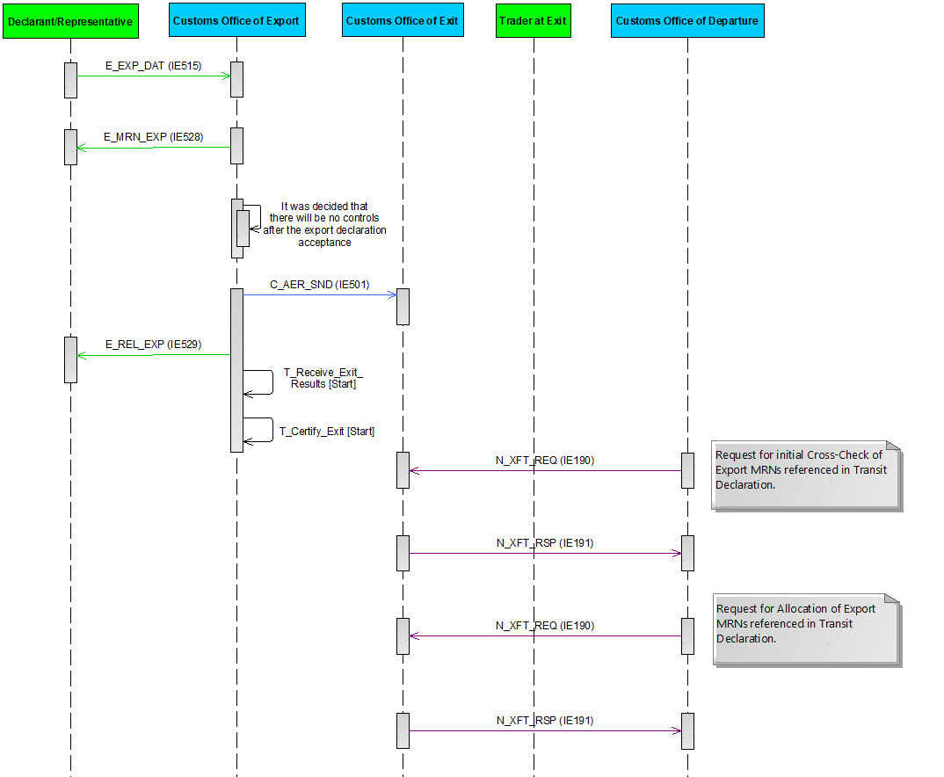

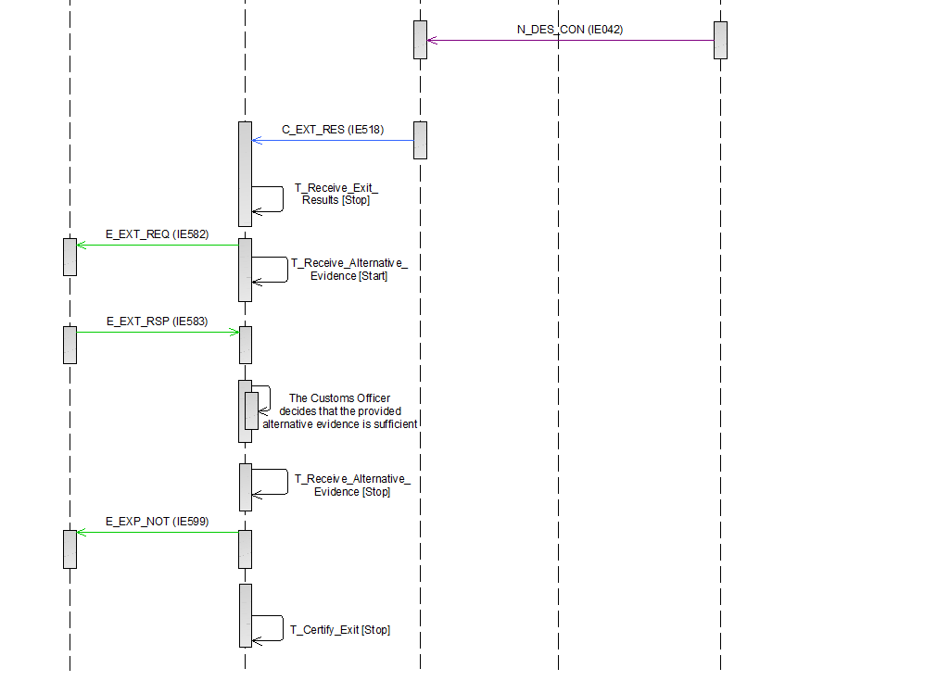

Figure : E-EXP-EFT-A-004 Departure notifies Office of Exit for non appropriate Office of Destination – Release for Exit by alternative evidence

###### E-EXP-EFT-A-005 Departure notifies Office of Exit for non appropriate Office of Destination – Invalidation due to lack of or insufficient alternative evidence

This scenario (Figure 74) describes the case that the flag “Appropriate Office of Destination ” = 0 (i.e. non-appropriate Office of Destination) is indicated in the ‘Destination Control Results to AES’ N_DES_CON (IE042) message and the export operation is finalised by invalidation due to insufficient alternative evidence.

This scenario starts at **[****Step 12****]** of the E-EXP-EFT-M-002 Core Flow of the Export Followed by Transit – Internal Transit. That is, **[**Step 1**]** until [Step 11] are the same as in E-EXP-EFT-M-002 Core Flow of the Export Followed by Transit – Internal Transit. However, this scenario assumes that the NCTS at the Office of Departure, based on the reception of the ‘Arrival Advice’ C_ARR_ADV (IE006), does not consider the Office of Destination as appropriate and thus the generated ‘Destination Control Results to AES’ N_DES_CON (IE042) message sets the flag ‘Appropriate Office of Destination’ to ‘0-No’ (i.e. non-appropriate Office of Destination).

**[Step 13]** Upon reception of the ‘Destination Control Results to AES’ N_DES_CON (IE042) message, the Office of Exit will generate and send to the AES at the Office of Export, an instance of the ‘Exit Results’ C_EXT_RES (IE518) for each referenced Export MRN in the N_DES_CON (IE042).

Since the flag ‘Appropriate Office of Destination’ is set to ‘0-No’ (i.e. non-appropriate Office of Destination) in the ‘Destination Control Results to AES’ N_DES_CON (IE042) message, the AES at the Office of Exit will set the value ‘B2’ in the Control result code of each instance of the ‘Exit Results’ C_EXT_RES (IE518) that is generated. This code will be used to signal a non-appropriate Office of Destination provided that the destination control results are satisfactory (‘A1’, ‘A4’). The involved export operations are transited to the final state “Handled Elsewhere” at the Office of Exit and to “Under Exit Confirmation Request” at the Office of Export.

**[Step** **14]** The AES at the Customs Office of Export requests from the Declarant/Representative for alternative evidence via a a ‘Request on Non-Exited Export’ E_EXT_REQ (IE582) message and the Time Limit to Receive Alternative Evidence (T_Receive_Alternative_Evidence) starts at this point **[Step 15]**.

**[Step 16]** The Declarant/Representative replies to the Customs Office of Export with an ‘Information on Non-Exited Export’ E_EXT_RSP (IE583) indicating a confirmation of exit by alternative evidence (Enquiry information code: “Exited-Alternative Evidence”).

**[Step 17]** The Customs Officer at the Office of Export decides that the provided alternative evidence is insufficient. AES at the Customs Office of Export sends a ‘Rejection from Office of Export’ E_EXP_REJ (IE556) to the Declarant/Representative.

Note: At this point, Declarant/Representative may send a new valid ‘Information on Non-Exited Export’ E_EXT_RSP (IE583) to the Customs Office of Export with sufficient Alternative Evidence (before the expiration of Time Limit to Receive Alternative Evidence (T_Receive_Alternative_Evidence)). In this case, the flow continues from **[Step 17]** of E-EXP-EFT-A-005 Departure notifies Office of Exit for non appropriate Office of Destination – Invalidation due to lack of or insufficient alternative evidence.

**[Step 18]** The Time Limit to Receive Alternative Evidence (T_Receive_Alternative_Evidence) expires (with no ‘Information on Non-Exited Export’ E_EXT_RSP (IE583) with sufficient alternative evidence received within the defined time limit) and the Customs Officer at the Customs Office of Export decides to initiate the invalidation process of the Export Declaration **[Step 19]**.

**[Step 20]** The AES at the Office of Export informs the Declarant/Representative about the declaration invalidation via an ‘Export Invalidation Decision’ E_EXP_DEC (IE509) message. The movement state at the Customs Office of Export is set to “Invalidated”. Following the declaration invalidation, all active timers related to the movement are stopped.

Note: The AES at the Office of Export does not inform the AES at the Office of Exit about the invalidation since the export operation (at the Office of Exit) is already in a final state (Handled Elsewhere).

The remaining steps of E-EXP-EFT-M-002 Core Flow of the Export Followed by Transit – Internal Transit are not applicable in this scenario, since the final step is the [Step 20] above.

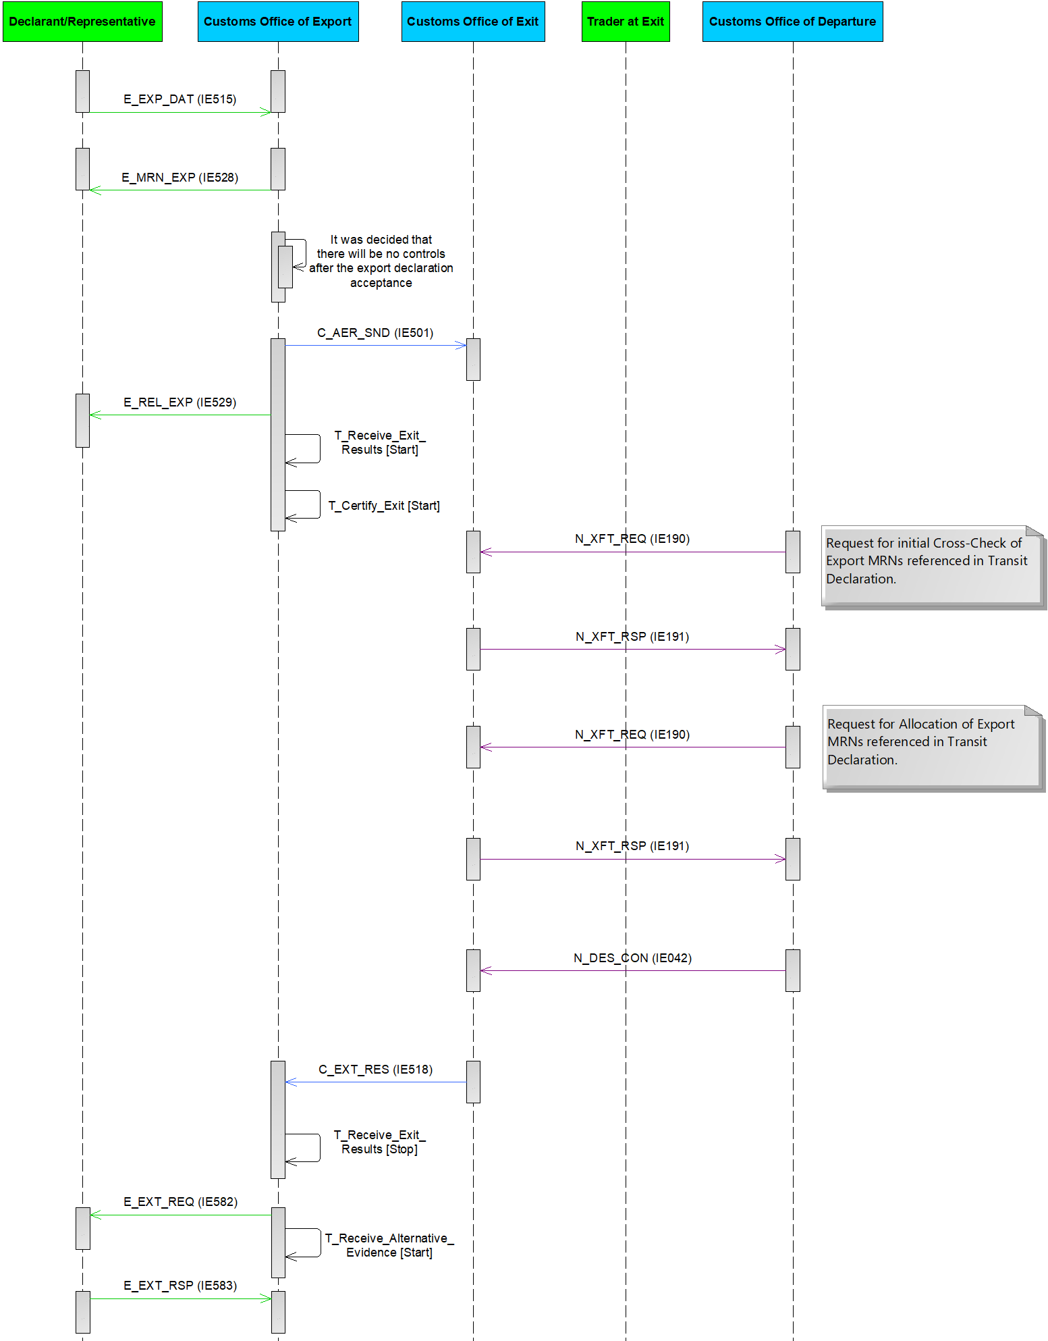

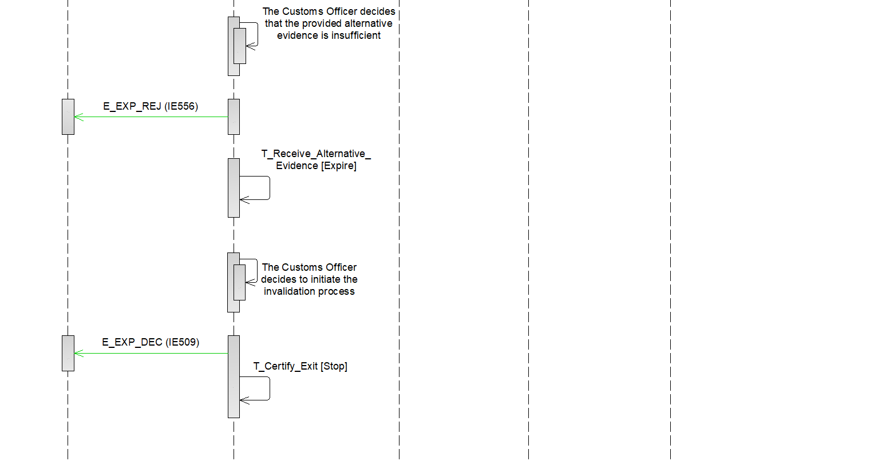

Figure 74: E-EXP-EFT-A-005 Non-appropriate Office of Destination – Invalidation

###### E-EXP-EFT-A-008 Departure notifies Office of Exit of unsatisfactory destination control results - Release for Exit by alternative evidence

This scenario (Figure 75) describes the case that major discrepancies are registered in the ‘Destination Control Results to AES’ N_DES_CON (IE042) message and the export operation is finalised by alternative evidence.

This scenario starts at **[****Step 12****]** of the E-EXP-EFT-M-002 Core Flow of the Export Followed by Transit – Internal Transit. That is, **[**Step 1**]** until [Step 11] are the same as in E-EXP-EFT-M-002 Core Flow of the Export Followed by Transit – Internal Transit. However, this scenario assumes that the NCTS at the Office of Departure registers ‘Destination Control Results to AES’ N_DES_CON (IE042) with major discrepancies **[Step 12].**

**[Step 13]** Upon reception of the ‘Destination Control Results to AES’ N_DES_CON (IE042) message, the Office of Exit will generate and send to the AES at the Office of Export, an instance of the ‘Exit Results’ C_EXT_RES (IE518) for each referenced Export MRN in the N_DES_CON (IE042).

Since major discrepancies are indicated in the ‘Destination Control Results to AES’ N_DES_CON (IE042) message, the AES at the Office of Exit will set the value ‘B3’ in the Control result code of each instance of the ‘Exit Results’ C_EXT_RES (IE518) that is generated. This code will be used to signal a different handling from the case of major discrepancies in the exit control results for both the Customs Office of Exit and the Customs Office of Export. The involved export operations are transited to the final state “Handled Elsewhere” at the Office of Exit and to “Under Exit Confirmation Request” at the Office of Export.

**[Step 14]** The Time Limit to Receive Exit Results (T_Receive_Exit_Results) at the Customs Office of Export stops at this point.

**[Step 15]** AES at the Customs Office of Export requests from the Declarant/Representative for alternative evidence via a ‘Request on Non-Exited Export’ E_EXT_REQ (IE582). In addition, AES at the Customs Office of Export initiates the Time Limit to Receive Alternative Evidence (T_Receive_Alternative_Evidence) **[Step 16]**.

**[Step 17]** The Declarant/Representative replies to the Customs Office of Export with an ‘Information on Non-Exited Export’ E_EXT_RSP (IE583) indicating a confirmation of exit by alternative evidence (Enquiry information code: “Exited-Alternative Evidence”). The Customs Officer at the Customs Office of Export examines the content of the ‘Information on Non-Exited Export’ E_EXT_RSP (IE583) and decides that the provided alternative evidence is sufficient **[Step 18]** and the Time Limit to Receive Alternative Evidence (T_Receive_Alternative_Evidence) stops **[Step 19]**.

**[Step 20]** The movement state at the Customs Office of Export is set toExported, which is a final state and the Time Limit to Certify Exit (T_Certify_Exit) stops at this point**.**

**[Step 21]** Finally, AES at the Customs Office of Export notifies via an ‘Export Notification’ E_EXP_NOT (IE599) message the Declarant/Representative that the movement has successfully.

The remaining steps of E-EXP-EFT-M-002 Core Flow of the Export Followed by Transit – Internal Transit are not applicable in this scenario, since the final step is the [Step 21] above.





Figure : E-EXP-EFT-A-008 Departure notifies Office of Exit of unsatisfactory destination control results - Release for Exit by alternative evidence

###### E-EXP-EFT-A-009 Departure notifies Office of Exit of unsatisfactory destination control results - Invalidation due to lack of or insufficient alternative evidence

This scenario (Figure 76) describes the case that major discrepancies are registered in the ‘Destination Control Results to AES’ N_DES_CON (IE042) message and the export operation is finalised by invalidation due to insufficient alternative evidence.

This scenario starts at **[****Step 12****]** of the E-EXP-EFT-M-002 Core Flow of the Export Followed by Transit – Internal Transit. That is, **[**Step 1**]** until [Step 11] are the same as in E-EXP-EFT-M-002 Core Flow of the Export Followed by Transit – Internal Transit. However, this scenario assumes that the NCTS at the Office of Departure registers ‘Destination Control Results to AES’ N_DES_CON (IE042) with major discrepancies **[Step 12].**

**[Step 13]** Upon reception of the ‘Destination Control Results to AES’ N_DES_CON (IE042) message, the Office of Exit will generate and send to the AES at the Office of Export, an instance of the ‘Exit Results’ C_EXT_RES (IE518) for each referenced Export MRN in the N_DES_CON (IE042).

Since major discrepancies are indicated in the ‘Destination Control Results to AES’ N_DES_CON (IE042) message, the AES at the Office of Exit will set the value ‘B3’ in the Control result code of each instance of the ‘Exit Results’ C_EXT_RES (IE518) that is generated. This code will be used to signal a different handling from the case of major discrepancies in the exit control results for both the Customs Office of Exit and the Customs Office of Export. The involved export operations are transited to the final state “Handled Elsewhere” at the Office of Exit and to “Under Exit Confirmation Request” at the Office of Export.

**[Step 14]** The AES at the Customs Office of Export requests from the Declarant/Representative for alternative evidence via a a ‘Request on Non-Exited Export’ E_EXT_REQ (IE582) message and the Time Limit to Receive Alternative Evidence (T_Receive_Alternative_Evidence) starts at this point **[Step 15]**.

**[Step 16]** The Declarant/Representative replies to the Customs Office of Export with an ‘Information on Non-Exited Export’ E_EXT_RSP (IE583) indicating a confirmation of exit by alternative evidence (Enquiry information code: “Exited-Alternative Evidence”).

**[Step 17]** The Customs Officer at the Office of Export decides that the provided alternative evidence is insufficient. AES at the Customs Office of Export sends a ‘Rejection from Office of Export’ E_EXP_REJ (IE556) to the Declarant/Representative.

Note: At this point, Declarant/Representative may send a new valid ‘Information on Non-Exited Export’ E_EXT_RSP (IE583) to the Customs Office of Export with sufficient Alternative Evidence (before the expiration of Time Limit to Receive Alternative Evidence (T_Receive_Alternative_Evidence)). In this case, the flow continues from **[Step 17]** of E-EXP-EFT-A-005 Departure notifies Office of Exit for non appropriate Office of Destination – Invalidation due to lack of or insufficient alternative evidence.

**[Step 18]** The Time Limit to Receive Alternative Evidence (T_Receive_Alternative_Evidence) expires (with no ‘Information on Non-Exited Export’ E_EXT_RSP (IE583) with sufficient alternative evidence received within the defined time limit) and the Customs Officer at the Customs Office of Export decides to initiate the invalidation process of the Export Declaration **[Step 19]**.

**[Step 20]** The AES at the Office of Export informs the Declarant/Representative about the declaration invalidation via an ‘Export Invalidation Decision’ E_EXP_DEC (IE509) message. The movement state at the Customs Office of Export is set to “Invalidated”. Following the declaration invalidation, all active timers related to the movement are stopped.

Note: The AES at the Office of Export does not inform the AES at the Office of Exit about the invalidation since the export operation (at the Office of Exit) is already in a final state (Handled Elsewhere).

The remaining steps of E-EXP-EFT-M-002 Core Flow of the Export Followed by Transit – Internal Transit are not applicable in this scenario, since the final step is the [Step 20] above.

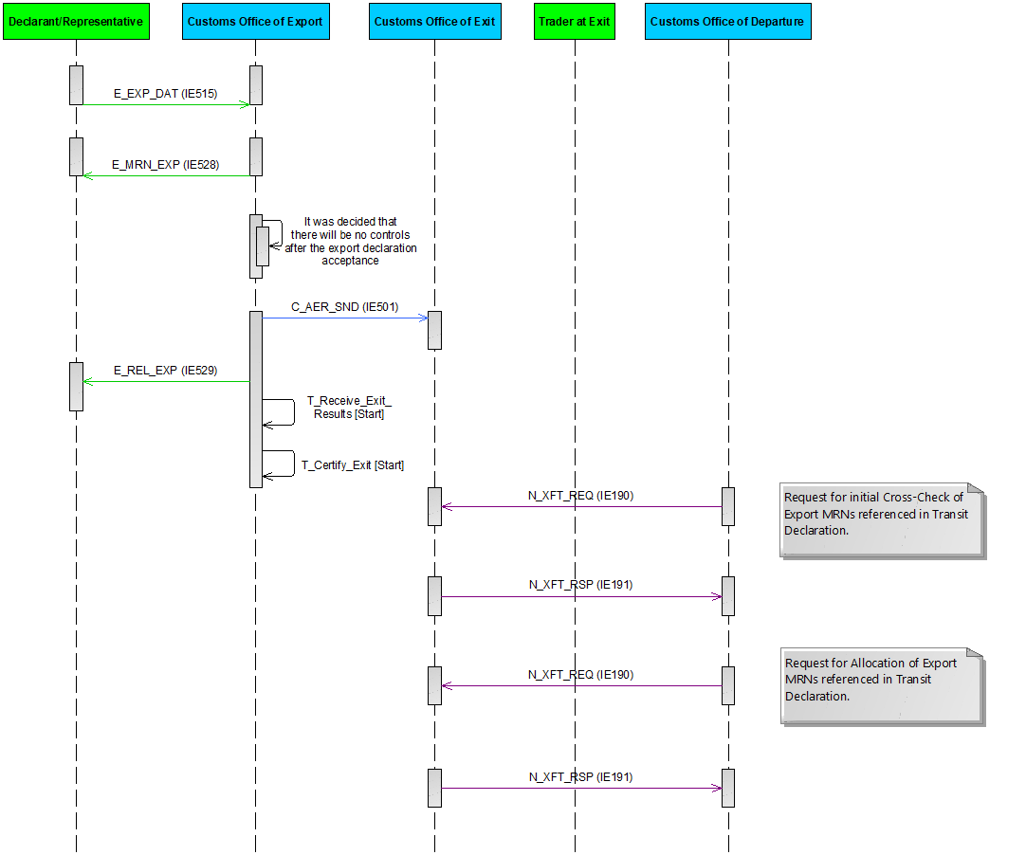

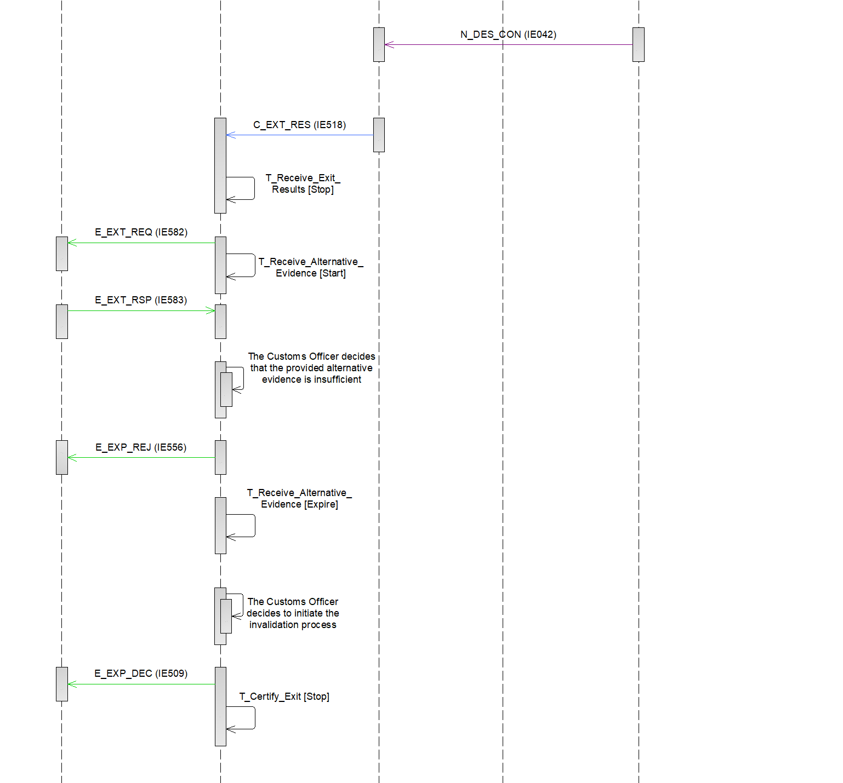

Figure : E-EXP-EFT-A-009 Departure notifies Office of Exit of destination unsatisfactory control results - Invalidation due to lack of or insufficient alternative evidence

##### E-EXP-EFT-A-006 Departure notifies Office of Exit of the initiation of recovery

This scenario describes the case that the recovery is initiated for a transit movement since no ‘Destination control results’ C_DES_CON (IE018) message has been received by the NCTS at the office of Departure from the NCTS at the Office of Destination.

The Competent Authority of Recovery at Departure notifies for the recovery initiation all the involved offices (related to the transit movement). The AES at the Office of Exit receives the message ‘Recovery Communication to AES’ N_REC_COM (IE048).

This scenario starts after **[****Step 11****]** of the E-EXP-EFT-M-002 Core Flow of the Export Followed by Transit – Internal Transit. That is, **[**Step 1**]** until [Step 11] are the same as in E-EXP-EFT-M-002 Core Flow of the Export Followed by Transit – Internal Transit.

**[Step 12]** AES at the Office of Exit receives the ‘Recovery Communication to AES’ N_REC_COM (IE048) message.

**[Step 13]** Upon reception of the ‘Recovery Communication to AES’ N_REC_COM (IE048) message AES generates and sends to the AES at the Office of Export distinct ‘Exit Results’ C_EXT_RES (IE518) per each Export MRN that is referenced in the ‘Recovery Communication to AES’ N_REC_COM (IE048) message. The generated IE518 instance(s) indicate unsatisfactory control results ‘B1’ and therefore the related export operation are transited to the “Goods Not Allowed to Exit” state at the Office of Exit and to the “Export Stopped, Discrepancies at Exit” state at the Office of Export.

The remaining steps of E-EXP-EFT-M-002 Core Flow of the Export Followed by Transit – Internal Transit are not applicable in this scenario, since the final step is the [Step 13] above.

##### Example business scenarios of allocation and amendment of the Export MRNs referenced in the transit Movement

The following section outlines the interface details that take place between AES and NCTS with two (2) short business scenarios. It presents step by step and in tabular format what information is exchanged between NCTS and AES and how it is processed afterwards, so as to illustrate how the allocation and/or the de-allocation between the transit MRN with the Export MRNs occurs during acceptance and amendment of the transit declaration.

###### Scenario A – Initial Cross-Check & Allocation of the Export MRNs with the Transit Declaration

The Holder of the Transit Procedure submits a transit declaration with the ‘Declaration Data’ E_DEC_DAT (IE015) message to the Office of Departure that references three (3) Export MRNs into the Previous Document data group (declaring one (1) Export MRN into the Previous Document data group per House Consignment data group). After all validations of the ‘Declaration Data’ E_DEC_DAT (IE015) message are complete and successful, the dispatch of the ‘Transit Presentation Notification’ N_XFT_REQ (IE190) message from the Office of Departure to the Office of Exit is triggered to validate these Export MRNs.

The information entered in the initial ‘Transit Presentation Notification’ N_XFT_REQ (IE190) message has the following basic association between the MRNs of the Export Movements and the LRN of the transit declaration:

|  |  |
| --- | --- |
| **Transit** | **Export** |
| LRN | MRN1 |
| MRN2 |
| MRN3 |

Upon reception of the ‘Transit Presentation Notification’ N_XFT_REQ (IE190) message, the Export MRNs are validated successfully in AES (OoExt), but nothing is stored in the Office of Exit yet:

|  |  |  |
| --- | --- | --- |
| **Transit** | **Export** | **Assessment of AES per Export MRN** |
| LRN | MRN1 | Valid |
| MRN2 | Valid |
| MRN3 | Valid |

The Office of Exit responds with the ‘Transit Presentation Notification Response’ N_XFT_RSP (IE191) (Positive) message to inform the Office of Departure of the successful validation. In that case, the Transit Declaration can be accepted at the Office of Departure and the ‘MRN Allocated’ E_MRN_ALL (IE028) message is sent to the Holder of the Transit Procedure containing the MRN of the transit movement. Then, the Office of Departure sends again the ‘Transit Presentation Notification’ N_XFT_REQ (IE190) message, but with the transit MRN this time instead of the LRN. The new ‘Transit Presentation Notification’ N_XFT_REQ (IE190) message now contains the allocation request per Export MRN:

|  |  |  |
| --- | --- | --- |
| **Transit** | **Export** | **Request from NCTS** |
| MRN | MRN1 | Allocation request |
| MRN2 | Allocation request |
| MRN3 | Allocation request |

Upon reception of the ‘Transit Presentation Notification’ N_XFT_REQ (IE190) message, the Office of Exit accepts the allocation requests of the Export MRNs with the Transit MRN and the information is now stored at the Office of Exit internally as follows:

|  |  |  |  |
| --- | --- | --- | --- |
| **Transit** | **Export** | **Allocation Status in AES** | **Movement Status in AES** |
| MRN | MRN1 | Allocated | Goods presented for transit |
| MRN2 | Allocated | Goods presented for transit |
| MRN3 | Allocated | Goods presented for transit |

###### Scenario B: Amendment of the Transit Declaration that references Export MRNs

As a continuation of the previous Scenario A, the Holder of the Transit Procedure decides to submit an amendment request for the transit declaration with the ‘Declaration Amendment’ E_DEC_AMD (IE013) message, which is accepted by the Office of Departure. Consequently, the ‘Amendment acceptance’ E_AMD_ACC (IE004) message is sent to the Holder of the Transit Procedure. Due to the amendment of the transit declaration, the Export MRNs are now represented as follows in the transit declaration:

|  |  |
| --- | --- |
| **Transit** | **Export** |
| MRN | MRN1 |
| MRN2 |
| MRN4* |

*The new Export MRN4 entered is depicted in turquoise, but the MRN3 is not depicted since it has been removed following amendment by the Holder of the Transit Procedure.

Since two (2) changes (i.e. addition and deletion) have been performed in the Export MRNs referenced in the transit declaration, the Office of Departure sends the ‘Transit Presentation Notification’ N_XFT_REQ (IE190) message with the above export movement reference numbers: MRN1, MRN2, MRN4.

Upon reception of the ‘Transit Presentation Notification’ N_XFT_REQ (IE190) message, the Office of Exit examines the contents of this message and compares it with the latest allocations table of the Export MRNs with the Transit MRN, which has been the following based on Scenario A above:

|  |  |  |  |
| --- | --- | --- | --- |
| **Transit** | **Export** | **Allocation status in AES** | **Movement Status in AES** |
| MRN | MRN1 | Allocated | Goods presented for Transit |
| MRN2 | Allocated | Goods presented for Transit |
| MRN3 | Allocated | Goods presented for Transit |

Following this change, the Office of Exit performs the following changes in the allocations table:

|  |  |  |  |
| --- | --- | --- | --- |
| **Transit** | **Export** | **Allocation status in AES** | **Movement Status in AES** |
| MRN | MRN1 | Allocated | Goods presented for Transit |
| MRN2 | Allocated | Goods presented for Transit |
| MRN3 | De-allocated | AER Created |
|  | MRN4 | Allocated | Goods presented for Transit |

Accordingly, the Office of Exit returns a ‘Transit Presentation Notification Response’ N_XFT_RSP (IE191) (Positive) message to inform the Office of Departure of the successful validation of the amendment of the Export MRNs referenced in the transit declaration (i.e. MRN1 , MRN2 , MRN4).

It should be noted that no interaction between NCTS and AES takes place after the initial allocation of the Transit MRN in the Office of Exit in case the amendment of the transit declaration has no changes in the Export MRNs.

#### Diversions

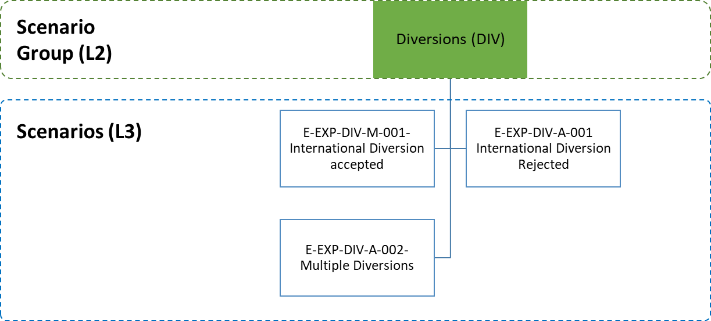

Figure 77: Diversions specific scenarios

Diversions occur when the goods are presented to a Customs Office of Exit different to the “Declared” one. Two types of diversion can take place:

* An International Diversion;
* A National Diversion.

An international diversion occurs when the goods are presented in another country than the country of the Customs Office of Exit (Declared).

A national diversion occurs when the goods are presented in the country of the Customs Office of Exit (Declared) but in another Customs Office than the “Declared” one.

In the case of an international diversion, the Customs Office of Exit (Actual) has no information about the presented goods. In order to be able to proceed with processing the arrived goods, the Customs Office of Exit (Actual) requests the AER from the Customs Office of Export. The Customs Office of Export may accept (III.4.1.9.1) or reject (III.4.1.9.2) the AER request via a positive or negative ‘AER Response’ C_AER_RSP (IE503) respectively.

When a national diversion occurs, the information about the movement is already available in the country (via the AER C_AER_SND (IE501) already sent to the Customs Office of Exit (Declared)). In this case, it is assumed that the Customs Office of Exit (Actual) can retrieve the information nationally and no AER request to the Customs Office of Export is placed (III.4.1.12.3). In case of a national diversion and while the time limit to certify exit has not expired; the Customs Office of Export remains unaware of the diversion having occurred.

In some Member States, the systems for the Customs Office of Export and the Customs Office of Exit are the same, so the information about the movement from the Customs Office of Export (located in another Member State) is available to the Customs Office of Exit by default.

##### E-EXP-DIV-M-001 International Diversion Accepted

Figure 78 displays the scenario in which the movement is presented to a Customs Office of Exit different than the one that has been declared, thus a diversion occurs. The diversion is accepted by the Customs Office of Export.

The flow continues up until **[Step 8]** of the E-EXP-CFL-M-001 Core flow scenario. That is, **[**Step 1**]** until **[**Step 7**]** are the same as in E-EXP-CFL-M-001 Core flow. However, in this scenario, the goods are presented at a Customs Office of Exit (Customs Office of Exit (Actual)) different than the Customs Office of Exit (Declared), which has no information regarding the specific movement **[Step 8].**

**[Step 9]** After the arrival notification has been received (‘Arrival at Exit’ E_ARR_EXT (IE507)), the Customs Office of Exit (Actual) submits a declaration request via a ‘Declaration Request Export’ C_EXP_REQ (IE502) message to the Customs Office of Export and the movement state at the Customs Office of Exit (Actual) is set to “AER Requested”.

**[Step 10]** The Customs Office of Export records the occurred diversion and accepts it by responding with an ‘AER Response’ C_AER_RSP (IE503) containing the export movement declaration data and the movement state at the Customs Office of Export is set to “Diversion Accepted”. Upon receiving the positive ‘AER Response’ C_AER_RSP (IE503), the movement state at the Customs Office of Exit (Actual) is set to “Goods Presented at Exit”. The Customs Office of Exit (Actual) interfaces with the national risk analysis systems of the Member States to request a Risk Analysis.

**[Step 11]** The Customs Office of Export also notifies the Customs Office of Exit (Declared) (the movement state is set to “AER Created”) via a ‘Forward Arrival Advice’ C_ARR_FWD (IE524) that the goods have arrived elsewhere.

**[Step 12]** Upon reception of ‘Forward Arrival Advice’ C_ARR_FWD (IE524), the Customs Office of Exit (Declared) starts the Timer to Receive Arrival at Exit (T_Receive_Arrival_Exit) and the movement state is set to “Arrived Elsewhere”.

**[Step 13]** Following the presentation of goods at the Customs Office of Exit (Actual), the Customs Officer at the Customs Office of Exit (Actual) decides to not perform any control on the goods and to authorise the exit of goods, so the movement state at the Customs Office of Exit (Actual) is set to “Goods Ready to be Released”.

**[Step 14]** AES checks that the Trader at Exit had requested the immediate release of the goods and therefore an ‘Exit Release Notification’ E_EXT_REL (IE525) message is sent to the Trader at Exit informing him/ her of the release, while the movement state at the Customs Office of Exit (Actual) is set to “Goods Released for Immediate Leave”.

**[Step 15]** When the consignment has left the European Union Customs Territory, the Trader at Exit notifies the Customs Office of Exit (Actual) via an ‘Exit Notification’ E_EXT_NOT (IE590) message that the goods have exited and the movement state is set to “Exited”.

**[Step 16]** The Customs Office of Exit (Actual) confirms to the Customs Office of Export via an Exit Results C_EXT_RES (ΙΕ518) message the exit of the consignment, including the exit control results.

**[Step 17]** The Time Limit to Receive Exit Results (T_Receive_Exit_Results) stops at this point.

AES verifies that the exit control results are found positive at the Customs Office of Export.

The movement state at the Customs Office of Export is set to “Exported” and the Time Limit to Certify Exit (T_Certify_Exit) stops at this point **[Step 18]**.

**[Step 19]** Finally, the Customs Office of Export notifies via an ‘Export Notification’ E_EXP_NOT (IE599) message the Declarant/Representative that the movement has successfully exited the European Union Customs Territory providing all the export details.

**[Step 20]** Upon the expiration of the Timer to Receive Arrival at Exit (T_Receive_Arrival_Exit) at the Customs Office of Exit (Declared), the movement state is set to “Handled Elsewhere”, which is a final state.

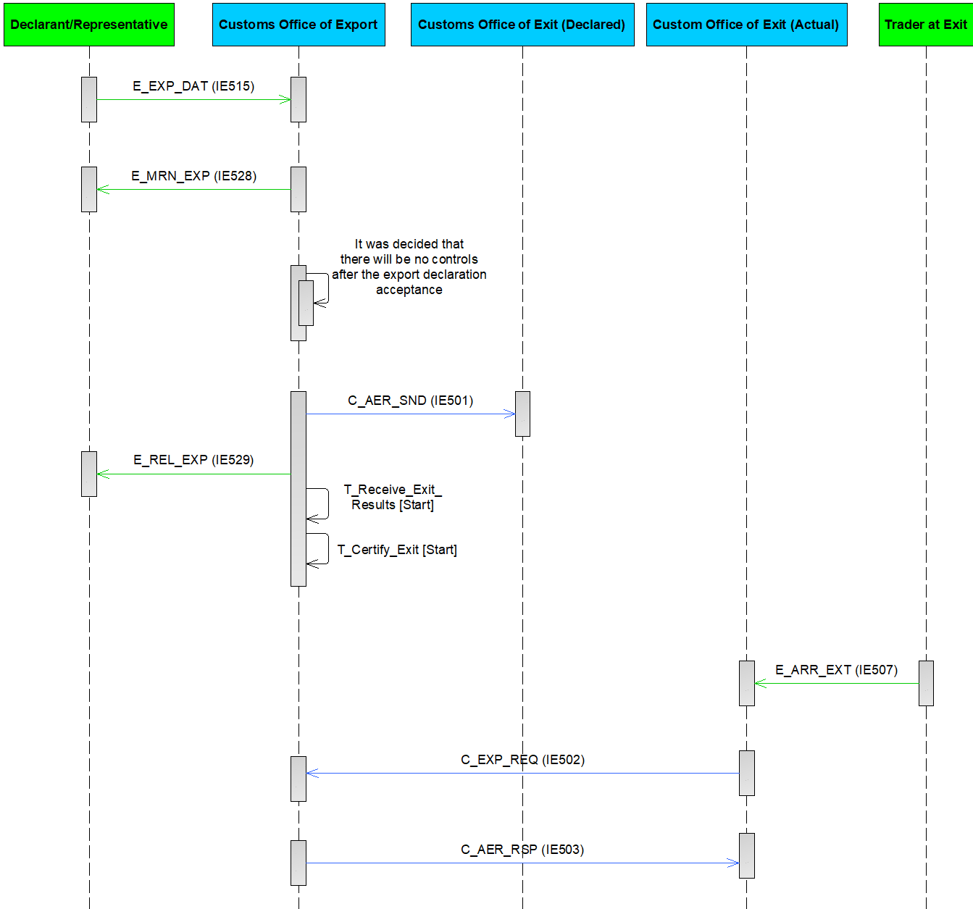

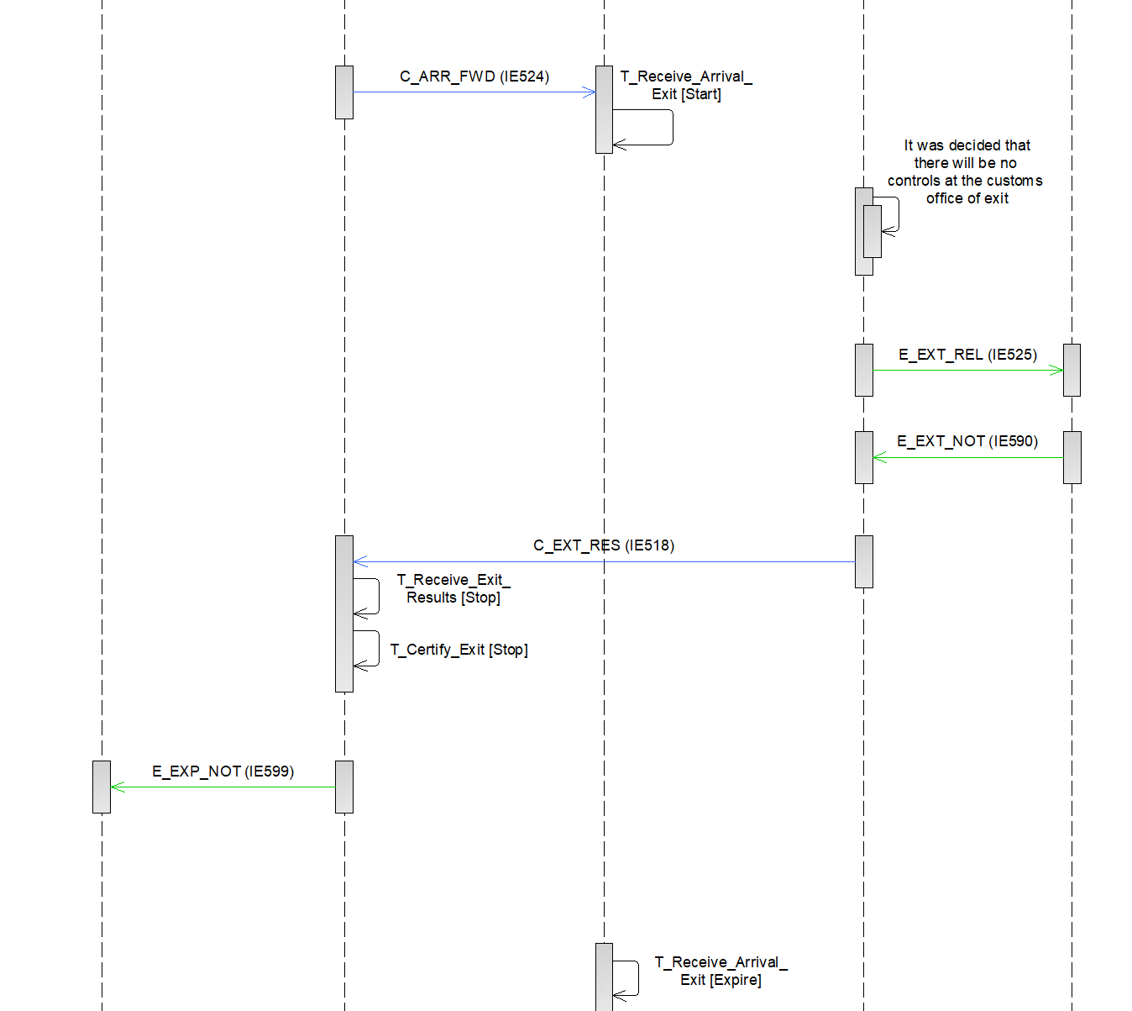

Figure 78: E-EXP-DIV-M-001 International Diversion accepted

##### E-EXP-DIV-A-001 International Diversion Rejected

Figure 79 displays the scenario where a diversion occurs and is rejected by the Customs Office of Export.

The flow continues up until **[Step 8]** of the E-EXP-CFL-M-001 Core flow scenario. That is, **[**Step 1**]** until **[**Step 7**]** are the same as in E-EXP-CFL-M-001 Core flow. However, in this scenario, the goods are presented at a Customs Office of Exit (Actual) different than the Customs Office of Exit (Declared), which has no information regarding the specific movement **[Step 8].**

**[Step 9]** After the arrival notification has been received (‘Arrival at Exit’ E_ARR_EXT (IE507)), the Customs Office of Exit (Actual) submits a declaration request via a ‘Declaration Request Export’ C_EXP_REQ (IE502) message to the Customs Office of Export and the movement state at the Customs Office of Exit (Actual) is set to “AER Requested”.

**[Step 10]** The Customs Office of Export rejects the diversion by submitting a negative ‘AER response’ (IE503) to the Customs Office of Exit (Actual).

**[Step 11]** The Timer to Receive Arrival at Exit (T_Receive_Arrival_Exit) starts at the Customs Office of Exit (Actual) and the movement state is set to “Diversion Rejected”.

**[Step 12]** In sequence, the Customs Office of Exit (Actual) notifies the Trader at Exit about the rejection via a ‘Diversion Rejection Notification’ E_DIV_REJ (IE521) message. The movement state at the Customs Office of Export remains as “Goods Released for Export”.

The scenario might continue with the registration of a new ‘Arrival at Exit’ E_ARR_EXT (IE507) or with the expiration of the Timer to Receive Arrival at Exit (T_Receive_Arrival_Exit). In case of the timer expires, the movement state at the Customs Office of Exit (Actual) will be set to “Handled Elsewhere”, which is a final state.

Note: The Customs Office of Exit (Actual) in the ‘AER Response’ C_AER_RSP (IE503) shall be the one that has sent the ‘Declaration Request Export’ C_EXP_REQ (IE502) and is indicated in this message as the Customs Office of Exit (Actual). This is applicable to both positive and negative ‘AER Response’ C_AER_RSP (IE503).

When the goods were declared as having left the EU and considering that the goods appear in another EU Member State, a manual procedure should be initiated between Country of Export and the “second” Country of Exit, in order to clarify the status of the goods.



Figure 79: E-EXP-DIV-A-001 International Diversion rejected

##### E-EXP-DIV-A-002 Multiple Diversions

Multiple diversions occur, if the export consignment is firstly diverted to several Customs Offices of Exit (in the same MS or in different MSs) and finally diverted back to the Customs Office of Exit (Declared). Due to the consequent diversions, multiple IE502s and IE503s will be exchanged over this consignment.

The flow continues up until **[Step 8]** of the E-EXP-CFL-M-001 Core flow scenario. That is, **[**Step 1**]** until **[**Step 7**]** are the same as in E-EXP-CFL-M-001 Core flow. However, in this scenario (Figure 80: E-EXP-DIV-A-002 Multiple Diversions ), the goods are presented at a Customs Office of Exit (Actual) (Customs Office of Exit 1) different than the Customs Office of Exit (Declared) one, which has no information regarding the specific movement **[Step 8].**

**[Step 9]** After the arrival notification has been received (‘Arrival at Exit’ E_ARR_EXT (IE507)), Customs Office of Exit 1 submits a declaration request via a ‘Declaration Request Export’ C_EXP_REQ (IE502) message to the Customs Office of Export and the movement state at the Customs Office of Exit 1 is set to “AER Requested”.

**[Step 10]** The Customs Office of Export records the occurred diversion and accepts it by responding with an ‘AER Response’ C_AER_RSP (IE503) containing the export movement declaration data while the movement state at the Customs Office of Export is set to “Diversion Accepted”.

**[Step 11]** The Customs Office of Export also notifies the Customs Office of Exit (Declared) via a ‘Forward Arrival Advice’ C_ARR_FWD (IE524) that the goods have arrived elsewhere.

**[Step 12]** Upon reception of ‘Forward Arrival Advice’ C_ARR_FWD (IE524), the Customs Office of Exit (Declared) starts the Timer to Receive Arrival at Exit (T_Receive_Arrival_Exit) and the movement state is set to “Arrived Elsewhere”.

**[Step 13]** At this point, another diversion occurs, and the goods are presented at another (Actual) Customs Office of Exit (Customs Office of Exit 2) different than the previous one and different to the Customs Office of Exit (Declared) one, which has no information regarding the specific movement.

**[Step 14]** After the arrival notification has been received (‘Arrival at Exit’ E_ARR_EXT (IE507)), the new (Actual) Customs Office of Exit 2 submits a declaration request via a ‘Declaration Request Export’ C_EXP_REQ (IE502) message to the Customs Office of Export and the movement state at the Customs Office of Exit 2 is set to “AER Requested”.

**[Step 15]** The Customs Office of Export records the new occurred diversion and accepts it by responding with an ‘AER Response’ C_AER_RSP (IE503) containing the export movement declaration data while the movement state at the Customs Office of Export remains as “Diversion Accepted”.

**[Step 16]** The Customs Office of Export also notifies Customs Office of Exit 1 via a ‘Forward Arrival Advice’ C_ARR_FWD (IE524) that the goods have arrived elsewhere.

**[Step 17]** Upon reception of ‘Forward Arrival Advice’ C_ARR_FWD (IE524), the Customs Office of Exit 1 starts the Timer to Receive Arrival at Exit (T_Receive_Arrival_Exit) and the movement state is set to “Arrived Elsewhere”.

**[Step 18]** At this point the movement is diverted back to the Customs Office of Exit (Declared).

**[Step 19]** After the arrival notification has been received (‘Arrival at Exit’ E_ARR_EXT (IE507)), the Customs Office of Exit (Declared) submits a declaration request via a ‘Declaration Request Export’ C_EXP_REQ (IE502) message to the Customs Office of Export and the movement state at the Customs Office of Exit (Declared) is set to “AER Requested”.

**[Step 20]** The Customs Office of Export records the occurred diversion and accepts it by responding with an ‘AER Response’ C_AER_RSP (IE503) containing the export movement declaration data while and the movement state at the Customs Office of Export remains as “Diversion Accepted”.

**[Step 21]** The Customs Office of Export also notifies Customs Office of Exit 2 via a ‘Forward Arrival Advice’ C_ARR_FWD (IE524) that the goods have arrived elsewhere.

**[Step 22]** Upon reception of ‘Forward Arrival Advice’ C_ARR_FWD (IE524), the Customs Office of Exit 2 starts the Timer to Receive Arrival at Exit (T_Receive_Arrival_Exit) and the movement state is set to “Arrived Elsewhere”.

**[Step 23]** Following the presentation of goods at the Customs Office of Exit (Declared), the Customs Officer at the Customs Office of Exit (Declared) decides to not perform any control on the goods and to authorise the exit of goods, so the movement state at the Customs Office of Exit is set to “Goods Ready to be Released”.

**[Step 24]** The Timer to Receive Arrival at Exit (T_Receive_Arrival_Exit) stops at this point at the Customs Office of Exit (Declared).

**[Step 25]** AES verifies that the Trader at Exit had requested the immediate release of the goods and therefore an ‘Exit Release Notification’ E_EXT_REL (IE525) message is sent to the Trader at Exit informing him/ her of the release, while the movement state at the Customs Office of Exit (Declared) is set to “Goods Released for Immediate Leave”.

**[Step 26]** When the consignment has left the European Union Customs Territory, the Trader at Exit notifies the Customs Office of Exit (Declared) via an ‘Exit Notification’ E_EXT_NOT (IE590) message that the goods have exited and the movement state is set to “Exited”.

**[Step 27]** The Customs Office of Exit (Declared) confirms to the Customs Office of Export via an Exit Results C_EXT_RES (ΙΕ518) message; the exit of the consignment including the exit control results.

**[Step 28]** The Time Limit to Receive Exit Results (T_Receive_Exit_Results) at the Customs Office of Export stops at this point.

AES verifies that the exit control results are found positive at the Customs Office of Export.

The movement state at the Customs Office of Export is set to “Exported” and the Time Limit to Certify Exit (T_Certify_Exit) stops at this point **[Step 29]**.

**[Step 30]** Finally, the Customs Office of Export notifies via an ‘Export Notification’ E_EXP_NOT (IE599) message the Declarant/Representative that the movement has successfully exited the European Union Customs Territory providing all the export details.

**[Steps 31, 32]** The movement state in Customs Office of Exit 1 and Customs Office of Exit 2 is set to “Handled Elsewhere” upon the expiration of the Timer to Receive Arrival at Exit (T_Receive_Arrival_Exit). This is a final state.

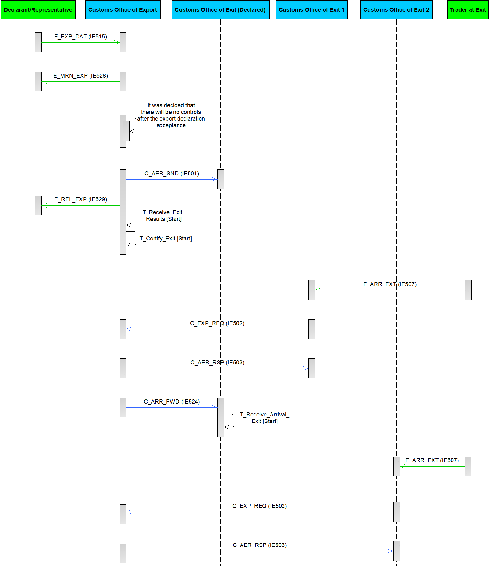

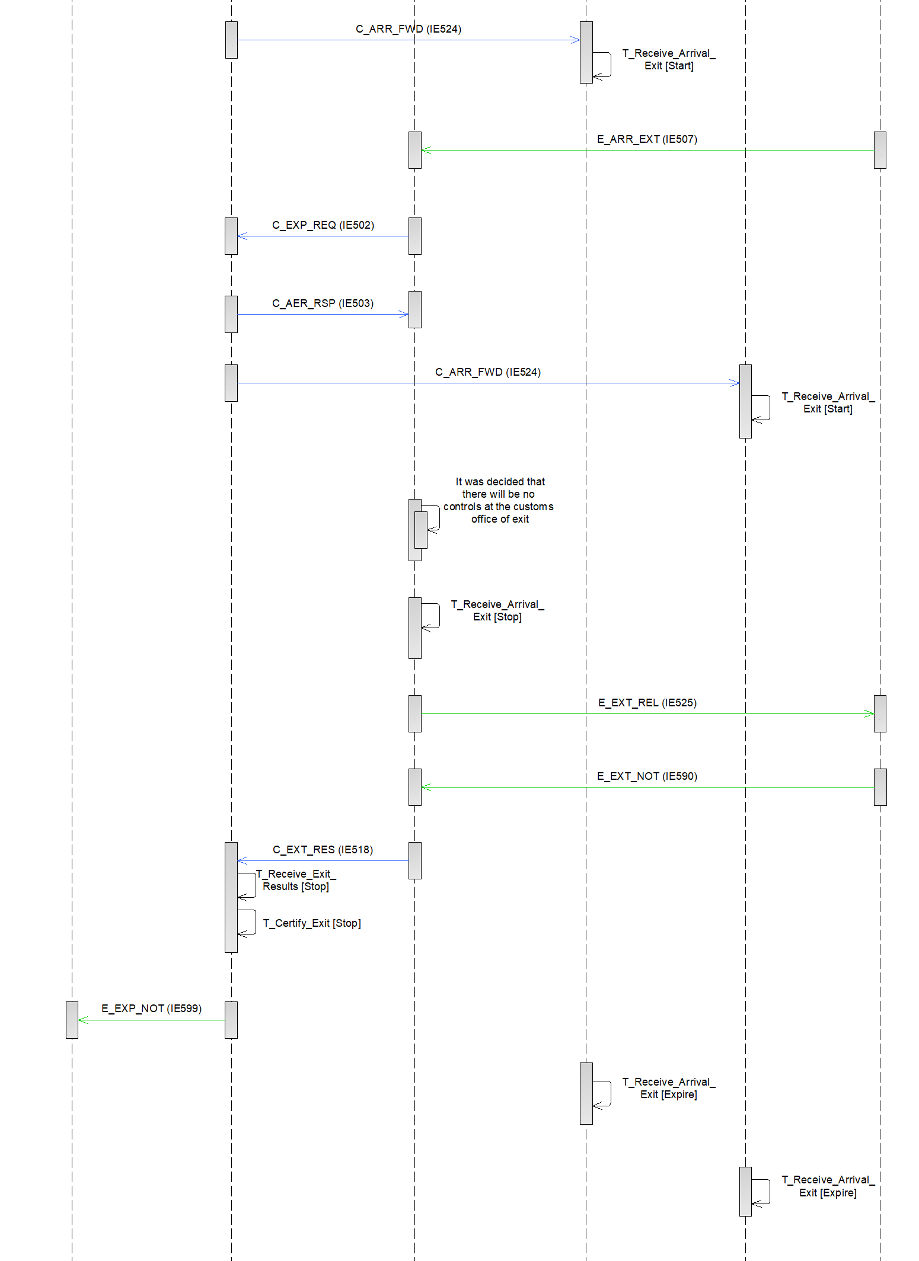

Figure 80: E-EXP-DIV-A-002 Multiple Diversions

#### Query Movement Information

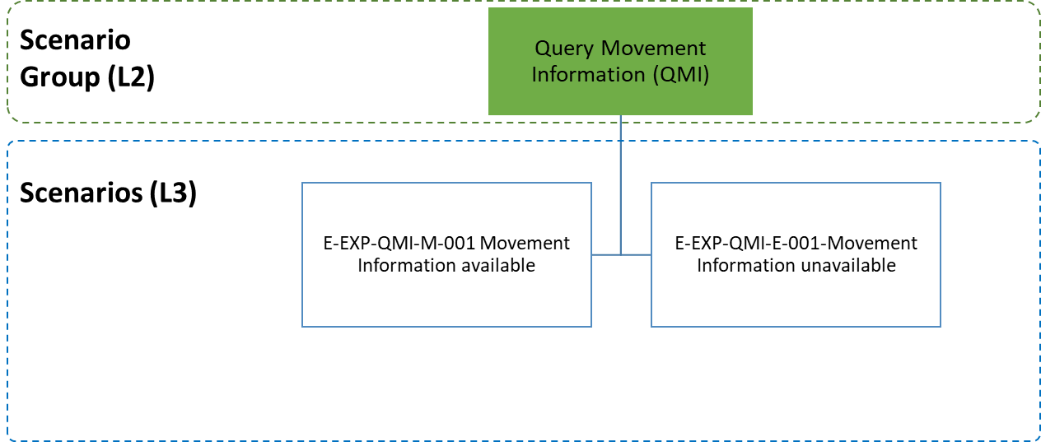

Figure 81: Query Movement Information specific scenarios

##### E-EXP-QMI-M-001 Movement Information available

At any Customs Office and at any moment, an appointed Customs Officer that needs to know the information based on an available MRN, may consult AES for export operation information. The consultation does not have any effect on the state of the movement at any customs office (Figure 82).

**[Step 1]** If the movement information is not available at the Requesting Customs Office, the Requesting Customs Office sends an export query to the Country of Export via an ‘Export Query’ C_EXP_QUE (IE527) message.

**[Step 2]** The Customs Office of Export queries for the movement information and since the information is available, the Customs Office of Export provides the response to the export query to the Requesting Customs Office via a ‘Response To Export Query’ C_EXP_RSP (IE538) message.



Figure 82: E-EXP-QMI-M-001 Movement Information available

##### E-EXP-QMI-E-001 Movement Information unavailable

Apart from the scenario above (III.4.1.10.1), here the information cannot be presented to the Customs Officer due to the rejection of the request (e.g. MRN is unknown at the Customs Office of Export) (Figure 83). The business messages IE538 is designed also for the rejections, thus, it is also used in case of Movement Information unavailability.

**[Step 1]** If the movement information is not available at the Requesting Customs Office, the Requesting Customs Office sends an export query to the Country of Export via an ‘Export Query’ C_EXP_QUE (IE527) message.

**[Step 2]** The Customs Office of Export queries for the movement information and since the information is not available, the Customs Office of Export provides the response to the export query to the Requesting Customs Office via a negative ‘Response To Export Query’ C_EXP_RSP (IE538) message.

.



Figure 83: E-EXP-QMI-E-001 Movement Information unavailable

#### Enquiry Procedure

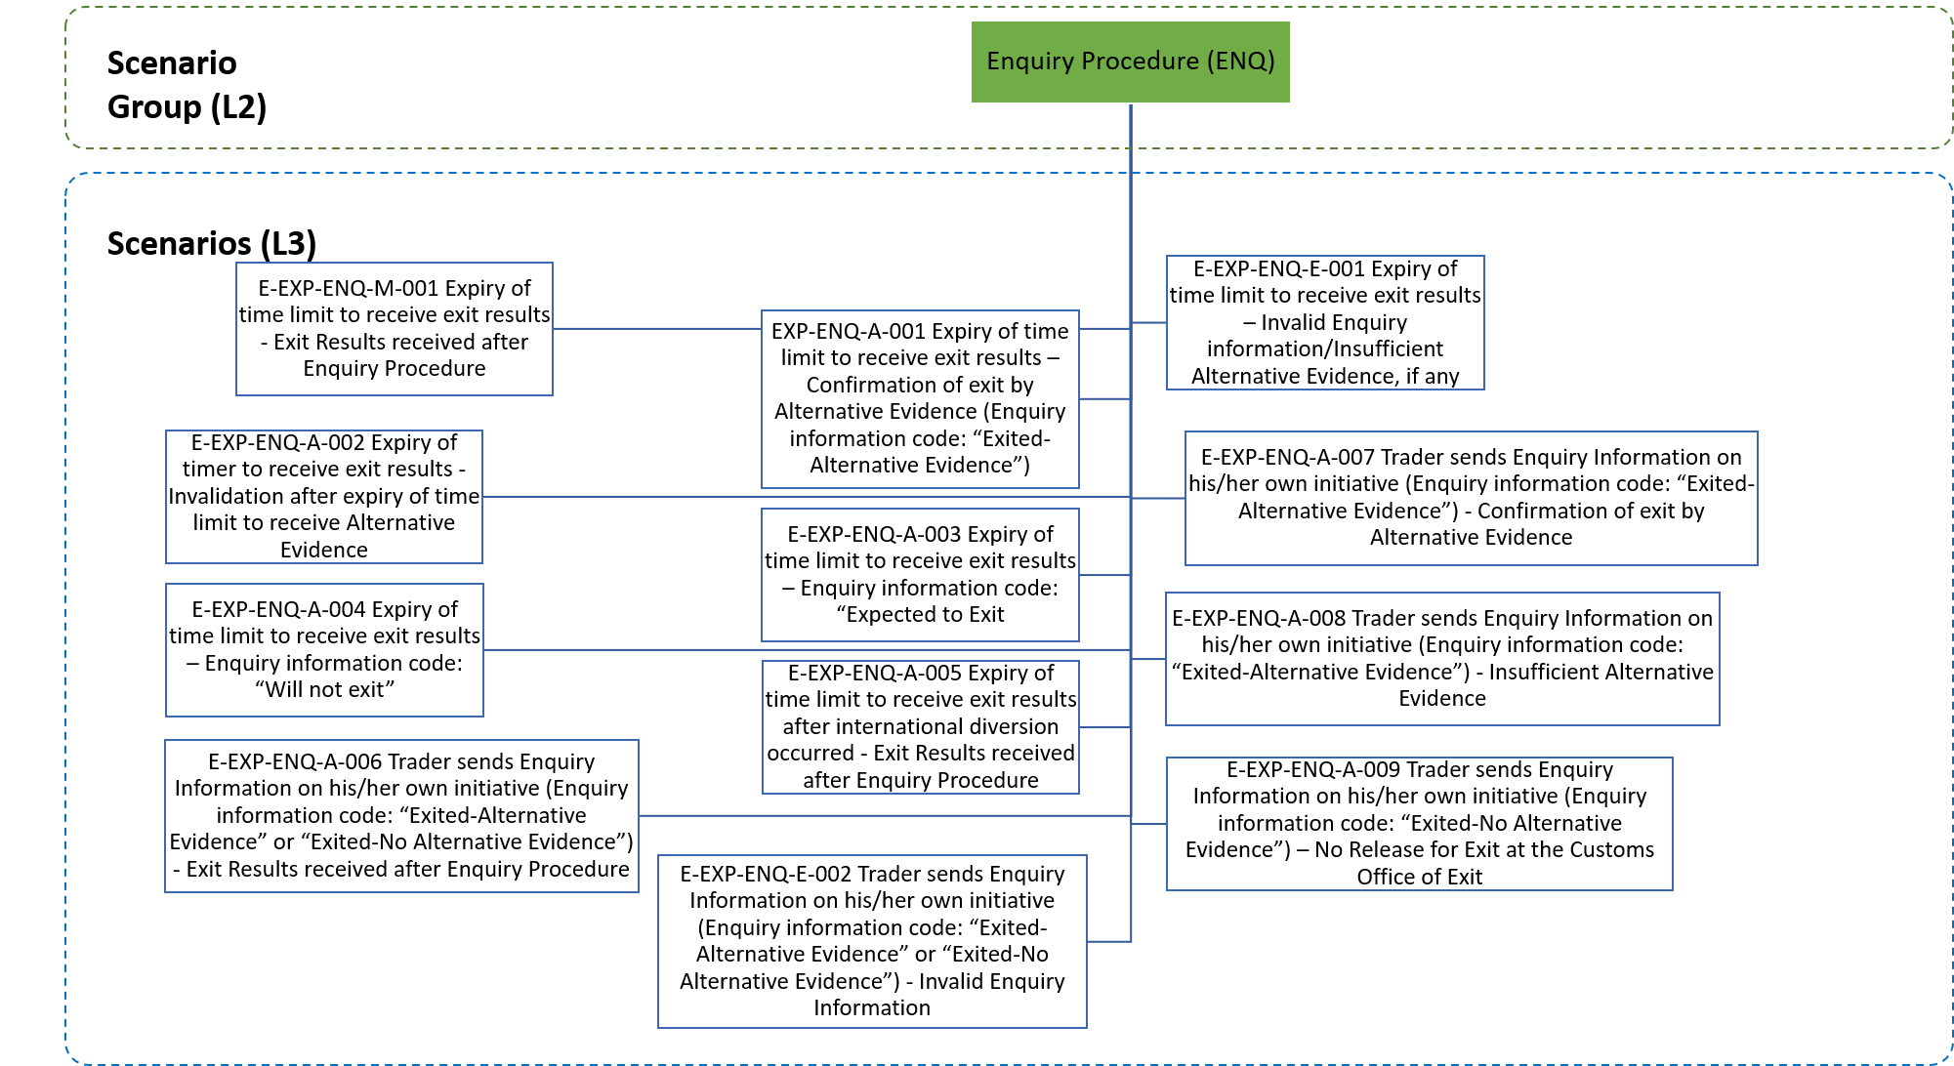

Figure 84: Enquiry Procedure specific scenarios

The current section describes the scenarios concerning the Enquiry Procedure. The scenarios can be categorised in the following major groupings:

* Initiation of the Enquiry Procedure after the expiration of the time limit (T_Receive_Exit_Results) to receive the Exit Results C_EXT_RES (ΙΕ518);
* Initiation of the Enquiry Procedure after the Trader sends Enquiry Information on his/her own initiative.

**Initiation of the Enquiry Procedure after the expiration of the time limit (****T_Receive_Exit_Results****) to receive the Exit Results C_EXT_RES (ΙΕ518):**

In these scenarios, the Customs Office of Export has not been informed of the goods exit within the declared time limit and so it uses the mechanism of the Status request/response (IE594-IE595) in order to identify the status at the Customs Office of Exit and receive the missing Exit Results C_EXT_RES (ΙΕ518) message, if any (see E-EXP-ENQ-M-001 Expiry of time limit to receive exit results - Exit Results received after Enquiry Procedure). It is also possible to receive the Exit results after international diversion occurred (see E-EXP-ENQ-A-005 Expiry of time limit to receive exit results after international diversion occurred - Exit Results received after Enquiry Procedure).

In the case that the ‘Status Response’ C_STD_RSP (IE595) indicates that there are no Exit Results at the Customs Office of Exit (i.e. the state at the Customs Office of Exit is other than “Exited” or “Goods Not Allowed to Exit”), then the Customs Office of Export requests from the Declarant/Representative information regarding the goods exit (via the a ‘Request on Non-Exited Export’ E_EXT_REQ (IE582)). Then, the following may happen:

1. The Trader (Declarant/Representative) replies with ‘Information on Non-Exited Export’ E_EXT_RSP (IE583) indicating Confirmation of exit by Alternative Evidence (Enquiry information code: “Exited-Alternative Evidence”) which is considered sufficient by the Customs Officer at the Customs Office of Export (see E-EXP-ENQ-A-001 Expiry of time limit to receive exit results – Confirmation of exit by Alternative Evidence (Enquiry information code: “Exited-Alternative Evidence”); OR
2. The Trader replies with ‘Information on Non-Exited Export’ E_EXT_RSP (IE583) which either is found invalid or it contains alternative evidence, if any, which is considered insufficient by the Customs Officer at the Customs Office of Export (see E-EXP-ENQ-E-001 Expiry of time limit to receive exit results – Invalid Enquiry information/Insufficient Alternative Evidence, if any; OR
3. The time limit to receive Alternative Evidence expires without any response from the Trader, hence the Customs Officer at the Customs Office of Export may decide to proceed with the Invalidation Process (see E-EXP-ENQ-A-002 Expiry of timer to receive exit results - Invalidation after expiry of time limit to receive Alternative Evidence);
4. The Trader replies with ‘Information on Non-Exited Export’ E_EXT_RSP (IE583) (Enquiry information code: “Expected to Exit”), see E-EXP-ENQ-A-003 Expiry of time limit to receive exit results – Enquiry information code: “Expected to Exit”;
5. The Trader replies with ‘Information on Non-Exited Export’ E_EXT_RSP (IE583) (Enquiry information code: “Will not Exit”), see E-EXP-ENQ-A-004 Expiry of time limit to receive exit results – Enquiry information code: “Will not exit”.

**Initiation of the Enquiry Procedure after the Trader sends Enquiry Information on his/her own initiative:**

In other terms, the Declarant/Representative may on his own initiative send Enquiry Information (‘Information on Non-Exited Export’ E_EXT_RSP (IE583) with Enquiry information code “Exited-Alternative Evidence” or “Exited-No Alternative Evidence”) to the Customs Office of Export for communicating the exit of goods. Following this, the Customs Office of Export uses the mechanism of the Status request/response (IE594-IE595) in order to identify the status at the Customs Office of Exit and receive the missing Exit Results C_EXT_RES (ΙΕ518) message, if any. Then, the following may happen:

1. Exit results are received after Enquiry Procedure (see E-EXP-ENQ-A-006 Trader sends Enquiry Information on his/her own initiative (Enquiry information code: “Exited-Alternative Evidence” or “Exited-No Alternative Evidence”) - Exit Results received after Enquiry Procedure);
2. Goods exit is certified with alternative evidence already provided by the Declarant/Representative (see E-EXP-ENQ-A-007 Trader sends Enquiry Information on his/her own initiative (Enquiry information code: “Exited-Alternative Evidence”) - Confirmation of exit by Alternative Evidence);
3. Insufficient alternative evidence is provided by the Declarant/Representative (see E-EXP-ENQ-A-008 Trader sends Enquiry Information on his/her own initiative (Enquiry information code: “Exited-Alternative Evidence”) - Insufficient Alternative Evidence);
4. No alternative evidence provided by the Declarant/Representative and no Exit Results are available at the Customs Office of Exit (i.e. the state at the Customs Office of Exit is other than “Exited” or “Goods Not Allowed to Exit”) see E-EXP-ENQ-A-009 Trader sends Enquiry Information on his/her own initiative (Enquiry information code: “Exited-No Alternative Evidence”) – No Release for Exit at the Customs Office of Exit;
5. Enquiry Information from the Declarant/Received is found invalid at the Customs office of Export (see E-EXP-ENQ-E-002 Trader sends Enquiry Information on his/her own initiative (Enquiry information code: “Exited-Alternative Evidence” or “Exited-No Alternative Evidence”) - Invalid Enquiry Information).

|  |
| --- |
| ! It shall be highlighted that:   * The mechanism of the Status request/response can be triggered also before the expiration of the time limit to receive the Exit Results (T_Receive_Exit_Results), as described in E-EXP-EMS-M-001 Status request/response; * In case the ‘Status Response’ C_STD_RSP (IE595) indicates that the state at the Customs Office of Exit is either “Exited” or “Goods not Allowed to Exit” but no ‘Exit Results’ C_EXT_RES (IE518) is received, then a communication with the Helpdesk should take place (outside the system), in order to retrieve the missing ‘Exit Results’ C_EXT_RES (IE518); * The ‘Status Response’ C_STD_RSP (IE595) shall include the latest information including the case of national diversion. Even though the ‘Status Request’ C_STD_REQ (IE594) is sent to the Customs Office of Exit that received the AER C_AER_SND (IE501) or the latest ‘AER Response’ C_AER_RSP (IE503) positive (in case of international diversion) from Customs Office of Export, the received National application shall respond with the latest information available nationally. This means that if national diversion has occurred, the ‘Status Response’ C_STD_RSP (IE595) shall include the latest Customs Office of Exit handling the export operation (following national diversions) and the latest status of the export operation at that office. |

##### E-EXP-ENQ-M-001 Expiry of time limit to receive exit results - Exit Results received after Enquiry Procedure

Figure 85 shows the flow of information when the time limit for the Customs Office of Export to receive exit results from the Customs Office of Exit expires and the ‘Exit Results’ C_EXT_RES (ΙΕ518) have not been received. According to this scenario, the Customs Office of Export receives the missing Exit Results C_EXT_RES (ΙΕ518) from the Customs Office of Exit, by using the mechanism of the Status request/response (IE594-IE595).

The current scenario starts identically to E-EXP-CFL-M-001 Core flow up to the [Step 7]. That is, [Step 1] until [Step 7]are the same as in E-EXP-CFL-M-001 Core flow.

**[Step 8]** The Time Limit to Receive Exit Results (T_Receive_Exit_Results) expires at the Customs Office of Export without any Exit Results being received.

**[Step 9]** The Customs Officer at the Customs Office of Export decides to start the Enquiry Procedure.

**[Step 10]** AES at the Customs Office of Export automatically requests the status for the export operation from the AES at the Customs Office of Exit by means of a ‘Status Request’ C_STD_REQ (IE594).

**[Step 11]** After receiving the ‘Status Request’ C_STD_REQ (IE594), AES at the Customs Office of Exit automatically replies to AES at the Customs Office of Export by sending a ‘Status Response’ C_STD_RSP (IE595) that contains the MRN and the movement state.

**[Step 12]** AES at the Customs Office of Exit identifies that there are Exit Results at the Customs Office of Exit (i.e. the state of the movement at the Customs Office of Exit is either “Exited” or “Goods Not Allowed to Exit”). Thus, AES at the Customs Office of Exit automatically sends the Exit Results to AES the Customs Office of Export with an ‘Exit Results’ C_EXT_RES (ΙΕ518) message (indicating positive/negative control results).

**[Step 13]** After receiving the ‘Exit Results’ C_EXT_RES (ΙΕ518) message (indicating positive/negative control results), AES at the Customs Office of Export sets the state of the movement either to “Exported” (in case of positive results) or to “Export Stopped, Discrepancies at Exit” (in case of negative results) which are both final states. In addition, AES at the Customs Office of Export stops the Time Limit to Certify Exit (T_Certify_Exit) timer.

**[Step 14]** Finally, AES at the Customs Office of Export sends to the Declarant/Representative an ‘Export Notification’ E_EXP_NOT (IE599), in order to notify him/her about the exit or the non-exit of the goods. This is the final step of the current scenario.



Figure 85: E-EXP-ENQ-M-001

##### E-EXP-ENQ-A-001 Expiry of time limit to receive exit results – Confirmation of exit by Alternative Evidence (Enquiry information code: “Exited-Alternative Evidence”)

Figure 86 shows the flow of information when the time limit for the Customs Office of Export to receive exit results from the Customs Office of Exit expires and the ‘Exit Results’ C_EXT_RES (ΙΕ518) have not been received. According to this scenario, the mechanism of the Status request/response (IE594-IE595) reveals that there are no Exit Results at the Customs Office of Exit, hence the Customs Office of Export requests from the Trader (Declarant/Representative) information regarding the non-exited export operation (via a ‘Request on Non-Exited Export’ E_EXT_REQ (IE582)). The Trader replies with ‘Information on Non-Exited Export’ E_EXT_RSP (IE583) indicating a confirmation of exit by alternative evidence (Enquiry information code: “Exited-Alternative Evidence”). In this scenario, the Customs Officer at the Customs Office of Export decides that the provided alternative evidence is sufficient, hence the exit of the goods is certified based on the alternative evidence.

The current scenario starts identically to E-EXP-ENQ-M-001 Expiry of time limit to receive exit results - Exit Results received after Enquiry Procedure up to the [Step 11]. That is, **[**Step 1**]** until [Step 11] are the same as in E-EXP-ENQ-M-001 Expiry of time limit to receive exit results - Exit Results received after Enquiry Procedure.

**[Step 12]** After receiving the ‘Status Response’ C_STD_RSP (IE595) from the Customs office of Exit, AES at the Customs Office of Export identifies that there are no Exit Results at the Customs Office of Exit (i.e. the state of movement at the Customs Office of Exit is other than “Exited” or “Goods Not Allowed to Exit”). Therefore, AES at the Customs Office of Export requests from the Declarant/Representative information regarding the whereabouts of the export operation, for which no exit confirmation has been received, via a ‘Request on Non-Exited Export’ E_EXT_REQ (IE582).

**[Step 13]** AES at the Customs Office of Export initiates the Time Limit to Receive Alternative Evidence (T_Receive_Alternative_Evidence) timer to expire at the time limit for receiving the response from the Declarant/Representative about the non-exited export operation[47].

**[Step 14]** The Trader (Declarant/Representative) replies with ‘Information on Non-Exited Export’ E_EXT_RSP (IE583) indicating a confirmation of exit by alternative evidence (Enquiry information code: “Exited-Alternative Evidence”).

**[Step 15]** AES at the Customs Office of Export receives the ‘Information on Non-Exited Export’ E_EXT_RSP (IE583) from the Declarant/Representative with Enquiry information code equal to “Exited-Alternative Evidence”. Then, the Customs Officer examines the content of the ‘Information on Non-Exited Export’ E_EXT_RSP (IE583) and decides that the provided alternative evidence is sufficient.

**[Step 16]** AES at the Customs Office of Export sets the state of the movement at the Customs Office of Export to “Exported” and also stops the Time Limit to Receive Alternative Evidence (T_Receive_Alternative_Evidence) timer.

**[Step 17]** Following, AES The Customs Office of Export notifies the Declarant/Representative via an ‘Export Notification’ E_EXP_NOT (IE599) message that the movement has successfully exited the European Union Customs Territory providing all the export details.

**[Step 18]** In parallel AES at the Customs Office of Export informs the Customs Office of Exit that the exit of the goods has been certified based on the alternative evidence via a ‘Certification of Exit on Alternative Evidence Notification’ C_ALT_EVD (IE588). The state of movement at the Customs Office of Exit is set to “Exited”.

**[Step 19]** Finally, AES at the Customs Office of Export stops the Time Limit to Certify Exit (T_Certify_Exit). This is the final step of the current scenario.



Figure 86: E-EXP-ENQ-A-001 Expiry of time limit to receive exit results – Confirmation of exit by Alternative Evidence (Enquiry information code: “Exited-Alternative Evidence”)

##### E-EXP-ENQ-E-001 Expiry of time limit to receive exit results – Invalid Enquiry information/Insufficient Alternative Evidence, if any

Figure 87 shows the flow of information when the time limit for the Customs Office of Export to receive exit results from the Customs Office of Exit expires and the ‘Exit Results’ C_EXT_RES (ΙΕ518) have not been received. In the present scenario, the mechanism of the Status request/response (IE594-IE595) reveals that there are no Exit Results at the Customs Office of Exit, hence the Customs Office of Export requests from the Trader (Declarant/Representative) information regarding the non-exited export operation (via a ‘Request on Non-Exited Export’ E_EXT_REQ (IE582)). The Trader replies with ‘Information on Non-Exited Export’ E_EXT_RSP (IE583) having the Enquiry information code equal to “Exited-Alternative Evidence” or “Expected to exit” or “Will not exit”. According to this scenario, the ‘Information on Non-Exited Export’ E_EXT_RSP (IE583) is found invalid or the Customs Officer at the Customs Office of Export decides that the provided alternative evidence, if any, is not sufficient.

The current scenario starts identically to E-EXP-ENQ-M-001 Expiry of time limit to receive exit results - Exit Results received after Enquiry Procedure up to the [Step 11]. That is, [Step 1] until [Step 11] are the same as in E-EXP-ENQ-M-001 Expiry of time limit to receive exit results - Exit Results received after Enquiry Procedure.

**[Step 12]** After receiving the ‘Status Response’ C_STD_RSP (IE595) from the Customs office of Exit, AES at the Customs Office of Export identifies that there are no Exit Results at the Customs Office of Exit (i.e. the state of movement at the Customs Office of Exit is other than “Exited” or “Goods Not Allowed to Exit”). Therefore, AES at the Customs Office of Export requests from the Declarant/Representative information regarding the whereabouts of the export operation, for which no exit confirmation has been received, via a ‘Request on Non-Exited Export’ E_EXT_REQ (IE582).

**[Step 13]** AES at the Customs Office of Export initiates the Time Limit to Receive Alternative Evidence (T_Receive_Alternative_Evidence) timer to expire at the time limit for receiving the response from the Declarant/Representative about the non-exited export operation.

**[Step 14]** The Trader (Declarant/Representative) replies with ‘Information on Non-Exited Export’ E_EXT_RSP (IE583) having the Enquiry information code equal to “Exited-Alternative Evidence” or “Expected to exit” or “Will not exit”.

**[Step 15]** According to this scenario, either the received ‘Information on Non-Exited Export’ E_EXT_RSP (IE583) is found invalid at the Customs Office of Export or the Customs Officer at the Customs Office of Export decides that the provided alternative evidence (which can be provided only when the Enquiry information code is equal to “Exited-Alternative Evidence”) is not sufficient. The state of the movement at the Customs Office of Export remains as is.

**[Step 16]** AES at the Customs Office of Export sends a ‘Rejection from Office of Export’ E_EXP_REJ (IE556) to the Declarant/Representative.

Then, the flow may continue as follows:

* The Customs Office of Export receives a new valid ‘Information on Non-Exited Export’ E_EXT_RSP (IE583) from the Declarant/Representative with Enquiry information code either equal to “Expected to exit” (in which case the flow continues from [Step 14] of E-EXP-ENQ-A-003 Expiry of time limit to receive exit results – Enquiry information code: “Expected to Exit”) or equal to “Will not exit” (in which case the flow continues from [Step 14] of E-EXP-ENQ-A-004 Expiry of time limit to receive exit results – Enquiry information code: “Will not exit”); OR
* The Customs Office of Export receives a new valid ‘Information on Non-Exited Export’ E_EXT_RSP (IE583) from the Declarant/Representative with Enquiry information code equal to “Exited-Alternative Evidence” and sufficient alternative evidence (in which case the flow continues from [Step 15] of the E-EXP-ENQ-A-001 Expiry of time limit to receive exit results – Confirmation of exit by Alternative Evidence (Enquiry information code: “Exited-Alternative Evidence”)); OR
* The Customs Office of Export receives the ‘Exit Results’ C_EXT_RES (ΙΕ518) from the Customs Office of Exit, before the expiration of the Time Limit to Receive Alternative Evidence (T_Receive_Alternative_Evidence) timer (in which case the flow continues from [Step 13] of the E-EXP-ENQ-M-001 Expiry of time limit to receive exit results - Exit Results received after Enquiry Procedure); OR
* The Time Limit to Receive Alternative Evidence (T_Receive_Alternative_Evidence) timer expires, in which case the Customs Officer at the Customs Office of Export may decide to initiate the invalidation process and the flow continues from [Step 15] of E-EXP-ENQ-A-002 Expiry of timer to receive exit results - Invalidation after expiry of time limit to receive Alternative Evidence.



Figure 87: E-EXP-ENQ-E-001 Expiry of time limit to receive exit results – Invalid Enquiry information/Insufficient Alternative Evidence, if any

##### E-EXP-ENQ-A-002 Expiry of timer to receive exit results - Invalidation after expiry of time limit to receive Alternative Evidence

Figure 88 shows the flow of information when the time limit for the Customs Office of Export to receive exit results from the Customs Office of Exit expires and the ‘Exit Results’ C_EXT_RES (ΙΕ518) have not been received. In the current scenario, the mechanism of the Status request/response (IE594-IE595) reveals that there are no Exit Results at the Customs Office of Exit, hence the Customs Office of Export requests from the Trader (Declarant/Representative) information regarding the non-exited export operation (via a ‘Request on Non-Exited Export’ E_EXT_REQ (IE582)). According to this scenario, the Time Limit to Receive Alternative Evidence (T_Receive_Alternative_Evidence) timer expires before the Declarant/Representative has sent an ‘Information on Non-Exited Export’ E_EXT_RSP (IE583). In this case, the Customs Officer at the Customs Office of Export may decide to initiate the invalidation process[48].

The current scenario starts identically to E-EXP-ENQ-M-001 Expiry of time limit to receive exit results - Exit Results received after Enquiry Procedure up to the [Step 11]. That is, **[**Step 1**]** until [Step 11] are the same as in E-EXP-ENQ-M-001 Expiry of time limit to receive exit results - Exit Results received after Enquiry Procedure.

**[Step 12]** After receiving the ‘Status Response’ C_STD_RSP (IE595) from the Customs office of Exit, AES at the Customs Office of Export identifies that there are no Exit Results at the Customs Office of Exit (i.e. the state of movement at the Customs Office of Exit is other than “Exited” or “Goods Not Allowed to Exit”). Therefore, AES at the Customs Office of Export requests from the Declarant/Representative information regarding the whereabouts of the export operation, for which no exit confirmation has been received, via a ‘Request on Non-Exited Export’ E_EXT_REQ (IE582).

**[Step 13]** AES at the Customs Office of Export initiates the Time Limit to Receive Alternative Evidence (T_Receive_Alternative_Evidence) timer to expire at the time limit for receiving the response from the Declarant/Representative about the non-exited export operation.

**[Step 14]** The Time Limit to Receive Alternative Evidence (T_Receive_Alternative_Evidence) timer expires before the Declarant/Representative has sent an ‘Information on Non-Exited Export’ E_EXT_RSP (IE583). At this point, it is strongly recommended to use the Status request/response mechanism (E-EXP-EMS-M-001 Status request/response) before the decision on declaration invalidation.

**[Step 15]** The Customs Officer at the Customs Office of Export decides to initiate the invalidation process.

**[Step 16]** AES atthe Customs Office of Export sends to AES the Customs Office of Exit an ‘Export Invalidation Notification’ C_INV_EXP (IE510) message.

**[Step 17]** AES at the Customs Office of Exit replies positively to the invalidation notification via an ‘Invalidation Acknowledgement’ C_INV_ACK (IE591).27

**[Step 18]** AES at the Customs Office of Export informs the Declarant/Representative about the declaration invalidation via an ‘Export Invalidation Decision’ E_EXP_DEC (IE509) message.

**[Step 19]** AES at the Customs Office of Export sets the state of the movement at the Customs Office of Export to “Invalidated” and stops the Time Limit to Certify Exit (T_Certify_Exit). This is a final state and the flow ends here.



Figure 88: E-EXP-ENQ-A-002 Expiry of timer to receive exit results - Invalidation after expiry of time limit to receive Alternative Evidence

##### E-EXP-ENQ-A-003 Expiry of time limit to receive exit results – Enquiry information code: “Expected to Exit”

Figure 89 shows the flow of information when the time limit for the Customs Office of Export to receive exit results from the Customs Office of Exit expires and the ‘Exit Results’ C_EXT_RES (ΙΕ518) have not been received. According to this scenario, the mechanism of the Status request/response (IE594-IE595) reveals that there are no Exit Results at the Customs Office of Exit, hence the Customs Office of Export requests from the Trader (Declarant/Representative) information regarding the non-exited export operation (via a ‘Request on Non-Exited Export’ E_EXT_REQ (IE582)). The Trader replies with ‘Information on Non-Exited Export’ E_EXT_RSP (IE583) indicating that the goods are expected to exit the European Union Customs Territory on a future date (Enquiry information code equal to “Expected to exit”).

The current scenario starts identically to E-EXP-ENQ-M-001 Expiry of time limit to receive exit results - Exit Results received after Enquiry Procedure up to the [Step 11]. That is, **[**Step 1**]** until [Step 11] are the same as in E-EXP-ENQ-M-001 Expiry of time limit to receive exit results - Exit Results received after Enquiry Procedure.

**[Step 12]** After receiving the ‘Status Response’ C_STD_RSP (IE595) from the Customs office of Exit, AES at the Customs Office of Export identifies that there are no Exit Results at the Customs Office of Exit (i.e. the state of movement at the Customs Office of Exit is other than “Exited” or “Goods Not Allowed to Exit”). Therefore, AES at the Customs Office of Export requests from the Declarant/Representative information regarding the whereabouts of the export operation, for which no exit confirmation has been received, via a ‘Request on Non-Exited Export’ E_EXT_REQ (IE582).

**[Step 13]** AES at the Customs Office of Export initiates the Time Limit to Receive Alternative Evidence (T_Receive_Alternative_Evidence) timer to expire at the time limit for receiving the response from the Declarant/Representative about the non-exited export operation.

**[Step 14]** The Trader (Declarant/Representative) replies with ‘Information on Non-Exited Export’ E_EXT_RSP (IE583) indicating that the goods are expected to exit the European Union Customs Territory on a future date (Enquiry information code equal to “Expected to exit”).

AES at the Customs Office of Export receives the ‘Information on Non-Exited Export’ E_EXT_RSP (IE583) with Enquiry information code equal to “Expected to exit” and the flow may continue as follows:

* The Customs Office of Export receives the ‘Exit Results’ C_EXT_RES (ΙΕ518) from the Customs Office of Exit, before the expiration of the Time Limit to Receive Alternative Evidence (T_Receive_Alternative_Evidence) timer (in which case the flow continues from [Step 13] of the E-EXP-ENQ-M-001 Expiry of time limit to receive exit results - Exit Results received after Enquiry Procedure); OR
* The Customs Office of Export receives a new ‘Information on Non-Exited Export’ E_EXT_RSP (IE583) from the Declarant/Representative with Enquiry information code either equal to “Exited-Alternative Evidence” (in which case the flow continues from [Step 15] of E-EXP-ENQ-A-001 Expiry of time limit to receive exit results – Confirmation of exit by Alternative Evidence (Enquiry information code: “Exited-Alternative Evidence”); OR
* The Time Limit to Receive Alternative Evidence (T_Receive_Alternative_Evidence) timer expires, in which case the Customs Officer at the Customs Office of Export may decide to initiate the invalidation process and the flow continues from [Step 15] of E-EXP-ENQ-A-002 Expiry of timer to receive exit results - Invalidation after expiry of time limit to receive Alternative Evidence.

In addition, considering the “Exit Date” in the ‘Information on Non-Exited Export’ E_EXT_RSP (IE583), the Customs Officer at the Customs Office of Export may decide to extend the Time Limit to Receive Alternative Evidence (T_Receive_Alternative_Evidence) if the “Exit Date” is greater than the Time Limit to Receive Alternative Evidence (T_Receive_Alternative_Evidence) end date, so as to receive the ‘Exit Results’ C_EXT_RES (ΙΕ518).



Figure 89: E-EXP-ENQ-A-003 Expiry of time limit to receive exit results – Enquiry information code: “Expected to Exit”

##### E-EXP-ENQ-A-004 Expiry of time limit to receive exit results – Enquiry information code: “Will not exit”

Figure 90 shows the flow of information when the time limit for the Customs Office of Export to receive exit results from the Customs Office of Exit expires and the ‘Exit Results’ C_EXT_RES (ΙΕ518) have not been received. According to this scenario, the mechanism of the Status request/response (IE594-IE595) reveals that there are no Exit Results at the Customs Office of Exit, hence the Customs Office of Export requests from the Trader (Declarant/Representative) information regarding the non-exited export operation (via a ‘Request on Non-Exited Export’ E_EXT_REQ (IE582)). The Trader replies with ‘Information on Non-Exited Export’ E_EXT_RSP (IE583) indicating that the goods will not exit the European Union Customs Territory (Enquiry information code equal to “Will not exit”).

The current scenario starts identically to E-EXP-ENQ-M-001 Expiry of time limit to receive exit results - Exit Results received after Enquiry Procedure up to the [Step 11]. That is, **[**Step 1**]** until [Step 11] are the same as in E-EXP-ENQ-M-001 Expiry of time limit to receive exit results - Exit Results received after Enquiry Procedure.

**[Step 12]** After receiving the ‘Status Response’ C_STD_RSP (IE595) from the Customs office of Exit, AES at the Customs Office of Export identifies that there are no Exit Results at the Customs Office of Exit (i.e. the state of movement at the Customs Office of Exit is other than “Exited” or “Goods Not Allowed to Exit”). Therefore, AES at the Customs Office of Export requests from the Declarant/Representative information regarding the whereabouts of the export operation, for which no exit confirmation has been received, via a ‘Request on Non-Exited Export’ E_EXT_REQ (IE582).

**[Step 13]** AES at the Customs Office of Export initiates the Time Limit to Receive Alternative Evidence (T_Receive_Alternative_Evidence) timer to expire at the time limit for receiving the response from the Declarant/Representative about the non-exited export operation.

**[Step 14]** The Trader (Declarant/Representative) replies with ‘Information on Non-Exited Export’ E_EXT_RSP (IE583) indicating that the goods will not exit the European Union Customs Territory (Enquiry information code equal to “Will not exit”).

AES at the Customs Office of Export receives the ‘Information on Non-Exited Export’ E_EXT_RSP (IE583) with Enquiry information code equal to “Will not exit” and the flow may continue as follows:

* The Time Limit to Receive Alternative Evidence (T_Receive_Alternative_Evidence) timer expires, in which case the Customs Officer at the Customs Office of Export may decide to initiate the invalidation process and the flow continues from [Step 15] of E-EXP-ENQ-A-002 Expiry of timer to receive exit results - Invalidation after expiry of time limit to receive Alternative Evidence; OR
* The invalidation process may be triggered by the Trader before the expiration of the Time Limit to Receive Alternative Evidence (T_Receive_Alternative_Evidence), in which case the flow continues from [Step 8] of E-EXP-INV-A-002 Invalidation requested by Trader for a Released Movement.



Figure 90: E-EXP-ENQ-A-004 Expiry of time limit to receive exit results – Enquiry information code: “Will not exit”

##### E-EXP-ENQ-A-005 Expiry of time limit to receive exit results after international diversion occurred - Exit Results received after Enquiry Procedure

Figure 91 shows the flow of information when, after an international diversion has occurred, the time limit for the Customs Office of Export to receive exit results from the Customs Office of Exit (Actual) expires and the ‘Exit Results’ C_EXT_RES (ΙΕ518) have not been received. According to this scenario, the Customs Office of Export receives the missing Exit Results C_EXT_RES (ΙΕ518) from the Customs Office of Exit (Actual), by using the mechanism of the Status request/response (IE594-IE595).

The current scenario starts identically to E-EXP-DIV-M-001 International Diversion Accepted up to the [Step 15]. That is, [Step 1] until [Step 15]are the same as E-EXP-DIV-M-001 International Diversion Accepted.

**[Steps 16 until 22]** These steps are the same as the steps [Step 8] until [Step 14] of the E-EXP-ENQ-M-001 Expiry of time limit to receive exit results - Exit Results received after Enquiry Procedure, respectively. However, in the current scenario the information exchanges are performed with the Customs Office of Exit (Actual) instead of the Customs Office of Exit.

**[Step 23]** This step is the same as the [Step 20] of E-EXP-DIV-M-001 International Diversion Accepted. This is the final step of the current scenario.



Figure 91: E-EXP-ENQ-A-005 Expiry of time limit to receive exit results after international diversion occurred - Exit Results received after Enquiry Procedure

##### E-EXP-ENQ-A-006 Trader sends Enquiry Information on his/her own initiative (Enquiry information code: “Exited-Alternative Evidence” or “Exited-No Alternative Evidence”) - Exit Results received after Enquiry Procedure

Figure 92 shows the flow of information when the Trader (Declarant/Representative), on his/her own initiative, sends to the Customs Office of Export an ‘Information on Non-Exited Export’ E_EXT_RSP (IE583) message for communicating the exit of goods. It is possible, the ‘Information on Non-Exited Export’ E_EXT_RSP (IE583) to contain alternative evidence (Enquiry information code equal to “Exited-Alternative Evidence”) or not to contain any alternative evidence (Enquiry information code equal to “Exited-No Alternative Evidence”). After receiving the ‘Information on Non-Exited Export’ E_EXT_RSP (IE583), the Customs Office of Export uses the mechanism of the Status request/response (IE594-IE595), for identifying the status of the export operation at the Customs Office of Exit. According to the current scenario, the Exit Results are available at the Customs Office of Exit, hence the Customs Office of Export receives the missing Exit Results C_EXT_RES (ΙΕ518) from the Customs Office of Exit.

The current scenario starts identically to E-EXP-CFL-M-001 Core flow up to the [Step 7]. That is, [Step 1] until [Step 7]are the same as in E-EXP-CFL-M-001 Core flow.

**[Step 8]** The Trader (Declarant/Representative), on his/her own initiative, sends to the AES at the Customs Office of Export an ‘Information on Non-Exited Export’ E_EXT_RSP (IE583) message for communicating the exit of goods (Enquiry information code equal to “Exited-Alternative Evidence” or “Exited-No Alternative Evidence”). The Declarant/Representative can send the Information on Non-Exited Export’ E_EXT_RSP (IE583) at earlier 10 days after the release of the movement (sent of AER C_AER_SND (IE501)).

**[Step 9]** After receiving the ‘Information on Non-Exited Export’ E_EXT_RSP (IE583) (with Enquiry information code equal to “Exited-Alternative Evidence” or “Exited-No Alternative Evidence”), AES at the Customs Office of Export automatically requests the status for the export operation from the AES at the Customs Office of Exit by means of a ‘Status Request’ C_STD_REQ (IE594).

**[Steps 10 until 11]** These steps are the same as the steps [Step 11] until [Step 12] of E-EXP-ENQ-M-001 Expiry of time limit to receive exit results - Exit Results received after Enquiry Procedure, respectively.

**[Step 12]** After receiving the ‘Exit Results’ C_EXT_RES (ΙΕ518) message (indicating positive/negative control results), AES at the Customs Office of Export sets the state of the movement either to “Exported” (in case of positive results) or to “Export Stopped, Discrepancies at Exit” (in case of negative results) which are both final states. AES at the Customs Office of Export stops the Time Limit to Receive Exit Results (T_Receive_Exit_Results).

**[Step 13]** In addition, AES at the Customs Office of Export stops the Time Limit to Certify Exit (T_Certify_Exit) timer.

**[Step 14]** This step is the same as the **[Step 14]** of E-EXP-ENQ-M-001 Expiry of time limit to receive exit results - Exit Results received after Enquiry Procedure. This is the final step of the current flow.



Figure 92: E-EXP-ENQ-A-006 Trader sends Enquiry Information on his/her own initiative (Enquiry information code: “Exited-Alternative Evidence” or “Exited-No Alternative Evidence”) - Exit Results received after Enquiry Procedure

##### E-EXP-ENQ-A-007 Trader sends Enquiry Information on his/her own initiative (Enquiry information code: “Exited-Alternative Evidence”) - Confirmation of exit by Alternative Evidence

Figure 93 shows the flow of information when the Trader (Declarant/Representative), on his/her own initiative, sends to the Customs Office of Export an ‘Information on Non-Exited Export’ E_EXT_RSP (IE583) message for communicating the exit of goods via alternative evidence (Enquiry information code equal to “Exited-Alternative Evidence”). According to this scenario, the mechanism of the Status request/response (IE594-IE595) reveals that there are no Exit Results at the Customs Office of Exit, hence the Customs Officer at the Customs Office of Export examines the alternative evidence already provided by the Declarant/Representative, via the previously received ‘Information on Non-Exited Export’ E_EXT_RSP (IE583). In this scenario, the Customs Officer at the Customs Office of Export decides that the provided alternative evidence is sufficient, hence the exit of the goods is certified based on the alternative evidence.

The current scenario starts identically to E-EXP-CFL-M-001 Core flow up to the [Step 7]. That is, [Step 1] until [Step 7]are the same as in E-EXP-CFL-M-001 Core flow.

**[Step 8]** The Trader (Declarant/Representative), on his/her own initiative, sends to the AES at the Customs Office of Export an ‘Information on Non-Exited Export’ E_EXT_RSP (IE583) message for communicating the exit of goods via alternative evidence (Enquiry information code equal to “Exited-Alternative Evidence”). The Declarant/Representative can send the Information on Non-Exited Export’ E_EXT_RSP (IE583) at earlier 10 days after the release of the movement (sent of AER C_AER_SND (IE501)).

**[Step 9]** After receiving the ‘Information on Non-Exited Export’ E_EXT_RSP (IE583) (with Enquiry information code equal to “Exited-Alternative Evidence”), AES at the Customs Office of Export automatically requests the status for the export operation from the AES at the Customs Office of Exit by means of a ‘Status Request’ C_STD_REQ (IE594).

**[Step 10]** Upon receiving the ‘Status Request’ C_STD_REQ (IE594), AES at the Customs Office of Exit automatically replies to AES at the Customs Office of Export by sending a ‘Status Response’ C_STD_RSP (IE595) that contains the MRN and the movement state.

**[Step 11]** AES at the Customs Office of Export receives the ‘Status Response’ C_STD_RSP (IE595) and identifies that there are no Exit Results at the Customs Office of Exit (i.e. the state of movement at the Customs Office of Exit is other than “Exited” or “Goods Not Allowed to Exit”). Thus, the Customs Officer at the Customs Office of Export examines the alternative evidence already provided by the Declarant/Representative, via the received ‘Information on Non-Exited Export’ E_EXT_RSP (IE583). According to the current scenario, the Customs Officer at the Customs Office of Export decides that the provided alternative evidence is sufficient, hence the state of the movement at the Customs Office of Export is set to “Exported”.

**[Steps 12 and 13]** These steps are the same as the [Step 17] and [Step 18] of E-EXP-ENQ-A-001 Expiry of time limit to receive exit results – Confirmation of exit by Alternative Evidence (Enquiry information code: “Exited-Alternative Evidence”), respectively.

**[Step 14]** AES at the Customs Office of Export stops the Time Limit to Receive Exit Results (T_Receive_Exit_Results).

**[Step 15]** Finally, AES at the Customs Office of Export stops the Time Limit to Certify Exit (T_Certify_Exit). This is the final step of the current scenario.



Figure 93: E-EXP-ENQ-A-007 Trader sends Enquiry Information on his/her own initiative (Enquiry information code: “Exited-Alternative Evidence”) - Confirmation of exit by Alternative Evidence

##### E-EXP-ENQ-A-008 Trader sends Enquiry Information on his/her own initiative (Enquiry information code: “Exited-Alternative Evidence”) - Insufficient Alternative Evidence

Figure 94 shows the flow of information when the Trader (Declarant/Representative), on his/her own initiative, sends to the Customs Office of Export an ‘Information on Non-Exited Export’ E_EXT_RSP (IE583) message for communicating the exit of goods via alternative evidence (Enquiry information code equal to “Exited-Alternative Evidence”). According to this scenario, the mechanism of the Status request/response (IE594-IE595) reveals that there are no Exit Results at the Customs Office of Exit, hence the Customs Officer at the Customs Office of Export examines the alternative evidence already provided by the Declarant/Representative, via the previously received ‘Information on Non-Exited Export’ E_EXT_RSP (IE583). In this scenario, the Customs Officer at the Customs Office of Export decides that the provided alternative evidence is insufficient, thus the Customs Office of Export sends a ‘Rejection from Office of Export’ E_EXP_REJ (IE556) to the Declarant/Representative.

The current scenario starts identically to E-EXP-CFL-M-001 Core flow up to the [Step 7]. That is, [Step 1] until [Step 7]are the same as in E-EXP-CFL-M-001 Core flow.

**[Steps 8 until 10]** These steps are the same as the **[Step 8]** until **[Step 10]** of E-EXP-ENQ-A-007 Trader sends Enquiry Information on his/her own initiative (Enquiry information code: “Exited-Alternative Evidence”) - Confirmation of exit by Alternative Evidence, respectively.

**[Step 11]** AES at the Customs Office of Export receives the ‘Status Response’ C_STD_RSP (IE595) and identifies that there are no Exit Results at the Customs Office of Exit (i.e. the state of movement at the Customs Office of Exit is other than “Exited” or “Goods Not Allowed to Exit”). Thus, the Customs Officer at the Customs Office of Export examines the alternative evidence already provided by the Declarant/Representative, via the received ‘Information on Non-Exited Export’ E_EXT_RSP (IE583). According to the current scenario, the Customs Officer at the Customs Office of Export decides that the provided alternative evidence is insufficient, hence the state of the movement at the Customs Office of Export remains as is.

**[Step 16]** AES at the Customs Office of Export sends a ‘Rejection from Office of Export’ E_EXP_REJ (IE556) to the Declarant/Representative.

Then, the flow may continue as follows:

* The Customs Office of Export receives the ‘Exit Results’ C_EXT_RES (ΙΕ518) from the Customs Office of Exit (in which case the flow continues from [Step 12] of E-EXP-ENQ-A-006 Trader sends Enquiry Information on his/her own initiative (Enquiry information code: “Exited-Alternative Evidence” or “Exited-No Alternative Evidence”) - Exit Results received after Enquiry Procedure; OR
* The Time Limit to Receive Exit Results (T_Receive_Exit_Results) timer expires, in which case the Enquiry Procedure can be initiated by the Customs Officer at the Customs Office of Export and the flow may continue from [Step 9] of E-EXP-ENQ-M-001 Expiry of time limit to receive exit results - Exit Results received after Enquiry Procedure.



Figure 94: E-EXP-ENQ-A-008 Trader sends Enquiry Information on his/her own initiative (Enquiry information code: “Exited-Alternative Evidence”) - Insufficient Alternative Evidence

##### E-EXP-ENQ-A-009 Trader sends Enquiry Information on his/her own initiative (Enquiry information code: “Exited-No Alternative Evidence”) – No Release for Exit at the Customs Office of Exit

Figure 95 shows the flow of information when the Trader (Declarant/Representative), on his/her own initiative, sends to the Customs Office of Export an ‘Information on Non-Exited Export’ E_EXT_RSP (IE583) message for communicating the exit of goods without alternative evidence (Enquiry information code equal to “Exited-No Alternative Evidence”). According to this scenario, the mechanism of the Status request/response (IE594-IE595) reveals that there are no Exit Results at the Customs Office of Exit. Since the exit of the goods cannot be certified (no alternative evidence has been provided with the previously received ‘Information on Non-Exited Export’ E_EXT_RSP (IE583)), the Customs Office of Export sends a ‘Rejection from Office of Export’ E_EXP_REJ (IE556) to the Declarant/Representative.

The current scenario starts identically to E-EXP-CFL-M-001 Core flow up to the [Step 7]. That is, [Step 1] until [Step 7]are the same as in E-EXP-CFL-M-001 Core flow.

**[Step 8]** The Trader (Declarant/Representative), on his/her own initiative, sends to the AES at the Customs Office of Export an ‘Information on Non-Exited Export’ E_EXT_RSP (IE583) message for communicating the exit of goods without providing any alternative evidence (Enquiry information code equal to “Exited-No Alternative Evidence”). The Declarant/Representative can send the Information on Non-Exited Export’ E_EXT_RSP (IE583) at earlier 10 days after the release of the movement (sent of AER C_AER_SND (IE501)).

**[Step 9]** After receiving the ‘Information on Non-Exited Export’ E_EXT_RSP (IE583) (with Enquiry information code equal to “Exited-No Alternative Evidence”), AES at the Customs Office of Export automatically requests the status for the export operation from the AES at the Customs Office of Exit by means of a ‘Status Request’ C_STD_REQ (IE594).

**[Step 10]** Upon receiving the ‘Status Request’ C_STD_REQ (IE594), AES at the Customs Office of Exit automatically replies to AES at the Customs Office of Export by sending a ‘Status Response’ C_STD_RSP (IE595) that contains the MRN and the movement state.

**[Step 11]** AES at the Customs Office of Export receives the ‘Status Response’ C_STD_RSP (IE595) and identifies that there are no Exit Results at the Customs Office of Exit (i.e. the state of movement at the Customs Office of Exit is other than “Exited” or “Goods Not Allowed to Exit”). Considering that the exit cannot be certified (since no alternative evidence has been provided via the previously received ‘Information on Non-Exited Export’ E_EXT_RSP (IE583)), AES at the Customs Office of Export sends a ‘Rejection from Office of Export’ E_EXP_REJ (IE556) to the Declarant/Representative.

Then, the flow may continue as follows:

* The Customs Office of Export receives the ‘Exit Results’ C_EXT_RES (ΙΕ518) from the Customs Office of Exit (in which case the flow continues from [Step 12] of E-EXP-ENQ-A-006 Trader sends Enquiry Information on his/her own initiative (Enquiry information code: “Exited-Alternative Evidence” or “Exited-No Alternative Evidence”) - Exit Results received after Enquiry Procedure; OR
* The Time Limit to Receive Exit Results (T_Receive_Exit_Results) timer expires, in which case the Enquiry Procedure can be initiated by the Customs Officer at the Customs Office of Export and the flow may continue from [Step 9] of E-EXP-ENQ-M-001 Expiry of time limit to receive exit results - Exit Results received after Enquiry Procedure.



Figure 95: E-EXP-ENQ-A-009 Trader sends Enquiry Information on his/her own initiative (Enquiry information code: “Exited-No Alternative Evidence”) – No Release for Exit at the Customs Office of Exit

##### E-EXP-ENQ-E-002 Trader sends Enquiry Information on his/her own initiative (Enquiry information code: “Exited-Alternative Evidence” or “Exited-No Alternative Evidence”) - Invalid Enquiry Information

Figure 96 shows the flow of information when the Trader (Declarant/Representative), on his/her own initiative, sends to the Customs Office of Export an ‘Information on Non-Exited Export’ E_EXT_RSP (IE583) message for communicating the exit of goods. It is possible, the ‘Information on Non-Exited Export’ E_EXT_RSP (IE583) to contain alternative evidence (Enquiry information code equal to “Exited-Alternative Evidence”) or not to contain any alternative evidence (Enquiry information code equal to “Exited-No Alternative Evidence”). According to the current scenario, the received ‘Information on Non-Exited Export’ E_EXT_RSP (IE583) is found invalid at the Customs Office of Export, hence the Customs Office of Export sends a ‘Rejection from Office of Export’ E_EXP_REJ (IE556) to the Declarant/Representative.

The current scenario starts identically to E-EXP-CFL-M-001 Core flow up to the [Step 7]. That is, [Step 1] until [Step 7]are the same as in E-EXP-CFL-M-001 Core flow.

**[Step 8]** The Trader (Declarant/Representative), on his/her own initiative, sends to the AES at the Customs Office of Export an ‘Information on Non-Exited Export’ E_EXT_RSP (IE583) message for communicating the exit of goods (Enquiry information code equal to “Exited-Alternative Evidence” or “Exited-No Alternative Evidence”). The Declarant/Representative can send the Information on Non-Exited Export’ E_EXT_RSP (IE583) at earlier 10 days after the release of the movement (sent of AER C_AER_SND (IE501)).

**[Step 9]** AES at the Customs Office of Export founds the received ‘Information on Non-Exited Export’ E_EXT_RSP (IE583) invalid, hence AES at the Customs of Export sends a ‘Rejection from Office of Export’ E_EXP_REJ (IE556) to the Declarant/Representative.

Then, the flow may continue as follows:

* The Customs Office of Export receives a new valid ‘Information on Non-Exited Export’ E_EXT_RSP (IE583) from the Declarant/Representative, with Enquiry information code equal to “Exited-Alternative Evidence” or “Exited-No Alternative Evidence” (in which case the flow continues from [Step 8] of E-EXP-ENQ-A-006 Trader sends Enquiry Information on his/her own initiative (Enquiry information code: “Exited-Alternative Evidence” or “Exited-No Alternative Evidence”) - Exit Results received after Enquiry Procedure); OR
* The Customs Office of Export receives the ‘Exit Results’ C_EXT_RES (ΙΕ518) from the Customs Office of Exit (in which case the flow continues from [Step 12] of E-EXP-ENQ-A-006 Trader sends Enquiry Information on his/her own initiative (Enquiry information code: “Exited-Alternative Evidence” or “Exited-No Alternative Evidence”) - Exit Results received after Enquiry Procedure); OR
* The Time Limit to Receive Exit Results (T_Receive_Exit_Results) timer expires, in which case the Enquiry Procedure can be initiated by the Customs Officer at the Customs Office of Export and the flow may continue from [Step 9] of E-EXP-ENQ-M-001 Expiry of time limit to receive exit results - Exit Results received after Enquiry Procedure.



Figure : E-EXP-ENQ-E-002 Trader sends Enquiry Information on his/her own initiative (Enquiry information code: “Exited-Alternative Evidence” or “Exited-No Alternative Evidence”) - Invalid Enquiry Information

#### Exceptions of message sequencing in the Common Domain

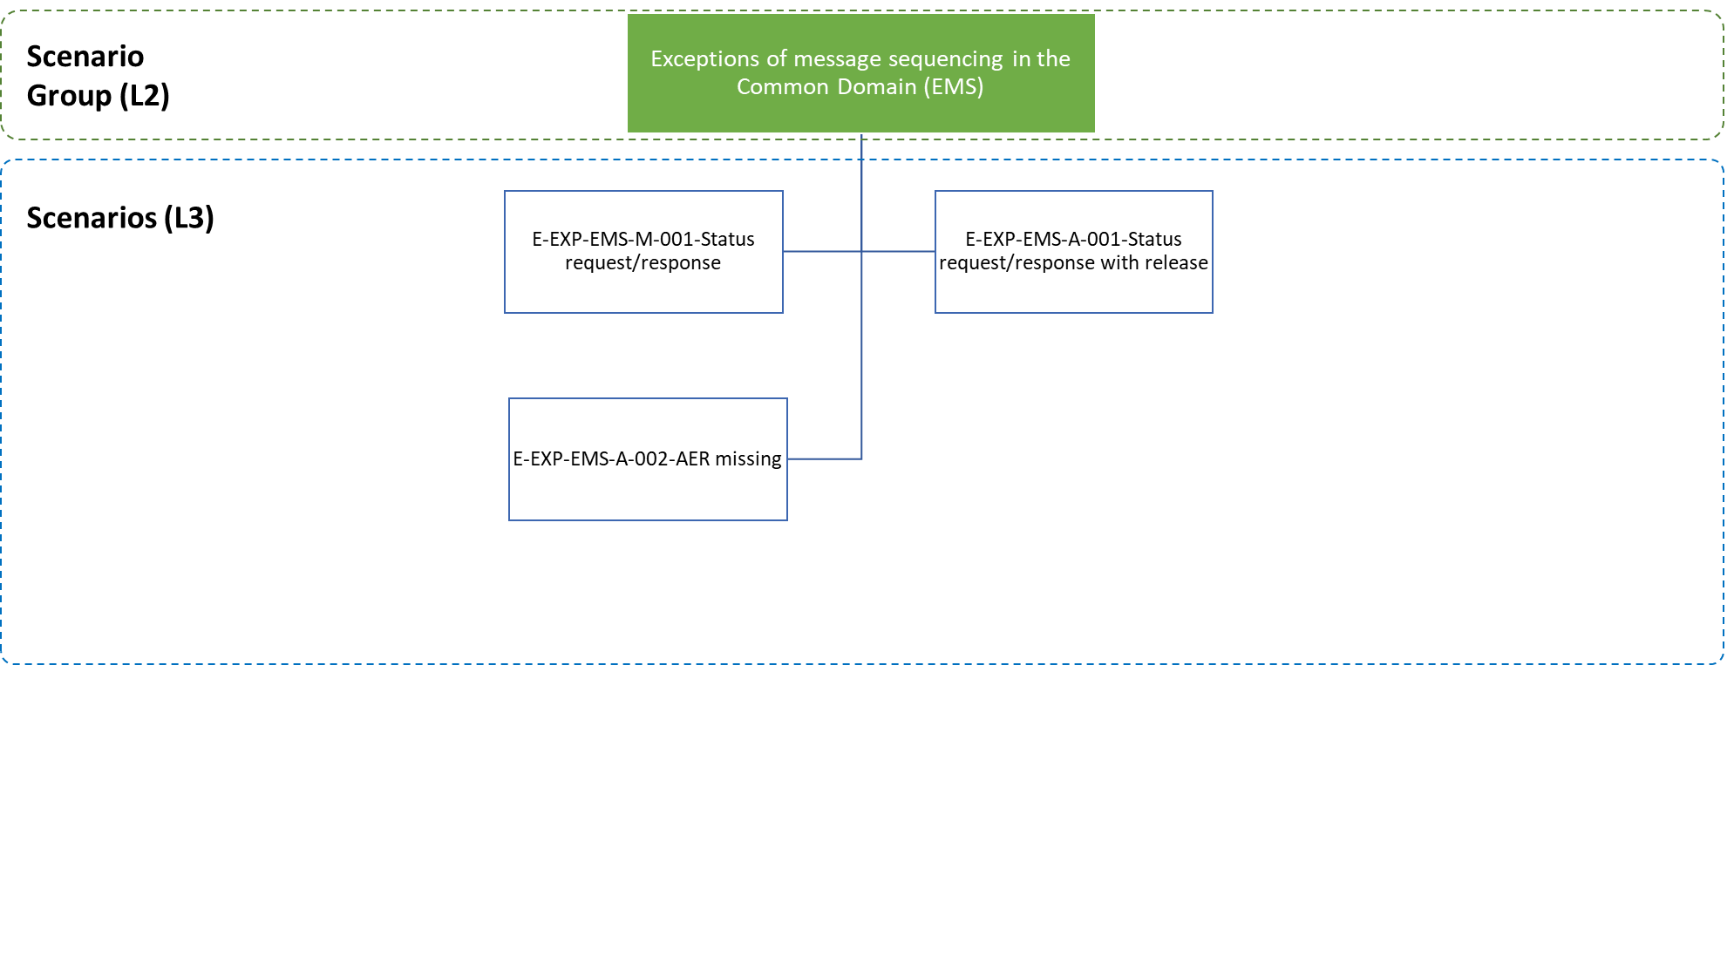

Figure 97: Exception of message sequencing in the Common Domain specific scenarios

##### E-EXP-EMS-M-001 Status request/response

The scenario (Figure 98) is initiated either by the Customs Officer or AES at the Customs of Office of Export. **[Step 1]** The Requesting Customs Office (Customs Office of Export or SCO) requests the status for an export operation from the Customs Office of Exit by means of a ‘Status Request’ C_STD_REQ (IE594).

AES retrieves the operation status of the export operation, identified by the MRN given in the status request.

**[Step 2]** The Customs Office of Exit informs the Customs Office of Export/SCO by sending a ‘Status Response’ C_STD_RSP (IE595) that contains the MRN and the movement state[49], [50].

At this point the Customs Office of Export identifies that the goods have not exited.

The Customs Office of Export compares the movement state received in the Status Response message with the current movement state for the export operation and if the states don’t match, then AES sets the movement state of the export operation to the movement state in the Status Response.

AES identifies that the updated movement state indicates that the goods have not exited.

The status check mechanism is of generic use and can be used at all times after the acceptance of the export declaration. All the mandatory cases where the status check mechanism is used in a scenario, are listed below:

* E-EXP-ENQ-M-001 Expiry of time limit to receive exit results - Exit Results received after Enquiry Procedure;
* E-EXP-ENQ-A-001 Expiry of time limit to receive exit results – Confirmation of exit by Alternative Evidence (Enquiry information code: “Exited-Alternative Evidence”);
* E-EXP-ENQ-E-001 Expiry of time limit to receive exit results – Invalid Enquiry information/Insufficient Alternative Evidence, if any;
* E-EXP-ENQ-A-002 Expiry of timer to receive exit results - Invalidation after expiry of time limit to receive Alternative Evidence;
* E-EXP-ENQ-A-003 Expiry of time limit to receive exit results – Enquiry information code: “Expected to Exit”;
* E-EXP-ENQ-A-004 Expiry of time limit to receive exit results – Enquiry information code: “Will not exit”;
* E-EXP-ENQ-A-005 Expiry of time limit to receive exit results after international diversion occurred - Exit Results received after Enquiry Procedure;
* E-EXP-ENQ-A-006 Trader sends Enquiry Information on his/her own initiative (Enquiry information code: “Exited-Alternative Evidence” or “Exited-No Alternative Evidence”) - Exit Results received after Enquiry Procedure;
* E-EXP-ENQ-A-007 Trader sends Enquiry Information on his/her own initiative (Enquiry information code: “Exited-Alternative Evidence”) - Confirmation of exit by Alternative Evidence;
* E-EXP-ENQ-A-008 Trader sends Enquiry Information on his/her own initiative (Enquiry information code: “Exited-Alternative Evidence”) - Insufficient Alternative Evidence;
* E-EXP-ENQ-A-009 Trader sends Enquiry Information on his/her own initiative (Enquiry information code: “Exited-No Alternative Evidence”) – No Release for Exit at the Customs Office of Exit;
* E-EXP-ENQ-E-002 Trader sends Enquiry Information on his/her own initiative (Enquiry information code: “Exited-Alternative Evidence” or “Exited-No Alternative Evidence”) - Invalid Enquiry Information.



Figure 98: E-EXP-EMS-M-001 Status request/response

##### E-EXP-EMS-A-001 Status request/response with release for exit

The scenario (Figure 99) is initiated either by the Customs Officer or AES. **[Step 1]** The Requesting Customs Office requests the status for an export operation from the Customs Office of Exit by means of a ‘Status Request’ C_STD_REQ (IE594).

AES retrieves the operation status of the export operation, identified by the MRN given in the status request.

**[Step 2]** The Customs Office of Exit informs the Requesting Customs Office by sending a ‘Status Response’ C_STD_RSP (IE595) that contains the MRN and the movement state.

**[Step 3]** At this point, the Customs Office of Exit verifies that the goods have exited, so the Customs Office of Exit sends the Exit Results to the Requesting Customs Office with an ‘Exit Results’ C_EXT_RES (ΙΕ518) message.

The Requesting Customs Office registers the Status Response and makes it available to the Customs Office.

AES identifies that the updated movement state indicates that the goods have exited. The Requesting Customs Office receives the ‘Exit Results’ C_EXT_RES (IE518) from the Customs Office of Exit.

The status check mechanism is of generic use and can be used at all times after the acceptance of the export declaration. All the mandatory cases where the status check mechanism is used in a scenario are listed below:

* E-EXP-ENQ-M-001 Expiry of time limit to receive exit results - Exit Results received after Enquiry Procedure;
* E-EXP-ENQ-A-001 Expiry of time limit to receive exit results – Confirmation of exit by Alternative Evidence (Enquiry information code: “Exited-Alternative Evidence”);
* E-EXP-ENQ-E-001 Expiry of time limit to receive exit results – Invalid Enquiry information/Insufficient Alternative Evidence, if any;
* E-EXP-ENQ-A-002 Expiry of timer to receive exit results - Invalidation after expiry of time limit to receive Alternative Evidence;
* E-EXP-ENQ-A-003 Expiry of time limit to receive exit results – Enquiry information code: “Expected to Exit”;
* E-EXP-ENQ-A-004 Expiry of time limit to receive exit results – Enquiry information code: “Will not exit”;
* E-EXP-ENQ-A-005 Expiry of time limit to receive exit results after international diversion occurred - Exit Results received after Enquiry Procedure;
* E-EXP-ENQ-A-006 Trader sends Enquiry Information on his/her own initiative (Enquiry information code: “Exited-Alternative Evidence” or “Exited-No Alternative Evidence”) - Exit Results received after Enquiry Procedure;
* E-EXP-ENQ-A-007 Trader sends Enquiry Information on his/her own initiative (Enquiry information code: “Exited-Alternative Evidence”) - Confirmation of exit by Alternative Evidence;
* E-EXP-ENQ-A-008 Trader sends Enquiry Information on his/her own initiative (Enquiry information code: “Exited-Alternative Evidence”) - Insufficient Alternative Evidence;
* E-EXP-ENQ-A-009 Trader sends Enquiry Information on his/her own initiative (Enquiry information code: “Exited-No Alternative Evidence”) – No Release for Exit at the Customs Office of Exit;
* E-EXP-ENQ-E-002 Trader sends Enquiry Information on his/her own initiative (Enquiry information code: “Exited-Alternative Evidence” or “Exited-No Alternative Evidence”) - Invalid Enquiry Information.



Figure 99: E-EXP-EMS-A-001 Status request/response with release for exit

##### E-EXP-EMS-A-002 AER missing

Figure 100 displays the scenario in which a declaration is accepted at the Customs Office of Export and the export movement information is for some reason not recorded from the Customs Office of Exit (Declared).

For one reason or another, an AER may be lost by a NA in its role of Customs Office of Exit without the Customs Office of Export being aware of it and the expected arrival date has not yet been met. Other reasons are possible why the AER is missing at the Customs Office of Exit. To represent this, the usual AER (IE501) does not appear in this Time Sequence Diagram.

The flow continues up until [**Step 8**] of the E-EXP-CFL-M-001 Core flow scenario. That is, **[**Step 1**]** until **[**Step 7**]** are the same as in E-EXP-CFL-M-001 Core flow. In this case, upon the arrival of the consignment at the Customs Office of Exit, the Trader at Exit sends an arrival notification via an ‘Arrival at Exit’ E_ARR_EXT (IE507) message to the Customs Office of Exit and requests that the goods are allowed to leave immediately the European Union Customs Territory.

AES verifies that the arrival notification is valid and identifies that the AER is not available at the Customs Office of Exit.

**[Step 9]** The Customs Office of Exit requests the missing movement information from the Customs Office of Export via a ‘Declaration Request Export’ C_EXP_REQ (IE502) message and the movement state at the Customs Office of Exit is set to “AER Requested”.

**[Step 10]** The Customs Office Export responds with an ‘AER Response’ C_AER_RSP (IE503) positive message including the requested export declaration data and the movement state at the Customs Office of Exit is set to “Goods Presented at Exit”. AES interfaces with the national risk analysis systems of the Member States to request a Risk Analysis.

**[Steps 11 until 17]** The scenario continues as per **[****Ste****p 9****]** until [Step 15**]** of the E-EXP-CFL-M-001 Core flow.

In case the Customs Office of Exit expects an ‘AER Response’ C_AER_RSP (IE503) (because it has previously formulated a request by means of an ‘AER Request’ C_AER_REQ (IE502)) but also receives the delayed AER C_AER_SND (IE501), either before or after the reception of ‘AER Response’ C_AER_RSP (IE503), it should process ‘AER Response’ C_AER_RSP (IE503) and ignore AER C_AER_SND (IE501).



Figure 100: E-EXP-EMS-A-002 AER missing

### Exit Summary Declaration

Where goods are to be taken out of the Customs territory of the Union and a Customs declaration or a re-export declaration is not lodged as pre-departure declaration, an Exit Summary Declaration shall be lodged at the Customs Office of Exit, as defined in UCC Article 271 [A1].

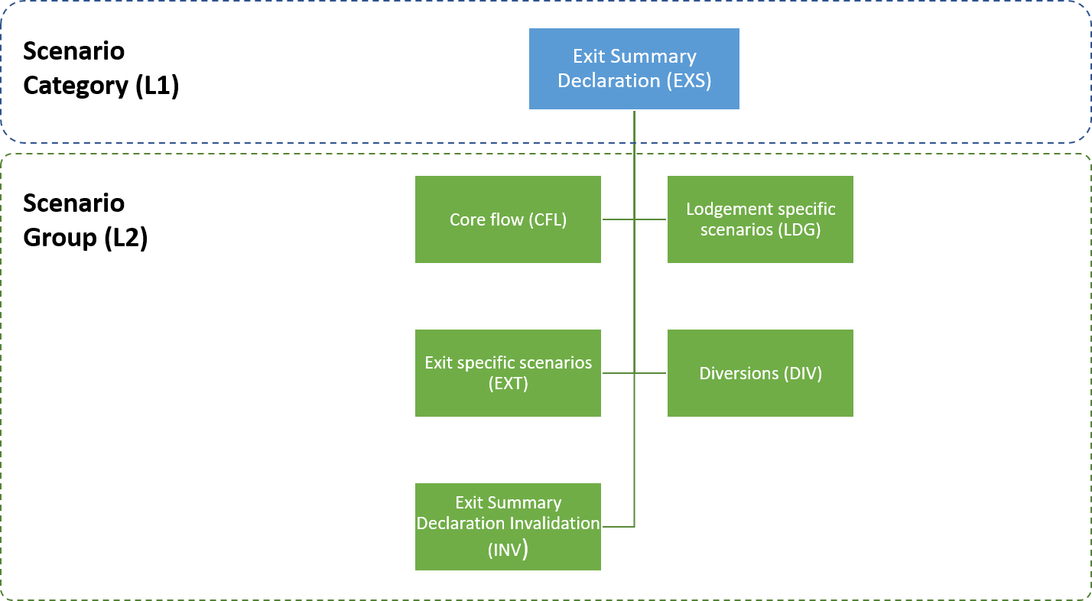

Figure 101: Exit Summary Declaration specific scenarios

#### E-EXS-CFL-M-001 Core Flow

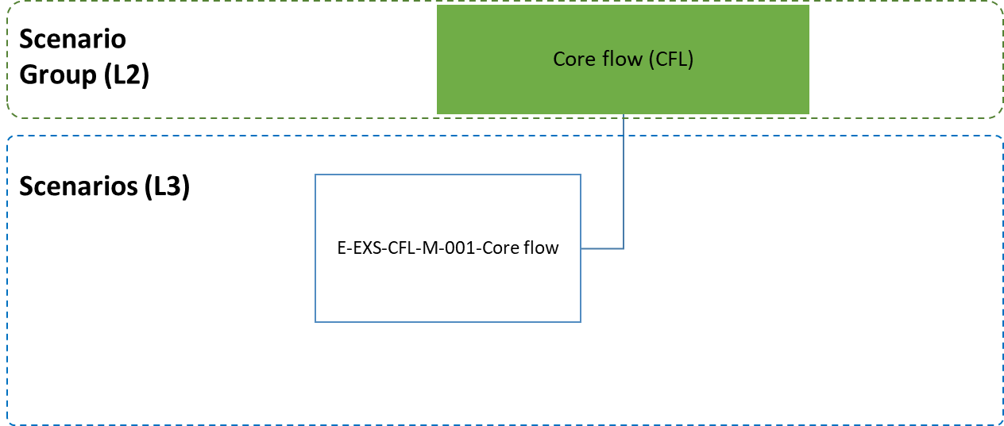

Figure 102: Core Flow Specific Scenario

**[****Step 1]** The scenario starts with the Declarant/Representative, submitting an Exit Summary Declaration via an ‘Exit Summary Declaration’ E_EXS_DAT (IE615) message to the Customs Office of Exit.

After a successful validation of the Exit Summary Declaration, AES registers the Exit Summary Declaration and allocates a Master Reference Number (MRN). The state of the movement is set to “Registered”.

**[Step 2]** The Timer to Receive Exit Notification (T_Receive_Exit_Notification) starts at this point.

**[Step 3]** The Customs Office of Exit informs the Declarant/Representative with an ‘Exit Summary Declaration Acknowledgement’ E_EXS_ACK (IE628) message of the Exit Summary Declaration acceptance and the MRN assignment.

Following the notification of the Exit Summary Declaration acceptance to the Declarant/Representative, AES interfaces with the national risk analysis systems of the Member States to request a Risk Analysis.

**[Step 4]** The Customs Officer at the Customs Office of Exit decides not to control the goods and that the movement can be immediately released for exit. The movement state is set to “Goods Ready to be Released”.

**[Step 5]** The Customs Office of Exit communicates the release for exit to the Trader at Exit via an ‘Exit Release Notification’ E_EXT_REL (IE525) message and the movement state is set to “Goods Released for Immediate Leave”.

**[Step 6]** When the consignment has left the European Union Customs Territory, the Trader at Exit9 notifies the Customs Office of Exit via an ‘Exit Notification’ E_EXT_NOT (IE590) message that the goods have exited.

AES validates the Exit Notification successfully and the movement state is set to “Exited”.

**[Step 7]** The Timer to Receive Exit Notification (T_Receive_Exit_Notification) stops at this point.

The scenario stops here. Different variations are possible to this scenario. They are discussed in subsequent paragraphs.



Figure 103: E-EXS-CFL-M-001 Core Flow

#### Lodgement specific scenarios

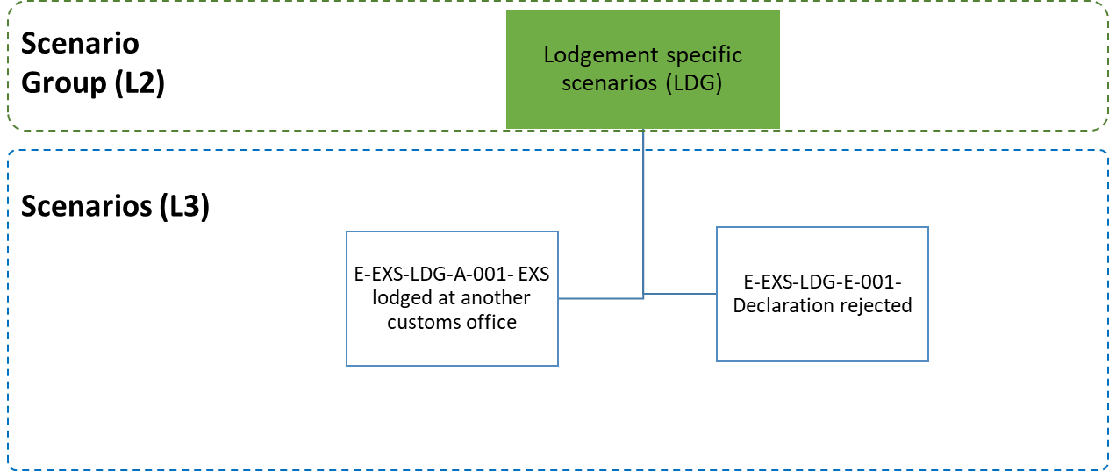

Figure 104: Lodgement specific scenarios

##### E-EXS-LDG-A-001 EXS lodged at another customs office

**[Step 1]** The scenario starts with the Declarant/Representative, submitting an Exit Summary Declaration via an ‘Exit Summary Declaration’ E_EXS_DAT (IE615) message to a Customs Office of Lodgement different office than the Customs Office of Exit (Declared).

After a successful validation of the Exit Summary Declaration, AES registers the Exit Summary Declaration and allocates a Master Reference Number (MRN). The state of the movement at the Customs Office of Lodgement is set to “Registered”.

**[Step 2]** The Customs Office of Lodgement informs the Declarant/Representative with an ‘Exit Summary Declaration Acknowledgement’ E_EXS_ACK (IE628) message of the Exit Summary Declaration acceptance and the MRN assignment.

AES identifies that the Customs Office of Lodgement is not the Customs Office of Exit (Declared).

**[Step 3]** As a result, the Customs Office of Lodgement communicates the Exit Summary Declaration to the Customs Office of Exit via an ‘EXS’ C_EXS_SND (IE601) message.

**[Step 4]** The Timer for Assumed Exited (T_Assumed Exited) starts at this point at the Customs Office of Lodgement.

**[Step 5]** The Customs Office of Exit registers the Exit Summary Declaration and the movement state at the Customs Office of Exit is set to “Registered”.

Following the registration of the Exit Summary Declaration, AES interfaces with the national risk analysis systems of the Member States to request a Risk Analysis.

The Timer to Receive Exit Notification (T_Receive_Exit_Notification) starts at this point at the Customs Office of Exit.

**[Step 6]** Upon the arrival of the consignment at the Customs Office of Exit, the Trader at Exit sends an arrival notification via an ‘Arrival at Exit’ E_ARR_EXT (IE507) message to the Customs Office of Exit and requests that the goods are allowed to leave immediately the European Union Customs Territory.

AES verifies that the arrival notification is valid, and that the AER is available at the Customs Office of Exit. The movement state at the Customs Office of Exit is set to “Goods Presented at Exit”.

AES interfaces with the national risk analysis systems of the Member States to request a Risk Analysis.

**[Step 7]** The Customs Officer at the Customs Office of Exit decides not to control the goods and that the movement can be immediately released for exit. The movement state is set to “Goods Ready to be Released”.

**[Step 8]** The Customs Office of Exit communicates the release for exit to the Trader at Exit via an ‘Exit Release Notification’ E_EXT_REL (IE525) message and the movement state is set to “Goods Released for Immediate Leave”.

**[Step 9]** When the consignment has left the European Union Customs Territory, the Trader at Exit9 notifies the Customs Office of Exit via an ‘Exit Notification’ E_EXT_NOT (IE590) message that the goods have exited.

AES validates the Exit Notification successfully and the movement state is set to “Exited”.

**[Step 10]** The Timer to Receive Exit Notification (T_Receive_Exit_Notification) stops at this point at the Customs Office of Exit.

**[****Step 11]** The Timer for Assumed Exited (T_Assumed Exited) expires at this point at the Customs Office of Lodgement and the movement state is set to “Assumed Exited”.



Figure 105: E-EXS-LDG-A-001 EXS lodged at another customs office

##### E-EXS-LDG-E-001 Declaration rejected

**[Step 1]** The scenario starts with the Declarant/Representative, submitting an Exit Summary Declaration via an ‘Exit Summary Declaration’ E_EXS_DAT (IE615) message to the Customs Office of Exit.

AES identifies that the Exit Summary Declaration is invalid.

**[Step 2]** The Customs Office of Exit sends a ‘Rejection from Office of Exit’ E_EXT_REJ (IE557) message to the Declarant/Representative, that the declaration is invalid; giving the reason for rejection. The scenario stops here.

It should be noted that a rejected Exit Summary Declaration does not have a state.When an Exit Summary Declaration has been rejected, the normal way of proceeding is to send a new Exit Summary Declaration that is acceptable.



Figure 106: E-EXS-LDG-E-001 Declaration rejected

#### Exit specific scenarios

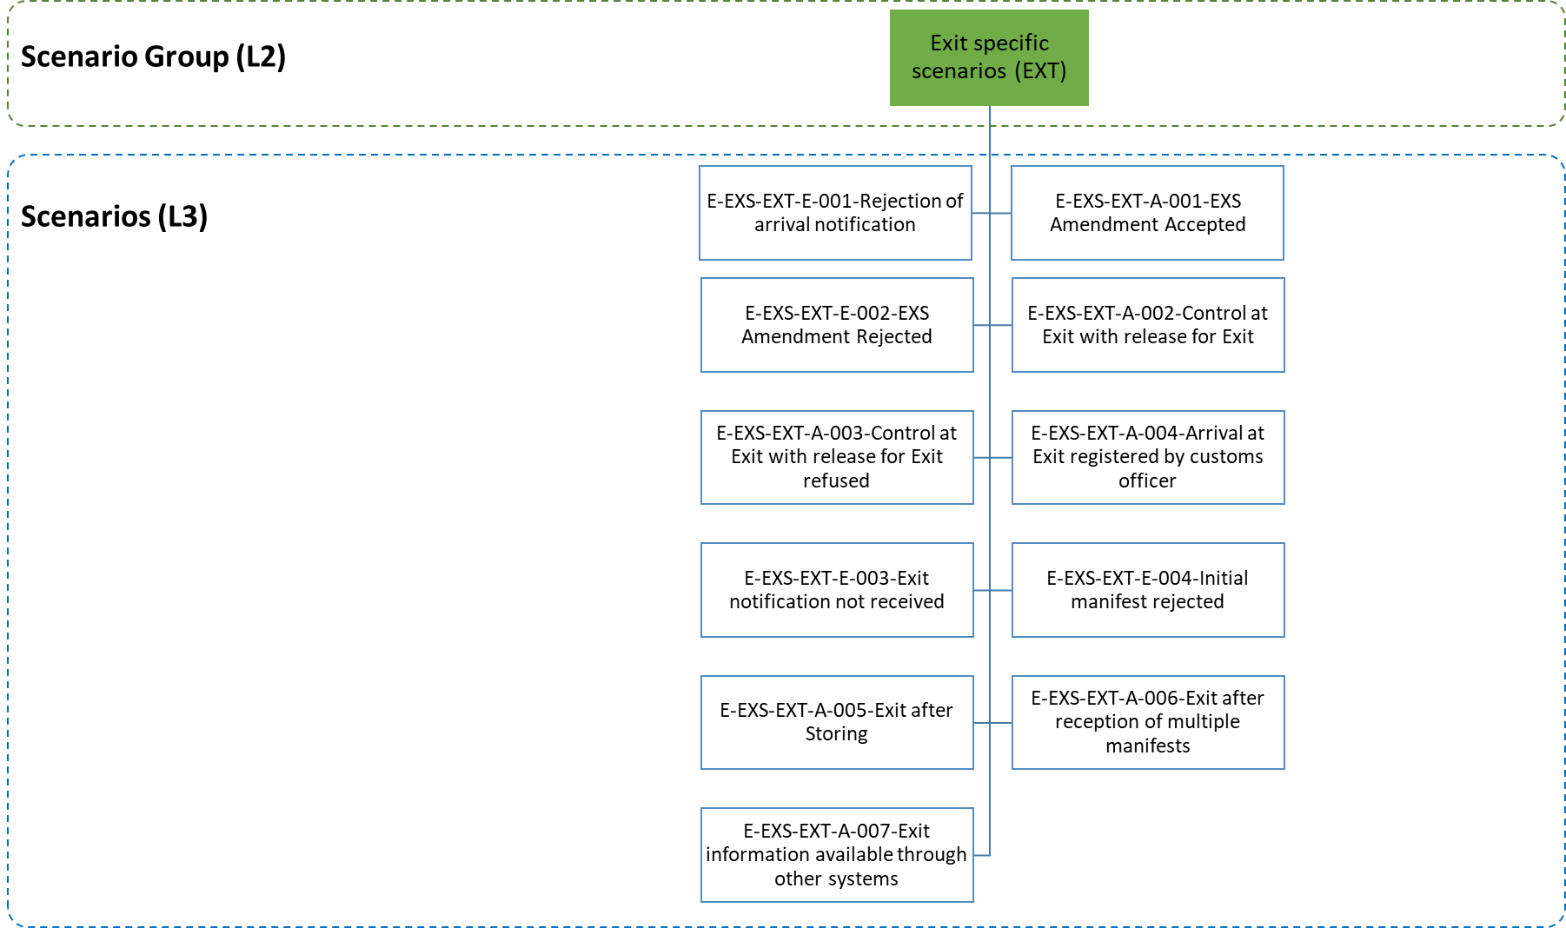

Figure 107: Exit specific scenarios

##### E-EXS-EXT-E-001 Rejection of arrival notification

Figure 108 displays the scenario in which an arrival notification for a movement lodged under an Exit Summary Declaration is rejected by the Customs Office of Exit.

The flow continues up to **[****Step 6**] of scenario E-EXS-LDG-A-001 EXS lodged at another customs office. That is, [**Step 1**] until [**Ste****p 5**] are the same as in E-EXS-LDG-A-001 EXS lodged at another customs office. In this case, after the reception of the arrival notification by the Trader at Exit via an ‘Arrival at Exit’ E_ARR_EXT (IE507) message (while the movement state is set to “Registered), the validation of the message is not successful due to inconsistencies or functional errors detected. The reason of the rejection of the arrival notification message is communicated to the Trader at Exit via a ‘Rejection from Office of Exit’ E_EXT_REJ (IE557) message **[Step 7]** and the movement state remains as “Registered”.

**[Step 8]** The Timer for Assumed Exited (T_Assumed Exited) expires at this point at the Customs Office of Lodgement and the movement state is set to “Assumed Exited”.



Figure 108: E-EXS-EXT-E-001 Rejection of arrival notification

##### E-EXS-EXT-A-001 EXS Amendment Accepted

Amendments allow for the Exit Summary Declaration data to be changed before the movement is released. The conditions under which an Exit Summary Declaration amendment can be sent are described in section III.5.3.2. It is worth noting that ‘Exit Summary Declaration Amendment’ E_EXS_AMD (IE613) can be sent to the Customs Office of Exit, as long as those conditions are fulfilled.

Figure 109 shows such a scenario. The flow continues up to [**Step 4**] of the E-EXS-CFL-M-001 Core Flow. That is, [**Step 1**] until [**Step 4**] are the same as in E-EXS-CFL-M-001 Core Flow.

The Declarant/Representative who sent the initial Exit Summary Declaration sends an ‘Exit Summary Declaration Amendment’ E_EXS_AMD (IE613) to the Customs Office of Exit in the time period between the Exit Summary Declaration acceptance and the release for exit (while the movement state is set to either “Registered”, “Goods Ready to be Released”, or “Goods Presented at Exit”) [**Step 5**].

**[Step 6]** Once the request is validated and accepted by AES, the Customs Office of Exit sends the ‘Exit Summary Declaration Amendment Acceptance’ E_EXS_AAC (IE604) to the Declarant/Representative and the movement state remain as is.

**[Steps 7 until 9]** These steps are the same as the steps [Step 5] until **[****Step 7****]** of the E-EXS-CFL-M-001 Core Flow.



Figure 109: EXS Amendment Accepted

##### E-EXS-EXT-E-002 EXS Amendment Rejected

Amendments allow for the Exit Summary Declaration data to be changed before the movement is released. The conditions under which an Exit Summary Declaration amendment can be sent are described in section III.5.3.2.

The flow continues up to **[****Step 4****]** of the E-EXS-CFL-M-001 Core Flow. That is, [**Step 1**] until [**Step 4**] are the same as in E-EXS-CFL-M-001 Core Flow.

In Figure 110, the Declarant/Representative sends an ‘Exit Summary Declaration Amendment’ E_EXS_AMD (IE613), which is rejected by the Customs Office of Exit due to errors (‘Rejection from Office of Exit’ E_EXT_REJ (IE557)) **[Step 7]**.

**[Steps 8 until 12]** The state of the movement at the Customs Office of Exit remains as is. The Declarant/Representative may send a new ‘Exit Summary Declaration’ E_EXS_AMD (IE613). Assuming that the second ‘Exit Summary Declaration Amendment’ E_EXS_AMD (IE613) is valid, the state of the movement at Exit remains as is and the scenario continues with [Step 5]. until **[**Steps 7 until 9**]** being the same as in the E-EXS-EXT-A-001 EXS Amendment Accepted.

An amendment cannot be sent (and should be rejected without changing the movement state) when the movement has already been released or when release of the movement has been refused or when the status of the export Exit Summary Declaration is “Under Control”.



Figure 110: E-EXS-EXT-E-002 EXS Amendment Rejected

##### E-EXS-EXT-A-002 Control at Exit with release for Exit

Figure 111 shows the flow of information when the Customs Officer at the Customs Office of Exit decides to control the goods lodged under an Exit Summary Declaration.

The flow continues up until **[****Step 4****]** of the E-EXS-CFL-M-001 Core Flow. That is, [**Step 1**] until **[**Step 3**]** are the same as in E-EXS-CFL-M-001 Core Flow.

In this case, following the risk analysis, the Customs Officer at the Customs Office of Exit decides to control the goods. The movement state is set to “Under Control”.

The Customs Office of Exit sends an ‘Export Control Decision Notification’ E_EXT_CTR (IE561) to the Trader at Exit in order to inform him/ her of the upcoming control activities.

The Customs Officer registers satisfactory control results at the Customs Office of Exit and the movement state is set to “Goods Ready to be Released” **[Step 4].**

**[Steps 5 until 7]** These steps are the same as the steps [Step 5] until **[****Step 7****]** of the E-EXS-CFL-M-001 Core Flow.



Figure 111: E-EXS-EXT-A-002 Control at Exit with release for Exit

##### E-EXS-EXT-A-003 Control at Exit with release for Exit refused

Figure 112 shows the sequence in case the Customs Officer at the Customs Office of Exit decides to control the goods lodged under an Exit Summary Declaration and afterwards decides to not release the movement for Exit.

The flow continues up until **[****Step 4****]** of the E-EXS-CFL-M-001 Core Flow. That is, [**Step 1**] until **[**Step 3**]** are the same as in E-EXS-CFL-M-001 Core Flow.

In this case, following the risk analysis, the Customs Officer at the Customs Office of Exit decides to control the goods. The movement state is set to “Under Control”.

The Customs Office of Exit sends an ‘Export Control Decision Notification’ E_EXT_CTR (IE561) to the Trader at Exit in order to inform him/ her of the upcoming control activities **[Step 4].**

The Customs Officer registers unsatisfactory control results at the Customs Office of Exit and movement state is set to “Goods Not Allowed to Exit”. As a result, the consignment cannot be released for Exit and the Customs Office of Exit informs the Trader at Exit by sending an ‘Exit Release Rejection’ E_EXT_REJ (IE522) **[Step 5]**.

The Timer to Receive Exit Notification (T_Receive_Exit_Notification) stops at this point. **[Step 6]**.

The remaining steps of the E-EXS-CFL-M-001 Core Flow ([Step 5] until [Step 7]) are not applicable, since the current scenario has terminated in [Step 6] above.



Figure 112: E-EXS-EXT-A-003 Control at Exit with release for Exit refused

##### E-EXS-EXT-A-004 Arrival at Exit registered by customs officer

Figure 113 displays the scenario in which a Customs Officer registers the arrival at Exit at the Customs Office of Exit.

The flow continues up until **[****Step 6**] of scenario E-EXS-LDG-A-001 EXS lodged at another customs office. That is, [**Step 1**] until [**Step 5**] are the same as in E-EXS-LDG-A-001 EXS lodged at another customs office. In this case, a Customs Officer will register the arrival at exit at the Customs Office of Exit instead of the communication of an arrival at exit by the Trader at Exit. The movement state at the Customs Office of Exit is set to “Goods Presented at Exit” **[Step 6]**.

**[Step 7]** The Timer for Assumed Exited (T_Assumed Exited) expires at this point at the Customs Office of Lodgement and the movement state is set to “Assumed Exited”.



Figure 113: E-EXS-EXT-A-004 Arrival at Exit registered by customs officer

##### E-EXS-EXT-E-003 Exit notification not received

Figure 114 displays the scenario in which the goods are stored prior to their exit and the manifest for the goods covered by the Exit Summary Declaration is not received by the Customs Office of Exit.

The flow continues up until **[****Step 9****]** of the E-EXS-LDG-A-001 EXS lodged at another customs office. That is, **[**Step 1**]** until **[****Step 8****]** are the same as in E-EXS-LDG-A-001 EXS lodged at another customs office.

**[Step 9]** In this case, after the communication of the release for exit to the Trader at Exit, the exiting process is not initiated by the submission of a manifest via a ‘Manifest Presentation’ E_MAN_PRE (IE547) message from the Trader at Exit within the time limit for providing the Exit Notification.

The Timer to Receive Exit Notification (T_Receive_Exit_Notification) expires, so the Customs Office of Exit invalidates the Exit Summary Declaration and the movement state is set to “Invalidated”.

**[Step 10]** The Timer for Assumed Exited (T_Assumed Exited) expires at this point at the Customs Office of Lodgement and the movement state is set to “Assumed Exited”.

The scenario ends at this point.



Figure : E-EXS-EXT-E-003 Exit notification not received

##### E-EXS-EXT-E-004 Initial manifest rejected

Figure 115 displays the scenario in which the goods are stored prior to their exit and the manifest is rejected and the goods are not allowed to exit from the European Union Customs Territory.

The flow continues up until **[****Step 7****]** of scenario E-EXS-EXT-A-005 Exit after Storing. That is, [**Step 1**] until **[**Step 6**]** are the same as in E-EXS-EXT-A-005 Exit after Storing.

The Customs Office of Exit upon the reception of the message checks its validity and rejects it. The Trader at Exit is notified via a ‘Manifest Validation’ E_MAN_VAL (IE548) message. Unless the Trader at Exit amends the manifest successfully, the movement remains at the same state waiting for a valid manifest to be submitted (“Goods Held for Storing”) **[Step 7].**



Figure 115: E-EXS-EXT-E-004 Initial manifest rejected

##### E-EXS-EXT-A-005 Exit after Storing

Figure 116 displays the scenario in which the goods lodged under an Exit Summary Declaration, are stored prior to their exit from the European Union Customs Territory. No control procedures are initiated by the Customs Officer in this scenario.

The flow continues up to **[****Step 4****]** of the E-EXS-CFL-M-001 Core Flow scenario. That is, [**Step 1**] until [**Step 4**] are the same as in E-EXS-CFL-M-001 Core Flow. In this case,the Customs Officer at the Customs Office of Exit decides not to control the goods and that the goods are allowed to be stored prior their exit.

**[Step 5]** The Customs Office of Exit communicates the release for exit to the Trader at Exit via an ‘Exit Release Notification’ E_EXT_REL (IE525) message and the movement state is set to “Goods Held for Storing”.

**[Step 6]** The exiting process of the goods being in the “Goods Held for Storing” state is initiated by the submission of a manifest via a ‘Manifest Presentation’ E_MAN_PRE (IE547) message from the Trader at Exit. In the present scenario, it is assumed that the manifest lists all the stored goods of the Exit Summary Declaration (meaning all items belonging to the corresponding MRN) intended to leave the European Union Customs Territory on a given mean of transport.

**[Step 7]** The Customs Office of Exit upon the reception of the message checks its validity and confirms its successful acceptance to the Trader at Exit via a ‘Manifest Validation’ E_MAN_VAL (IE548) message. The movement state is set to “Goods Released for Immediate Leave”.

**[Steps 8 until 9]** The scenario continues as per [Step 6] until [**Step 7**] of the E-EXS-CFL-M-001 Core Flow.



Figure 116: E-EXS-EXT-A-005 Exit after Storing

##### E-EXS-EXT-A-006 Exit after reception of multiple manifests

Figure 117 depicts the process of a movement exiting via multiple manifests after it is held for storing.

The flow continues up until **[****Step 7****]** of scenario E-EXS-EXT-A-005 Exit after Storing. That is, [**Step 1**] until **[**Step 6**]** are the same as in E-EXS-EXT-A-005 Exit after Storing.

However, in this scenario it is assumed that the initial manifest covers only part of the goods items of the movement. The Customs Office of Exit upon the reception of the manifest checks its validity and confirms its successful acceptance via a ‘Manifest Validation’ E_MAN_VAL (IE548) message **[Step 7]**. The state of the movement changes to “Goods Released for Immediate Leave (Partial)”.

After the specific goods items of the movement (as indicated in the initial manifest) have exited, the Trader at Exit9 indicates the fact to the Office of Exit via an ‘Exit Notification’ E_EXT_NOT (IE590) message and the state of the movement is set to “Partially Exited” **[Step 8]**.

A second (or more) manifest(s) can follow covering the remaining (or part of the remaining) goods items of the stored movement **[Steps 9 10]**. However, the state of the movement remains to “Partially Exited”. It is only when the final ‘Exit Notification’ E_EXT_NOT (IE590) message is received confirming the exiting of the last manifest (covering all the remaining goods items of the movement) that the movement state is set to “Exited” and the scenario continues as per as per **[****Step 7****]** of the E-EXS-CFL-M-001 Core Flow.



Figure 117: E-EXS-EXT-A-006 Exit after reception of multiple manifests

##### E-EXS-EXT-A-007 Exit information available through other systems

Figure 118 displays the scenario in which an Exit Summary Declaration is accepted at the Customs Office of Exit and the exit information is available through the Commercial or Port or Transport System linked to the declaration.

The flow continues up until **[****Step 6****]** of scenario E-EXS-EXT-A-005 Exit after Storing. That is, [**Step 1**] until **[**Step 5**]** are the same as in E-EXS-EXT-A-005 Exit after Storing.

In this case, after the communication of an ‘Exit Release Notification’ E_EXT_REL (IE525) message to the Trader at Exit informing him/ her that the goods can be immediately released (movement state is set to “Goods Released for Immediate Leave”), the Customs Office of Exit receives the information that the goods have exited through the Commercial or Port or Transport System linked to the export declaration and the movement state is set to “Exited”.

**[Step 7]** The Timer to Receive Exit Notification (T_Receive_Exit_Notification) stops at this point.



Figure 118: E-EXS-EXT-A-007 Exit information available through other systems

#### Diversions

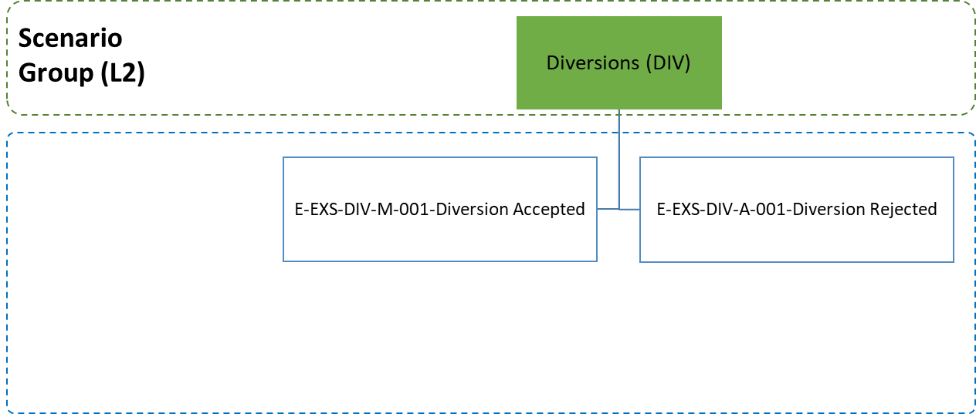

Figure 119: Diversions specific scenarios

##### E-EXS-DIV-M-001 Diversion Accepted

Figure 120 displays the scenario in which the movement is presented to a Customs Office of Exit different than the one that has been declared, thus a diversion occurs. The diversion is accepted by the Customs Office of Lodgement.

The flow continues up to **[****Step 7****]** of scenario E-EXS-LDG-A-001 EXS lodged at another customs office. That is, [**Step 1**] until **[****Step 6****]** are the same as in E-EXS-LDG-A-001 EXS lodged at another customs office. However, in this scenario, the goods are presented at a Customs Office of Exit (Actual) different than the Customs Office of Exit (Declared), which has no information regarding the specific movement.

**[Step 7]** After the arrival notification has been received (‘Arrival at Exit’ E_ARR_EXT (IE507)), the Customs Office of Exit (Actual) submits a declaration request via a ‘Declaration Request Export’ C_EXP_REQ (IE502) message to the Customs Office of Lodgement and the movement state at the Customs Office of Exit (Actual) is set to “Summary Declaration Requested”.

**[Step 8]** The Customs Office of Lodgement records the occurred diversion and accepts it by responding with an ‘Exit Summary Declaration Response’ C_EXS_RSP (IE603) containing the Exit Summary Declaration data while the the movement state at the Customs Office of Lodgement is set to “Arrived Elsewhere”, which is a final state.

**[Step 9]** The Timer for Assumed Exited (T_Assumed Exited) stops at this point at the Customs Office of Lodgement.

**[Step 10]** The movement state at the Customs Office of Exit (Actual) is set to “Goods Presented at Exit”. AES interfaces with the national risk analysis systems of the Member States to request a Risk Analysis.

**[Step 11 until 14]** The flow continues as per **[****Step 7****]** until **[****Step 10****]** the scenario E-EXS-LDG-A-001 EXS lodged at another customs office.



Figure 120: E-EXS-DIV-M-001 Diversion Accepted

##### E-EXS-DIV-Α-001 Diversion Rejected

Figure 121 displays the scenario where a diversion occurs and is rejected by the Customs Office of Lodgement.

The flow continues up to **[****Step 7****]** of scenario E-EXS-LDG-A-001 EXS lodged at another customs office. That is, [**Step 1**] until **[****Step 6****]** are the same as in E-EXS-LDG-A-001 EXS lodged at another customs office. However, in this scenario, the goods are presented at a Customs Office of Exit (Actual) different than the Customs Office of Exit (Declared), which has no information regarding the specific movement.

**[Step 7]** After the arrival notification has been received (‘Arrival at Exit’ E_ARR_EXT (IE507)), the Customs Office of Exit (Actual) submits a declaration request via a ‘Declaration Request Export’ C_EXP_REQ (IE502) message to the Customs Office of Lodgement and the movement state at the Customs Office of Exit (Actual) is set to “Summary Declaration Requested”.

**[Step 8]** The Customs Office of Lodgement rejects the diversion by submitting a negative **‘**Exit Summary Declaration Response’ C_EXS_RSP (IE603) to the Customs Office of Exit (Actual). The movement state at the the Customs Office of Exit (Actual) will be set from “Summary Declaration Requested” to “Diversion Rejected”.

**[Step 9]** In sequence, the Customs Office of Exit (Actual) notifies the Trader at Exit about the rejection via a ‘Diversion Rejection Notification’ E_DIV_REJ (IE521) message.

**[Step 10]** The Timer for Assumed Exited (T_Assumed Exited) expires at this point at the Customs Office of Lodgement and the movement state is set to “Assumed Exited”.

Note: The Customs Office of Exit (Actual) in the ‘Exit Summary Declaration Response’ C_EXS_RSP (IE603) shall be the one that has sent the ‘Declaration Request Export’ C_EXP_REQ (IE502) and is indicated in this message as the Customs Office of Exit (Actual). This is applicable to both positive and negative ‘Exit Summary Declaration Response’ C_EXS_RSP (IE603).

When the goods were declared as having left the EU and considering that the goods appear in another EU Member State, a manual procedure should be initiated between Country of Lodgement and the “second” Country of Exit, in order to clarify the status of the goods.



Figure 121: E-EXS-DIV-Α-001 Diversion Rejected

#### Exit Summary Declaration Invalidation

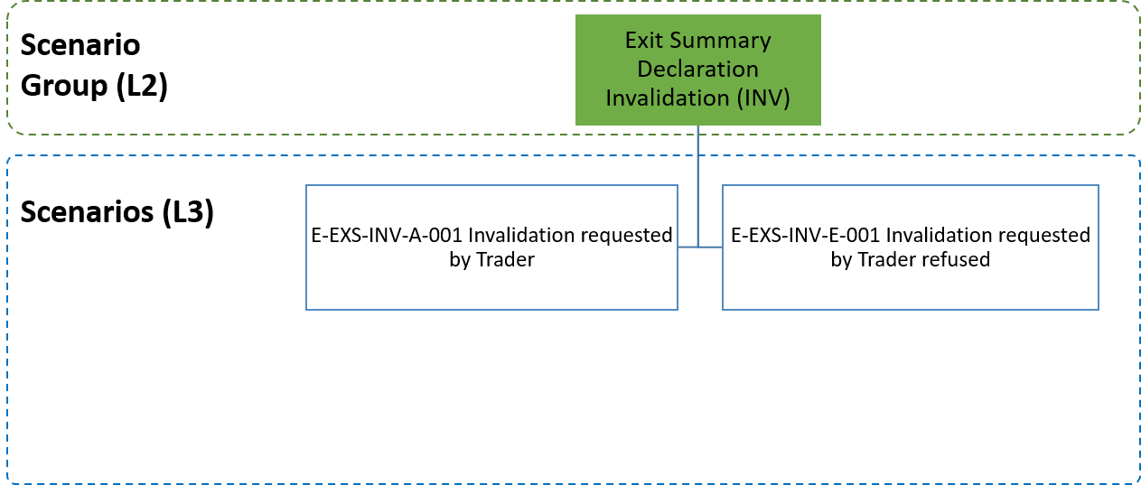

Figure : Invalidation specific scenarios

##### E-EXS-INV-A-001 Invalidation requested by Trader

Figure 123 displays the scenario in which the Trader at Exit decides to invalidate an Exit Summary Declaration after the Exit Summary Declaration has been registered at the Customs Office of Exit.

The flow continues up to **[****Step 3****]** of the E-EXS-CFL-M-001 Core Flow. That is, [**Step 1**] until **[****Step 3****]** are the same as in E-EXS-CFL-M-001 Core Flow.

**[Step 4]** In this case, following the communication of the Exit Summary Declaration registration and up until the goods exit (**[****Step 4****]** and **[****Step 5****]** of the E-REN-CFL-M-001 Core flow), the Trader at Exit decides to invalidate the Exit Summary Declaration and thus submits an invalidation request via an ‘EXS/REN Invalidation Request’ E_INV_REQ (IE614) message to the Customs Office of Exit. The movement states at the Customs Office of Exit from which the invalidation can occur are listed in III.5.3.3.2.

**[Step 5]** AES at the Customs Office of Exit verifies that the invalidation request is valid. Hence, AES at the Customs Office of Exit proceeds with the invalidation of the Exit Summary Declaration and informs the Trader at Exit via an ‘EXS/REN Invalidation Decision’ E_INV_DEC (IE609) message. The movement state is set to “Invalidated”, which is the final state.

**[Step 6]** The Timer to Receive Exit Notification (T_Receive_Exit_Notification) stops at this point. This is the final state and flow ends here.



Figure : E-EXS-INV-A-001 Invalidation requested by Trader

##### E-EXS-INV-E-001 Invalidation requested by Trader refused

Figure 124 displays the scenario in which the Trader at Exit decides to invalidate an Exit Summary Declaration after the Exit Summary Declaration has been registered at the Customs Office of Exit.

The flow continues up to **[****Step 3****]** of the E-EXS-CFL-M-001 Core Flow scenario. That is, [**Step 1**] until **[****Step 3****]** are the same as in E-EXS-CFL-M-001 Core Flow.

**[Step 4]** In this case, following the communication of the Exit Summary Declaration registration and up until the goods exit (**[****Step 4****]** and **[****Step 5****]** of the E-EXS-CFL-M-001 Core Flow scenario), the Trader at Exit decides to invalidate the Exit Summary Declaration and thus submits an invalidation request via an ‘EXS/REN Invalidation Request’ E_INV_REQ (IE614) message to the Customs Office of Exit. The movement states at the Customs Office of Exit from which the invalidation can occur are listed in III.5.3.2.2.

**[Step 5]** AES at the Customs Office of Exit verifies that the invalidation request is invalid. Hence, AES at the Customs Office of Exit informs the Trader at Exit of the declaration invalidation rejection via a ‘Rejection from Office of Exit’ E_EXT_REJ (IE557) and the movement state remains as is.

Since the invalidation request has been rejected, the Exit Summary Declaration remains valid and the flow may continue from **[****Step 3****]** of the E-EXS-CFL-M-001 Core Flow scenario.



Figure : E-EXS-INV-E-001 Invalidation requested by Trader refused

### Re-Export Notification

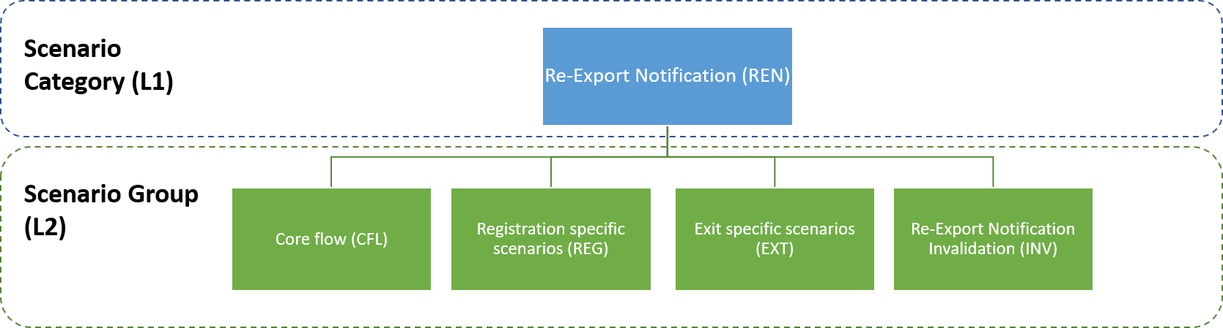

Figure 125: Re-Export Notification specific scenarios

Where non-Union goods referred to in points (b) and (c) of UCC [A1] Article 270 (3) are taken out of the Customs territory of the Union and the obligation to lodge an exit summary declaration for those goods is waived, a re-export notification shall be lodged, as defined in UCC [A1] Article 274.

#### E-REN-CFL-M-001 Core flow

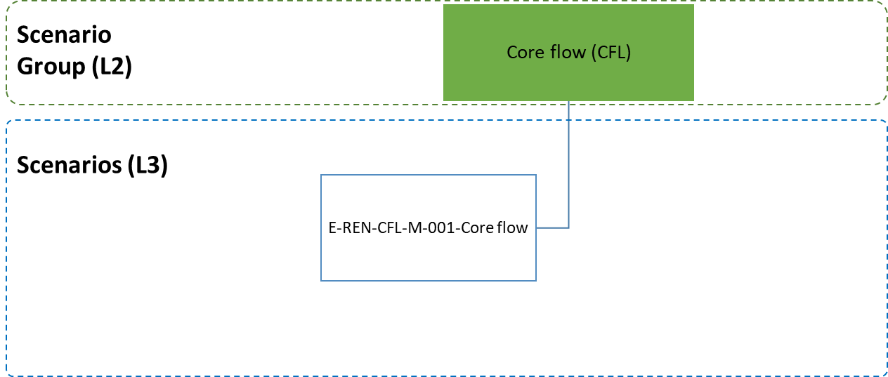

Figure 126: Core flow specific scenario

**[****Step 1]** The scenario starts with the Trader at Exit submitting a Re-Export Notification via a ‘Re-Export Notification’ E_REE_NOT (IE570) message to the Customs Office of Exit.

After a successful validation of the Re-Export Notification, AES registers the Re-Export Notification and assigns a Master Reference Number (MRN). The state of the movement is set to “Registered”.

**[Step 2]** The Timer to Receive Exit Notification (T_Receive_Exit_Notification) starts at this point.

**[****Step 3]** The Customs Office of Exit informs the Trader at Exit with a ‘Re-Export Notification Registration’ E_REE_REG (IE571) message of the Re-Export Notification registration and the MRN assignment.

Following the Trader’s notification of the Re-Export Notification registration, AES interfaces with the national risk analysis systems of the Member States to request a Risk Analysis.

**[Step 4]** The Customs Officer at the Customs Office of Exit decides not to control the goods and that the movement can be immediately released for exit. The movement state is set to “Goods Ready to be Released”.

**[Step 5]** The Customs Office of Exit communicates the release for exit to the Trader at Exit via an ‘Exit Release Notification’ E_EXT_REL (IE525) message and the movement state is set to “Goods Released for Immediate Leave”.

**[Step 6]** When the consignment has left the European Union Customs Territory, the Trader at Exit notifies the Customs Office of Exit via an ‘Exit Notification’ E_EXT_NOT (IE590) message that the goods have exited. AES validates the Exit Notification successfully and the movement state is set to “Exited”.

**[Step 7]** The Timer to Receive Exit Notification (T_Receive_Exit_Notification) stops at this point.

The scenario stops here. Different variations are possible to this scenario. They are discussed in subsequent paragraphs.



Figure 127: E-REN-CFL-M-001 Core flow

#### Registration specific scenarios

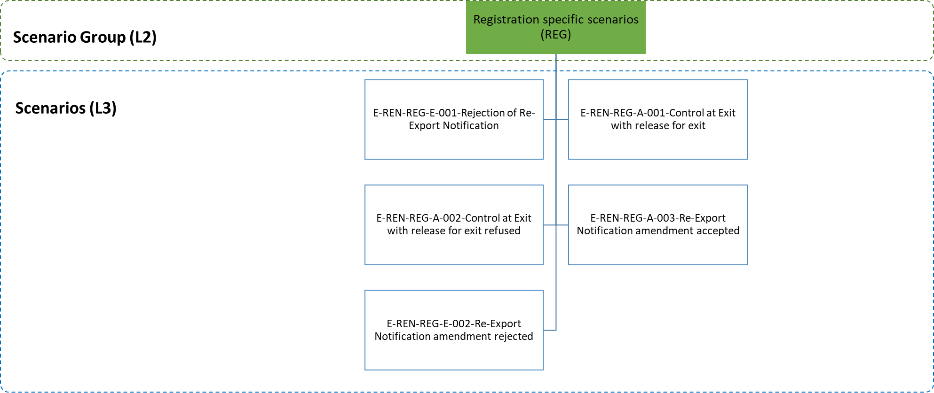

Figure 128: Registration specific scenarios

##### E-REN-REG-E-001 Rejection of Re-Export Notification

Figure 129 displays the scenario in which a ‘Re-Export Notification’ E_REE_NOT (IE570) submitted by the Trader at Exit is rejected.

**[Step 1]** The scenario starts with the Trader at Exit submitting a Re-Export Notification via a ‘Re-Export Notification’ E_REE_NOT (IE570) message to the Customs Office of Exit.

AES identifies that the Re-Export Notification is invalid.

**[Step 2]** The Customs Office of Export sends to the Trader at Exit a ‘Rejection from Office of Exit’ E_EXT_REJ (IE557) message that the Re-Export Notification is invalid, giving the reason for rejection. The scenario stops here.

It should be noted that a rejected Re-Export Notification does not have a state.When a Re-Export Notification has been rejected, the normal way of proceeding is to send a new Re-Export Notification that is acceptable.



Figure 129: E-REN-REG-E-001 Rejection of Re-Export Notification

##### E-REN-REG-A-001 Control at Exit with release for Exit

Figure 130 shows the flow of information when the Customs Officer at the Customs Office of Exit decides to control the goods lodged under a Re-Export Notification.

The flow continues up until **[****Step 4****]** of the E-REN-CFL-M-001 Core flow. That is, [**Step 1**] until [**Step 3**] are the same as in E-REN-CFL-M-001 Core flow. In this case, the Customs Officer at the Customs Office of Exit decides to control the goods. The movement state is set to “Under Control”.

The Customs Office of Exit sends an ‘Export Control Decision Notification’ E_EXT_CTR (IE561) to the Trader at Exit in order to inform him/ her of the upcoming control activities.

The Customs Officer registers satisfactory control results at the Customs Office of Exit and the movement state is set to “Goods Ready to be Released” [**Step 4**].

**[Steps 5 until 7]** These steps are the same as the steps **[****Step 5****]** until [**Step 7**] of the E-REN-CFL-M-001 Core flow.



Figure 130: E-REN-REG-A-001 Control at Exit with release for Exit

##### E-REN-REG-Α-002 Control at Exit with release for Exit refused

Figure 131 shows the sequence in case the Customs Officer at the Customs Office of Exit decides to control the goods lodged under a Re-Export Notification and afterwards decides to not release the movement for Exit.

The flow continues up until **[****Step 4****]** of the E-REN-CFL-M-001 Core flow. That is, [**Step 1**] until [**Step 3**] are the same as in E-REN-CFL-M-001 Core flow. In this case, the Customs Officer at the Customs Office of Exit decides to control the goods. The movement state is set to “Under Control”.

The Customs Office of Exit sends an ‘Export Control Decision Notification’ E_EXT_CTR (IE561) to the Trader at Exit in order to inform him/ her of the upcoming control activities.

The Customs Officer registers unsatisfactory control results at the Customs Office of Exit and movement state is set to “Goods Not Allowed to Exit” [**Step 4**].

**[Step 5]** As a result, the consignment cannot be released for Exit and the Customs Office of Exit informs the Trader at Exit by sending an ‘Exit Release Rejection’ E_EXT_REJ (IE522).

The remaining steps of the E-REN-CFL-M-001 Core flow ([Step 5] until [Step 7]) are not applicable, since the current scenario has terminated in [Step 5] above.



Figure 131: E-REN-REG-Α-002 Control at Exit with release for exit refused

##### E-REN-REG-A-003 Re-Export Notification amendment accepted

Amendments allow for the Re-Export Notification data to be changed before the movement is released. The conditions under which a Re-Export Notification amendment can be sent are described in section III.5.3.3. It is worth noting that multiple ‘Re-Export Notification Amendment Request’ E_REE_AMD (IE573) can be sent to the Customs Office of Exit, as long as those conditions are fulfilled.

Figure 132 shows such a scenario. The flow continues up to **[****Step 4****]** of the E-REN-CFL-M-001 Core flow. That is, [**Step 1**] until **[****Step 4****]** are the same as in E-REN-CFL-M-001 Core flow.

**[Step 5]** The Trader at Exit who sent the initial Re-Export Notification sends a ‘Re-Export Notification Amendment’ E_REE_AMD (IE573) to the Customs Office of Exit in the time period between the Re-Export Notification registration and the release for exit (while the movement state is set to either “Registered” or “Goods Ready to be Released”).

**[Step 6]** Once the request is validated and accepted by AES, the Customs Office of Exit sends the ‘Re-Export Notification Amendment Acceptance’ E_REE_AMA (IE574) to the Trader at Exit and the movement state remains as is.

**[Steps 7 until 9]** These steps are the same as the steps **[****Step 5****]** until [**Step 7**] of the E-REN-CFL-M-001 Core flow.



Figure 132: E-REN-REG-A-003 Re-Export Notification amendment accepted

##### E-REN-REG-E-002 Re-Export Notification amendment rejected

Amendments allow for the Re-Export Notification data to be changed before the movement is released. The conditions under which a Re-Export Notification amendment can be sent are described in section III.5.3.3.

The flow continues up until **[****Step 6****]** of the E-REN-CFL-M-001 Core flow. That is, [**Step 1**] until **[****Step 5****]** are the same as in E-REN-CFL-M-001 Core flow. In Figure 133, the Trader at Exit sends a ‘Re-Export Notification Amendment’ E_REE_AMD (IE573) **[Step 6]**, which is rejected by the Customs Office of Exit due to errors (‘Rejection from Office of Exit’ E_EXT_REJ (IE557)) **[Step 7]**. The state of the movement at the Customs Office of Exit remains as is (either “Registered” or “Goods Ready to be Released”).

The Trader at Exit may send a new ‘Re-Export Notification Amendment Request’ E_REE_AMD (IE573). Assuming that the second ‘Re-Export Notification Amendment Request’ E_REE_AMD (IE573) is valid, the state of the movement at Exit remains as is and the scenario continues as per the E-REN-CFL-M-001 Core flow in **[****Step 7****]**.

An amendment cannot be sent (and should be rejected without changing the movement state) when the movement has already been released or when release of the movement has been refused or when the status of the export Re-Export Notification is “Under Control”.



Figure 133: E-REN-REG-E-002 Re-Export Notification amendment rejected

#### Exit specific scenarios

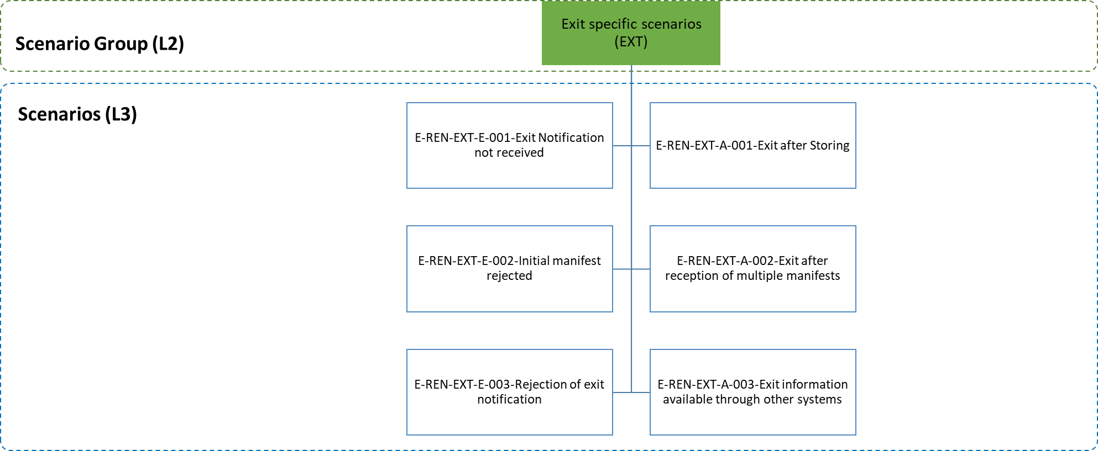

Figure 134: Exit specific scenarios

##### E-REN-EXT-E-001 Exit Notification not received

Figure 135 displays the scenario in which the goods are stored prior to their exit and the manifest for the goods covered by the Re-Export Notification is not received by the Customs Office of Exit.

The flow continues up until **[****Step 6****]** of the E-REN-CFL-M-001 Core flow. That is, [**Step 1**] until **[****Step 5****]** are the same as in E-REN-CFL-M-001 Core flow. After the storing of the goods, the exiting process is not initiated by the submission of a manifest via a ‘Manifest Presentation’ E_MAN_PRE (IE547) message from the Trader at Exit within the time limit for providing the Exit Notification.

The Timer to Receive Exit Notification (T_Receive_Exit_Notification) expires, so the Customs Office of Exit invalidates the Re-Export Notification and the movement state is set to “Invalidated” **[Step 6]**.

The scenario ends at this point. The remaining [Step 7] of the E-REN-CFL-M-001 Core flow is not applicable, since the current scenario has terminated in [Step 6] above.

Figure 135 displays also the scenario in which the goods are released for immediate exit and the Exit Notification is not received by the Customs Office of Exit.

The flow continues up until **[****Step 6****]** of the E-REN-CFL-M-001 Core flow. That is, [**Step 1**] until **[****Step 5****]** are the same as in E-REN-CFL-M-001 Core flow. After the goods are released for immediate exit and the movement state is set to “Goods Released for Immediate Leave”, the exiting process is not initiated by the submission of an Exit Notification via an ‘Exit Notification’ E_EXT_NOT (IE590) message from the Trader at Exit within defined the time limit.

The Timer to Receive Exit Notification (T_Receive_Exit_Notification) expires, so the Customs Office of Exit invalidates the Re-Export Notification and the movement state is set to “Invalidated” **[Step 6]**.

The scenario ends at this point. The remaining [Step 7] of the E-REN-CFL-M-001 Core flow is not applicable, since the current scenario has terminated in [Step 6] above.



Figure 135: E-REN-EXT-E-001 Exit Notification not received

##### E-REN-EXT-A-001 Exit after Storing

Figure 136 displays the scenario in which the goods lodged under a Re-Export Notification, are stored prior to their exit from the European Union Customs Territory. No control procedures are initiated by the Customs Officer in this scenario.

The flow continues up to **[****Step 4****]** of the E-REN-CFL-M-001 Core flow. That is, [**Step 1**] until **[****Step 4****]** are the same as in E-REN-CFL-M-001 Core flow. In this case,the Customs Officer at the Customs Office of Exit decides not to control the goods and that the goods are allowed to be stored prior their exit.

**[Step 5]** The Customs Office of Exit communicates the release for exit to the Trader at Exit via an ‘Exit Release Notification’ E_EXT_REL (IE525) message and the movement state is set to “Goods Held for Storing”.

**[Step 6]** The exiting process of the goods being in the “Goods Held for Storing” state is initiated by the submission of a manifest via a ‘Manifest Presentation’ E_MAN_PRE (IE547) message from the Trader at Exit. In the present scenario, it is assumed that the manifest lists all the stored goods of the Re-Export Notification (meaning all items belonging to the corresponding MRN) intended to leave the European Union Customs Territory on a given mean of transport.

**[Step 7]** The Customs Office of Exit upon the reception of the message checks its validity and confirms its successful acceptance to the Trader at Exit via a ‘Manifest Validation’ E_MAN_VAL (IE548) message. The movement state is set to “Goods Released for Immediate Leave”.

**[Steps 8 until 9]** These steps are the same as the steps **[****Step 6****]** until [**Step 7**] of the E-REN-CFL-M-001 Core flow.



Figure 136: E-REN-EXT-A-001 Exit after Storing

##### E-REN-EXT-E-002 Initial manifest rejected

Figure 137 displays the scenario in which the goods are stored prior to their exit and the manifest is rejected and the goods are not allowed to exit from the European Union Customs Territory.

The flow continues up until **[****Step 7****]** of scenario E-REN-EXT-A-001 Exit after Storing. That is, [**Step 1**] until **[****Step 6****]** are the same as in E-REN-EXT-A-001 Exit after Storing.

The Customs Office of Exit upon the reception of ‘Manifest Presentation’ E_MAN_PRE (IE547) checks its validity and rejects it. The Trader at Exit is notified via a ‘Manifest Validation’ E_MAN_VAL (IE548) message. Unless the Trader at Exit amends the manifest successfully, the movement remains at the same state waiting for a valid manifest to be submitted (“Goods Held for Storing”) **[Step 7].**

The remaining steps of the E-REN-EXT-A-001 Exit after Storing ([Step 8] until [Step 9]) are not applicable, since the current scenario has terminated in [Step 7] above.



Figure 137: E-REN-EXT-E-002 Initial manifest rejected

##### E-REN-EXT-A-002 Exit after reception of multiple manifests

Figure 138 depicts the process of a movement exiting via multiple manifests after it is held for storing.

The flow continues up to **[****Step 6****]** of scenario E-REN-EXT-A-001 Exit after Storing. That is, [**Step 1**] until **[****Step 6****]** are the same as in E-REN-EXT-A-001 Exit after Storing. However, in this scenario it is assumed that the initial manifest covers only part of the goods items of the movement. The Customs Office of Exit upon the reception of the manifest checks its validity and confirms its successful acceptance via a ‘Manifest Validation’ E_MAN_VAL (IE548) message **[Step 7]**. The state of the movement changes to “Goods Released for Immediate Leave (Partial)”.

After the specific goods items of the movement (as indicated in the initial manifest) have exited, the Trader at Exit indicates the fact to the Office of Exit via an ‘Exit Notification’ E_EXT_NOT (IE590) message and the state of the movement is set to “Partially Exited” **[Step 8]**.

A second (or more) manifest(s) can follow covering the remaining (or part of the remaining) goods items of the stored movement **[Steps 9-10]**. However, the state of the movement remains to “Partially Exited”. It is only when the final ‘Exit Notification’ E_EXT_NOT (IE590) message is received confirming the exiting of the last manifest (covering all the remaining goods items of the movement) that the movement state is set to “Exited” **[Step 11]** and the scenario continues as per **[****St****ep 7****]** of the E-REN-CFL-M-001 Core flow **[Step 12].**



Figure 138: E-REN-EXT-A-002 Exit after reception of multiple manifests

##### E-REN-EXT-E-003 Rejection of exit notification

Figure 139 displays the scenario in which an ‘Exit Notification’ E_EXT_NOT (IE590) for a Re-Export Notification submitted by the Trader at Exit is rejected.

The flow continues up until **[****Step 6****]** of the E-REN-CFL-M-001 Core flow. That is, [**Step 1**] until **[****Step 5****]** are the same as in E-REN-CFL-M-001 Core flow. In this case, following the goods release for immediate leave (movement state is set to “Goods Released for Immediate Leave”), AES identifies that the ‘Exit Notification’ E_EXT_NOT (IE590) submitted at the Customs Office of Exit by the Trader at Exit is invalid **[Step 6]**.

The Customs Office of Exit informs the Trader at Exit that the Exit Notification is invalid via a ‘Rejection from Office of Exit’ E_EXT_REJ (IE557) message **[Step 7]**, giving the reasons for the rejection and the movement state remains as is.

The Trader at Exit sends a second Exit Notification to the Customs Office of Exit via an ‘Exit Notification’ E_EXT_NOT (IE590) message, in order to notify that the goods have exited **[Step 8]**.

AES validates the Exit Notification against business rules and conditions successfully. The movement state is set to “Exited”. The Timer to Receive Exit Notification (T_Receive_Exit_Notification) stops at this point **[Step 9]**.

More Exit Notification can follow at this point if the second Exit Notification is found invalid as well.



Figure 139: E-REN-EXT-E-003 Rejection of exit notification

##### E-REN-EXT-A-003 Exit information available through other systems

Figure 140 displays the scenario in which a Re-Export Notification is registered at the Customs Office of Exit and the exit information is available through the Commercial or Port or Transport System linked to the declaration.

The flow continues up to **[****Step 5****]** of the E-REN-CFL-M-001 Core flow. That is, [**Step 1**] until **[****Step 5****]** are the same as in E-REN-CFL-M-001 Core flow. In this case, after the communication of an ‘Exit Release Notification’ E_EXT_REL (IE525) message to the Trader at Exit informing him/ her that the goods can be immediately released (movement state is set to “Goods Released for Immediate Leave”), the Customs Office of Exit receives the information that the goods have exited through the Commercial or Port or Transport System linked to the export declaration and the movement state is set to “Exited” **[Step 6]**.

**[Step 7]** The Timer to Receive Exit Notification (T_Receive_Exit_Notification) stops at this point.



Figure 140: E-REN-EXT-A-003 Exit information available through other systems

#### Re-Export Notification Invalidation

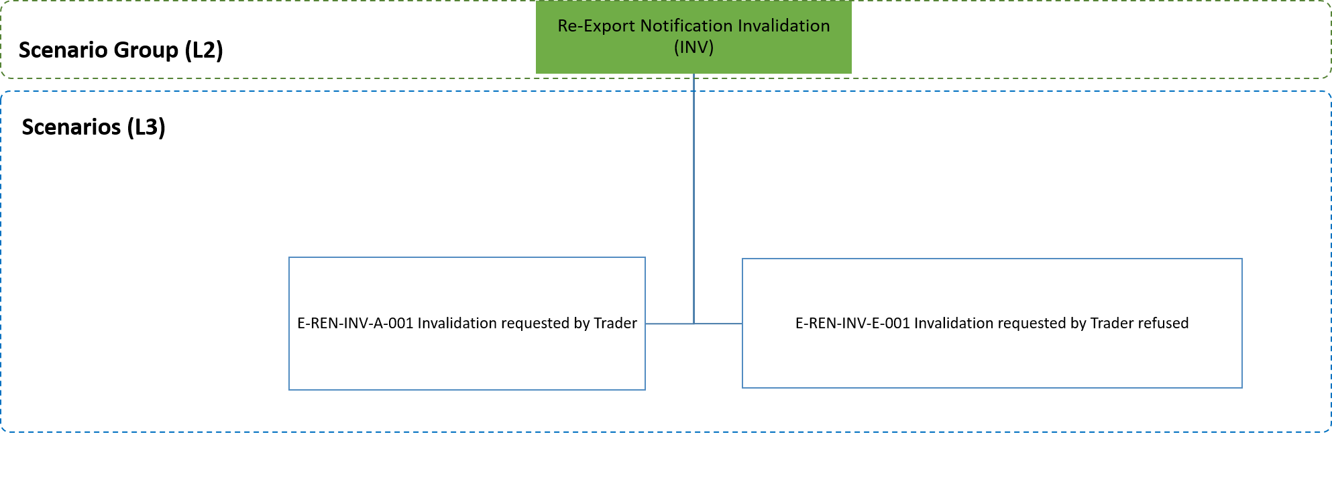

Figure : Invalidation specific scenarios

##### E-REN-INV-A-001 Invalidation requested by Trader

Figure 142 displays the scenario in which the Trader at Exit decides to invalidate a Re-Export Notification after the Re-Export Notification has been registered at the Customs Office of Exit.

The flow continues up to **[****Step 3****]** of the E-REN-CFL-M-001 Core flow scenario. That is, [**Step 1**] until **[****Step 3****]** are the same as in E-REN-CFL-M-001 Core flow.

**[Step 4]** In this case, following the communication of the Re-Export Notification registration and up until the goods exit (**[****Step 4****]** and **[****Step 5****]** of the E-REN-CFL-M-001 Core flow scenario), the Trader at Exit decides to invalidate the Re-Export Notification and thus submits an invalidation request via an ‘EXS/REN Invalidation Request’ E_INV_REQ (IE614) message to the Customs Office of Exit. The movement states at the Customs Office of Exit from which the invalidation can occur are listed in III.5.3.3.2.

**[Step 5]** AES at the Customs Office of Exit verifies that the invalidation request is valid. Hence, AES at the Customs Office of Exit proceeds with the invalidation of the Re-Export Notification and informs the Trader at Exit via an ‘EXS/REN Invalidation Decision’ E_INV_DEC (IE609) message. The movement state is set to “Invalidated”, which is the final state.

**[Step 6]** The Timer to Receive Exit Notification (T_Receive_Exit_Notification) stops at this point. This is the final state and flow ends here.



Figure : E-REN-INV-A-001 Invalidation requested by Trader

##### E-REN-INV-E-001 Invalidation requested by Trader refused

Figure 143 displays the scenario in which the Trader at Exit decides to invalidate a Re-Export Notification after the Re-Export Notification has been registered at the Customs Office of Exit.

The flow continues up to **[****Step 3****]** of the E-REN-CFL-M-001 Core flow scenario. That is, [**Step 1**] until **[****Step 3****]** are the same as in E-REN-CFL-M-001 Core flow.

**[Step 4]** In this case, following the communication of the Re-Export Notification registration and up until the goods exit (**[****Step 4****]** and **[****Step 5****]** of the E-REN-CFL-M-001 Core flow scenario), the Trader at Exit decides to invalidate the Re-Export Notification and thus submits an invalidation request via an ‘EXS/REN Invalidation Request’ E_INV_REQ (IE614) message to the Customs Office of Exit. The movement states at the Customs Office of Exit from which the invalidation can occur are listed in III.5.3.3.2.

**[Step 5]** AES at the Customs Office of Exit verifies that the invalidation request is invalid. Hence, AES at the Customs Office of Exit informs the Trader at Exit of the declaration invalidation rejection via a ‘Rejection from Office of Exit’ E_EXT_REJ (IE557) and the movement state remains as is.

Since the invalidation request has been rejected, the Re-Export Notification remains valid and the flow may continue from **[****Step 3****]** of the E-REN-CFL-M-001 Core flow scenario.



Figure : E-REN-INV-E-001 Invalidation requested by Trader refused

## State Transition Diagrams

The following chapter presents the State Transition Diagrams for all Export operations. The purpose of this chapter is to define the different states that an AES application needs to maintain. Any Member State must be capable of maintaining the roles of Customs Office of Export, Customs Office of Lodgement and Customs Office of Exit and support the status models below for every movement (MRN).

The following interactions should therefore be defined:

* When acting as Customs Office of Export:
  + Interacting with Declarant/Representative;
  + Interacting with Customs Office of Exit;
  + Interacting with MSA of Export;
  + Interacting with Presentation Customs Office.
* When acting as Customs Office of Lodgement:
  + Interacting with Declarant/Representative;
  + Interacting with Customs Office of Exit.
* When acting as Customs Office of Exit:
  + Interacting with Trader at Exit;
  + Interacting with Customs Office of Export;
  + Interacting with Customs Office of Lodgement;
  + Interacting with Customs Office of Departure;
  + Interacting with Declarant/Representative.
* When acting as Presentation Customs Office:
  + Interacting with Customs Office of Export (Supervising Customs Office);

Therefore, the State Transition Diagrams are described per role:

* **Customs Office of Export**: Three State Transition Diagrams are defined to describe the state transitions at the Customs Office of Export.
  + The first diagram contains the state transitions up to release of the movement (which consists of interactions between the Customs Office of Export and the Declarant/Representative, the Presentation Customs Office and the MSA of Export);
  + The second diagrams contain all state transitions after the release of the movement (which consists of interactions between the Customs Office of Export and the Customs Office of Exit, the Declarant/Representative, the Presentation Customs Office and the MSA of Export);
  + The third diagram describes the state transitions for the declaration invalidation at the Customs Office of Export (which consists of interactions between the Customs Office of Export and the Customs Office of Exit, the Declarant/Representative, the Presentation Customs Office and the MSA of Export);
* **Customs Office of Lodgement**:One State Transition Diagram is defined to show the interaction between the Customs Office of Lodgement, the Declarant/Representative and the Customs Office of Exit.
* **Customs Office of Exit**: The State Transition Diagrams at the Office of Exit are divided into three main categories: “Export Process”, “Exit Summary Declaration” and “Re-Export Notification”:
  + **Export Process:** contains two State Transition Diagrams.
    - The first describesthe state transitions for the Export Process, which consists of interaction between the Customs Office of Exit and the Trader at Exit, the Customs Office of Export and the Customs Office of Departure;
    - The second describes the state transitions for declaration invalidation at the Customs Office of Exit.
  + **Exit Summary Declaration:** contains one State Transition Diagram and describes all state transitions for the Exit Summary Declaration, which consists of interaction between the Customs Office of Exit, the Trader at Exit and Customs Office of Lodgement.
  + **Re-Export Notification:** contains one State Transition Diagram and describes all state transitions for the o Re-Export Notification, which consists of interaction between the Customs Office of Exit and the Trader at Exit.
* **Presentation Customs Office:** One State Transition Diagram, defined to describe the state transitions at the Presentation Customs Office.
  + The diagram describes the state transitions for the export declaration at the Presentation Customs Office which consists of interactions between the Presentation Customs Office and the Customs Office of Export (Supervising Customs Office);

Status requests and responses and movement queries and responses have not been included as these can, in principle, happen in any state.

### Customs Office of Export STD

#### Before movement release

The State Transition Diagram in Figure 144 below describes all the possible states at the Customs Office of Export up until the release of the goods for export

Any movement is initiated at the Customs Office of Export through the receipt of the ‘Export Declaration’ E_EXP_DAT (IE515), submitted by the Declarant/Representative.

If the Export Declaration is invalid against business rules and conditions or if any of the corresponding authorisations does not exist or it is invalid or if the corresponding ARCs are not valid, then the declaration will be rejected, the Declarant/Representative will be notified with a ‘Rejection from Office of Export’ E_EXP_REJ (IE556) and the movement state will be set to **“Rejected”**, which is a final state.

If the goods were not presented with the Export Declaration; the movement state will be set to **“Registered and Waiting for Presentation of Goods”**.

* The Declarant/Representative provides a valid ‘Export Presentation Notification’ E_PRE_NOT (IE511) within the defined time limit, the Export Declaration will be accepted, the Declarant/Representative will be notified with an ‘Export MRN Allocated’ E_MRN_EXP (IE528) and the movement state will be set to **“Accepted”**;
* The Declarant/Representative provides an invalid ‘Export Presentation Notification’ E_PRE_NOT (IE511) and so AES will inform him/her with an ‘Rejection from Office of Export’ E_EXP_REJ (IE556) and the movement state remains as is;
* The Timer Awaiting for Export Presentation Notification (T_Awaiting_Export_Presentation_Notification) expires, then the Export Declaration will be rejected, the Declarant/Representative will be notified with a ‘Rejection from Office of Export’ E_EXP_REJ (IE556) and the movement state will be set to **“Rejected”**, which is a final state;
* The Declarant/Representative provides a valid cancellation request (‘Export Invalidation Request’ E_EXP_INV (IE514)). The Customs Office of Export will notify the Declarant/Representative of the successful cancellation by sending an ‘Export Invalidation Decision’ E_EXP_DEC (IE509) and the movement state will be set to **“Cancelled”**, which is a final state;
* The Declarant/Representative provides an invalid cancellation request (‘Export Invalidation Request’ E_EXP_INV (IE514)). The Customs Office of Export will notify the Declarant/Representative of the unsuccessful cancellation by sending a ‘Rejection from Office of Export’ E_EXP_REJ (IE556) and the movement state remains as is;
* The Declarant/Representative provides a valid correction request (Export Declaration Amendment’ E_EXP_AMD (IE513)). The Customs Office of Export will notify the Declarant/Representative of the successful correction by sending an ‘Export Declaration Amendment Acceptance of E_EXP_AAC’ (IE504) and the movement state remains as is;
* The Declarant/Representative provides an invalid correction request (Export Declaration Amendment’ E_EXP_AMD (IE513)). The Customs Office of Export will notify the Declarant/Representative of the unsuccessful correction by sending a ‘Rejection from Office of Export’ E_EXP_REJ (IE556) and the movement state remains as is.

If the Export Declaration at this point is valid and the goods were presented together with the Export Declaration, the Export Declaration will be accepted, the Declarant/Representative will be notified with an ‘Export MRN Allocated’ E_MRN_EXP (IE528) and the movement state will be set to **“Accepted”**.

The Exporter or Declarant, by means of an ‘Export Declaration Amendment’ E_EXP_AMD (IE513), can perform declaration amendments. Amendments on declarations can be sent to the Customs Office of Export when the movement state is set to “**Accepted**”. In all other states, they will be rejected.

A declaration amendment will always be replied to by either an ‘Export Declaration Amendment Acceptance of E_EXP_AAC’ (IE504) or a ‘Rejection from Office of Export’ E_EXP_REJ (IE556).

When an invalid amendment has been sent, the movement state will remain as “**Accepted**”. The state will also remain as “**Accepted**” when an acceptable declaration amendment is received.

The flow at this point will differentiate for a declaration lodged under the standard procedure and a declaration lodged under Centralised Clearance.

**Standard Procedure**

The Customs Officer at the Customs Office of Export may decide to control the movement, to release the goods for export.

* If the Customs Officer decides to release the goods for export, then the Declarant/Representative will be notified with a ‘Release for Export’ E_REL_EXP (IE529) and the movement state will be set to **“Goods Released for Export”**. The Customs Office of Exit (Declared) will be notified with an AER C_AE_SND (IE501) in case it is different than the Customs Office of Export.
* If the Customs Officer decides to control the movement, then the Declarant/Representative will be notified with an ‘Export Control Decision Notification’ E_EXP_CTR (IE560) and the movement state will be set to **“Under Control”**.

The Customs Officer will perform the movement controls and register the control results.

* If the control results are Satisfactory (A1) or Considered Satisfactory (A2), then the Declarant/Representative will be notified with a ‘Release for Export’ E_REL_EXP (IE529) and the movement state will be set to **“Goods Released for Export”**. The Customs Office of Exit (Declared) will be notified with an AER C_AE_SND (IE501) in case it is different than the Customs Office of Export.
* If the control results are Unsatisfactory (B1), then the Declarant/Representative will be notified an ‘Export No Release’ E_EXP_NRL (IE551) and the movement state will be set to **“Not Released for Export”** (final state).

**Centralised Clearance**

According to the current scenarios, the AES at Supervising Customs Office (in the scenarios of Centralised Clearance for Export, the Customs Office of Export is considered as the Supervising Customs Office) identifies that the ‘Export Declaration’ E_EXP_DAT (IE515) has been lodged under the Centralised Clearance procedure. The Customs Officer at the Supervising Customs Office may decide to control or not to control the movement.

If the **Customs Officer at the Supervising Customs Office decides to perform documentary controls at the Supervising Customs Office**, the AES at the Supervising Customs Office shall send an ‘Export Control Decision Notification’ E_EXP_CTR (IE560) only in case there is a need to request documents in terms of documentary controls. Otherwise, if no documents need to be requested no ‘Export Control Decision Notification’ E_EXP_CTR (IE560) shall be sent. At any case, the state of the movement at the Supervising Customs Office changes to “Under Control”.

The following may then happen:

* If the documentary control results at the Supervising Customs Office are Satisfactory (A1) or Considered Satisfactory (A2), then the Presentation Customs Office is notified via a ‘Pre-release/Control Notification’ C_PRC_NOT (IE540) recommending Pre-release or recommending Control which in turn responds with a ‘Pre-release/Control Acknowledgement’ C_PRE_ACK (IE545) and the movement state remains as “Under Control”;
* If the documentary control results at the Supervising Customs Office are Unsatisfactory (B1), then the Presentation Customs Office is notified via a ‘Pre-release/Control Notification’ C_PRC_NOT (IE540) indicating release rejection, which in turn responds with a ‘Pre-release/Control Acknowledgement’ C_PRE_ACK (IE545). In parallel, the Declarant/Representative will receive an ‘Export No Release’ E_EXP_NRL (IE551) and the state of the movement at the Supervising Customs Office will be updated to “Not Released for Export” (final state).

If the **Supervising Customs Office decides that no controls are deemed required** (neither by the Supervising Customs Office nor by the Presentation Customs Office), the AES at the Supervising Customs Office informs the AES at the Presentation Customs Office, via a ‘Pre-release/Control Notification’ C_PRC_NOT (IE540) recommending Pre-release, that the declared goods are ready to be released for export. Following this, the AES at the Supervising Customs Office receives from the AES at the Presentation Customs Office a ‘Pre-release/Control Acknowledgement’ C_PRE_ACK (IE545) and the state of the movement at the Supervising Customs Office is updated to “Awaiting for PCO Control Decision”. Then the following cases are possible:

* Within the time limit for sending the control decision (as defined by Timer to Receive Control Notification from PCO (T_Awaiting_Control_Dec_Not) timer), the AES at the Supervising Customs Office receives from the AES at the Presentation Customs Office a ‘Control Decision from Presentation Customs Office’ C_PRE_DEC (IE563) indicating that the Presentation Customs Office decided not to perform any control. Following this, the AES at the Supervising Customs Office sends to the AES at the Presentation Customs Office a ‘Release Notification to Presentation Customs Office’ C_REL_PRE (IE543), indicating that the goods are released for Export. In addition, the Supervising Customs Office sends an AER C_AER_SND (IE501) to the Customs Office of Exit and ‘Release for Export’ E_REL_EXP (IE529) to the Declarant/Representative. In this case, the state of the movement at the Supervising Customs Office is updated to “Goods Released for Export”;
* Within the time limit for sending the control decision (as defined by Timer to Receive Control Notification from PCO (T_Awaiting_Control_Dec_Not) timer), the AES at the Supervising Customs Office receives from the AES at the Presentation Customs Office a ‘Control Decision from Presentation Customs Office’ C_PRE_DEC (IE563) indicating the decision to perform controls (physical controls or other types of controls which require the presence of Declarant/Representative and for requesting documents, if necessary). In this case, the Supervising Customs Office sends an ‘Export Control Decision Notification’ E_EXP_CTR (IE560) to the Declarant/Representative and the state of the movement at the Supervising Customs Office is updated to “Under Control”; or
* The time limit for receiving the control decision (as defined by Timer to Receive Control Notification from PCO (T_Awaiting_Control_Dec_Not) timer) expires without receiving from the AES at the Presentation Customs Office a ‘Control Decision from Presentation Customs Office’ C_PRE_DEC (IE563). Following this, the AES at the Supervising Customs Office sends to the Presentation Customs Office a ‘Release Notification to Presentation Customs Office’ C_REL_PRE (IE543), indicating that the goods are released for Export (after the automatic/manual decision from the Supervising Customs Office). In addition, the Supervising Customs Office sends an AER C_AER_SND (IE501) to the Customs Office of Exit and ‘Release for Export’ E_REL_EXP (IE529) to the Declarant/Representative. In this case, the state of the movement at the Supervising Customs Office is updated to “Goods Released for Export”.

If the **Supervising Customs Office decides to recommend controls at the Presentation Customs Office**, the AES at the Supervising Customs Office informs the AES at the Presentation Customs Office, via a ‘Pre-release/Control Notification’ C_PRC_NOT (IE540) recommending Control to the Presentation Customs Office and then receives from the AES at the Presentation Customs Office the automatic ‘Pre-release/Control Acknowledgement’ C_PRE_ACK (IE545). The state of the movement at the Supervising Customs Office remains as “Under Control”. The following are then possible:

* Within the time limit for sending the control decision (as defined by Timer to Receive Control Notification from PCO (T_Awaiting_Control_Dec_Not) timer), the AES at the Supervising Customs Office receives from the AES at the Presentation Customs Office a ‘Control Decision from Presentation Customs Office’ C_PRE_DEC (IE563) indicating the decision to perform controls (physical controls or other types of controls which require the presence of Declarant/Representative and for requesting documents, if necessary). In this case, the Supervising Customs Office sends an ‘Export Control Decision Notification’ E_EXP_CTR (IE560) to the Declarant/Representative and the state of the movement at the Supervising Customs Office remains as “Under Control”;
* Within the time limit for sending the control decision (as defined by Timer to Receive Control Notification from PCO (T_Awaiting_Control_Dec_Not) timer), the AES at the Supervising Customs Office receives from the AES at the Presentation Customs Office a ‘Control Decision from Presentation Customs Office’ C_PRE_DEC (IE563) indicating that the PCO decided not to perform any control. Following this, the AES at the Supervising Customs Office sends to the Presentation Customs Office a ‘Release Notification to Presentation Customs Office’ C_REL_PRE (IE543), indicating that the goods are released for Export (after the automatic/manual decision from the Supervising Customs Office). In addition, the Supervising Customs Office sends an AER C_AER_SND (IE501) to the Customs Office of Exit and ‘Release for Export’ E_REL_EXP (IE529) to the Declarant/Representative. In this case, the state of the movement at the Supervising Customs Office is updated to “Goods Released for Export”.
* The time limit for receiving the control decision (as defined by Timer to Receive Control Notification from PCO (T_Awaiting_Control_Dec_Not) timer) expires without receiving from the AES at the Presentation Customs Office a ‘Control Decision from Presentation Customs Office’ C_PRE_DEC (IE563). Following this, the AES at the Supervising Customs Office sends to the Presentation Customs Office a ‘Release Notification to Presentation Customs Office’ C_REL_PRE (IE543), indicating that the goods are released for Export (after the automatic/manual decision from the Supervising Customs Office). In addition, the Supervising Customs Office sends an AER C_AER_SND (IE501) to the Customs Office of Exit and ‘Release for Export’ E_REL_EXP (IE529) to the Declarant/Representative. In this case, the state of the movement at the Supervising Customs Office is updated to “Goods Released for Export”.

When the movement at the Supervising Customs Office is in the “Under Control” state and the **Supervising Customs Office is expecting control results** from the Presentation Customs Office (‘Control Results from Presentation Customs Office’ C_PRE_RES (IE541), then one of the following cases might occur:

* The AES at the Supervising Customs Office receives the ‘Control Results from Presentation Customs Office’ C_PRE_RES (IE541 with Control Result Code equal to “A1: Satisfactory” or “A2: Considered Satisfactory”) from the Presentation Customs Office. Following this, the AES at the Supervising Customs Office sends to the AES at the Presentation Customs Office a ‘Release Notification to Presentation Customs Office’ C_REL_PRE (IE543), indicating that the goods are released for Export. In addition, the Supervising Customs Office sends an AER C_AER_SND (IE501) to the Customs Office of Exit and ‘Release for Export’ E_REL_EXP (IE529) to the Declarant/Representative. The state of the movement at the Supervising Customs Office is updated to “Goods Released for Export”;
* The AES at the Supervising Customs Office sends to the AES at the Presentation Customs Office the ‘Control Results from Presentation Customs Office’ C_PRE_RES (IE541 with Control Result Code equal to “B1: Unsatisfactory”). Following this, the AES at the Supervising Customs Office sends to the AES at the Presentation Customs Office a ‘Release Rejection Notification’ C_PRE_REJ (IE542). In addition, the Supervising Customs Office also informs the Declarant/Representative about the release rejection by sending an ‘Export No Release’ E_EXP_NRL (IE551). The state of the movement at the Supervising Customs Office is updated to “Not Released for Export” (final state).



Figure 144: State Transition Diagram for the Customs Office of Export up to the release of the movement

#### After movement release

The State Transition Diagram in Figure 145 below depicts all the possible states at the Customs Office of Export after the release of the goods for export along with those related to the Enquiry Procedure.

This State Transition Diagram begins at state **“Goods Released for Export”**. The Customs Office of Exit (Declared) will be notified with an AER C_AE_SND (IE501) in case it is different than the Customs Office of Export.

If the Customs Office of Export is different than the Customs Office of Exit, it may receive an AER request via a ‘Declaration Request Export’ C_EXP_REQ (IE502) from a Customs Office of Exit.

* If the Customs Office of Exit is the declared one and the AER response is positive, then the Customs Office of Exit will be notified with an ‘AER Response’ C_AER_RSP (IE503) and the movement state will remain as **“Goods Released for Export”**;
* If the Customs Office of Exit is not the declared one and the AER response is positive, then the Customs Office of Exit (Actual) will be notified with an ‘AER Response’ C_AER_RSP (IE503), the Customs Office of Exit (Declared) will be notified with a ‘Forwarded Arrival Advice’ C_ARR_FWD (IE524) and the movement state will be set to **“Diversion Accepted”**;
* If the AER response is negative, then the requesting Customs Office of Exit will be notified with an ‘AER Response’ C_AER_RSP (IE503) and the movement state will remain as **“Goods Released for Export”**.

The Customs Office of Export receives the ‘Exit Results’ C_EXT_RES (IE518) from the Customs Office of Exit.

* If the exit results are satisfactory or if minor discrepancies were identified, then the exit of goods will be certified, the Declarant/Representative will be notified with an ‘Export Notification’ E_EXP_NOT (IE599) and the movement state will be set to **“Exported”**, which is a final state;
* If the exit results are not satisfactory, then the movement state will be set to **“Export Stopped, Discrepancies at Exit”**, which is a final state.

The Enquiry Procedure shall begin in one of the following cases:

* The Time Limit to Receive Exit Results (T_Receive_Exit_Results) expires;
* The Customs Officer at the Customs Office of Export decides to start the Enquiry Procedure while movement state is set to either **“Goods Released for Export”** or **“Diversion Accepted”** (the exit results have not yet been received);
* The Customs Office of Export receives a valid ‘Information on Non-Exited Export’ E_EXT_RSP (IE583) from the Declarant/Representative while the movement state is set to either **“Goods Released for Export”** or **“Diversion Accepted”** (the exit results have not yet been received).

If the Customs Office of Export receives from the Customs Office of Exit an IE518 with Control Result Code equal to ‘B2’ (non-appropriate office of Destination) or ‘B3’ (unsatisfactory destination control results), then the movement state will be set to **“Under Exit Confirmation Request”.**

If the Customs Office of Export receives a ‘Status Response’ C_STD_RSP (IE595) from the Customs office of Exit, indicating that there are no Exit Results at the Customs Office of Exit (i.e. the state of movement at the Customs Office of Exit is other than “Exited” or “Goods Not Allowed to Exit”), then the goods whereabouts are unknown, and the Customs Officer will request alternative evidence of the goods exit from the Declarant/Representative (while at state **“Goods Released for Export”**, **“Diversion Accepted”** or **“Under Exit Confirmation Request”**).

* If the Customs Officer verifies that the alternative evidence is sufficient, then the movement state will be set to “Exported”, which is a final state. Additionally, the exit of goods will be certified, the Declarant/Representative will be notified with an ‘Export Notification’ E_EXP_NOT (IE599) and the Customs Office of Exit will be notified with a Certification of ‘Exit on Alternative Evidence Notification’ C_ALT_EVD (IE588);
* If the Customs Officer identifies that the alternative evidence are not sufficient or the Time Limit to Receive Alternative Evidence (T_Receive_Alternative_Evidence) expires, then the Customs Officer may decide to proceed with the invalidation process the movement state will be set to “Invalidated” (III.5.1.3).

In case of multiple diversions, the movement state is set to **“Diversion Accepted”** since one diversion already took place. At this point new sequential diversions might take place.

If the Customs Office of Export receives an AER request via a ‘Declaration Request Export’ C_EXP_REQ (IE502) from the latest Customs Office of Exit presented with the goods, one of the following cases will be fulfilled:

* If the Customs Office of Exit is the declared one and the AER response is positive, then the Customs Office of Exit will be notified with an ‘AER Response’ C_AER_RSP (IE503) and the movement state will remain as **“Diversion Accepted”**;
* If the Customs Office of Exit is not the declared one and the AER response is positive, then the requesting Customs Office of Exit will be notified with an ‘AER Response’ C_AER_RSP (IE503), the previous Customs Office of Exit presented with the goods will be notified with a ‘Forwarded Arrival Advice’ C_ARR_FWD (IE524) and the movement state will remain as **“Diversion Accepted”**;
* If the AER response is negative, then the requesting Customs Office of Exit will be notified with an ‘AER Response’ C_AER_RSP (IE503) and the movement state will remain as **“Diversion Accepted”**.

If the Customs Office of Export has sent an invalidation notification to the Customs Office of Exit via an Export Invalidation Notification’ C_INV_EXP (IE510) (while at state **“Goods Released for Export”**, **“Diversion Accepted”** or **“Under Exit Confirmation Request**”) due to the reasons described in III.5.1.3 and the Customs Office of Exit in return replies negatively with an ‘Invalidation Acknowledgement’ C_INV_ACK (IE591), then the Customs Office of Export will notify the Declarant/Representative with a ‘Rejection from Office of Export’ E_EXP_REJ (IE556) and the movement state remains as is.

Finally, it is worth noting that a declaration amendment could be performed:

* after the goods release for export: the amendment can be handled by the Customs Office of Export without any electronic information exchange and without any impact to the Common Domain. The Customs Office of Exit formalities are performed based on the received AER from the Customs Office of Export (AER C_AE_SND (IE501) or ‘AER Response’ C_AER_RSP (IE503)).
* after the goods released for exit for statistical purposes: the amendment can be handled by the Customs Office of Export without any further electronic information exchange since the movement is Exited (closed).

Therefore, both cases are not depicted in AES state transition diagrams and message exchange protocols since they do not impact the flow described for AES.



Figure 145: State Transition Diagram for the Customs Office of Export after the release of the movement

#### Invalidation

The Customs Office of Export will handle all declaration invalidations initiated by one of the following:

* the Customs Officer at the Customs Office of Export, or
* the receipt of a valid ‘Export Invalidation Request’ E_EXP_INV (IE514) from the Declarant/Representative.

A declaration can reach the **“Invalidated”** state directly when being in the **“Accepted”**, **“Diversion Accepted”**, **“Goods Released for Export”** and **“Under Exit Confirmation Request”** states.

A declaration cannot be invalidated before the declaration acceptance (state is set to **“Accepted”**), therefore the declaration cannot reach the “Invalidated” state while being in the **“Registered and Waiting for Presentation of Goods”** states.

Furthermore, a declaration cannot be invalidated while the movement is under control (state is set to **“Under Control”** or “**Awaiting for PCO Control Decision**”; in case of Centralised Clearance).

Finally, a declaration cannot be invalidated while being in **“Rejected”**, **“Not Released for Export”**, **“Export Stopped, Discrepancies at Exit”** and **“Exported”** states, since they are final states.

The Customs Office of Export will notify the Declarant/Representative of either the successful or unsuccessful invalidation by sending an ‘Export Invalidation Decision’ E_EXP_DEC (IE509) and if necessary, it will notify the Customs Office of Exit of the successful invalidation with an ‘Export Invalidation Notification’ C_INV_EXP (IE510). In this case the Customs Office of Exit will have to provide a positive reply to the invalidation notification via an ‘Invalidation Acknowledgement’ C_INV_ACK (IE591), in order for the flow to continue.

Following the notification of the Declarant/Representative of the ‘Export Invalidation Decision’ E_EXP_DEC (IE509), the movement state will be set to **“Invalidated”**; which is a final state.



Figure 146: State Transition Diagram for Customs Office of Export – Invalidation

#### MRN States at the Customs Office of Export

The possible status values for Customs Office of Export are summarised in the table below. This table shows which status values are Required (R) or Strongly Recommended (SR). All states that are related to the Common Domain are required, while states related to National and External Domains are strongly recommended for implementation. The required states are the ones that a NECA must implement whereas the SR states are the ones that are up to the NA to decide on their implementation although are strongly recommended.

The “Reported to Requested AES Office” column indicates the expected state when the status of the movement must be reported with a response message as per applicable mechanism in each Office (e.g. E-EXP-EMS-M-001 Status request/response) for both R or SR states.

| **Name** | **Status** | **Final** | **Reported to Requested AES Office** |
| --- | --- | --- | --- |
| None | SR | No | *None* |
| Registered and Waiting for Presentation of Goods | SR | No | *None**[51]* |
| Rejected | SR | Yes | *None51* |
| Cancelled | SR | Yes | *None51* |
| Accepted | R | No | Accepted |
| Under Control | R | No | Under Control |
| Awaiting for PCO Control Decision | R | No | Awaiting for PCO Control Decision |
| Not Released for Export | R | Yes | Not Released for Export |
| Goods Released for Export | R | No | Goods Released for Export |
| Diversion Accepted | R | No | Diversion Accepted |
| Under Exit Confirmation Request | R | No | Under Exit Confirmation Request |
| Export Stopped, Discrepancies at Exit | R | Yes | Export Stopped, Discrepancies at Exit |
| Exported | R | Yes | Exported |
| Invalidated | R | Yes | Invalidated |

Table 7: States of an MRN at a Customs Office of Export[52]

### Customs Office of Lodgement STD

There are only two states supported by the Customs Office of Lodgement. The operation is initiated at the Customs Office of Lodgement through the receipt of the ‘Exit Summary Declaration’ E_EXS_DAT (IE615), submitted by the Declarant/Representative.

* If the Exit Summary Declaration is rejected, then a ‘Rejection from Office of Exit’ E_EXT_REJ (IE557) will be sent to the Declarant/Representative;
* If the ‘Exit Summary Declaration’ E_EXS_DAT (IE615) is accepted, an ‘Exit Summary Declaration Acknowledgement’ E_EXS_ACK (IE628) will be sent to the Declarant/Representative. The EXS C_EXS_SND (IE601) will be sent to the Customs Office of Exit and the movement state will be set to **“Registered”**.
  + If the Customs Office of Lodgement is asked by the Customs Office of Exit to provide information about the movement by means of a ‘Declaration Request Export’ C_EXP_REQ (IE502), then the Customs Office of Lodgement will provide either a positive or a negative response with an ‘Exit Summary Declaration Response’ C_EXS_RSP (IE603).
    - In case of a positive response, the movement state will be set to **“Arrived Elsewhere”**, which is a final state;
    - In case of a negative response, the movement state will remain as “**Registered**”.
  + If the Timer for Assumed Exited (T_Assumed Exited) expires then, the movement state will be set to **“Assumed Exited”**, which is a final state.



Figure 147: State Transition Diagram for the Customs Office of Lodgement

The states listed in the following table are Required (R) or Strongly Recommended (SR). All states that are related to the Common Domain are required, while states related to National and External Domains are strongly recommended for implementation. The required states are the ones that a NECA must implement whereas the SR states are the ones that are up to the NA to decide on their implementation although are strongly recommended.

| **Name** | **Status** | **Final** |
| --- | --- | --- |
| None | SR | No |
| Registered | R | Yes |
| Arrived Elsewhere | R | Yes |
| Assumed Exited | R | Yes |

Table 8: States of an MRN at a Customs Office of Lodgement

### Customs Office of Exit STD

#### Export Process

##### Customs Office of Exit

The State Transition Diagram in Figure 148 depicts the state transitions when processing an Export Operation at the Office of Exit.

The operation is initiated at the Customs Office of Exit through the receipt of the AER C_AER_SND (IE501), sent by the Customs Office of Export. The movement state will be set as **“AER Created”**.

* Normally, the next event should be the submission of an ‘Arrival at Exit’ E_AAR_EXT (IE507) by the Trader at Exit, reporting the presentation of goods at exit. The arrival at exit may alternatively be registered by the Customs Officer at the Customs Office of Exit;
* However, it is possible that the AER never reached the Customs Office of Exit (Declared) or there is an international diversion where the consignment may have arrived in a different Country and Customs Office from the one declared. If either of these two cases has occurred, then the export operation will be initiated when the Trader at Exit submits the ‘Arrival at Exit’ E_AAR_EXT (IE507) or when the Customs Officer registers the Arrival at Exit.

The arrival at exit will be handled similarly in both cases, with the difference that in the latter case, there is no previous movement state.

* If the Arrival at Exit is invalid, then the Trader at Exit will be informed with a ‘Rejection from Office of Exit’ E_EXT_REJ (IE557) and the movement state will remain as **“AER Created”**. The movement state will remain as such, until a valid Arrival at Exit is registered at the Customs Office of Exit or until an ‘Export Invalidation Notification’ C_INV_EXP (IE510) is received from the Customs Office of Export due to the expiration of the Time Limit to Certify Exit (T_Certify_Exit);
* If the Arrival at Exit is valid and the corresponding AER data are available at the Customs Office of Exit, then the movement state will be set as **“Goods Presented at Exit”**;
* If the Arrival at Exit is valid and the corresponding AER data are not available at the Customs Office of Exit (Actual), then the Customs Office of Export will be notified with a ‘Declaration Request Export’ C_EXP_REQ (IE502) and the movement state will be set as **“AER Requested”**.
  + If the ‘AER Response’ C_AER_RSP (IE503) from the Customs Office of Export is positive, then the movement state will be set as **“Goods Presented at Exit”**;
  + If the ‘AER Response’ C_AER_RSP (IE503) from the Customs Office of Export is negative, then the movement state will be set as **“Diversion Rejected”**; which is a final state. The Trader at Exit will be notified with a ‘Diversion Rejection Notification’ E_DIV_REJ (IE521). At this point, new diversions might take place:
    - If the Trader at Exit submits a valid ‘Arrival at Exit’ E_AAR_EXT (IE507) and the corresponding AER data are not available the Customs Office of Export will be notified with a ‘Declaration Request Export’ C_EXP_REQ (IE502) and the movement state will be set as “AER Requested”. The flow will continue from the point above, handling the AER Response’ C_AER_RSP (IE503) from the Customs Office of Export.
    - If the Trader at Exit submits an invalid ‘Arrival at Exit’ E_AAR_EXT (IE507), then the Trader at Exit will be informed with a ‘Rejection from Office of Exit’ E_EXT_REJ (IE557) and the movement state will remain as “**Diversion Accepted**”.
    - If the Timer to Receive Arrival at Exit (T_Receive_Arrival_Exit) expires without another submission of an ‘Arrival at Exit’ E_AAR_EXT (IE507) by the Trader at Exit, then the movement state will be set to “**Handled Elsewhere**”, which is a final state.

If the Customs Office of Exit (Declared) receives a ‘Forwarded Arrival Advice’ C_ARR_FWD (IE524) from the Customs Office of Export while the movement state is set to **“AER Created”** or **“Goods Presented at Exit”**, then this is the case where the Customs Office of Exit is the declared one and it is informed of diversion. As a result, the movement state will be set to **“Arrived Elsewhere”**.

At this point the Customs Officer at the Customs Office of Exit (Actual) may decide to control the movement, or to release the goods for exit.

* If the Customs Officer decides to release the goods for exit, then the movement state will be set to **“Goods Ready to be Released”**;
* If the Customs Officer decides to control the movement, then the Trader at Exit will be notified with an ‘Exit Control Decision Notification’ E_EXT_CTR (IE561) and the movement state will be set to **“Under Control”**.
  + If the control results are satisfactory (type ‘A1’) or if minor discrepancies were identified (type ‘A4’), then the goods will be released for exit and the movement state will be set to “**Goods Ready to be Released**”;
  + If the control results are not satisfactory (type ‘B1’), then the Customs Office of Export will be notified with the ‘Exit Results’ C_EXT_RES (IE518) and the Trader at Exit will be notified with an ‘Exit Release Rejection’ E_EXT_REJ (IE522). The movement state will be set to **“Goods not Allowed to Exit”**, which is a final state.

If no control was performed at the Customs Office of Exit or if the control results are satisfactory, or minor discrepancies were identified, then goods are released either for immediately leaving the European Union Customs Territory (Storing Flag = No) or for being stored in a warehouse prior to their exit (Storing Flag = Yes). An ‘Exit Release Notification’ E_EXT_REL (IE525) will be sent to the Trader at Exit in both cases and the state of the movement will be set to either **“Goods released for Immediate Leave”** or **“Goods Held for Storing”** respectively.

* When goods are ready for immediate leave and a valid ‘Exit Notification’ E_EXT_NOT (IE590) is received from the Trader at Exit conforming the actual exiting of the goods, the movement state will be set to **“Exited”** which is a final state and the Customs Office of Export will be notified with the ‘Exit Results’ C_EXT_RES (IE518).

If the Exit Notification E_EXT_NOT (IE590) is rejected, then the movement state will remain “s **"Goods Released for Immediate Leave"** until a valid ‘Exit Notification’ E_EXT_NOT (IE590) is received or until an ‘Export Invalidation Notification’ C_INV_EXP (IE510) is received from the Customs Office of Export due to the expiration of the Time Limit to Certify Exit (T_Certify_Exit);

* When the goods are held for storing, the Trader at Exit may submit a ‘Manifest Presentation’ E_MAN_PRE (IE547) to the Customs Office of Exit that covers the whole Export Declaration. AES will check the information against the related operation data.
  + If the ‘Manifest Presentation’ E_MAN_PRE (IE547) is valid, it will be accepted, the Trader at Exit will be notified with a ‘Manifest Validation’ E_MAN_VAL (IE548) and the state of the movement state will be set to **“Goods Released for Immediate Leave”**.
    - When the goods (in one shipment) have left the European Union Customs Territory, the Trader at Exit9 submits an ‘Exit Notification’ E_EXT_NOT (IE590). If the ‘Exit Notification’ E_EXT_NOT (IE590) is valid, the state of the movement will be changed to **“Exited”** which is a final state. The Customs Office of Export will be notified with the ‘Exit Results’ C_EXT_RES (IE518);
    - Rejected Exit Notifications are not retained within AES and so the movement state will remain as **“Goods Released for Immediate Leave”** until a valid ‘Exit Notification’ E_EXT_NOT (IE590) is received or until an ‘Export Invalidation Notification’ C_INV_EXP (IE510) is received from the Customs Office of Export due to the expiration of the Time Limit to Certify Exit (T_Certify_Exit).
  + If the Manifest is rejected, then a ‘Manifest Validation’ E_MAN_VAL (IE548) will be sent to the Trader at Exit. The state will remain as **“Goods Held for Storing”** until a valid ‘Manifest Presentation’ E_MAN_PRE (IE547) is received or until an ‘Export Invalidation Notification’ C_INV_EXP (IE510) is received from the Customs Office of Export due to the expiration of the Time Limit to Certify Exit (T_Certify_Exit).
* If the presented Manifest is valid but covers only a part of the Export Declaration, the Manifest is accepted, and the movement state is set “o **"Goods Release for Immediate Leave (Partial)"**.

At this stage, it is theoretically possible that additional Manifests covering the remaining goods items of the export declaration are presented. The state will remain as **“Goods Release for Immediate Leave (Partial)”** and a ‘Manifest Validation’ E_MAN_VAL (IE548) will be sent to the Trader at Exit; each time a valid Manifest is received.

If the Manifest is rejected, then a ‘Manifest Validation’ E_MAN_VAL (IE548) will be sent to the Trader at Exit. The state remains as **“Goods Release for Immediate Leave (Partial)”** until all the required Manifest are received or until an ‘Export Invalidation Notification’ C_INV_EXP (IE510) is received from the Customs Office of Export due to the expiration of the Time Limit to Certify Exit (T_Certify_Exit).

When the first valid Exit Notification of one of the Manifests is received, the movement state will be updated to **“Partially Exited”**. Rejected Exit Notifications are not retained within AES and so the movement state will remain as **“Partially Exited”** until all the required Exit Notifications are received.

It is still possible that more Manifests are presented for goods of the movement, without affecting the movement state **(“Partially Exited”**). In each case, a ‘Manifest Validation’ E_MAN_VAL (IE548) will be sent to the Trader at Exit. If the Manifest is rejected, then a ‘Manifest Validation’ E_MAN_VAL (IE548) will be sent to the Trader at Exit. The state remains as **“Partially Exited”**.

The movement remains as **“Partially Exited”** while the Customs Office of Exit receives the remaining Exit Notifications by the Trader at Exit. Rejected Exit Notifications are not retained within AES and so the movement state will remain as **“Partially Exited”** until all the required Exit Notifications are received.

After all the goods have left the European Union Customs Territory (meaning all related Exit Notifications have been received), the movement state will be changed to **“Exited”** which is a final state. The Customs Office of Export will be notified with the ‘Exit Results’ C_EXT_RES (IE518).

If the Customs Office of Exit receives an ‘Alternative Evidence Notification’ C_ALT_EVD (IE588) from the Customs Office of Export while the movement state is set to **“AER Created”**, then this is the case where the Customs Office of Exit is informed by the Customs Office of Export of the goods exit; based on alternative evidence. As a result, the movement state will be set to **“Exited”**; which is a final state.

If the Customs Office of Exit receives an ‘Alternative Evidence Notification’ C_ALT_EVD (IE588) from the Customs Office of Export while the movement state is set to **“AER Requested”**, **“Goods Presented at Exit”**, **“Goods Ready to be Released”**, **“Under Control”**, **“Goods Held for Storing”**, **“Goods Released for Immediate Leave”**, **“Goods Released for Immediate Leave (Partial)”**, **“Partially Exited”** then this is the case where the flow did not proceed as expected and the Customs Office of Exit closes the movement electronically based on alternative evidence by the Customs Office of Export. As a result, the movement state will be set to **“Exited”**; which is a final state.

If the Customs Office of Exit receives a ‘Transit Presentation Notification’ N_AES_REQ (IE190) from the Customs Office of Departure while the movement state is set to **“AER Created”** and replies with a positive ‘Transit Presentation Notification Response’ N_AES_RSP (IE191), then the movement state is set to **“Goods Presented at Transit”**. If the Customs Office of Exit replies with a negative ‘Transit Presentation Notification Response’ N_AES_RSP (IE191), then the movement state remains as **“AER Created”**.

Following the positive ‘Transit Presentation Notification Response’ N_AES_RSP (IE191), the Customs Office of Departure might send one of the following to the Customs Office of Exit:

* Positive ‘Destination Control Results to AES’ N_DES_CON (IE042) (type ‘A1’ or type ‘A4’). In this case, the movement state will be set to **“Exited”**;
* ‘Destination Control Results to AES’ N_DES_CON (IE042) registering a non-appropriate Customs Office of Destination (type ‘B2’) or not sufficient destination control results (type ‘B3’). In this case, the movement state will be set to **“Handled Elsewhere”**;
* Α ‘Transit Invalidation Notification’ N_INV_TRA (IE040). In this case, the movement state will be set back to **“AER Created”**.
* If the Transit MRN is de-associated from the Export MRN, then the movement state will be set back to the previous state before the transition to **“Goods Presented at Transit”** (**“AER Created”**, **“Goods Presented at Exit”** or **“Goods Ready to be Released”**).

In case of multiple diversions, the movement state is set to **“Arrived Elsewhere”** since one diversion already took place. At this point new sequential diversions might take place.

* If a Customs Office of Exit receives an ‘Arrival at Exit’ E_AAR_EXT (IE507) by the Trader at Exit while the movement state is set to **“Arrived Elsewhere”**, then this is the case where the goods are presented at a Customs Office of Exit in which they had previously been presented. As a result, the movement state will be set to **“AER Requested”**;
* In the Customs Offices of Exit where the goods had previously been presented but in the meantime the goods were diverted at other Customs Offices of Exit and so the state is set to **“Arrived Elsewhere”**, the movement state will be set to “**Handled Elsewhere**” due to the expiration of the Timer to Receive Arrival at Exit (T_Receive_Arrival_Exit). This is a final state.



Figure 148: State Transition Diagram for the Customs Office of Exit when processing an Export Declaration

##### Invalidation

The “Invalidated” state is reached when the Customs Office of Exit receives an ‘Export Invalidation Notification’ C_INV_EXP (IE510) from the Customs Office of Export and the movement is at one of the following states:

* **AER Created;**
* **Arrived Elsewhere;**
* **Goods Presented at Exit;**
* **Goods Ready to be Released;**
* **Goods Held for Storing;**
* **Goods Released for Immediate Leave;**
* **Goods Release for Immediate Leave (Partial).**

A declaration cannot be invalidated while being in the **“Partially Exited”**, since the exit of goods is undergoing and while the movement is under control (state is set to **“Under Control”**). Furthermore, a declaration cannot be invalidated while being in, **“Handled Elsewhere”**, **“Goods not Allowed to Exit”** and **“Exited”** states, since they are final states.

Following the receipt of the ‘Export Invalidation Notification’ C_INV_EXP (IE510), a positive reply to the invalidation notification will follow via an ‘Invalidation Acknowledgement’ C_INV_ACK (IE591) and the movement state will be set to **“Invalidated”**, which is a final state.



Figure 149: State Transition Diagram for Customs Office of Exit – Invalidation

##### MRN States at the Customs Office of Exit for Export Process

The possible status values for Customs Office of Export are summarised in the table below. This table shows which status values are Required (R) or Strongly Recommended (SR). All states that are related to the Common Domain are required, while states related to National and External Domains are strongly recommended for implementation. The required states are the ones that a NECA must implement whereas the SR states are the ones that are up to the NA to decide on their implementation although are strongly recommended.

The “Reported to Requested AES Office” column indicates the expected state when the status of the movement must be reported with a response message as per applicable mechanism in each Office (e.g. E-EXP-EMS-M-001 Status request/response) for both R or SR states.

| **Name** | **Status** | **Final** | **Reported to Requested AES Office[53]** |
| --- | --- | --- | --- |
| None | R | No | *None* |
| AER Created | R | No | AER Created |
| Invalidated | R | Yes | Invalidated |
| AER Requested | R | No | AER Requested |
| Diversion Rejected | R | No | Diversion Rejected |
| Arrived Elsewhere | R | No | Arrived Elsewhere |
| Goods Presented at Exit | R | No | Goods Presented at Exit[54] |
| Goods Ready to be Released | SR | No | Goods Presented at Exit54 |
| Under Control | SR | No | Under Control[55] |
| Goods Held for Storing | SR | No | Goods Presented at Exit54 |
| Goods Released for Immediate Leave | SR | No | Goods Presented at Exit54 |
| Goods Released for Immediate Leave (Partial) | SR | No | Goods Presented at Exit54 |
| Partially Exited | SR | No | Partially Exited |
| Goods Not Allowed to Exit | R | Yes | Goods Not Allowed to Exit |
| Goods Presented at Transit | R | No | Goods Presented at Transit |
| Handled Elsewhere | R | Yes | Handled Elsewhere |
| Exited | R | Yes | Exited |

Table 9: States of an MRN at a Customs Office of Exit for Export Process[56]

#### Exit Summary Declaration

##### Customs Office of Exit

The operation is initiated at the Customs Office of Exit through the receipt of the ‘Exit Summary Declaration’ E_EXS_DAT (IE615), submitted by the Declarant/Representative.

If the Exit Summary Declaration is rejected, then a ‘Rejection from Office of Exit’ E_EXT_REJ (IE557) will be sent to the Declarant/Representative.

If the Exit Summary Declaration is accepted, an ‘Exit Summary Declaration Acknowledgement’ E_EXS_ACK (IE628) will be sent to the Declarant/Representative and the movement state will be set to **“Registered”**.

The Declarant/Representative may alternatively submit the Exit Summary Declaration at a Customs Office of Lodgement which is different from the Customs Office of Exit. In this case, and if the Exit Summary Declaration is accepted at the Customs Office of Lodgement, the Customs Office of Lodgement will send the EXS C_EXS_SND (IE601) to the Customs Office of Exit.

Upon reception of the C_EXS_SND (IE601) from the Customs Office of Lodgement, the movement state will be set to **“Registered”**.

Normally, the next event should be the presentation of the goods at exit. If the presentation is invalid, then the movement state will remain as **“Registered”** and a ‘Rejection from Office of Exit’ E_EXT_REJ (IE557) will be sent to the Trader at Exit.

If the presentation is valid and the corresponding AER is available at the Customs Office of Exit, the movement state will be changed to **“Goods presented at Exit”**. If the presentation is valid and the corresponding AER is not available at the Customs Office of Exit, then the movement state will be changed to **“Summary Declaration Requested”** and a ‘Declaration Request Export’ C_EXP_REQ (IE502) will be sent to the Customs Office of Lodgement.

However, it is possible that the Exit Summary Declaration never reached the Customs Office of Exit (Declared) or the consignment may have arrived in a different Country and Customs Office from the one declared. If either one of these two cases has occurred, then when the goods are presented to the Customs Office of Exit (Declared or Actual) this office will request information for the Exit Summary Declaration. Upon submission of the ‘Declaration Request’ C_EXP_REQ (IE502) to the Customs Office of Lodgement, the movement state will be changed to **“Summary Declaration Requested”**.

The Customs Office of Lodgement will reply to the Declaration Request with an ‘Exit Summary Declaration Response’ C_EXS_RSP (IE603). The response may be positive or negative.

In case of a positive response, the movement state will be changed to **“Goods Presented at Exit”**. In case of a negative response, the movement state will be changed to **“Diversion Rejected”** which is a final state.

The Declarant/Representative or his Representative at Exit (declared in the initial Exit Summary Declaration) can perform declaration amendments by means of an ‘Exit Summary Declaration Amendment’ E_EXS_AMD (IE613).

Amendments on declarations can be sent only before the goods are released for exit. This means that the amendments can only be accepted when the movement state is originally in state **“Registered”**, **“Goods Presented at Exit”** or **“Goods Ready to be Released”**.

An Exit Summary Declaration Amendment will always be replied to by either an ‘Exit Summary Declaration Amendment Acceptance’ E_EXS_AAC (IE604) or a ‘Rejection from Office of Exit’ E_EXT_REJ (IE557).

In case a valid Exit Summary Declaration Amendment is received, the system will update the Exit Summary Declaration data according to the received amendment and the state of the movement will remain as is. In case the received Exit Summary Declaration Amendment is invalid, the amendment will be rejected, and the state of the movement will remain again asis.

When the movement state is set to **“Registered”**, **“Goods Presented at Exit”** or **“Goods Ready to be Released”**, the Customs Officer at the Customs Office of Exit may decide to control the movement. In that case an ‘Exit Control Decision Notification’ E_EXT_CTR (IE561) will be sent to the Trader at Exit and the movement state will become **“Under Control”**.

If the control results are not satisfactory, they will be stored in AES and an ‘Exit Release Rejection’ E_EXT_REJ (IE522) will be sent to the Trader at Exit. The state of the movement will be changed to **“Goods not allowed to Exit”**, which is a final state.

However, if there is no control or the control results are satisfactory, they are stored in AES and the goods are ready to be released. The state of the movement will be changed to **“Goods Ready to be Released”**.

Goods that are ready to be released, are released either for immediately leaving the European Union Customs Territory (Storing Flag = No) or for being stored in a warehouse prior to their exit (Storing Flag = Yes). An ‘Exit Release Notification’ E_EXT_REL (IE525) will be sent to the Trader at Exit in both cases and the state of the movement will be set to **either “Goods released for Immediate Leave”** or **“Goods Held for Storing”** respectively.

* When goods are ready for immediate leave and a valid ‘Exit Notification’ E_EXT_NOT (IE590) is received from the Trader at Exit conforming the actual exiting of the goods, a transition from **“Goods Released for Immediate Leave”** state to **“Exited”** state will occur.

If the Exit Notification is rejected, then so the movement state will remain as **“Goods Released for Immediate Leave”** until a valid ‘Exit Notification’ E_EXT_NOT (IE590) is received or until the Timer to Receive Exit Notification (T_Receive_Exit_Notification) expires;

* When the goods are held for storing, the Trader at Exit may submit a ‘Manifest Presentation’ E_MAN_PRE (IE547) to the Customs Office of Exit that covers the whole Export Declaration. AES will check the information against the related operation data.
  + If the Manifest is valid, it will be accepted, the Trader at Exit will be notified with a ‘Manifest Validation’ E_MAN_VAL (IE548) and the state of the movement state will be set to **“Goods Released for Immediate Leave”**.
    - When the goods (in one shipment) have left the European Union Customs Territory, the Trader at Exit9 submits an ‘Exit Notification’ E_EXT_NOT (IE590). If the ‘Exit Notification’ E_EXT_NOT (IE590) is valid, the state of the movement will be changed to **“Exited”** which is a final state;
    - Rejected Exit Notifications are not retained within AES and so the movement state will remain as **“Goods Released for Immediate Leave”** until a valid ‘Exit Notification’ E_EXT_NOT (IE590) is received or until the Timer to Receive Exit Notification (T_Receive_Exit_Notification) expires.
  + If the Manifest is rejected, then a ‘Manifest Validation’ E_MAN_VAL (IE548) will be sent to the Trader at Exit. The state remains as **“Goods Held for Storing”**.
* If the presented Manifest is valid but covers only a part of the Export Declaration, the Manifest is accepted, and the movement state is set to **“Goods Release for Immediate Leave (Partial)”**.

At this stage, it is theoretically possible that additional Manifests covering the remaining goods items of the export declaration are presented. The state will remain as **“Goods Release for Immediate Leave (Partial)”** and a ‘Manifest Validation’ E_MAN_VAL (IE548) will be sent to the Trader at Exit; each time a valid Manifest is received.

Rejected Manifests are not retained within AES and a ‘Manifest Validation’ E_MAN_VAL (IE548) will be sent to the Trader at Exit. The state remains as **“Goods Release for Immediate Leave (Partial)”** until all the required Manifest are received or until the Timer to Receive Exit Notification (T_Receive_Exit_Notification) expires.

When the first valid Exit Notification of one of the Manifests is received, the movement state will be updated to **“Partially Exited”**. Rejected Exit Notifications are not retained within AES and so the movement state will remain as **“Partially Exited”** until all the required Exit Notifications are received.

It is still possible that more Manifests are presented for goods of the movement, without affecting the movement state (**“Partially Exited”**). In each case, a ‘Manifest Validation’ E_MAN_VAL (IE548) will be sent to the Trader at Exit. If the Manifest is rejected, then a ‘Manifest Validation’ E_MAN_VAL (IE548) will be sent to the Trader at Exit. The state remains as **“Partially Exited”**.

The movement remains as **“Partially Exited”** while the Customs Office of Exit receives the remaining Exit Notifications by the Trader at Exit. Rejected Exit Notifications are not retained within AES and so the movement state will remain as **“Partially Exited”** until all the required Exit Notifications are received.

After all the goods have left the European Union Customs Territory (meaning all related Exit Notifications have been received), the state of the movement will be changed to **“Exited”** which is a final state.



Figure 150: State Transition Diagram for the Customs Office of Exit when processing an EXS

##### Invalidation

The “**Invalidated**” state is reached when the Customs Office of Exit receives an ‘EXS/REN Invalidation Request’ E_INV_REQ (IE614) from the Trader at Exit and the movement is at one of the following states:

* **Registered;**
* **Goods Ready to be Released;**
* **Goods Held for Storing;**
* **Goods Released for Immediate Leave;**
* **Goods Release for Immediate Leave (Partial);**
* **Goods Presented at Exit.**

The “**Invalidated**” state can also be reached while the movement state at the Customs Office of Exit is set to one of the following states: **“Goods Held for Storing”**, **“Goods Released for Immediate Leave”** and **“Goods Released for Immediate Leave (Partial)”** and the Timer to Receive Exit Notification (T_Receive_Exit_Notification) expires.

An Exit Summary Declaration cannot be invalidated while being in the **“Partially Exited”**, since the exit of goods is undergoing, while the movement is under control (state is set to **“Under Control”**) and during a diversion validation (state is set to “**Summary Declaration Requested**”). Furthermore, a declaration cannot be invalidated while being in **“Goods not Allowed to Exit”** and **“Exited”** states, since they are final states.



Figure : State Transition Diagram for Customs Office of Exit - EXS - Invalidation

##### MRN States at the Customs Office of Exit for Exit Summary Declaration

The possible status values for Customs Office of Export are summarised in the table below. This table shows which status values are Required (R) or Strongly Recommended (SR). All states that are related to the Common Domain are required, while states related to National and External Domains are strongly recommended for implementation. The required states are the ones that a NECA must implement whereas the SR states are the ones that are up to the NA to decide on their implementation although are strongly recommended.

| **Name** | **Status** | **Final** |
| --- | --- | --- |
| None | R | No |
| Registered | R | No |
| Goods Presented at Exit | R | No |
| Summary Declaration Requested | R | No |
| Diversion Rejected | R | Yes |
| Goods Ready to be Released | SR | No |
| Under Control | SR | No |
| Goods Held for Storing | SR | No |
| Goods Released for Immediate Leave | SR | No |
| Goods Released for Immediate Leave (Partial) | SR | No |
| Partially Exited | SR | No |
| Goods Not Allowed to Exit | R | Yes |
| Exited | R | Yes |
| Invalidated | R | Yes |

Table 10: States of an MRN at a Customs Office of Exit for an EXS

#### Re-Export Notification

##### Customs Office of Exit

The operation is initiated at the Customs Office of Exit through the receipt of the ‘Exit Re-Export Notification’ E_REE_NOT (IE570), submitted by the Trader at Exit.

If the Re-Export Notification is rejected, then a ‘Rejection from Office of Exit’ E_EXT_REJ (IE557) will be sent to the Trader at Exit.

If the ‘Re-Export Notification’ E_REE_NOT (IE570) is accepted, a ‘Re-Export Notification Registration’ E_REE_REG (IE571) will be sent to the Trader at Exit and the movement state will be set to **“Registered”**.

The Trader at Exit or his Representative at Exit (declared in the initial Re-Export Notification) can perform notifications amendments by means of a ‘Re-Export Notification Amendment Request’ E_ARR_EXT (IE573).

Amendments on notifications can be sent only before the goods are released for exit. This means that the amendments can only be accepted when the movement state is originally either in state **“Registered”** or **“Goods Ready to be Released”**.

A Re-Export Notification Amendment Request will always be replied to by either a ‘Re-Export Notification Amendment Acceptance’ E_REE_AMA (IE574) or a ‘Rejection from Office of Exit’ E_EXT_REJ (IE557).

In case a valid Re-Export Notification Amendment Request is received, the system will update the Re-Export Notification data according to the received amendment and the state of the movement will remain as is. In case the received Re-Export Notification Amendment Request is invalid, the amendment will be rejected, and the state of the movement will remain again as is.

When the movement state is set to **“Registered”** or **“Goods Ready to be Released”**, the Customs Officer at the Customs Office of Exit may decide to control the movement. In that case an ‘Exit Control Decision Notification’ E_EXT_CTR (IE561) will be sent to the Trader at Exit and the movement state will become **“Under Control”**.

If the control results are not satisfactory, they will be stored in AES and an ‘Exit Release Rejection’ E_EXT_REJ (IE522) will be sent to the Trader at Exit. The state of the movement will be changed to **“Goods not allowed to Exit”**, which is a final state.

However, if there is no control or the control results are satisfactory, they are stored in AES and the goods are ready to be released. The state of the movement will be changed to **“Goods Ready to be Released”**.

Goods that are ready to be released, are released either for immediately leaving the European Union Customs Territory (Storing Flag = No) or for being stored in a warehouse prior to their exit (Storing Flag = Yes). An ‘Exit Release Notification’ E_EXT_REL (IE525) will be sent to the Trader at Exit in both cases and the state of the movement will be set to either **“Goods released for Immediate Leave”** or **“Goods Held for Storing”** respectively.

* When goods are ready for immediate leave and a valid ‘Exit Notification’ E_EXT_NOT (IE590) is received from the Trader at Exit conforming the actual exiting of the goods, a transition from **“Goods Released for Immediate Leave”** state to **“Exited”** state will occur.

If the Exit Notification is rejected, then a ‘Rejection from Office of Exit’ E_EXT_REJ (IE557) will be sent to the Trader at Exit. The state remains as **“Goods Released for Immediate Leave”** until a valid ‘Exit Notification’ E_EXT_NOT (IE590) is received or until the Timer to Receive Exit Notification (T_Receive_Exit_Notification) expires;

* When the goods are held for storing, the Trader at Exit may submit a ‘Manifest Presentation’ E_MAN_PRE (IE547) to the Customs Office of Exit that covers the whole Re-Export Notification. AES will check the information against the related operation data.
  + If the ‘Manifest Presentation’ E_MAN_PRE (IE547) is valid, it will be accepted, the Trader at Exit will be notified with a ‘Manifest Validation’ E_MAN_VAL (IE548) and the state of the movement state will be set **to “Goods Released for Immediate Leave”**.
    - When the goods (in one shipment) have left the European Union Customs Territory, the Trader at Exit9 submits an ‘Exit Notification’ E_EXT_NOT (IE590). If the ‘Exit Notification’ E_EXT_NOT (IE590) is valid, the state of the movement will be changed to **“Exited”** which is a final state;
    - If the Exit Notification is rejected, then a ‘Rejection from Office of Exit’ E_EXT_REJ (IE557) will be sent to the Trader at Exit. The state remains as **“Goods Released for Immediate Leave”**.
  + If the Manifest is rejected, then a ‘Manifest Validation’ E_MAN_VAL (IE548) will be sent to the Trader at Exit. The state remains as “Goods Held for Storing”.
* If the presented Manifest is valid but covers only a part of the Re-Export Notification, the Manifest is accepted, and the movement state is set to **“Goods Release for Immediate Leave (Partial)”**.

At this stage, it is theoretically possible that additional Manifests covering the remaining goods items of the Re-Export Notification are presented. The state will remain as **“Goods Release for Immediate Leave (Partial)”** and a ‘Manifest Validation’ E_MAN_VAL (IE548) will be sent to the Trader at Exit; each time a valid Manifest is received.

If the Manifest is rejected, then a ‘Manifest Validation’ E_MAN_VAL (IE548) will be sent to the Trader at Exit. The state remains as **“Goods Release for Immediate Leave (Partial)”** until all the required Manifest are received or until the Timer to Receive Exit Notification (T_Receive_Exit_Notification) expires.

When the first valid Exit Notification of one of the Manifests is received, the movement state will be updated to **“Partially Exited”**. If the Exit Notification is rejected, then a ‘Rejection from Office of Exit’ E_EXT_REJ (IE557) will be sent to the Trader at Exit. The state remains “s "Goods Released for Immediate Leave (Partial)".

It is still possible that more Manifests are presented for goods of the movement, without affecting the movement state **(“Partially Exited”**). In each case, a ‘Manifest Validation’ E_MAN_VAL (IE548) will be sent to the Trader at Exit. If the Manifest is rejected, then a ‘Manifest Validation’ E_MAN_VAL (IE548) will be sent to the Trader at Exit. The state remains as **“Partially Exited”**.

The movement remains as **“Partially Exited”** while the Customs Office of Exit receives the remaining Exit Notifications by the Trader at Exit. If the Exit Notification is rejected, then a ‘Rejection from Office of Exit’ E_EXT_REJ (IE557) is sent to the Trader at Exit. The state remains as **“Partially Exited”**.

After all the goods have left the European Union Customs Territory (meaning all related Exit Notifications have been received), the state of the movement will be changed to **“Exited”** which is a final state.



Figure 152: State Transition Diagram for the Customs Office of Exit when processing a Re-Export Notification

##### Invalidation

The “**Invalidated**” state is reached when the Customs Office of Exit receives an ‘EXS/REN Invalidation Request’ E_INV_REQ (IE614) from the Trader at Exit and the movement is at one of the following states:

* **Registered;**
* **Goods Ready to be Released;**
* **Goods Held for Storing;**
* **Goods Released for Immediate Leave;**
* **Goods Release for Immediate Leave (Partial).**

The “**Invalidated**” state can also be reached while the movement state at the Customs Office of Exit is set to one of the following states: **“Goods Held for Storing”**, **“Goods Released for Immediate Leave”** and **“Goods Released for Immediate Leave (Partial)”** and the Timer to Receive Exit Notification (T_Receive_Exit_Notification) expires.

A Re-Export Notification cannot be invalidated while being in the **“Partially Exited”**, since the exit of goods is undergoing and while the movement is under control (state is set to **“Under Control”**). Furthermore, a declaration cannot be invalidated while being in **“Goods not Allowed to Exit”** and **“Exited”** states, since they are final states.



Figure : State Transition Diagram for Customs Office of Exit - Re-Export Notification - Invalidation

##### MRN States at the Customs Office of Exit for Re-Export Notification

The possible status values for Customs Office of Exit are summarised in the table below. This table shows which status values are Required (R) or Strongly Recommended (SR). All states that are related to the Common Domain are required, while states related to National and External Domains are strongly recommended for implementation. The required states are the ones that a NECA must implement whereas the SR states are the ones that are up to the NA to decide on their implementation although are strongly recommended.

| **Name** | **Status** | **Final** |
| --- | --- | --- |
| None | SR | No |
| Registered | SR | No |
| Goods Ready to be Released | SR | No |
| Under Control | SR | No |
| Goods Held for Storing | SR | No |
| Goods Released for Immediate Leave | SR | No |
| Goods Released for Immediate Leave (Partial) | SR | No |
| Partially Exited | SR | No |
| Goods Not Allowed to Exit | SR | Yes |
| Exited | SR | Yes |
| Invalidated | SR | Yes |

Table 11: States of an MRN at a Customs Office of Exit for a Re-Export Notification

### Presentation Customs Office STD

#### Export Declaration

The operation is initiated at the Presentation Customs Office through the receipt of a ‘Pre-release/Control Notification’ C_PRC_NOT (IE540), having the two following possible cases:

* Includes a recommendation for Pre-release or Control from the Supervising Customs Office. The AES Presentation Customs Office automatically sends to the AES at the Supervising Customs Office a ‘Pre-release/Control Acknowledgement’ C_PRE_ACK (IE545) and the movement state at Presentation Customs Office is set to “Awaiting for PCO Control Decision”, or
* Includes a decision for release rejection of the goods from the Supervising Customs Office. The AES Presentation Customs Office automatically sends to the AES at the Supervising Customs Office a ‘Pre-release/Control Acknowledgement’ C_PRE_ACK (IE545) and the movement state at the Presentation Customs Office is updated to “Not Released for Export” (final state).

When a movement under centralised clearance is in the “Awaiting for PCO Control Decision” state at the Presentation Customs Office (following a recommendation for Pre-release or a recommendation for Control) and after the AES Presentation Customs Office has automatically sent to the AES at the Supervising Customs Office a ‘Pre-release/Control Acknowledgement’ C_PRE_ACK (IE545), it is possible to have the following cases:

* Within the time limit for sending the control decision (as defined by Timer to Receive Control Notification from PCO (T_Awaiting_Control_Dec_Not) timer), the AES at the Presentation Customs Office sends to the AES at the Supervising Customs Office a ‘Control Decision from Presentation Customs Office’ C_PRE_DEC (IE563) indicating that the Presentation Customs Office decided not to perform any control. Following this, the AES at the Supervising Customs Office sends to the AES at the Presentation Customs Office a ‘Release Notification to Presentation Customs Office’ C_REL_PRE (IE543), indicating that the goods are released for Export. In this case, the state of the movement at the Presentation Customs Office is updated to “Goods Released for Export”; or
* Within the time limit for sending the control decision (as defined by Timer to Receive Control Notification from PCO (T_Awaiting_Control_Dec_Not) timer), the AES at the Presentation Customs Office sends to the AES at the Supervising Customs Office a ‘Control Decision from Presentation Customs Office’ C_PRE_DEC (IE563) indicating the decision to perform controls. In this case, the state of the movement at the Presentation Customs Office is updated to “Under Control”; or
* The time limit for sending the control decision (as defined by Timer to Receive Control Notification from PCO (T_Awaiting_Control_Dec_Not) timer) expires without the AES at the Presentation Customs Office sending to the AES at the Supervising Customs Office a ‘Control Decision from Presentation Customs Office’ C_PRE_DEC (IE563). Following this, the AES at the Presentation Customs Office receives from the Supervising Customs Office a ‘Release Notification to Presentation Customs Office’ C_REL_PRE (IE543), indicating that the goods are released for Export (after the automatic/manual decision from the Supervising Customs Office). In this case, the state of the movement at the Presentation Customs Office is updated to “Goods Released for Export”.

When a movement under centralised clearance is in the “Under Control” state, it is possible to have the following cases:

* The AES at the Presentation Customs Office sends to the AES at the Supervising Customs Office the ‘Control Results from Presentation Customs Office’ C_PRE_RES (IE541 with Control Result Code equal to “A1: Satisfactory” or “A2: Considered Satisfactory”). Following this, the AES at the Presentation Customs Office receives from the AES at the Supervising Customs Office a ‘Release Notification to Presentation Customs Office’ C_REL_PRE (IE543), indicating that the goods are released for Export. The state of the movement at the Presentation Customs Office is updated to “Goods Released for Export”; or
* The AES at the Presentation Customs Office sends to the AES at the Supervising Customs Office the ‘Control Results from Presentation Customs Office’ C_PRE_RES (IE541 with Control Result Code equal to “B1: Unsatisfactory”). Following this, the AES at the Presentation Customs Office receives from the AES at the Supervising Customs Office a ‘Release Rejection Notification’ C_PRE_REJ (IE542) and the state of the movement at the Presentation Customs Office is updated to “Not Released for Export” (final state).

When the state of the movement at the Presentation Customs Office is “Goods Released for Export”, the AES at the Presentation Customs Office may receive from the AES at the Supervising Customs Office one of the following:

* An ‘Exit Results to Presentation Customs Office’ C_EXT_PCO (IE592), indicating that the Supervising Customs Office certifies the goods exit. In this case, the state of the movement at the Presentation Customs Office is update to “Exported”, which is a final state; or
* An ‘Exit Results to Presentation Customs Office’ C_EXT_PCO (IE592), indicating that the Supervising Customs Office does not certify the goods exit, due to negative exit results from the Customs Office of Exit. In this case, the state of the movement at the Presentation Customs Office is updated to “Export Stopped, Discrepancies at Exit”, which is a final state; or
* An ‘Export Invalidation Notification’ C_INV_EXP (IE510), indicating that the Export Declaration is invalidated at the Supervising Customs Office. In this case, the state of the movement at the Presentation Customs Office is updated to “Invalidated”, which is also final state.



Figure 154: State Transition Diagram for Presentation Customs Office - Export Declaration

The possible status values for Customs Office of Export are summarised in the table below. This table shows which status values are Required (R) or Strongly Recommended (SR). All states that are related to the Common Domain are required, while states related to National and External Domains are strongly recommended for implementation. The required states are the ones that a NECA must implement whereas the SR states are the ones that are up to the NA to decide on their implementation although are strongly recommended.

| **Name** | **Status** | **Final** |
| --- | --- | --- |
| None | R | No |
| Awaiting for PCO Control Decision | R | No |
| Under Control | R | No |
| Not Released for Export | R | Yes |
| Goods Released for Export | R | No |
| Exported | R | Yes |
| Export Stopped, Discrepancies at Exit | R | Yes |
| Invalidated | R | Yes |

Table 12: States of an MRN at a Presentation Customs Office

## Timers

Every AES Application needs to conform to a number of timing rules. The different timing aspects are discussed in this chapter. There are the following types of timers and/or timing rules to be implemented:

* Functional timers
* Timely Response Recommendations. These are defined in paragraph III.6.2 below.

### Functional Timers

The following table lists the functional timers. For each timer, the table lists:

* Timer name;
* Short Description of the timer;
* Role, which defines the Office handling the timer;
* Duration of the timer;
* Business Process, event or condition triggering the timer;
* Business Process, event or condition stopping the timer;
* Business Process, event or condition reseting the timer;
* Event followed by the timer expiration.

| **Timer Name** | **Description** | **Role** | **Duration[57]** | | **Timer Actions** | | | **Event following Expiration** |
| --- | --- | --- | --- | --- | --- | --- | --- | --- |
| **Start** | **Stop** | **Reset** |
| Timer Awaiting for Export Presentation Notification (**T_Awaiting_Export_Presentation_Notification**) | Defines the time limit for receiving an ‘Export Presentation Notification’ E_PRE_NOT (IE511) from the Declarant/Representative. | OoExp | M | **30 days** | * Successful validation of Pre-lodged Export Declaration;   OR   * Successful validation of Pre-lodged Export Declaration (with goods under excise duty suspension arrangement) and successful cross-check of e-AD(s) against Export Declaration (**Receive_IE801**). | * Successful validation of Export Presentation Notification (**Receive_IE511**);   OR   * Approval of Cancellation of Pre-lodged Export Declaration (**Send_IE509**). |  | OoExp rejects the Pre-lodged Export Declaration (**Send_IE556**). |
| Timer to Receive Control Notification from PCO **(T_Awaiting_Control_Dec_Not)** | Defines the time limit for receiving a ‘Control Decision from Presentation Customs Office’ C_PRE_DEC (IE563) from PCO (in order the PCO to finalise the Risk Analysis and respond to SCO). | SCO | SR | As per the one **specified in the authorisation for Centralised Clearance** (data field 4/16 of Annex A) | Receipt of Pre-release/Control Acknowledgement (**Receive_IE545**). | Receipt of Control Decision from the PCO (**Receive_IE563**). |  | SCO decides (manually or automatically) to release the goods for export (**Send_IE543 and Send_IE501**). |
| Time Limit to Receive Exit Results (**T_Receive_Exit_Results**) | Defines the time limit for receiving the ‘Exit Results’ C_EXT_RES (IE518) from OoExt. | OoExp | M | **90 days** | Release of movement (**Send_IE501**). | * Receipt of Exit Results (**Receive_IE518**);   OR   * Receipt of positive Invalidation Acknowledgment (**Receive_IE591**);   OR   * Alternative Evidence is sufficient and certifies exit of goods (**Send_IE588**). |  | Customs Officer at OoExp decides to Initiate Enquiry Procedure (**Send_IE594**). |
| Time Limit to Certify Exit (**T_Certify_Exit**) | Defines the time limit for certifying the exit of the goods (either via the ‘Exit Results’ C_EXT_RES (IE518) or via the ‘Certification of Exit on Alternative Evidence Notification’ C_ALT_EVD (IE588). | OoExp | M | **150 days** | Release of movement (**Send_ IE501**). | * Receipt of Exit Results (**Receive_IE518**);   OR   * Receipt of positive Invalidation Acknowledgment (**Receive_IE591**);   OR   * Alternative Evidence is sufficient and certifies exit of goods (**Send_IE588**). |  | Customs Officer at OoExp may decide to initiate Invalidation process (**Send_IE510**). |
| Timer for Lodgement of Supplementary Declaration (**T_Lodgement_Supplementary_Declaration**) | Defines the time limit for receiving a Supplementary Declaration (via an ‘Export Declaration’ E_EXP_DAT (IE515)) from the Declarant/Representative. | OoExp | M | **10 days**[58] | Release of movement, which refers to Simplified Export Declaration (Additional declaration type equal to “B” or “C” or “E” or “F”)  (**Send_IE501**). | Receipt of Supplementary Export Declaration (**Receive_IE515 with Additional declaration type equal to “X” or “Y”**). | Customs Officer at OoExp may decide to extend timer58. | 1. OoExp informs the Declarant/Representative about the timer expiration (**Send IE531**); AND 2. Customs Officer at OoExp may also decide to extend the timer (**Send_IE531**). |
| Time Limit to Receive Alternative Evidence (**T_Receive_Alternative_Evidence**) |  | OoExp | SR | **60 days** | OoExp requests from the Declarant/Representative information regarding the non-exited export operation (**Send_IE582**). | * Successful validation of Information on Non-Exited Export (Enquiry information code: “Exited-Alternative Evidence”) and decision from the Customs Officer at OoExp that the provided alternative evidence is sufficient (**Receive_IE583** with sufficient alternative evidence);   OR   * Receipt of positive Invalidation Acknowledgment (**Receive_IE591**) | Customs Officer at OoExp may decide to extend this timer before its expiration. | Customs Officer at OoExp may decide to initiate Invalidation process (**Send_IE510**). |
| Timer to Receive Exit Notification (**T_Receive_Exit_Notification**) **- EXS** |  | OoExt | M | **150 days** | * Successful validation of the Exit Summary Declaration registration (**Receive_IE615**);   OR   * Receipt of EXS from Customs Office of Lodgement (**Receive_IE601**). | * Successful validation of the one or the last of the multiple Exit notification(s) for all the movement goods (**Receive_IE590**);   OR   * Rejection of Exit Release due to unsatisfactory control results (**Send_IE522**);   OR   * OoExt receives the information that the goods have exited through the Commercial or Port or Transport System linked to the export declaration.   OR   * Upon reception of successful invalidation request for the Exit Summary Declaration from Trader at Exit to OoExt **(Receive_IE614)** |  | OoExt invalidates the Exit Summary Declaration. |
| Timer to Receive Exit Notification (**T_Receive_Exit_Notification**) **- REN** |  | OoExt | M | **150 days** | Successful validation of the Re-Export Notification (**Receive_IE570**). | * Successful validation of the one or the last of the multiple Exit notification(s) for all the movement goods (**Receive_IE590**);   OR   * OoExt receives the information that the goods have exited through the Commercial or Port or Transport System linked to the export declaration.   OR   * Upon reception of successful invalidation request for the Re-Export Notification from Trader at Exit to OoExt **(Receive_IE614)** |  | OoExt invalidates the Re-Export Notification. |
| Timer to Receive Arrival at Exit (**T_Receive_Arrival_Exit**) |  | OoExt | M | **200 days** | * Receipt of ‘Forward Arrival Advice’ C_ARR_FWD (IE524) at the former OoExt (following receipt of positive ‘AER Response’ C_AER_RSP (IE503) at the new OoExt) (**Receive_IE524**); OR * Receipt of negative ‘AER response’ (IE503) at the new OoExt (**Receive_IE503 negative**) | Customs Officer at the OoExt (which used to be a former Customs Office of Exit) decides not to perform any control on the goods and to authorise the exit of goods. |  | Expiration of this timer means that goods have been handled in another OoExt and leads to no action from the respective OoExt (Declared or Actual – but not final). |
| Timer for Assumed Exited (**T_Assumed_Exited**) |  | OoLdg | M | **150 days** | Upon sending of EXS from OoLdg to OoExt (Declared) (**Send_IE601**). | The OoLdg sends an ‘Exit Summary Declaration Response’ C_EXS_RSP (IE603) to the OoExt (Actual) (indicating the diversion acceptance). **(Send_IE603)** |  | Expiration of this Timer means that the respective office assumed that goods have been exited the EU territory. |

Table : Functional Timers

### Timely Response Recommendations

Whenever a Customs Office of Exit requests a declaration through a ‘Declaration Request Export’ C_EXP_REQ (IE502), it needs the AER Response or Exit Summary Declaration Response in order to be able to start the processing of an awaiting movement. It is therefore recommended that the automated AER Response from the Customs Office of Export and the Exit Summary Declaration Response from the Customs Office of Lodgement should be issued within maximum 60 seconds.

In addition, it is recommended that whenever a Customs Office of Exit receives an Invalidation Notification, an Export Query or a Status Request, the automated responses (Invalidation Acknowledgement, Response to Export Query and Status Response respectively) must be issued automatically.

### CCN/CSI Related Timers

A CCN/CSI report message (see X Transport of messages via CCN/CSI) is sent back to the sender:

* CoD report [CCN/CSI ‘Confirm on Delivery Acknowledgement’ C_COD_ACK (IE908)] when the message has been read by the receiving application and deleted from the queue;
* CoA report [CCN/CSI ‘Confirm on Arrival Acknowledgement’ C_COA_ACK (IE909)] when the message has arrived on the remote Gateway;
* Expiration report [CCN/CSI ‘Expiration Notification’ C_EXP_NOT (IE910)] when a value of time lapse set in the CSIMQMD.Expiry variable has expired: the message, once arrived on destination queue (CoA), was not fetched from this queue by an application program during the time allotted.

An exception report [CCN/CSI ‘Exception Notification’ C_EXC_NOT (IE911)] is generated if the CSI message is blocked and the message cannot be put in the destination queue for whatever reason. The receiving CCN Gateway generates an *exception report*.

When the CCN/CSI ‘Confirm on Arrival Acknowledgement’ C_COA_ACK (IE909) has been received but the original message has not been read from the destination queue before the timer set by the ‘Expiry’ field of the message descriptor expires, an expiration report is generated. The *expiration timer* is handled by the destination CCN Gateway.



Figure 155: Exception and expiration reports

All possible options for the use of the QoS parameters and their exceptions are defined in Section VIII of DDCOM [A11]. This State Transition Diagram specifies the states of one CSI message present in the sending CSI stack, with respect to the use of CCN. It assumes that the binding of the CSI stack to the CCN Gateway has successfully taken place.

# AES Transitional Scenarios

This section provides the principles to be applied by NAs implementing AES-P1 functionality during the Transitional Period. In addition, it provides the outcome of transition analysis and the definition of necessary scenarios (and Time Sequence Diagrams and if any State Transition Diagrams) which shall be applied during the transitional period (hereafter Transitional Scenarios).

## Introduction

The current operational phase Export Control System Phase 2 (ECS-P2) implements the functionality for the Export and Exit formalities including the safety and security features, as described in the Community Customs Code (CCC) [R1] and its Implementing Provisions [R2].

AES-P1 is a new phase implementing the new requirements of the Union Customs Code (UCC) [A1] with its Delegated Act (DA) [A3] and Implementing Act (IA) [A2].

A brief description of AES-P1 functionality is provided in section I.1.4. The AES-P1 Vision Document defines the scope of the AES phase.

As per Transition Strategy from ECS Phase 2 to AES [A9], the 'Progressive Start of Operation' approach has been selected for the transition from ECS-P2 to AES-P1 to ensure business continuity. This will enable MS to adapt their developments considering the various national constraints (resources, technical, etc.) and trader constraints (offering flexibility to EOs in countries with many EOs) while tackling the migration to the new Customs data model and major evolution of the processes and messages between ECS-P2 and AES-P1.

At this point, two key terms for this document are introduced namely the “Legacy” and To Be” situation during Transition Period. Hereafter, the “Legacy” term refers to the ECS-P2 [R7] currently operating in compliance with the CCC and transitional arrangement of the UCC. Whereas “To Be” term refers to “To Be” NAs during Transition Period supporting “To Be” processes as specified in the “To Be” DDNA (Scope during Transition Period in section IV.3) with the applicable restrictions & relaxations during the Transitional Period and the processing any movement (including the “Legacy” ones). “To Be” must comply with the Common Domain Protocol Policy during Transition Period (refer to section IV.5) so as to interoperate and exchange IEs with other NAs which would be in the “Legacy” or “To Be” in operation mode. Further detailed information about *Transition Sequencing for the TES & an NA* is provided in section 4.1.3.1 of the AES and NCTS-P5 Transition Implementation document [A10].

In addition to this section, the AES and NCTS-P5 Transition Implementation document [A10] presents and clarify the time sequencing and planning of the of the transition strategy. Moreover, it defines the policy for the open movements, analyse the implications for the NAs and the Traders and describes the operations management during the Transitional Period. Finally, it summarizes the timeline of the transition.

## Identification of “To Be” NA operational mode in Common Domain

### Start of operations in the “To Be” NA operational mode in Common Domain Phase

Each NA shall declare and maintain (when necessary) the start date of operations in the “To-Be” operational mode in Common Domain. This information is critical for the operations during the Transition Period.

### Not implemented/supported functionality

Each NA running in the “To Be” NA operational mode in Common Domain must also declare any functionality not implemented/operated via the “Availability Management” in CS/MIS.

In particular, the *Business service not implemented (System Unavailability Type “N”)* shall be used for “specific” functionalities (if any) not implemented yet by pertinent NA in the scope of “To Be” phase. These functionalities cannot be any of functionalities/scenarios of the “To Be” phase guarantying the business continuity as defined in section IV.3.1. Finally, this unavailability must be declared before the start of operations.

### Identification of Recipient NA operational mode by Sender in “To Be”

The sending NCA operating in the “To Be” NA operational mode in Common Domain must check:

1. the operational mode of NAs of receiving offices and (IV.2.1)
2. whether a specific business service is implemented and ready to receive and process IEs (IV.2.2).

The check shall be performed before sending an IE in the common domain in order to decide which protocol will be used. Please refer to “Protocol for Common Domain exchanges during TP” in section IV.5.

|  |  |
| --- | --- |
| 1. Warning | From the current analysis so far, there is only the case of Centralised Clearance (CCE) where implementation of functionality by other NAs (NA of declared Presentation Office (PCO)) shall be ensured before acceptance of the declaration (precondition). Nevertheless, in this specific case it has been decided that this will be guaranteed by the Authorization for Centralised Clearance. Therefore, PCOs mentioned in the authorization for CCE will imply also support of the functionality by the pertinent NA of PCO. |

## Scope during Transition Period

This section defines the scope of transition period by clustering the functionality into the following clusters:

1. Mandatory Existing processes (continuity)**:** it defines the UCC compliant scenarios/processes, states and IEs that must be implemented by an NA in “To Be” phase so as to ensure business continuity with “Legacy” phase.
2. New processes between “To Be” countries**:** it defines the “To Be” scenarios/processes, states and IEs that must be implemented from NAs in “To Be” phase implementing pertinent new processes. Nevertheless, new processes require specific pre-conditions to be satisfied as defined per process.
3. Existing processes being phased out**:** it defines the “Legacy” scenarios/processes, states and IEs phased-out in the “To Be” phase for which there is no interoperability problem in case of communication with “Legacy” NA.
4. Existing processes upgraded under UCC to be applied at the end of the Transition**:** it defines existing processes/scenarios in “Legacy” that have been upgraded in “To Be” phase but cannot be performed during Transition due to incompatibility between “Legacy” and “To Be” phases. These processes/scenarios can be applied in operations with Big-Bang after end of Transition period.

The above resulted from transition analysis performed. Details about transition analysis approach are provided in Appendix B of DDNXA. The detailed transitional analysis of all AES-P1 scenarios is provided in the Appendix M excel file which accompanies DDNXA. This is also complemented with the State Machine Transition Analysis, which is provided in the Appendix N.

### Mandatory Existing processes (continuity)

This category includes processes and IEs in relation to export and exit processing for a Standard Export Declaration and Exit Summary Declaration (EXS) that exist both in “To Be” and “Legacy”.

#### Export Process

##### Scenarios

Table 14 presents the AES-P1 Export Process scenarios related to Mandatory Existing processes (continuity) so as to ensure smooth transition in the Common Domain (interoperability) with “Legacy” phase.

| AES L2 Scenario Group | AES Scenario | ECS-P2 Scenario | Transition Analysis Outcome[59] | Gap Analysis Indicator[60] | Remarks | Reference to Transitional Scenario |
| --- | --- | --- | --- | --- | --- | --- |
| Core flow | AES/EXP/CFL/E-EXP-CFL-M-001 Core flow | ECSP2/EXP/CFL/Core flow | 1 | 1 | The "Under Release" state of Customs Office of Export in ECS-P2 is no more applicable in AES. The state is not "Required" states affecting CD exchanges |  |
| Declaration Invalidation | AES/EXP/INV/E-EXP-INV-A-001 Invalidation by Trader before release of the movement for Export | ECSP2/EXP/INV/Cancellation by Trader before release of the movement for Export | 1 | 1 | The following states of Customs Office of Export in ECS-P2 are no more applicable in AES for cancellation **before release of the movement (non common domain exchange)**: Under release, Under release request, Idle, Declaration under Amendment, Under Control.  all states are not "Required" states affecting CD exchanges  In addition, in AES invalidation is allowed also in the "Diversion Accepted" state. |  |
| Declaration Invalidation | AES/EXP/INV/E-EXP-INV-A-002 Invalidation requested by Trader for a Released Movement[61] | ECSP2/EXP/INV/Cancellation requested by Trader for a Released Movement | 1 | 1 | There are some differences on states where Invalidation can be accepted in AES-P1 compared to ECS-P2. When “To Be” and “Legacy” communicates, each office assess the invalidation based on its state machine. |  |
| Declaration Invalidation | AES/EXP/INV/E-EXP-INV-A-003 Invalidation initiated by the Customs Officer at Export61 | ECSP2/EXP/INV/Cancellation initiated by the Customs Officer at Export | 1 | 1 | In ECS-P2 if the movement is on “Diversion Accepted” state then the cancellation shall be rejected immediately by the OoEXP since a diversion has already been accepted and the goods have been presented in another OoEXT. The “Cancelled” state is a final state. |  |
| Declaration Invalidation | AES/EXP/INV/E-EXP-INV-A-004 Invalidation requested by Trader for a released movement refused | ECSP2/EXP/INV/Cancellation requested by Trader Rejected | 1 | 1 | If the OoExp is in AES, the OoExp can accept an invalidation request (IE514) from the Declarant/Representative while being in one of the following states: Accepted, Under Exit Confirmation Request, Goods Released for Export, or Diversion Accepted.  If the OoExp is in ECS-P2, the OoExp can accept an cancellation request (IE514) from the Declarant/Representative while being in one of the following states: Accepted, Under Exit confirmation request, or Good Released for Export. |  |
| Declaration Invalidation | AES/EXP/INV/E-EXP-INV-A-008 Invalidation when the Customs Office of Export is the Customs Office of Exit[62] |  | 1 | 2 |  |  |
| Declaration Invalidation | AES/EXP/INV/E-EXP-INV-A-009 Invalidation requested by Trader for a released movement refused by Office of Exit61 |  | 2 | 1 | In ECS-P2 if the movement is on “Diversion Accepted” state then the cancellation shall be rejected immediately by the OoEXP since a diversion has already been accepted and the goods have been presented in another OoEXT. The “Cancelled” state is a final state. Therefore, no cancellation will be sent to OoExt (AES) in this case.  In AES, a declaration at OoEXP can reach the “Invalidated” state when being in the “Diversion Accepted” following acknowledgement from OoEXT (IE591). In case OoEXT in ECS-P2 will receive the cancellation request (IE510) and can accept cancellation if the movement is at the following states: AER Created, AER Requested, Goods Presented at Exit, Under Control, Goods ready to be released, Goods released for immediate leave, Goods held for storing, Goods release for immediate leave (partial).  If OoEXP is in ECS-P2, then OoEXT in AES will receive the cancellation request (IE510) and can accept cancellation if the movement is at the following states: AER Created, AER Requested, Arrived Elsewhere, Goods Presented at Exit, Goods Ready to be Released, Goods Held for Storing, Goods Released for Immediate Leave, Goods Release for Immediate Leave (Partial). | E-EXP-INV-A-TP-009 Invalidation requested by Trader for a Released Movement refused by the Customs Office of Exit (Transitional Scenario) (IV.3.5.1) |
| Declaration Invalidation | AES/EXP/INV/E-EXP-INV-E-001 Invalidation requested by Trader before the release of the movement for export refused | ECSP2/EXP/INV/Cancellation requested by Trader Rejected | 1 | 1 |  |  |
| Diversions | AES/EXP/DIV/E-EXP-DIV-A-001 International Diversion Rejected | ECSP2/EXP/DIV/International Diversion Rejected | 1 | 1 |  |  |
| Diversions | AES/EXP/DIV/E-EXP-DIV-A-002 Multiple Diversions62,[63] |  | 1 | 2 |  |  |
| Diversions | AES/EXP/DIV/E-EXP-DIV-M-001 International Diversion Accepted | ECSP2/EXP/DIV/International Diversion Accepted | 1 | 1 | In AES, "Arrived Elsewhere" is not a final state. It goes automatically to "Exit Elsewhere" which is the final state following timer expiration. Nevertheless, no conflict to common domain. |  |
| Enquiry Procedure | AES/EXP/ENQ/E-EXP-ENQ-A-001 Expiry of time limit to receive exit results – Confirmation of exit by Alternative Evidence (Enquiry information code: “Exited-Alternative Evidence”) | ECSP2/EXP/EXP/Manual Closure at Export based on alternative proof | 1 | 2 | Case: OoExp AES - OoExt ECSP2 No State transition causing conflict to common domain. Nevertheless, it must be noted that OoExt ECSP2 can accept IE524 only under "AER Created", “AER Requested”, “Goods Presented at Exit” and “Goods Partially Exited” states (as per section III.4.1.2.10 Manual Closure at Export based on alternative proof of ECS P2 DDNXA Main Document).  The CD588C will be converted (downgraded) to CD524B. Therefore, from OoExt ECSP2 point of view is similar to ECSP2/EXP/EXP/Manual Closure at Export based on alternative proof (APoE case) |  |
| Enquiry Procedure | AES/EXP/ENQ/E-EXP-ENQ-A-002 Expiry of timer to receive exit results - Invalidation after expiry of time limit to receive Alternative Evidence | ECSP2/EXP/EMS/Status request/response, ECSP2/EXP/INV/Cancellation initiated by the Customs Officer at Export | 1 | 2 |  |  |
| Enquiry Procedure | AES/EXP/ENQ/E-EXP-ENQ-A-003 Expiry of time limit to receive exit results – Enquiry information code: “Expected to Exit” | ECSP2/EXP/EMS/Status request/response | 1 | 2 |  |  |
| Enquiry Procedure | AES/EXP/ENQ/E-EXP-ENQ-A-004 Expiry of time limit to receive exit results – Enquiry information code: “Will not exit” | ECSP2/EXP/EMS/Status request/response | 1 | 2 |  |  |
| Enquiry Procedure | AES/EXP/ENQ/E-EXP-ENQ-A-005 Expiry of time limit to receive exit results after international diversion occurred - Exit Results received after Enquiry Procedure | ECSP2/EXP/EXP/Manual Closure at Export based on alternative proof | 1 | 2 |  |  |
| Enquiry Procedure | AES/EXP/ENQ/E-EXP-ENQ-A-006 Trader sends Enquiry Information on his/her own initiative (Enquiry information code: “Exited-Alternative Evidence” or “Exited-No Alternative Evidence”) - Exit Results received after Enquiry Procedure | ECSP2/EXP/EXP/Manual Closure at Export based on alternative proof | 1 | 2 |  |  |
| Enquiry Procedure | AES/EXP/ENQ/E-EXP-ENQ-A-007 Trader sends Enquiry Information on his/her own initiative (Enquiry information code: “Exited-Alternative Evidence”) - Confirmation of exit by Alternative Evidence | ECSP2/EXP/EXP/Manual Closure at Export based on alternative proof | 1 | 2 | Case: OoExp AES - OoExt ECSP2 No State transition causing conflict to common domain. Nevertheless, it must be noted that OoExt ECSP2 can accept IE524 only under "AER Created", “AER Requested”, “Goods Presented at Exit” and “Goods Partially Exited” states (as per section III.4.1.2.10 Manual Closure at Export based on alternative proof of ECS P2 DDNXA Main Document).  The CD588C will be converted (downgraded) to CD524B. Therefore, from OoExt ECSP2 point of view is similar to ECSP2/EXP/EXP/Manual Closure at Export based on alternative proof (APoE case) |  |
| Enquiry Procedure | AES/EXP/ENQ/E-EXP-ENQ-A-008 Trader sends Enquiry Information on his/her own initiative (Enquiry information code: “Exited-Alternative Evidence”) - Insufficient Alternative Evidence | ECSP2/EXP/EMS/Status request/response | 1 | 2 |  |  |
| Enquiry Procedure | AES/EXP/ENQ/E-EXP-ENQ-A-009 Trader sends Enquiry Information on his/her own initiative (Enquiry information code: “Exited-No Alternative Evidence”) – No Release for Exit at the Customs Office of Exit | ECSP2/EXP/EMS/Status request/response | 1 | 2 |  |  |
| Enquiry Procedure | AES/EXP/ENQ/E-EXP-ENQ-E-001 Expiry of time limit to receive exit results – Invalid Enquiry information/Insufficient Alternative Evidence, if any | ECSP2/EXP/EMS/Status request/response | 1 | 2 |  |  |
| Enquiry Procedure | AES/EXP/ENQ/E-EXP-ENQ-E-002 Trader sends Enquiry Information on his/her own initiative (Enquiry information code: “Exited-Alternative Evidence” or “Exited-No Alternative Evidence”) - Invalid Enquiry Information |  | 1 | 2 | No CD Exchange |  |
| Enquiry Procedure | AES/EXP/ENQ/E-EXP-ENQ-M-001 Expiry of time limit to receive exit results - Exit Results received after Enquiry Procedure | ECSP2/EXP/EXP/Manual Closure at Export based on alternative proof | 1 | 2 |  |  |
| Exceptions of message sequencing in the Common Domain | AES/EXP/EMS/E-EXP-EMS-A-001 Status request/response with release for exit | ECSP2/EXP/EMS/Status request/response | 1 | 1 |  |  |
| Exceptions of message sequencing in the Common Domain | AES/EXP/EMS/E-EXP-EMS-A-002 AER missing | ECSP2/EXP/EMS/AER missing | 1 | 1 |  |  |
| Exceptions of message sequencing in the Common Domain | AES/EXP/EMS/E-EXP-EMS-M-001 Status request/response | ECSP2/EXP/EMS/Status request/response | 1 | 1 |  |  |
| Exit specific scenarios | AES/EXP/EXT/E-EXP-EXT-A-001 Control at Exit with release for Exit | ECSP2/EXP/EXT/Control at Exit with release for Exit | 1 | 1 |  |  |
| Exit specific scenarios | AES/EXP/EXT/E-EXP-EXT-A-002 Control at Exit with release for Exit refused | ECSP2/EXP/EXT/Control at Exit with release for Exit refused | 1 | 1 |  |  |
| Exit specific scenarios | AES/EXP/EXT/E-EXP-EXT-A-003 Arrival at Exit registered by customs officer | ECSP2/EXP/CFL/Core flow | 1 | 1 |  |  |
| Exit specific scenarios | AES/EXP/EXT/E-EXP-EXT-A-004 Exit after Storing | ECSP2/EXP/EXT/Exit after Storing | 1 | 1 |  |  |
| Exit specific scenarios | AES/EXP/EXT/E-EXP-EXT-A-005 Exit after reception of multiple manifests | ECSP2/EXP/EXT/Exit after reception of multiple manifests | 1 | 1 |  |  |
| Exit specific scenarios | AES/EXP/EXT/E-EXP-EXT-A-006 Exit information available through other systems | ECSP2/EXP/CFL/Core flow | 1 | 1 |  |  |
| Exit specific scenarios | AES/EXP/EXT/E-EXP-EXT-E-001 Rejection of arrival notification | ECSP2/EXP/EXT/Rejection of arrival notification | 1 | 1 |  |  |
| Exit specific scenarios | AES/EXP/EXT/E-EXP-EXT-E-002 Rejection of Manifest | ECSP2/EXP/EXT/Rejection of Manifest | 1 | 1 |  |  |
| Export specific scenarios | AES/EXP/EXP/E-EXP-EXP-A-001 Control at Export with release for Export (Standard declaration) | ECSP2/EXP/EXP/Control at Export with release for Export (Normal procedure) | 1 | 1 | The "Under Release" state of Customs Office of Export in ECS-P2 is no more applicable in AES. The state is not "Required" states affecting CD exchanges |  |
| Export specific scenarios | AES/EXP/EXP/E-EXP-EXP-A-001 Control at Export with release for Export (Standard declaration) | ECSP2/EXP/EXP/Control at Export with release for Export (Simplified procedure) [64] | 1 | 3 | The "Under Release" state of Customs Office of Export in ECS-P2 is no more applicable in AES. The state is not "Required" states affecting CD exchanges |  |
| Export specific scenarios | AES/EXP/EXP/E-EXP-EXP-A-001 Control at Export with release for Export (Standard declaration) | ECSP2/EXP/EXP/Release request accepted and release for Export64 | 1 | 3 | The following states of Customs Office of Export in ECS-P2 are no more applicable in AES: Idle and Under release request. Both states are not "Required" states affecting CD exchanges. |  |
| Export specific scenarios | AES/EXP/EXP/E-EXP-EXP-A-001 Control at Export with release for Export (Standard declaration) | ECSP2/EXP/EXP/Second Release request accepted64 | 1 | 3 | The following states of Customs Office of Export in ECS-P2 are no more applicable in AES: Idle and Under release request. Both states are not "Required" states affecting CD exchanges. |  |
| Export specific scenarios | AES/EXP/EXP/E-EXP-EXP-A-002 Control at Export with release for Export refused | ECSP2/EXP/EXP/Control at Export with release for Export refused (Normal procedure) | 1 | 1 |  |  |
| Export specific scenarios | AES/EXP/EXP/E-EXP-EXP-A-002 Control at Export with release for Export refused | ECSP2/EXP/EXP/Control at Export with release for Export refused (Simplified procedure)64 | 1 | 3 |  |  |
| Export specific scenarios | AES/EXP/EXP/E-EXP-EXP-A-007 Export and Exit when the Customs Office of Export is the Customs Office of Exit62 |  | 1 | 2 |  |  |
| Export specific scenarios | AES/EXP/EXP/ E-EXP-EXP-A-008 Declaration amendment accepted | ECSP2/EXP/EXP/Declaration amendment accepted | 1 | 1 | The transition from "Under Release" to "Accepted" in amendment was removed however does not affect common domain. |  |
| Export specific scenarios | AES/EXP/EXP/E-EXP-EXP-E-002 Rejection of declaration | ECSP2/EXP/EXP/Rejection of declaration | 1 | 1 | "Rejected state" does not exist in ECS-P2 STD. |  |
| Export specific scenarios | AES/EXP/EXP/E-EXP-EXP-E-003 Declaration amendment rejected | ECSP2/EXP/EXP/Declaration amendment rejected | 1 | 1 | The transition from "Under Release" to "Accepted" in amendment was removed however does not affect common domain. |  |
| Query Movement Information | AES/EXP/QMI/E-EXP-QMI-E-001 Movement Information unavailable | ECSP2/EXP/QMI/Query Movement Information | 2 | 1 |  | E-EXP-QMI-E-TP-001 Movement Information unavailable (Transitional Scenario) (IV.3.5.4) |
| Query Movement Information | AES/EXP/QMI/E-EXP-QMI-M-001 Movement Information available | ECSP2/EXP/QMI/Query Movement Information | 1 | 1 |  |  |

Table : AES-P1 Export Process scenarios related to Mandatory Existing processes (continuity)

##### State Machine

###### Customs Office of Export STD

For the Mandatory Existing processes (continuity) - Export Process (IV.3.1.1), the AES-P1 state machine of Customs Office of Export STD (III.5.1) is applicable with the following deviations as defined in Table 15.

It is worth noting that:

* the blue columns define the Customs Office of Export STD for AES-P1 (To Be) as defined in section III.5.1. Blue columns are explained in section III.5.1.4.
* the orange columns show the relevant deviations for Mandatory Existing processes (continuity) - Export Process (IV.3.1.1).
* the column ‘Not applicable State Transitions To other states**’** defines state transitions from the concerned state to other states, which are not applicable for the Mandatory Existing processes (continuity) - Export Process (IV.3.1.1). All other not mentioned state transitions remains applicable as per Customs Office of Export STD for AES-P1 (To Be) in section III.5.1.
* the ‘Reported to Requested “Legacy” Office’column indicates the expected state to be reported when the status of the movement must be reported to a “Legacy” NA with a response message as per applicable mechanism in each Office (e.g. E-EXP-EMS-M-001 Status request/response) for both R or SR states.
* **the states from the Customs Office of Export STD for AES-P1 (To Be) which are not applicable at all, are excluded from Table 15**

| **AES-P1 Customs Office of Export STD for AES-P1 (To Be) - III.5.1** | | | | **Deviations for Mandatory Existing processes (continuity) - Export Process (IV.3.1.1)** | |
| --- | --- | --- | --- | --- | --- |
| **Name** | **Status** | **Final** | **Reported to Requested AES Office** | **Not applicable State Transitions To other states** | **Reported to Requested “Legacy” Office** |
| None | SR | No | *None* | No transitions to *Registered and Waiting for Presentation of Goods* state | *None* |
| Rejected | SR | Yes | *None51* |  | *None* |
| Accepted | R | No | Accepted | * No transitions to *Awaiting for PCO Control Decision* state | Accepted |
| Under Control | R | No | Under Control | * No self-transition with IE545 * No transition IE541 (A1 or A2)^IE501.IE543.IE529 to *Goods Released for Export* state * No transition IE541 (B1)^IE551.IE542 to *Not Released for Export* state * No transition IE563 (A2)^IE501.IE543.IE529 to *Goods Released for Export* state * No transition TTRCNFP Expired ^IE501.IE543.IE529 to *Goods Released for Export* state | Accepted |
| Not Released for Export | R | Yes | Not Released for Export |  | *None* |
| Goods Released for Export | R | No | Goods Released for Export |  | Goods Released for Export |
| Diversion Accepted | R | No | Diversion Accepted |  | Diversion Accepted |
| Under Exit Confirmation Request | R | No | Under Exit Confirmation Request |  | Under Exit Confirmation Request |
| Export Stopped, Discrepancies at Exit | R | Yes | Export Stopped, Discrepancies at Exit |  | Export Stopped, Discrepancies at Exit |
| Exported | R | Yes | Exported |  | Exported |
| Invalidated | R | Yes | Invalidated |  | Cancelled |

Table : States of an MRN at a Customs Office of Export during TP for Mandatory Existing processes (continuity) - Export Process (IV.3.1.1)

###### Customs Office of Exit STD

For the Mandatory Existing processes (continuity) - Export Process (IV.3.1.1), the AES-P1 state machine of Customs Office of Exit STD for Export Process (III.5.3.1) is applicable with the following deviations as defined in Table 16.

It is worth noting that:

* the blue columns define the Customs Office of Exit STD for AES-P1 (To Be) as defined in section (III.5.3.1). Blue columns are explained in section III.5.3.1.3.
* the orange columns show the relevant deviations for Mandatory Existing processes (continuity) - Export Process (IV.3.1.1).
* the column ‘Not applicable State Transitions To other states**’** defines state transitions from the concerned state to other states, which are not applicable for the Mandatory Existing processes (continuity) - Export Process (IV.3.1.1). All other not mentioned state transitions remains applicable as per Customs Office of Exit STD for AES-P1 (To Be) in section III.5.3.1.
* the ‘Reported to Requested “Legacy” Office’column indicates the expected state to be reported when the status of the movement must be reported to a “Legacy” NA with a response message as per applicable mechanism in each Office (e.g. E-EXP-EMS-M-001 Status request/response) for both R or SR states.
* **the states from the Customs Office of Exit STD for AES-P1 (To Be) which are not applicable at all, are excluded from Table 16.**

| **AES-P1Customs Office of Exit STD for AES-P1 (To Be) - III.5.3.1** | | | | **Deviations for Mandatory Existing processes (continuity) - Export Process (IV.3.1.1)** | |
| --- | --- | --- | --- | --- | --- |
| **Name** | **Status** | **Final** | **Reported to AES Office** | **Not applicable State Transitions To other states** | **Reported to Requested “Legacy” Office** |
| None | R | No | *None* |  | *None* |
| AER Created | R | No | AER Created | * No self-transition IE190 ^ IE191 (Negative) * No transition IE190 ^ IE191 (Positive) to *Goods Presented at Transit* state | AER Created |
| Invalidated | R | Yes | Invalidated |  | Cancelled |
| AER Requested | R | No | AER Requested |  | AER Requested |
| Diversion Rejected | R | No | Diversion Rejected |  | Diversion Rejected |
| Arrived Elsewhere | R | Yes | Arrived Elsewhere |  | Arrived Elsewhere |
| Goods Presented at Exit | R | No | Goods Presented at Exit54 | * No transition IE190 ^ IE191 (Positive) to *Goods Presented at Transit* state * No self-transition IE190 ^ IE191 (Negative) | Goods Presented at Exit542 |
| Goods Ready to be Released | SR | No | Goods Presented at Exit54 | * No self-transition IE190 ^ IE191 (Negative) * No transition De-allocation of Transit MRN to *Goods Presented at Transit* state | Goods Presented at Exit54 |
| Under Control | SR | No | Under Control55 |  | Goods presented at exit54 |
| Goods Held for Storing | SR | No | Goods Presented at Exit54 |  | Goods Presented at Exit54 |
| Goods Released for Immediate Leave | SR | No | Goods Presented at Exit54 |  | Goods Presented at Exit54 |
| Goods Released for Immediate Leave (Partial) | SR | No | Goods Presented at Exit54 |  | Goods Presented at Exit54 |
| Partially Exited | SR | No | Partially Exited |  | Partially Exited |
| Goods Not Allowed to Exit | R | Yes | Goods Not Allowed to Exit |  | Goods Not Allowed to Exit |
| Handled Elsewhere | R | Yes | Handled Elsewhere |  | Arrived Elsewhere |
| Exited | R | Yes | Exited |  | Exited |

Table : States of an MRN at a Customs Office of Exit during TP for Mandatory Existing processes (continuity) - Export Process (IV.3.1.1)

##### Information Exchanges[65]

The following IEs must be implemented in the scope of Export Process (IV.3.1.1) - Mandatory Existing processes (continuity):

| AES-P1 IE Domain | IE Number | AES-P1 IE Version | AES-P1 IE Name | ECS-P2 IE Version | AES-P1 IE Send[66] | AES-P1 IE Receive[67] | IE Status compared to ECS-P2[68] |
| --- | --- | --- | --- | --- | --- | --- | --- |
| CD | IE501 | CD501C | AER | CD501B | M | M | Modified |
| CD | IE502 | CD502C | DECLARATION REQUEST EXPORT | CD502A | M | M | Modified |
| CD | IE503 | CD503C | AER RESPONSE | CD503B | M | M | Modified |
| CD | IE510 | CD510C | EXPORT INVALIDATION NOTIFICATION | CD510A | M | M | Modified |
| CD | IE518 | CD518C | EXIT RESULTS | CD518B | M | M | Modified |
| CD | IE524 | CD524C | FORWARDED ARRIVAL ADVICE | CD524B | M | M | Modified |
| CD | IE527 | CD527C | EXPORT QUERY | CD527A | M | M | Modified |
| CD | IE538 | CD538C | RESPONSE TO EXPORT QUERY | CD538A | M | M | Modified |
| CD | IE588**[69]** | CD588C | CERTIFICATION OF EXIT ON ALTERNATIVE EVIDENCE NOTIFICATION | IE524 (CD524B) | M | M | Added |
| CD | IE591 | CD591C | INVALIDATION ACKNOWLEDGEMENT | Previous IE Number: IE901 (CD901B) | M | M | Replacement (To Be) |
| CD | IE594 | CD594C | STATUS REQUEST | Previous IE Number: IE904 (CD904A) | M | M | Replacement (To Be) |
| CD | IE595 | CD595C | STATUS RESPONSE | Previous IE Number: IE905 (CD905A) | M | M | Replacement (To Be) |
| CD | IE906 | CD906C | FUNCTIONAL NACK | CD906A | M | M | Modified |
| CD | IE917[70] | CD917C | XML NACK |  | M | M | Added |
| ED | IE504 | CC504C | EXPORT DECLARATION AMENDMENT ACCEPTANCE | CC504A | SR |  | Modified |
| ED | IE507 | CC507C | ARRIVAL AT EXIT | CC507A |  | SR | Modified |
| ED | IE509 | CC509C | EXPORT INVALIDATION DECISION | CC509A | SR |  | Modified |
| ED | IE513 | CC513C | EXPORT DECLARATION AMENDMENT | CC513A |  | SR | Modified |
| ED | IE514 | CC514C | EXPORT INVALIDATION REQUEST | CC514A |  | SR | Modified |
| ED | IE515 | CC515C | EXPORT DECLARATION | CC515A |  | SR | Modified |
| ED | IE521 | CC521C | DIVERSION REJECTION NOTIFICATION | CC521A | SR |  | Modified |
| ED | IE522 | CC522C | EXIT RELEASE REJECTION | CC522A | SR |  | Modified |
| ED | IE525 | CC525C | EXIT RELEASE NOTIFICATION | CC525A | SR |  | Modified |
| ED | IE528 | CC528C | EXPORT MRN ALLOCATED | CC528A | SR |  | Modified |
| ED | IE529 | CC529C | RELEASE FOR EXPORT | CC529A | SR |  | Modified |
| ED | IE547 | CC547C | MANIFEST PRESENTATION | CC547A |  | SR | Modified |
| ED | IE548 | CC548C | MANIFEST VALIDATION | CC548A | SR |  | Modified |
| ED | IE551 | CC551C | EXPORT NO RELEASE | CC551A | SR |  | Modified |
| ED | IE556 | CC556C | REJECTION FROM OFFICE OF EXPORT | Previous IE Number: IE516 (CC516A), IE505 (CC505A) | SR |  | Replacement (To Be) |
| ED | IE557 | CC557C | REJECTION FROM OFFICE OF EXIT | Previous IE Number: IE508 (CC508A), IE605 (CC605A), IE616 (CC616A) | SR |  | Replacement (To Be) |
| ED | IE560 | CC560C | EXPORT CONTROL DECISION NOTIFICATION | CC560A | SR |  | Modified |
| ED | IE561 | CC561C | EXIT CONTROL DECISION NOTIFICATION | CC561A | SR |  | Modified |
| ED | IE582 | CC582C | REQUEST ON NON-EXITED EXPORT | CC582A | SR |  | Modified |
| ED | IE583 | CC583C | INFORMATION ON NON-EXITED EXPORT | CC583A |  | SR | Modified |
| ED | IE590 | CC590C | EXIT NOTIFICATION | CC590A | SR |  | Modified |
| ED | IE599 | CC599C | EXPORT NOTIFICATION | CC599A | SR |  | Modified |

Table : Information Exchanges scope for Export Process - Mandatory Existing processes (continuity)

#### Exit Summary Declaration

##### Scenarios

Table 14 presents the AES-P1 Exit Summary Declaration scenarios related to the existing functionality “Legacy”. The following Exit Summary Declaration scenarios are presented so as to ensure smooth transition however under the “Pre-condition” defined below. About scenarios involving the functionality of ‘Customs Office of Lodgement` during the transitional period, please refer to IV.3.4

|  |  |
| --- | --- |
| Warning | **Pre-condition during TP:** All the processes/scenarios below can be executed only if:   * the scenarios are performed in **Customs Office of Exit** without the involvement of “Customs Office of Lodgement” **(**case forconsidered compatible with “Legacy”). Therefore, all the scenarios below do not involve common domain exchanges.   **AND**   * the Trader at Office of Exit is in “To Be” phase. |

| AES L2 Scenario Group | AES Scenario | ECS-P2 Scenario | Transition Analysis Outcome[71] | Gap Analysis Indicator[72] | Remarks | Reference to Transitional Scenario |
| --- | --- | --- | --- | --- | --- | --- |
| Core Flow | AES/EXS/CFL/E-EXS-CFL-M-001 Core Flow |  | 1 | 1 | Some state differences although do not consider common domain:  • "Registered" instead of "Summary Declaration Created".  • "Goods Presented at Exit" is never reached. |  |
| Exit specific scenarios | AES/EXS/EXT/E-EXS-EXT-A-001 EXS Amendment Accepted | ECSP2/EXS/EXT/EXS Amendment Accepted | 1 | 1 | Some state differences although do not consider common domain:  • "Registered" instead of "Summary Declaration Created". |  |
| Exit specific scenarios | AES/EXS/EXT/E-EXS-EXT-A-002 Control at Exit with release for Exit | ECSP2/EXP/EXT/Control at Exit with release for Exit | 1 | 1 | Some state differences although do not consider common domain:  • "Registered" instead of "Summary Declaration Created".  • "Goods Presented at Exit" is never reached. |  |
| Exit specific scenarios | AES/EXS/EXT/E-EXS-EXT-A-003 Control at Exit with release for Exit refused | ECSP2/EXP/EXT/Control at Exit with release for Exit refused | 1 | 1 | Some state differences although do not consider common domain:  • "Registered" instead of "Summary Declaration Created".  • "Goods Presented at Exit" is never reached. |  |
| Exit specific scenarios | AES/EXS/EXT/E-EXS-EXT-A-005 Exit after Storing | ECSP2/EXS/EXT/Exit after Storing | 1 | 1 | Some state differences although do not consider common domain:  • "Registered" instead of "Summary Declaration Created".  • "Goods Presented at Exit" is never reached. |  |
| Exit specific scenarios | AES/EXS/EXT/E-EXS-EXT-A-006 Exit after reception of multiple manifests | ECSP2/EXS/EXT/Exit after reception of multiple manifests | 1 | 1 | Some state differences although do not consider common domain:  • "Registered" instead of "Summary Declaration Created".  • "Goods Presented at Exit" is never reached. |  |
| Exit specific scenarios | AES/EXS/EXT/E-EXS-EXT-A-007 Exit information available through other systems |  | 1 | 1 | Some state differences although do not consider common domain:  • "Registered" instead of "Summary Declaration Created".  • "Goods Presented at Exit" is never reached. |  |
| Exit specific scenarios | AES/EXS/EXT/E-EXS-EXT-E-002 EXS Amendment Rejected | ECSP2/EXS/EXT/Amendment Rejected | 1 | 1 | Some state differences although do not consider common domain:  • "Registered" instead of "Summary Declaration Created". |  |
| Exit specific scenarios | AES/EXS/EXT/E-EXS-EXT-E-003 Exit notification not received |  | 1 | 1 |  |  |
| Exit specific scenarios | AES/EXS/EXT/E-EXS-EXT-E-004 Initial manifest rejected | ECSP2/EXS/EXT/Initial manifest rejected | 1 | 1 | Some state differences although do not consider common domain:  • "Registered" instead of "Summary Declaration Created".  • "Goods Presented at Exit" is never reached. |  |
| Lodgement specific scenarios | AES/EXS/LDG/E-EXS-LDG-E-001 Declaration rejected | ECSP2/EXS/LDG/Declaration Rejected | 1 | 1 |  |  |
| Exit specific scenarios | AES/EXS/EXT/E-EXS-EXT-E-001 Rejection of arrival notification | ECSP2/EXS/EXT/Presentation Invalid | 1 | 1 |  |  |
| Exit Summary Declaration Invalidation | AES/EXS/INV/E-EXS-INV-A-001 Invalidation requested by Trader |  | 3 | 3 |  |  |
| Exit Summary Declaration Invalidation | AES/EXS/INV/E-EXS-INV-E-001 Invalidation requested by Trader refused |  | 3 | 3 |  |  |

Table : AES-P1 Exit Summary Declaration related to Mandatory Existing processes (continuity)

##### State Machine

###### Customs Office of Exit STD

The state machine of Customs Office of Exit STD for Exit Summary Declaration (III.5.3.2) is applicable with the following deviations:

For the Mandatory Existing processes (continuity) - Exit Summary Declaration (IV.3.1.2), the AES-P1 state machine of Customs Office of Exit STD for Exit Summary Declaration (III.5.3.2) is applicable with the following deviations as defined in Table 19.

It is worth noting that:

* the blue columns define the Customs Office of Exit STD for AES-P1 (To Be) as defined in section (III.5.3.2). Blue columns are explained in section III.5.3.2.
* the orange columns show the relevant deviations for Mandatory Existing processes (continuity) - Exit Summary Declaration (IV.3.1.2).
* the column ‘Not applicable State Transitions To other states**’** defines state transitions from the concerned state to other states, which are not applicable for the Mandatory Existing processes (continuity) - Exit Summary Declaration (IV.3.1.2). All other not mentioned state transitions remains applicable as per Customs Office of Exit STD for AES-P1 (To Be) in section III.5.3.2.
* **the states from the Customs Office of Exit STD for AES-P1 (To Be) which are not applicable at all, are excluded from Table 19.**

| **AES-P1Customs Office of Exit STD for AES-P1 (To Be) - III.5.3.1** | | | **Deviations for Mandatory Existing processes (continuity) - Exit Summary Declaration (IV.3.1.2)** |
| --- | --- | --- | --- |
| **Name** | **Status** | **Final** | **Not applicable State Transitions To other states** |
| None | R | No | * No transition IE601 to *Registered* state * No transition to (Arrival Registered and AER not available) to *Summary Declaration Requested* state as per STD (III.5.3.2) |
| Registered | R | No |  |
| Goods Presented at Exit | R | No |  |
| Goods Ready to be Released | SR | No |  |
| Under Control | SR | No |  |
| Goods Held for Storing | SR | No |  |
| Goods Released for Immediate Leave | SR | No |  |
| Goods Released for Immediate Leave (Partial) | SR | No |  |
| Partially Exited | SR | No |  |
| Goods Not Allowed to Exit | R | Yes |  |
| Exited | R | Yes |  |
| Invalidated | R | Yes |  |

Table : States of an MRN at a Customs Office of Exit during TP for Mandatory Existing processes (continuity) - Exit Summary Declaration (IV.3.1.2)

##### Information Exchanges[73]

The following IEs must be implemented in the scope of Exit Summary Declaration - Mandatory Existing processes (continuity):

| AES-P1 IE Domain | IE Number | AES-P1 IE Version | AES-P1 IE Name | ECS-P2 IE Version | AES-P1 IE Send[74] | AES-P1 IE Receive[75] | IE Status compared to ECS-P2[76] |
| --- | --- | --- | --- | --- | --- | --- | --- |
| ED | IE507 | CC507C | ARRIVAL AT EXIT | CC507A |  | SR | Modified |
| ED | IE521 | CC521C | DIVERSION REJECTION NOTIFICATION | CC521A | SR |  | Modified |
| ED | IE522 | CC522C | EXIT RELEASE REJECTION | CC522A | SR |  | Modified |
| ED | IE525 | CC525C | EXIT RELEASE NOTIFICATION | CC525A | SR |  | Modified |
| ED | IE547 | CC547C | MANIFEST PRESENTATION | CC547A |  | SR | Modified |
| ED | IE548 | CC548C | MANIFEST VALIDATION | CC548A | SR |  | Modified |
| ED | IE557 | CC557C | REJECTION FROM OFFICE OF EXIT | Previous IE Number: IE508 (CC508A), IE605 (CC605A), IE616 (CC616A) | SR |  | Replacement (To Be) |
| ED | IE561 | CC561C | EXIT CONTROL DECISION NOTIFICATION | CC561A | SR |  | Modified |
| ED | IE590 | CC590C | EXIT NOTIFICATION | CC590A | SR |  | Modified |
| ED | IE604 | CC604C | EXIT SUMMARY DECLARATION AMENDMENT ACCEPTANCE | CC604A | SR |  | Modified |
| ED | IE609 | CC609C | EXS/REN INVALIDATION DECISION |  | SR |  | Added |
| ED | IE613 | CC613C | EXIT SUMMARY DECLARATION AMENDMENT | CC613A |  | SR | Modified |
| ED | IE614 | CC614C | EXS/REN INVALIDATION REQUEST |  |  | SR | Added |
| ED | IE615 | CC615C | EXIT SUMMARY DECLARATION | CC615A |  | SR | Modified |
| ED | IE628 | CC628C | EXIT SUMMARY DECLARATION ACKNOWLEDGEMENT | CC628A | SR |  | Modified |

Table : Information Exchanges scope for Exit Summary Declaration - Mandatory Existing processes (continuity)

#### Other Scenarios from “Legacy” phase to be supported in “To Be”

##### Scenarios

Table 21 defines some scenarios from the “Legacy” phase for which no corresponding scenario found in “To Be” but can be supported with the above scenarios and state machines as described in IV.3.1.1 for Mandatory Existing processes (continuity).

| AES L2 Scenario Group | AES Scenario | ECS-P2 L1 Scenario Group | ECS-P2 L2 Scenario Group | ECS-P2 Scenario | Transition Analysis Outcome[77] | Gap Analysis Indicator[78] | Remarks | Reference to Transitional Scenario |
| --- | --- | --- | --- | --- | --- | --- | --- | --- |
|  |  | Export Process | Diversions | ECSP2/EXP/DIV/National Diversion[79] | 1 | 1 | Although no special scenario exist in AES, the case is valid as per ECS-P2 scenario. |  |
|  |  | Export Process | Export specific scenarios | ECSP2/EXP/EXP/Manual Closure at Export based on alternative proof[80] | 1 | 3 | Case: OoExp AES - OoExt ECSP2  Please refer to AES Enquiry scenarios.  Case: OoExp ECSP2 - OoExt AES No State transition causing conflict to common domain. To be noted that OoExt AES can be able to handle IE524 from OoExp when it is under states "AER Created" and "Goods Presented at Exit". This will lead to "Arrived Elsewhere", which is not final state. It will close when timer TTRAAE (Time Limit to Receive Arrival at Exit) will expire (Exited Elsewhere) |  |
|  |  | Export Process | Follow-Up | ECSP2/EXP/ENQ/Follow-Up with exit resumed | 2 | 3 | Case: OoExp ECSP2 - OoExt AES In this case, the OoExt AES will receive the ‘Export Follow-Up Request’ C_EXP_FUR (IE584) and will not provide any reply to the ECS-P2 OoExp and will not reject the message. | ECSP2-EXP-ENQ-TP-Follow-Up with exit resumed (Transitional Scenario) (IV.3.5.5) |
|  |  | Export Process | Follow-Up | ECSP2/EXP/ENQ/Follow-Up with negative response | 2 | 3 | Case: OoExp ECSP2 - OoExt AES In this case, the OoExt AES will receive the ‘Export Follow-Up Request’ C_EXP_FUR (IE584) and will not provide any reply to the ECSP2 OoExp and will not reject the message. | ECSP2-EXP-ENQ-TP-Follow-Up with negative response (Transitional Scenario) (IV.3.5.6) |

Table : Other Scenarios from “Legacy” phase to be supported in “To Be”

##### State Machine

The state machine for the above scenarios is covered by the implemented state machines during TP for Export Process (IV.3.1.1.2)

### New processes between “To Be” countries

#### Export Process - Declaration submission prior presentation

##### Scenarios

Table 22 presents the Export Process - Declaration submission prior presentation scenarios related to New processes between “To Be” countries functionality.

|  |  |
| --- | --- |
| Warning | **Pre-condition during TP:** All the processes/scenarios below can be executed only if:   * the Declarant/Representative at Customs Office of Export is in the “To Be” phase.   **AND**   * the Customs Office of Export is in the “To Be” phase. |

|  |  |  |  |  |  |  |
| --- | --- | --- | --- | --- | --- | --- |
| AES L2 Scenario Group | AES Scenario | ECS-P2 Scenario | Transition Analysis Outcome[81] | Gap Analysis Indicator[82] | Remarks | Reference to Transitional Scenario |
| Export specific scenarios | AES/EXP/EXP/E-EXP-EXP-A-003 Declaration submission prior to presentation | ECSP2/EXP/CFL/Core flow[83] | 1 | 2 | A new state "Registered and Waiting for Presentation of Goods has been added for this functionality. No impact to Common Domain. |  |
| Export specific scenarios | AES/EXP/EXP/E-EXP-EXP-A-004 Correction of the pre-lodged declaration prior to presentation of goods | ECSP2/EXP/CFL/Core flow83 | 1 | 2 |  |  |
| Export specific scenarios | AES/EXP/EXP/E-EXP-EXP-A-005 Cancellation of the pre-lodged declaration prior to presentation of goods |  | 1 | 2 |  |  |
| Export specific scenarios | AES/EXP/EXP/E-EXP-EXP-A-006 Declaration submission prior to presentation with invalid presentation notification | ECSP2/EXP/CFL/Core flow83 | 1 | 2 | A new state "Registered and Waiting for Presentation of Goods has been added for this functionality |  |
| Export specific scenarios | AES/EXP/EXP/E-EXP-EXP-E-001 Declaration submission prior to presentation with timer expiry |  | 1 | 2 |  |  |

Table : AES-P1 Export Process - Declaration submission prior presentation scenarios related to New processes between “To Be” countries processes

##### State Machine

###### Customs Office of Export STD

For the Export Process - Declaration submission prior presentation scenarios related to New processes between “To Be” countries processes, the AES-P1 state machine of Mandatory Existing processes (continuity) - Export Process (IV.3.1.1.2) is extended with the following changes as defined in Table 23.

It is worth noting that:

* the blue columns define the Customs Office of Export STD for AES-P1 (To Be) as defined in section III.5.1. Blue columns are explained in section III.5.1.4.
* the orange columns show the relevant **state changes/extensions** of state machine of Mandatory Existing processes (continuity) - Export Process (IV.3.1.1.2) for Export Process - Declaration submission prior presentation.
* the column ‘Change Type’ defines the type of extension.
  + ‘New State Transition’ means that a state of state machine of Mandatory Existing processes (continuity) - Export Process (IV.3.1.1.2) exists and is extended with some new state transitions to other states for the purpose of Export Process - Declaration submission prior presentation.
  + ‘New State’ means that the state machine of Mandatory Existing processes (continuity) - Export Process (IV.3.1.1.2) is extended with a new state and this includes the addition of all state transitions of this new state to other states as defined in Customs Office of Export STD for AES-P1 (To Be) as defined in section III.5.1. Therefore, the state transitions are not mentioned but a reference is made on the applicable STD
* the column ‘Changes to State Transitions To other states’ defines based on the ‘Change Type’ which changes must be done on the state transitions from the pertinent state to other states in the Mandatory Existing processes (continuity) - Export Process (IV.3.1.1.2) state machine.
* the ‘Reported to Requested “Legacy” Office’column indicates the expected state to be reported when the status of the movement must be reported to a “Legacy” NA with a response message as per applicable mechanism in each Office (e.g. E-EXP-EMS-M-001 Status request/response) for both R or SR states.
* **the states from the Mandatory Existing processes (continuity) - Export Process (IV.3.1.1.2) state machine which are not affected at all, are not included in Table 23.**

| **AES-P1 Customs Office of Export STD for AES-P1 (To Be) - III.5.1** | | | | **Changes for Export Process - Declaration submission prior presentation(IV.3.2.1)** | | |
| --- | --- | --- | --- | --- | --- | --- |
| **Name** | **Status** | **Final** | **Reported to Requested AES Office** | **Change Type** | **Changes to State Transitions To other states** | **Reported to Requested “Legacy” Office** |
| None | SR | No | *None* | New State Transition | State Transition to *Registered and Waiting for Presentation of Goods* state as per STD (III.5.1.1) | *None* |
| Registered and Waiting for Presentation of Goods | SR | No | *None51* | New State | State Transitions **from this state to other states** as per STD (III.5.1.1) | *None51* |
| Cancelled | SR | No | *None51* | New State |  | *None51* |

Table : States changes of an MRN at a Customs Office of Export for Export Process - Declaration submission prior presentation scenarios related to New processes between “To Be” countries processes

##### Additional Information Exchanges

The following IEs must also be implemented in addition to Mandatory Existing processes (continuity) (section IV.3.1) in the scope of Export Process - Declaration submission prior presentation.

| AES-P1 IE Domain | IE Number | AES-P1 IE Version | AES-P1 IE Name | ECS-P2 IE Version | AES-P1 IE Send[84] | AES-P1 IE Receive[85] | IE Status compared to ECS-P2[86] |
| --- | --- | --- | --- | --- | --- | --- | --- |
| ED | IE511 | CC511C | EXPORT PRESENTATION NOTIFICATION |  |  | SR | Added |

Figure : Additional Information Exchanges scope for Export Process - Declaration submission prior presentation related to New processes between “To Be” countries functionality

#### Export Process – Centralised Clearance

##### Scenarios

Table 24 presents the Export Process – Centralised Clearance scenarios related to New processes between “To Be” countries functionality.

|  |  |
| --- | --- |
| Warning | **Pre-condition during TP:** All the processes/scenarios below can be executed only if:   * the Declarant/Representative at SCO (Supervising Customs Office) is in the “To Be” phase.   **AND**   * the SCO (Supervising Customs Office) is in the “To Be” phase implementing Export Process – Centralised Clearance.   **AND**   * the PCO (Presentation Customs Office) is in the “To Be” phase implementing Export Process – Centralised Clearance. |

|  |  |  |  |  |  |  |
| --- | --- | --- | --- | --- | --- | --- |
| AES L2 Scenario Group | AES Scenario | ECS-P2 Scenario | Transition Analysis Outcome[87] | Gap Analysis Indicator[88] | Remarks | Reference to Transitional Scenario |
| Centralised Clearance | AES/EXP/CCE/E-EXP-CCE-A-001 SCO recommends pre-release - Satisfactory/considered satisfactory control results at PCO83 | ECSP2/EXP/CFL/Core flow | 1 | 2 |  |  |
| Centralised Clearance | AES/EXP/CCE/E-EXP-CCE-A-002 SCO recommends pre-release - Unsatisfactory control results at PCO83 | ECSP2/EXP/EXP/Control at Export with release for Export refused (Normal procedure) | 1 | 2 |  |  |
| Centralised Clearance | AES/EXP/CCE/E-EXP-CCE-A-003 SCO recommends control at PCO - Satisfactory/Considered satisfactory control results at PCO83 | ECSP2/EXP/EXP/Control at Export with release for Export (Normal procedure) | 1 | 2 |  |  |
| Centralised Clearance | AES/EXP/CCE/E-EXP-CCE-A-004 SCO recommends control at PCO - Unsatisfactory control results at PCO83 | ECSP2/EXP/EXP/Control at Export with release for Export refused (Normal procedure) | 1 | 2 |  |  |
| Centralised Clearance | AES/EXP/CCE/E-EXP-CCE-A-005 Unsatisfactory documentary control results at SCO83 | ECSP2/EXP/EXP/Control at Export with release for Export refused (Normal procedure) | 1 | 2 |  |  |
| Centralised Clearance | AES/EXP/CCE/E-EXP-CCE-A-006 Declaration amendment accepted under centralised clearance83 | ECSP2/EXP/EXP/Declaration amendment accepted | 1 | 2 |  |  |
| Centralised Clearance | AES/EXP/CCE/E-EXP-CCE-E-001 SCO recommends pre-release - Expiry of timer for receiving control decision from PCO83 | ECSP2/EXP/CFL/Core flow | 1 | 2 |  |  |
| Centralised Clearance | AES/EXP/CCE/E-EXP-CCE-E-002 SCO recommends control at PCO - PCO decides not to perform any control83 | ECSP2/EXP/EXP/Control at Export with release for Export (Normal procedure) | 1 | 2 |  |  |
| Centralised Clearance | AES/EXP/CCE/E-EXP-CCE-E-003 SCO recommends control at PCO - Expiry of timer for receiving control decision from PCO83 | ECSP2/EXP/EXP/Control at Export with release for Export (Normal procedure) | 1 | 2 |  |  |
| Centralised Clearance | AES/EXP/CCE/E-EXP-CCE-M-001 SCO recommends pre-release - No controls at SCO and PCO83 | ECSP2/EXP/CFL/Core flow | 1 | 2 |  |  |
| Declaration Invalidation | AES/EXP/INV/E-EXP-INV-A-006 Invalidation of an export declaration lodged under centralised clearance |  | 1 | 2 |  |  |

Table : AES-P1 Export Process – Centralised Clearance scenarios related to New processes between “To Be” countries functionality

##### State Machine

###### Customs Office of Export STD

For the Export Process – Centralised Clearance scenarios related to New processes between “To Be” countries processes, the AES-P1 state machine of Customs Office of Export STD for Mandatory Existing processes (continuity) - Export Process (IV.3.1.1.2.1) is extended with the following changes as defined in Table 26.

It is worth noting that:

* the blue columns define the Customs Office of Export STD for AES-P1 (To Be) as defined in section III.5.1. Blue columns are explained in section III.5.1.4.
* the orange columns show the relevant **state changes/extensions** of state machine of Customs Office of Export STD for Mandatory Existing processes (continuity) - Export Process (IV.3.1.1.2.1) for Export Process – Centralised Clearance.
* the column ‘Change Type’ defines the type of extension.
  + ‘New State Transition’ means that a state of state machine of Customs Office of Export STD for Mandatory Existing processes (continuity) - Export Process (IV.3.1.1.2.1) exists and is extended with some new state transitions to other states for the purpose of Export Process – Centralised Clearance.
  + ‘New State’ means that the state machine of Customs Office of Export STD for Mandatory Existing processes (continuity) - Export Process (IV.3.1.1.2.1) is extended with a new state and this includes the addition of all state transitions of this new state to other states as defined in Customs Office of Export STD for AES-P1 (To Be) in section III.5.1. Therefore, the state transitions are not mentioned but a reference is made on the applicable STD.
* the column ‘Changes to State Transitions To other states’ defines based on the ‘Change Type’ which changes must be done on the state transitions from the pertinent state to other states in the Customs Office of Export STD for Mandatory Existing processes (continuity) - Export Process (IV.3.1.1.2.1) state machine.
* the ‘Reported to Requested “Legacy” Office’column indicates the expected state to be reported when the status of the movement must be reported to a “Legacy” NA with a response message as per applicable mechanism in each Office (e.g. E-EXP-EMS-M-001 Status request/response) for both R or SR states.
* **the states from the Customs Office of Export STD for Mandatory Existing processes (continuity) - Export Process (IV.3.1.1.2.1**) **state machine which are not affected at all, are not included in Table 23.**
* **the state machine for the Customs Office of Export STD for Mandatory Existing processes (continuity) - Export Process (IV.3.1.1.2.1) might have been affected from other New processes between “To Be” countries, however this section defines only changes for Export Process – Centralised Clearance.**

| **AES-P1 Customs Office of Export STD for AES-P1 (To Be) - III.5.1** | | | | **Changes for Export Process – Centralised Clearance (IV.3.2.2)** | | |
| --- | --- | --- | --- | --- | --- | --- |
| **Name** | **Status** | **Final** | **Reported to Requested AES Office** | **Change Type** | **Changes to State Transitions To other states** | **Reported to Requested “Legacy” Office** |
| Accepted | R | No | Accepted | New State Transition | State Transition to *Awaiting for PCO Control Decision* state as per STD (III.5.1.1) | Accepted |
| Under Control | R | No | Under Control | New State Transition | * Self-transition to IE545 * State Transition to IE541 (A1 or A2)^IE501.IE543.IE529 to *Goods Released for Export* state * State Transition to IE541 (B1)^IE551.IE542 to *Not Released for Export* state * State Transition to IE563 (A2)^IE501.IE543.IE529 to *Goods Released for Export* state * State Transition to TTRCNFP Expired ^IE501.IE543.IE529 to *Goods Released for Export* state | Under Control |
| Awaiting for PCO Control Decision | R | No | Awaiting for PCO Control Decision | New State | State Transitions **from this state to other states** as per STD (III.5.1.1) | Accepted |

Table : States changes of an MRN at a Customs Office of Export for Export Process - Declaration submission prior presentation scenarios related to New processes between “To Be” countries processes

###### Presentation Customs Office STD

The AES-P1 state machine of Presentation Customs Office STD for Export Declaration (III.5.4.1) is applicable for the Export Process – Centralised Clearance scenarios related to New processes between “To Be” countries processes.

##### Additional Information Exchanges

The following IEs must also be implemented in addition to Mandatory Existing processes (continuity) (section IV.3.1) in the scope of Export Process – Centralised Clearance.

| AES-P1 IE Domain | IE Number | AES-P1 IE Version | AES-P1 IE Name | ECS-P2 IE Version | AES-P1 IE Send[89] | AES-P1 IE Receive[90] | IE Status compared to ECS-P2[91] |
| --- | --- | --- | --- | --- | --- | --- | --- |
| CD | IE540 | CD540C | PRE-RELEASE/CONTROL NOTIFICATION |  | M | M | Added |
| CD | IE541 | CD541C | CONTROL RESULTS FROM PRESENTATION CUSTOMS OFFICE |  | M | M | Added |
| CD | IE542 | CD542C | RELEASE REJECTION NOTIFICATION |  | M | M | Added |
| CD | IE543 | CD543C | RELEASE NOTIFICATION TO PRESENTATION CUSTOMS OFFICE |  | M | M | Added |
| CD | IE545 | CD545C | PRE-RELEASE/CONTROL ACKNOWLEDGEMENT |  | M | M | Added |
| CD | IE563 | CD563C | CONTROL DECISION FROM PRESENTATION CUSTOMS OFFICE |  | M | M | Added |
| CD | IE564 | CD564C | REMINDER FOR CONTROL DECISION |  | M | M | Added |
| CD | IE592 | CD592C | EXIT RESULTS TO PRESENTATION CUSTOMS OFFICE |  | M | M | Added |

Table : Additional Information Exchanges scope for Export Process – Centralised Clearance related to New processes between “To Be” countries functionality

#### Export Process - Simplified and Supplementary Declaration

##### Scenarios

Table 27 presents the Export Process - Simplified and Supplementary Declaration scenarios related to New processes between “To Be” countries functionality.

|  |  |
| --- | --- |
| Warning | **Pre-condition during TP:** All the processes/scenarios below can be executed only if:   * the Declarant/Representative at the Customs Office of Export is in the “To Be” phase.   **AND**   * the Customs Office of Export is in the “To Be” phase. |

|  |  |  |  |  |  |  |
| --- | --- | --- | --- | --- | --- | --- |
| AES L2 Scenario Group | AES Scenario | ECS-P2 Scenario | Transition Analysis Outcome[92] | Gap Analysis Indicator[93] | Remarks | Reference to Transitional Scenario |
| Simplified and Supplementary Declaration | AES/EXP/SSD/E-EXP-SSD-A-001 Control at Export with release for Export (Simplified Declaration) 83 | ECSP2/EXP/EXP/Control at Export with release for Export (Normal procedure) | 1 | 2 |  |  |
| Simplified and Supplementary Declaration | AES/EXP/SSD/E-EXP-SSD-A-002 Recording of Supplementary Declaration |  | 1 | 2 |  |  |
| Simplified and Supplementary Declaration | AES/EXP/SSD/E-EXP-SSD-E-001 Rejection of Supplementary Declaration |  | 1 | 2 |  |  |
| Simplified and Supplementary Declaration | AES/EXP/SSD/E-EXP-SSD-E-002 Extension/Expiry of the timer for lodgement of Supplementary Declaration |  | 1 | 2 |  |  |
| Simplified and Supplementary Declaration | AES/EXP/SSD/E-EXP-SSD-M-001 Simplified Declaration83 | ECSP2/EXP/CFL/Core flow | 1 | 2 |  |  |

Table : AES-P1 Export Process - Simplified and Supplementary Declaration scenarios related to New processes between “To Be” countries functionality

##### State Machine

The state machine of Mandatory Existing processes (continuity) - Export Process (IV.3.1.1.2) is applicable for the Export Process - Simplified and Supplementary Declaration scenarios related to New processes between “To Be” countries processes.

##### Additional Information Exchanges

The following IEs must also be implemented in addition to the Mandatory Existing processes (continuity) (section IV.3.1) in the scope of Export Process - Simplified and Supplementary Declaration.

|  |  |  |  |  |  |  |  |
| --- | --- | --- | --- | --- | --- | --- | --- |
| AES-P1 IE Domain | IE Number | AES-P1 IE Version | AES-P1 IE Name | ECS-P2 IE Version | AES-P1 IE Send[94] | AES-P1 IE Receive[95] | IE Status compared to ECS-P2[96] |
| ED | IE531 | CC531C | EXPORT OF TIMER FOR SUPPLEMENTARY DECLARATION NOTIFICATION |  | SR |  | Added |

Table : Additional Information Exchanges scope for Export Process - Simplified and Supplementary Declaration related to New processes between “To Be” countries functionality

#### Export Process - Export Followed by Transit

##### Scenarios

Table 29 presents the Export Process - Export Followed by Transit scenarios related to New processes between “To Be” countries processes.

|  |  |
| --- | --- |
| Warning | **Pre-condition during TP:** All the processes/scenarios below can be executed only if:   * the AES Customs Office of Exit is in the “To Be” phase and have implemented the Export Process - Export Followed by Transit of AES-P1 and NCTSP5 as specified in this document.   **AND**   * the NCTS-P5 Customs Office of Departure (same country and same office with AES Customs Office of Exit) is in the “To Be” phase and have implemented the Export Process - Export Followed by Transit of AES-P1 and NCTSP5 as specified in DDNTA for NCTS-P5 [].   **AND**   * For NCTS-P5, the Holder of the Transit Procedure at the Customs Office of Departure must also be in “To Be” phase |

**Important Notes:**

1. During Transition Period, since 1 house consignment will be available at Transit declaration then the export Goods Items declared in the Transit declaration will be accommodated in the consignment items of this 1 house consignment
2. AES-P1 Customs Office of Exit: A new state "Goods presented at Transit" has been added in Customs Office of Exit state machine. In case of status request/response by AES-P1 Customs Office of Export in ECS-P2, the AES-P1 Customs Office of Exit shall return "Goods presented at Exit". Also, it is not possible to invalidate the movement in the "Goods presented at Transit” state.

| AES L2 Scenario Group | AES Scenario | ECS-P2 Scenario | Transition Analysis Outcome[97] | Gap Analysis Indicator[98] | Remarks | Reference to Transitional Scenario |
| --- | --- | --- | --- | --- | --- | --- |
| Export Followed by Transit | AES/EXP/EFT/E-EXP-EFT-A-001 Lodgment of Transit Declaration having Export as Previous Procedure – Negative response from Office of Exit (before acceptance of the transit declaration) 83 | ECSP2/EXP/CFL/Core flow | 1 | 2 |  |  |
| Export Followed by Transit | AES/EXP/EFT/E-EXP-EFT-A-002 Lodgment of Transit Declaration having Export as Previous Procedure – Unknown Export MRN and Positive IE50383 | ECSP2/EXP/DIV/Diversion Accepted | 1 | 2 |  |  |
| Export Followed by Transit | AES/EXP/EFT/E-EXP-EFT-A-003 Amendment of a Transit declaration83 | ECSP2/EXP/CFL/Core flow | 1 | 2 |  |  |
| Export Followed by Transit | AES/EXP/EFT/E-EXP-EFT-A-004 Departure notifies Office of Exit for non appropriate Office of Destination – Release for Exit by alternative evidence83 | ECSP2/EXP/CFL/Core flow | 2 | 2 |  | E-EXP-EFT-A-TP-004 Departure notifies Office of Exit for non-appropriate Office of Destination – Release for Exit by alternative evidence (Transitional Scenario) |
| Export Followed by Transit | AES/EXP/EFT/E-EXP-EFT-A-005 Departure notifies Office of Exit for non appropriate Office of Destination – Invalidation due to lack of or insufficient alternative evidence83 | ECSP2/EXP/CFL/Core flow | 2 | 2 |  | E-EXP-EFT-A-TP-005 Departure notifies Office of Exit for non appropriate Office of Destination – Invalidation due to lack of or insufficient alternative evidence (Transitional Scenario) |
| Export Followed by Transit | AES/EXP/EFT/E-EXP-EFT-A-006 Departure notifies Office of Exit for the initiation of recovery83 | ECSP2/EXP/CFL/Core flow | 1 | 2 |  |  |
| Export Followed by Transit | AES/EXP/EFT/E-EXP-EFT-A-007 Invalidation by Transit or Not released for Transit83 | ECSP2/EXP/CFL/Core flow | 1 | 2 |  |  |
| Export Followed by Transit | AES/EXP/EFT/E-EXP-EFT-A-008 Departure notifies Office of Exit of unsatisfactory destination control results - Release for Exit by alternative evidence83 | ECSP2/EXP/CFL/Core flow | 2 | 2 |  | E-EXP-EFT-A-TP-006 Departure notifies Office of Exit of unsatisfactory destination control results - Release for Exit by alternative evidence (Transitional Scenario) |
| Export Followed by Transit | AES/EXP/EFT/E-EXP-EFT-A-009 Departure notifies Office of Exit of unsatisfactory destination control results - Invalidation due to lack of or insufficient alternative evidence83 | ECSP2/EXP/CFL/Core flow | 2 | 2 |  | E-EXP-EFT-A-TP-007 Departure notifies Office of Exit of unsatisfactory destination control results - Invalidation due to lack of or insufficient alternative evidence |
| Export Followed by Transit | AES/EXP/EFT/E-EXP-EFT-M-001 Core Flow of the export followed by transit - External Transit83 | ECSP2/EXP/CFL/Core flow | 1 | 2 |  |  |
| Export Followed by Transit | AES/EXP/EFT/E-EXP-EFT-M-002 Core Flow of the Export followed by Transit – Internal Transit83 | ECSP2/EXP/CFL/Core flow | 1 | 2 |  |  |

Table : AES-P1 Export Process - Export Followed by Transit scenarios related to New processes between “To Be” countries functionality

##### State Machine

###### Customs Office of Export STD

The state machine of Customs Office of Export STD for Mandatory Existing processes (continuity) - Export Process (IV.3.1.1.2.1) is applicable for the Export Process - Export Followed by Transit scenarios related to New processes between “To Be” countries processes.

###### Customs Office of Exit STD

For the Export Process - Export Followed by Transit scenarios related to New processes between “To Be” countries processes, the AES-P1 state machine of Customs Office of Exit STD for Mandatory Existing processes (continuity) - Export Process (IV.3.1.1.2.2) is extended with the following changes as defined in Table 30.

It is worth noting that:

* the blue columns define the Customs Office of Exit STD for AES-P1 (To Be) as defined in section III.5.3.1. Blue columns are explained in section III.5.3.1.3.
* the orange columns show the relevant **state changes/extensions** of state machine of Customs Office of Exit STD for Mandatory Existing processes (continuity) - Export Process (IV.3.1.1.2.2) for Export Process - Export Followed by Transit.
* the column ‘Change Type’ defines the type of extension.
  + ‘New State Transition’ means that a state of state machine of Customs Office of Exit STD for Mandatory Existing processes (continuity) - Export Process (IV.3.1.1.2.2) exists and is extended with some new state transitions to other states for the purpose of Export Process - Export Followed by Transit.
  + ‘New State’ means that the state machine of Customs Office of Exit STD for Mandatory Existing processes (continuity) - Export Process (IV.3.1.1.2.2) is extended with a new state and this includes the addition of all state transitions of this new state to other states as defined in Customs Office of Exit STD for AES-P1 (To Be) in section III.5.3. Therefore, the state transitions are not mentioned but a reference is made on the applicable STD.
* the column ‘Changes to State Transitions To other states’ defines based on the ‘Change Type’ which changes must be done on the state transitions from the pertinent state to other states in the Customs Office of Exit STD for Mandatory Existing processes (continuity) - Export Process (IV.3.1.1.2.2) state machine.
* the ‘Reported to Requested “Legacy” Office’column indicates the expected state to be reported when the status of the movement must be reported to a “Legacy” NA with a response message as per applicable mechanism in each Office (e.g. E-EXP-EMS-M-001 Status request/response) for both R or SR states.
* **the states from the Customs Office of Exit STD for Mandatory Existing processes (continuity) - Export Process (IV.3.1.1.2.2) state machine which are not affected at all, are not included in Table 39.**
* **the state machine for the Customs Office of Exit STD for Mandatory Existing processes (continuity) - Export Process (IV.3.1.1.2.2) might have been affected from other New processes between “To Be” countries, however this section defines only changes for Export Process - Export Followed by Transit.**

| **AES-P1 Customs Office of Exit STD for AES-P1 (To Be) - III.5.3.1** | | | | **Changes for Export Process - Export Followed by Transit (IV.3.2.4)** | | |
| --- | --- | --- | --- | --- | --- | --- |
| **Name** | **Status** | **Final** | **Reported to AES Office** | **Change Type** | **Changes to State Transitions To other states** | **Reported to Requested “Legacy” Office** |
| AER Created | R | No | AER Created | New State Transition | * Self-transition IE190 ^ IE191 (Negative) * State transition IE190 ^ IE191 (Positive) to *Goods Presented at Transit* state | AER Created |
| Goods Presented at Exit | R | No | Goods Presented at Exit54 | New State Transition | * State transition IE190 ^ IE191 (Positive) to *Goods Presented at Transit* state * Self-transition IE190 ^ IE191 (Negative) | Goods Presented at Exit54 |
| Goods Ready to be Released | SR | No | Goods Presented at Exit54 | New State Transition | * Self-transition IE190 ^ IE191 (Negative) * State transition De-allocation of Transit MRN to *Goods Presented at Transit* state | Goods Presented at Exit54 |
| Goods Presented at Transit | R | No | Goods Presented at Transit | New State | * State transitions **from this state to other states** as per STD (III.5.3.1) | Goods Presented at Exit |

Table : States changes of an MRN at a Customs Office of Exit for Export Process - Export Followed by Transit

##### Additional Information Exchanges

The following IEs must also be implemented in addition to Mandatory Existing processes (continuity) (section IV.3.1) in the scope of Export Process - Export Followed by Transit.

| AES-P1 IE Domain | IE Number | AES-P1 IE Version | AES-P1 IE Name | ECS-P2 IE Version | AES-P1 IE Send[99] | AES-P1 IE Receive[100] | IE Status compared to ECS-P2[101] |
| --- | --- | --- | --- | --- | --- | --- | --- |
| ND | IE040 | CC040C | TRANSIT INVALIDATION NOTIFICATION TO AES |  |  | SR | Added |
| ND | IE042 | CC042C | DESTINATION CONTROL RESULTS TO AES |  |  | SR | Added |
| ND | IE048 | CC048C | RECOVERY COMMUNICATION TO AES |  |  | SR | Added |
| ND | IE190 | CC190C | TRANSIT PRESENTATION NOTIFICATION |  |  | SR | Added |
| ND | IE191 | CC191C | TRANSIT PRESENTATION NOTIFICATION RESPONSE |  | SR |  | Added |

Table : Additional Information Exchanges scope for Export Process - Export Followed by Transit related to New processes between “To Be” countries functionality

#### Export Process - Goods under Excise duty suspension arrangement

##### Scenarios

Table 32 presents the Export Process - Goods under Excise duty suspension arrangement scenarios related to New processes between “To Be” countries processes.

|  |  |
| --- | --- |
| Warning | **Pre-condition during TP:** All the processes/scenarios below can be executed only if:   * the Declarant/Representative at the Customs Office of Export is in the “To Be” phase.   **AND**   * the AES Customs Office of Export is in the “To Be” phase and have implemented the Export Process - Goods under Excise duty suspension arrangement of AES-P1 as specified in this document (III.4.1.6).   **AND**   * the EMCS MSA of Export (same country with AES Customs Office of Export) has implemented Export Process - Goods under Excise duty suspension arrangement interface as per “To Be” phase specifications in this document (III.4.1.6). |

| AES L2 Scenario Group | AES Scenario | ECS-P2 Scenario | Transition Analysis Outcome[102] | Gap Analysis Indicator[103] | Remarks | Reference to Transitional Scenario |
| --- | --- | --- | --- | --- | --- | --- |
| Goods under Excise duty suspension arrangement | AES/EXP/GUE/E-EXP-GUE-M-001 Core flow with goods under excise duty suspension arrangement83 | ECSP2/EXP/EXT/Control at Exit with release for Exit | 1 | 2 |  |  |
| Goods under Excise duty suspension arrangement | AES/EXP/GUE/E-EXP-GUE-A-001 Control at Export with release for Export when goods are under excise duty suspension arrangement83 | ECSP2/EXP/EXT/Control at Exit with release for Exit | 1 | 2 |  |  |
| Goods under Excise duty suspension arrangement | AES/EXP/GUE/E-EXP-GUE-A-002 Control at Export with release for Export refused when goods are under excise duty suspension arrangement83 | ECSP2/EXP/EXP/Control at Export with release for Export refused (Normal procedure) | 1 | 2 |  |  |
| Goods under Excise duty suspension arrangement | AES/EXP/GUE/E-EXP-GUE-A-003 Control at Exit with release for Exit refused when goods are under excise duty suspension arrangement83 | ECSP2/EXP/EXT/Control at Exit with release for Exit refused | 1 | 2 |  |  |
| Goods under Excise duty suspension arrangement | AES/EXP/GUE/E-EXP-GUE-A-007 Declaration amendment accepted when goods are under excise duty suspension arrangement83 | ECSP2/EXP/EXP/Declaration amendment accepted | 1 | 2 |  |  |
| Goods under Excise duty suspension arrangement | AES/EXP/GUE/E-EXP-GUE-A-008 Certification of Exit in the enquiry procedure with goods under excise duty suspension arrangement |  | 1 | 2 |  |  |
| Goods under Excise duty suspension arrangement | AES/EXP/GUE/E-EXP-GUE-E-001 Rejection of declaration with goods under excise duty suspension arrangement due to e-AD request rejection83 | ECSP2/EXP/EXP/Rejection of declaration | 1 | 2 |  |  |
| Goods under Excise duty suspension arrangement | AES/EXP/GUE/E-EXP-GUE-E-002 Rejection of declaration with goods under excise duty suspension arrangement due to negative cross-check83 | ECSP2/EXP/EXP/Rejection of declaration | 1 | 2 |  |  |
| Declaration Invalidation | AES/EXP/INV/E-EXP-INV-A-005 Invalidation with goods under excise duty suspension arrangement |  | 1 | 2 |  |  |

Table : AES-P1 Export Process - Goods under Excise duty suspension arrangement scenarios related to New processes between “To Be” countries functionality

##### State Machine

The state machine of Mandatory Existing processes (continuity) - Export Process (IV.3.1.1.2) is applicable for the Export Process - Goods under Excise duty suspension arrangement scenarios related to New processes between “To Be” countries processes.

##### Additional Information Exchanges

The following IEs must also be implemented in addition to Mandatory Existing processes (continuity) (section IV.3.1) in the scope of Export Process - Goods under Excise duty suspension arrangement.

|  |  |  |  |  |  |  |  |
| --- | --- | --- | --- | --- | --- | --- | --- |
| AES-P1 IE Domain | IE Number | AES-P1 IE Version | AES-P1 IE Name | ECS-P2 IE Version | AES-P1 IE Send[104] | AES-P1 IE Receive[105] | IE Status compared to ECS-P2[106] |
| ND | IE519 | CC519C | EXPORT DECLARATION REJECTION NOTIFICATION TO MSA OF EXPORT | CC519A | SR |  | Replacement (To Be)[107] |
| ND | IE532 | CC532C | E-AD REQUEST |  |  | SR | Added |
| ND | IE534 | CC534C | NON-RELEASE FOR EXPORT NOTIFICATION TO MSA OF EXPORT |  | SR |  | Added |
| ND | IE535 | CC535C | RELEASE FOR EXPORT NOTIFICATION TO MSA OF EXPORT |  | SR |  | Added |
| ND | IE536 | CC536C | INVALIDATION NOTIFICATION TO MSA OF EXPORT |  | SR |  | Added |
| ND | IE537 | CC537C | E-AD NEGATIVE CROSS CHECK RESULT |  | SR |  | Added |
| ND | IE539 | CC539C | EXPORT DECLARATION ACCEPTANCE NOTIFICATION TO MSA OF EXPORT |  | SR |  | Added |
| ND | IE598 | CC598C | EXIT RESULTS TO MSA OF EXPORT |  | SR |  | Added |
| ND | IE801 | CC801A | E-AD |  |  | SR | Added |
| ND | IE8xx | CC8xxC | E-AD REJECTION |  |  | SR | Added |

Table : Additional Information Exchanges scope for Export Process - Goods under Excise duty suspension arrangement related to New processes between “To Be” countries functionality

#### Export Process - Centralised Clearance & Simplified and Supplementary Declaration

##### Scenarios

Table 34 presents the Export Process - Centralised Clearance & Simplified and Supplementary Declaration scenarios related to New processes between “To Be” countries processes.

|  |  |
| --- | --- |
| Warning | **Pre-condition during TP:** All the processes/scenarios below can be executed only if:   * Individual Export Process – Centralised Clearance and Export Process - Simplified and Supplementary Declaration processes are implemented.   **AND**   * the Declarant/Representative at SCO (Supervising Customs Office) is in the “To Be” phase.   **AND**   * the SCO (Supervising Customs Office) is in the “To Be” phase implementing Export Process – Centralised Clearance.   **AND**   * the PCO (Presentation Customs Office) is in the “To Be” phase implementing Export Process – Centralised Clearance. |

| AES L2 Scenario Group | AES Scenario | ECS-P2 Scenario | Transition Analysis Outcome[108] | Gap Analysis Indicator[109] | Remarks | Reference to Transitional Scenario |
| --- | --- | --- | --- | --- | --- | --- |
| Simplified and Supplementary Declaration | AES/EXP/SSD/E-EXP-SSD-A-003 Recording of Supplementary Declaration under Centralized Clearance |  | 1 | 2 |  |  |
| Declaration Invalidation | AES/EXP/INV/E-EXP-INV-A-007 Invalidation with Supplementary Declaration lodged under Centralised Clearance |  | 1 | 2 |  |  |

Table : AES-P1 Export Process - Centralised Clearance & Simplified and Supplementary Declaration scenarios related to New processes between “To Be” countries functionality

##### State Machine

The state machines for Mandatory Existing processes (continuity) - Export Process (IV.3.1.1.2.1) as complemented with state machine changes (if any) for Export Process – Centralised Clearance (IV.3.2.2.2) and Export Process - Simplified and Supplementary Declaration (IV.3.2.3.2) are applicable for the scenarios above.

##### Additional Information Exchanges

The following IEs must also be implemented in addition to Mandatory Existing processes (continuity) (section IV.3.1) in the scope of combination of Export Process – Centralised Clearance and Export Process - Simplified and Supplementary Declaration.

| AES-P1 IE Domain | IE Number | AES-P1 IE Version | AES-P1 IE Name | ECS-P2 IE Version | AES-P1 IE Send[110] | AES-P1 IE Receive[111] | IE Status compared to ECS-P2[112] |
| --- | --- | --- | --- | --- | --- | --- | --- |
| CD | IE533 | CD533C | MATCHED DATA DECLARATION |  | M | M | Added |

Table : Additional Information Exchanges scope for AES-P1 Export Process - Centralised Clearance & Simplified and Supplementary Declaration related to New processes between “To Be” countries functionality

#### Export Process - Declaration submission prior presentation & Goods under Excise duty suspension arrangement

##### Scenarios

Table 36 presents the Export Process - Declaration submission prior presentation & Goods under Excise duty suspension arrangement scenarios related to New processes between “To Be” countries processes.

|  |  |
| --- | --- |
| Warning | **Pre-condition during TP:** All the processes/scenarios below can be executed only if:   * Individual Export Process - Declaration submission prior presentation and Export Process - Goods under Excise processes are implemented and fulfill individual pre-conditions. |

|  |  |  |  |  |  |  |
| --- | --- | --- | --- | --- | --- | --- |
| AES L2 Scenario Group | AES Scenario | ECS-P2 Scenario | Transition Analysis Outcome[113] | Gap Analysis Indicator[114] | Remarks | Reference to Transitional Scenario |
| Goods under Excise duty suspension arrangement | AES/EXP/GUE/E-EXP-GUE-A-004 Declaration submission prior to presentation when goods are under excise duty suspension arrangement83 | ECSP2/EXP/EXT/Control at Exit with release for Exit | 1 | 2 |  |  |
| Goods under Excise duty suspension arrangement | AES/EXP/GUE/E-EXP-GUE-A-005 Correction of the pre-lodged declaration prior to presentation of goods when goods are under excise duty suspension arrangement83 | ECSP2/EXP/EXT/Control at Exit with release for Exit | 1 | 2 |  |  |
| Goods under Excise duty suspension arrangement | AES/EXP/GUE/E-EXP-GUE-A-006 Cancellation of the pre-lodged declaration prior to presentation of goods when goods are under excise duty suspension arrangement83 | ECSP2/EXP/INV/Cancellation by Trader before release of the movement for Export | 1 | 2 |  |  |
| Goods under Excise duty suspension arrangement | AES/EXP/GUE/E-EXP-GUE-E-003 Declaration submission prior to presentation with timer expiry when goods are under excise duty suspension arrangement83 | ECSP2/EXP/EXP/Rejection of declaration | 1 | 2 |  |  |

Table : AES-P1 Export Process - Declaration submission prior presentation & Goods under Excise duty suspension arrangement scenarios related to New processes between “To Be” countries functionality

##### State Machine

The state machines for Mandatory Existing processes (continuity) - Export Process (IV.3.1.1.2.1) as complemented with state machine changes (if any) for Export Process - Declaration submission prior presentation (IV.3.2.1.2) Export Process - Goods under Excise duty suspension arrangement (IV.3.2.5.2) are applicable for the scenarios above.

##### Additional Information Exchanges

No additional IEs.

#### Re-Export Notification

##### Scenarios

Table 37 presents the Re-Export Notification scenarios related to New processes between “To Be” countries processes.

|  |  |
| --- | --- |
| Warning | **Pre-condition during TP:** All the processes/scenarios below can be executed only if:   * the Trader at Exit at the Customs Office of Exit is in the “To Be” phase.   **AND**   * the Customs Office of Exit is in the “To Be” phase. |

| AES L2 Scenario Group | AES Scenario | ECS-P2 Scenario | Transition Analysis Outcome[115] | Gap Analysis Indicator[116] | Remarks | Reference to Transitional Scenario |
| --- | --- | --- | --- | --- | --- | --- |
| Core flow | AES/REN/CFL/E-REN-CFL-M-001 Core flow |  | 1 | 2 |  |  |
| Exit specific scenarios | AES/REN/EXT/E-REN-EXT-A-001 Exit after Storing |  | 1 | 2 |  |  |
| Exit specific scenarios | AES/REN/EXT/E-REN-EXT-A-002 Exit after reception of multiple manifests |  | 1 | 2 |  |  |
| Exit specific scenarios | AES/REN/EXT/E-REN-EXT-A-003 Exit information available through other systems |  | 1 | 2 |  |  |
| Exit specific scenarios | AES/REN/EXT/E-REN-EXT-E-001 Exit Notification not received |  | 1 | 2 |  |  |
| Exit specific scenarios | AES/REN/EXT/E-REN-EXT-E-002 Initial manifest rejected |  | 1 | 2 |  |  |
| Exit specific scenarios | AES/REN/EXT/E-REN-EXT-E-003 Rejection of exit notification |  | 1 | 2 |  |  |
| Registration specific scenarios | AES/REN/REG/E-REN-REG-A-001 Control at Exit with release for Exit |  | 1 | 2 |  |  |
| Registration specific scenarios | AES/REN/REG/E-REN-REG-A-003 Re-Export Notification amendment accepted |  | 1 | 2 |  |  |
| Registration specific scenarios | AES/REN/REG/E-REN-REG-E-001 Rejection of Re-Export Notification |  | 1 | 2 |  |  |
| Registration specific scenarios | AES/REN/REG/E-REN-REG-E-002 Re-Export Notification amendment rejected |  | 1 | 2 |  |  |
| Registration specific scenarios | AES/REN/REG/E-REN-REG-Α-002 Control at Exit with release for Exit refused |  | 1 | 2 |  |  |
| Registration specific scenarios | AES/REN/INV/E-REN-INV-A-001 Invalidation requested by Trader |  | 1 | 2 |  |  |
| Registration specific scenarios | AES/REN/INV/E-REN-INV-E-001 Invalidation requested by Trader refused |  | 1 | 2 |  |  |

Table : AES-P1 Re-Export Notification scenarios related to New processes between “To Be” countries functionality

##### State Machine

The Customs Office of Exit STD is applicable as defined for Re-Export Notification in section III.5.3.3.

##### Information Exchanges

The following IEs must also be implemented in the scope of combination of Re-Export Notification.

| AES-P1 IE Domain | IE Number | AES-P1 IE Version | AES-P1 IE Name | ECS-P2 IE Version[117] | AES-P1 IE Send[118] | AES-P1 IE Receive[119] |
| --- | --- | --- | --- | --- | --- | --- |
| ED | IE522 | CC522C | EXIT RELEASE REJECTION |  | SR |  |
| ED | IE525 | CC525C | EXIT RELEASE NOTIFICATION |  | SR |  |
| ED | IE547 | CC547C | MANIFEST PRESENTATION |  |  | SR |
| ED | IE548 | CC548C | MANIFEST VALIDATION |  | SR |  |
| ED | IE557 | CC557C | REJECTION FROM OFFICE OF EXIT |  | SR |  |
| ED | IE561 | CC561C | EXIT CONTROL DECISION NOTIFICATION |  | SR |  |
| ED | IE570 | CC570C | RE-EXPORT NOTIFICATION |  |  | SR |
| ED | IE571 | CC571C | RE-EXPORT NOTIFICATION REGISTRATION NOTIFICATION |  | SR |  |
| ED | IE573 | CC573C | RE-EXPORT NOTIFICATION AMENDMENT REQUEST |  |  | SR |
| ED | IE574 | CC574C | RE-EXPORT NOTIFICATION AMENDMENT ACCEPTANCE |  | SR |  |
| ED | IE590 | CC590C | EXIT NOTIFICATION |  | SR |  |
| ED | IE609 | CC609C | EXS/REN INVALIDATION DECISION |  | SR |  |
| ED | IE614 | CC614C | EXS/REN INVALIDATION REQUEST |  |  | SR |

Table : Information Exchanges scope for AES-P1 Re-Export Notification related to New processes between “To Be” countries functionality

### Existing processes being phased out

The scenarios below concern ECS-P2 functionality [R7]. Those ECS-P2 Scenarios are not valid **when Declarant/Representative is in AES (phased out in new phase, GAI=3)**:

1. Control at Export with release for Export (Simplified procedure) (section III.4.1.2.3 in DDNXA ECS-P2 [R7])
2. Control at Export with release for Export refused (Simplified procedure) (section III.4.1.2.5 in DDNXA ECS-P2 [R7])
3. Release request accepted and release for Export (section III.4.1.2.6 in DDNXA ECS-P2 [R7])
4. Second Release request accepted (section III.4.1.2.7 in DDNXA ECS-P2 [R7])

Nevertheless, business continuity is ensured when Customs Office of Export is “Legacy” and Customs Office of Exit is in “To Be”. Please refer to the Table 14 in the scope of Mandatory Existing processes (continuity) (IV.3.1).

### Existing processes upgraded under UCC to be applied at the end of the Transition

#### Scenarios

Following cost-benefit analysis considering the complex structure of new IE615, IE601 and IE603 in the new Customs Data Model and the high complexity effort for IE601 and IE603 conversions compared to the volume of cases (usage) of Exit Summary Declaration with ‘Customs Office of Lodgement`, ECCG 43 on 22nd & 23rd November 2018 decided to waive the functionality of ‘Customs Office of Lodgement` during the transitional period and implement this option at the end of the transitional period with a `Big Bang`.

Consequently, theconversion of IE601 and IE603 is not supported. The transition analysis for the following scenarios concerning existing processes upgraded under UCC concluded that are *blocking/not feasible* during Transition period (TAO value 3) when “Legacy” NA is involved. **Therefore, the specific processes when involving Customs Office of Lodgement and Customs Office of Exit must be applied in operations as `Big Bang`after the end of Transition period.**

**The above also impacts “Legacy” functionality. A “Legacy” Customs Office of Lodgement cannot exchange CD messages with Customs Office of Exit in “To Be” and vice versa.**

During Transition Period, the processes of lodging an Exit Summary Declaration directly to Customs Office of Exit will be supported as per Mandatory Existing processes (continuity) (IV.3.1.2) assuming that the applicable pre-conditions are fulfilled (IV.3.1.2.1).

|  |  |
| --- | --- |
| Warning | **Pre-condition:** All the processes/scenarios below can be executed after TP since:   * Declarant/Representative at Customs Office of Lodgement must be in “To Be” phase   **AND**   * Customs Office of Lodgement must be in “To Be” phase implementing Lodgement scenarios for Exit Summary Declaration.   **AND**   * Customs Office of Exit must be in “To Be” phase implementing Lodgement scenarios for Exit Summary Declaration. |

|  |  |  |  |  |  |  |
| --- | --- | --- | --- | --- | --- | --- |
| AES L1 Scenario Category | AES L2 Scenario Group | AES Scenario | Transition Analysis Outcome[120] | Gap Analysis Indicator[121] | Remarks | Reference to Transitional Scenario |
| Exit Summary Declaration | Diversions | AES/EXS/DIV/E-EXS-DIV-M-001 Diversion Accepted | 3 | 1 |  |  |
| Exit Summary Declaration | Diversions | AES/EXS/DIV/E-EXS-DIV-Α-001 Diversion Rejected | 3 | 1 |  |  |
| Exit Summary Declaration | Exit specific scenarios | AES/EXS/EXT/E-EXS-EXT-A-004 Arrival at Exit registered by customs officer | 3 | 1 |  |  |
| Exit Summary Declaration | Exit specific scenarios | AES/EXS/EXT/E-EXS-EXT-E-003 Exit notification not received | 3 | 2 |  |  |
| Exit Summary Declaration | Lodgement specific scenarios | AES/EXS/LDG/E-EXS-LDG-A-001 EXS lodged at another customs office | 3 | 1 |  |  |
| Exit Summary Declaration | Exit specific scenarios | AES/EXS/EXT/E-EXS-EXT-E-001 Rejection of arrival notification | 3 | 1 |  |  |

Figure : Existing processes upgraded under UCC to be applied at the end of the Transition

#### State Machine

##### Customs Office of Lodgement STD

Please refer to the state machine of Customs Office of Lodgement STD of “To Be” in section III.5.2 for Exit Summary Declaration.

##### Customs Office of Exit STD

The state machine of Customs Office of Exit STD for Exit Summary Declaration (III.5.3.2)

For the additional CD exchanges with Customs Office of Lodgement related to Existing processes upgraded under UCC to be applied at the end of the Transition, the state machine of Customs Office of Exit STD for Mandatory Existing processes (continuity) - Exit Summary Declaration(IV.3.1.2.2.1) is extended for **after Transition** with the following changes as defined in Table 39.

It is worth noting that:

* the blue columns define the Customs Office of Exit STD for AES-P1 (To Be) as defined in section III.5.3.2. Blue columns are explained in section III.5.3.2.
* the orange columns show the relevant **state changes/extensions** of state machine of Customs Office of Export STD for Mandatory Existing processes (continuity) - Export Process (IV.3.1.1.2.1) for Export Process – Centralised Clearance.
* the column ‘Change Type’ defines the type of extension.
  + ‘New State Transition’ means that a state of state machine of Customs Office of Exit STD for Mandatory Existing processes (continuity) - Exit Summary Declaration(IV.3.1.2.2.1) exists and is extended with some new state transitions to other states for the purpose of CD exchanges with Customs Office of Lodgement related to Existing processes upgraded under UCC to be applied at the end of the Transition.
  + ‘New State’ means that the state machine of Customs Office of Exit STD for Mandatory Existing processes (continuity) - Exit Summary Declaration(IV.3.1.2.2.1) is extended with a new state and this includes the addition of all state transitions of this new state to other states as defined in Customs Office of Exit STD for AES-P1 (To Be) as defined in section III.5.3.2. Therefore, the state transitions are not mentioned but a reference is made on the applicable STD.
* the column ‘Changes to State Transitions To other states’ defines based on the ‘Change Type’ which changes must be done on the state transitions from the pertinent state to other states in the Customs Office of Exit STD for Mandatory Existing processes (continuity) - Exit Summary Declaration(IV.3.1.2.2.1) state machine.
* **the states from the Customs Office of Exit STD for Mandatory Existing processes (continuity) - Exit Summary Declaration(IV.3.1.2.2.1) state machine which are not affected at all, are not included in Table 39.**

| **AES-P1 Customs Office of Exit STD for AES-P1 (To Be) - III.5.3.2** | | | **Changes for CD exchanges with Customs Office of Lodgement related to Existing processes upgraded under UCC to be applied at the end of the Transition (IV.3.4)** | |
| --- | --- | --- | --- | --- |
| **Name** | **Status** | **Final** | **Change Type** | **Changes to State Transitions To other states** |
| None | R | No | New State Transition | * State Transition to IE601 to *Registered* state as per STD (III.5.3.2) * State Transition to (Arrival Registered and AER not available) to *Summary Declaration Requested* state as per STD (III.5.3.2) |
| Summary Declaration Requested | R | No | New State | State transitions **from this state to other states** as per STD (III.5.3.2) |
| Diversion Rejected | R | Yes | New State |  |

Table : States changes of an MRN at a Customs Office of Exit for additional CD exchanges with Customs Office of Lodgement related to Existing processes upgraded under UCC to be applied at the end of the Transition

#### Information Exchanges

The following CD IEs **cannot be** exchanged in Common Domain between NAs in “Legacy” and “To Be” in the scope of Existing processes upgraded under UCC to be applied at the end of the Transition. In additions, the following ED IEs are performed at Customs Office of Lodgement.

| AES-P1 IE Domain | IE Number | AES-P1 IE Version | AES-P1 IE Name | ECS-P2 IE Version | AES-P1 IE Send[122] | AES-P1 IE Receive[123] | IE Status compared to ECS-P2[124] |
| --- | --- | --- | --- | --- | --- | --- | --- |
| CD | IE502 | CD502C | DECLARATION REQUEST EXPORT | CD502A | M | M | Modified |
| CD | IE601 | CD601C | EXS | CD601A | M | M | Modified |
| CD | IE603 | CD603C | EXIT SUMMARY DECLARATION RESPONSE | CD603A | M | M | Modified |
| ED | IE557 | CC557C | REJECTION FROM OFFICE OF EXIT | Previous IE Number: IE616 (CC616A) | SR |  | Replacement (To Be) |
| ED | IE615 | CC615C | EXIT SUMMARY DECLARATION | CC615A |  | SR | Modified |
| ED | IE628 | CC628C | EXIT SUMMARY DECLARATION ACKNOWLEDGEMENT | CC628A | SR |  | Modified |

Figure : Information Exchanges in the scope of Existing processes upgraded under UCC to be applied at the end of the Transition

### AES-P1Transitional Scenarios and Time Sequence Diagrams

The transition analysis for the following scenarios concluded that the following scenarios are feasible with special resolution/transitional scenario for resolving discontinuity (TAO value 2). These scenarios are the following:

* E-EXP-INV-A-009 Invalidation requested by Trader for a Released Movement refused by the Customs Office of Exit
* E-EXP-EFT-A-004 Departure notifies Office of Exit for non appropriate Office of Destination – Release for Exit by alternative evidence
* E-EXP-EFT-A-005 Departure notifies Office of Exit for non appropriate Office of Destination – Invalidation due to lack of or insufficient alternative evidence

The above scenarios are further defined in subsequent sections. Detailed information can be found in Appendix M.

#### E-EXP-INV-A-TP-009 Invalidation requested by Trader for a Released Movement refused by the Customs Office of Exit (Transitional Scenario)

##### Case 1: Office of Export [AES] and Office of Exit [ECS-P2]

The scenario defines that AES at the Customs Office of Export must consider as valid the reception of ‘Functional NACK’ C_FUN_NCK (IE906) (out of sequence) when Customs Office of Exit is in ECS-P2, as a negative alternative of ‘Invalidation Acknowledgement’ C_INV_ACK (IE591).

Figure 159 displays the scenario in which the Declarant/Representative decides to invalidate an Export Declaration after the movement has been released at the Customs Office of Export. According to this scenario, the Customs Office of Exit refuses the invalidation request.

The flow continues up until **[****Step 8****]** of the E-EXP-CFL-M-001 Core flow scenario. In this case, the Declarant/Representative decides to invalidate the Export Declaration for a movement that has been released for export (the movement state at the Customs Office of Export is set to either “Goods Released for Export” or “Diversion Accepted”). The Declarant/Representative submits an invalidation request via an ‘Export Invalidation Request’ E_EXP_INV (IE514) message.

The Customs Office of Export evaluates the invalidation request and AES verifies that the invalidation request is valid.

The Customs Officer at the Customs Office of Export decides to allow the invalidation request.

**[Step 9]** The Customs Office of Export proceeds with the invalidation of the Export Declaration. The Customs Office of Export informs the Customs Office of Exit about the declaration invalidation via an ‘Export Invalidation Notification’ C_INV_EXP (IE510) message.

**[Step 10]** The Customs Office of Exit replies negatively to the invalidation notification via an ‘Functional NACK’ C_FUN_NCK (IE906).

**[Step 11]** The Customs Office of Export informs the Declarant/Representative about the declaration invalidation rejection via an ‘Export Invalidation Decision’ E_EXP_DEC (IE509) message. The movement state at the Customs Office of Export remains as is.

It shall be noted that a similar flow can apply when the Invalidation is initiated by the Customs Officer at Export (as per the scenario E-EXP-INV-A-003 Invalidation initiated by the Customs Officer at Export). That is, in case the Customs Office of Exit replies negatively to the invalidation notification (which was initiated by the Customs Officer at Export) via an Functional NACK C_FUN_NCK (IE906), the Customs Office of Export will inform the Declarant/Representative about the declaration invalidation rejection via an ‘Export Invalidation Decision’ E_EXP_DEC (IE509) and the movement state will remain as is.

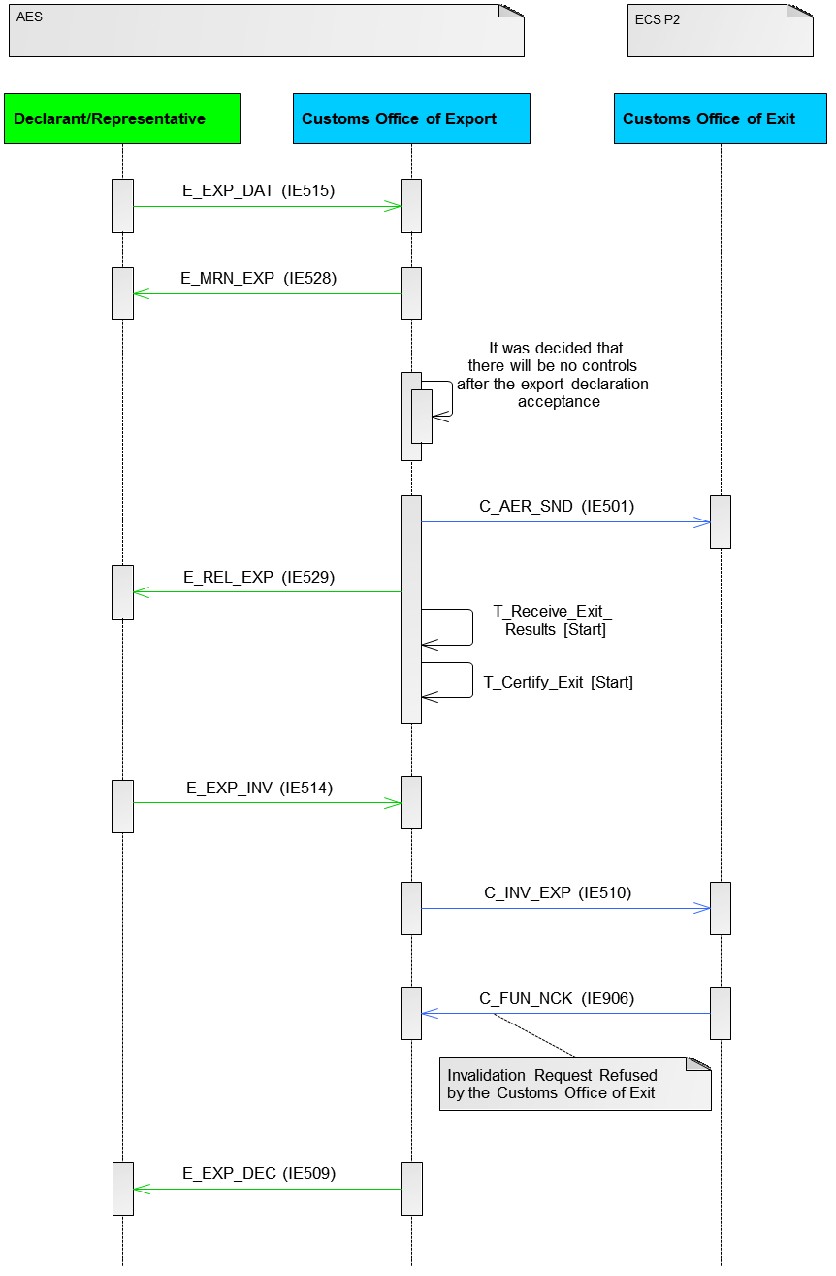

Figure 159: E-EXP-INV-A-TP-009 Invalidation requested by Trader for a released movement refused by the Customs Office of Exit (Transitional Scenario) (Case 1: Office of Export [AES] and Office of Exit [ECS-P2])

It is worth noting that Figure 149 above does not show conversion of messages which might be required for its execution if NECA use a conversion service. It shows only the IE numbers to be exchanged in the Common Domain. Based on the transition strategy, the common domain exchange with a role in the legacy phase (ECS-P2) shall be performed as per ECS-P2 specifications. Appendix A defines the mapping of messages per phase which shall be used for CD IEs conversion (e.g. upgrade from CD501B to CD501C, downgrade from CD510C to CD510B).

##### Case 2: Office of Export [ECS-P2] and Office of Exit [AES]

Figure 160 displays the scenario in which the Declarant/Representative decides to invalidate an Export Declaration after the movement has been released at the Customs Office of Export. According to this scenario, the Customs Office of Exit refuses the invalidation request.

The flow continues up until **[****Step 8****]** of the E-EXP-CFL-M-001 Core flow scenario. In this case, the Declarant/Representative decides to invalidate the Export Declaration for a movement that has been released for export (the movement state at the Customs Office of Export is set to “Goods Released for Export”). The Declarant/Representative submits an invalidation request via an ‘Export Invalidation Request’ E_EXP_INV (IE514) message.

The Customs Office of Export evaluates the invalidation request and ECS-P2 verifies that the invalidation request is valid.

The Customs Officer at the Customs Office of Export decides to allow the invalidation request.

**[Step 9]** The Customs Office of Export proceeds with the invalidation of the Export Declaration. The Customs Office of Export informs the Customs Office of Exit about the declaration invalidation via an ‘Export Invalidation Notification’ C_INV_EXP (IE510) message.

**[Step 10]** The Customs Office of Exit replies negatively to the invalidation notification via a Functional NACK C_FUN_NCK (IE906).

It shall be noted that a similar flow can apply when the Invalidation is initiated by the Customs Officer at Export (as per the scenario E-EXP-INV-A-003 Invalidation initiated by the Customs Officer at Export). That is, in case the Customs Office of Exit replies negatively to the invalidation notification (which was initiated by the Customs Officer at Export) via an Functional NACK C_FUN_NCK (IE906), the Customs Office of Export will inform the Declarant/Representative about the declaration invalidation rejection via an ‘Export Invalidation Decision’ E_EXP_DEC (IE509) and the movement state will remain as is.

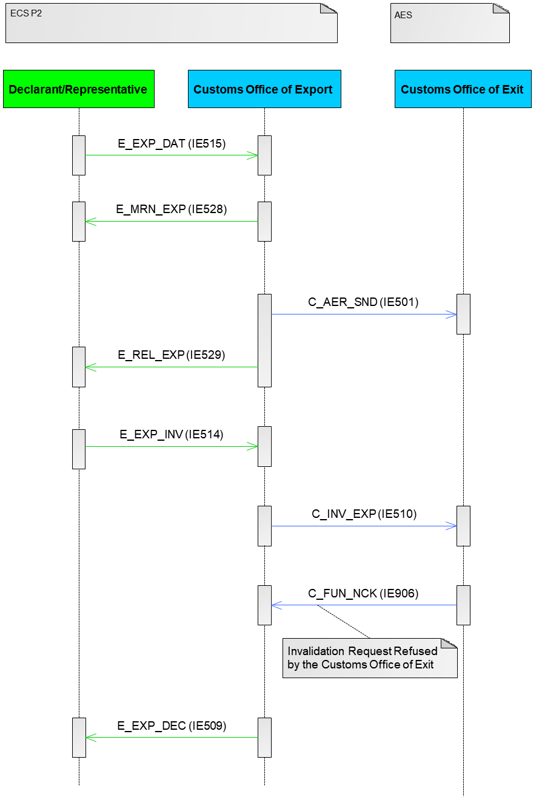

Figure 160: E-EXP-INV-A-TP-009 Invalidation requested by Trader for a released movement refused by the Customs Office of Exit (Transitional Scenario) (Case 2: Office of Export [ECS-P2] and Office of Exit [AES])

It is worth noting that figure above does not show conversion of messages which might be required for its execution if NECA use a conversion service. It shows only the IE numbers to be exchanged in the Common Domain. Based on the transition strategy, the common domain exchange with a role in the legacy phase (ECS-P2) shall be performed as per ECS-P2 specifications. Appendix A defines the mapping of messages per phase which shall be used for CD IEs conversion (e.g. upgrade from CD501B to CD501C, downgrade from CD510C to CD510B).

#### E-EXP-EFT-A-TP-004 Departure notifies Office of Exit for non-appropriate Office of Destination – Release for Exit by alternative evidence (Transitional Scenario)

##### Case 1: Office of Export [AES] and Office of Exit [ECS-P2]

This scenario describes the case of Export Followed by Transit when the Customs Office of Export is in AES and the Customs of Exit is in ECS-P2.

The flow continues up until **[****Step 7****]** of the E-EXP-CFL-M-001 Core flow scenario. In this case however, the Customs Office of Exit interfaces with NCTS and the goods exit is handled in NCTS.

**[Step 8]** ECS-P2 at the Customs Office of Exit will send the ‘Exit Results’ C_EXT_RES (IE518) with Transit flag = ‘1’, Control result code = ‘A4’ and the Transit MRNs declared in PRODUCED DOCUMENTS/CERTIFICATES. The state of the involved export operation is set to the final state “**Exited**”.

**[Step 9]** The Time Limit to Receive Exit Results (T_Receive_Exit_Results) stops in AES at the Customs Office of Export.

AES verifies that the exit control results are found positive at the Customs Office of Export.

The movement state at the Customs Office of Export is set to “Exported” and the Time Limit to Certify Exit (T_Certify_Exit) stops at this point **[Step 10]**.

**[Step 11]** Finally, the Customs Office of Export notifies the Declarant/Representative via an ‘Export Notification’ E_EXP_NOT (IE599) message that the movement has successfully exited the European Union Customs Territory providing all the export details.

The case of not appropriate office is not identifiable in ECS-P2 and hence no further action (alternative evidence) can be performed in AES at the Customs of Export following reception of ‘Exit Results’ C_EXT_RES (IE518). In AES TO-BE functionality, when Customs of Export and Customs of Exit are both in AES phase, the state machine of the Customs of Export will be updated to “Under Exit Confirmation Request” if ‘Exit Results’ C_EXT_RES (IE518) has B2 control result ("not appropriate office") while Customs of Exit state will be set to the final state “Handled Elsewhere”. This transition will not be possible in the scenario of ECS-P2 at the Customs of Exit since will send ‘Exit Results’ C_EXT_RES (IE518) without control result B2 (not supported in ECS-P2) and therefore Customs of Export cannot identify such case. Consequently, the AES at the Customs of Export state will be based on ‘Exit Results’ C_EXT_RES (IE518) control result (A4 or B1) – in this case ‘A4’ - so no alternative evidence will be triggered in AES at the Customs Office of Export.

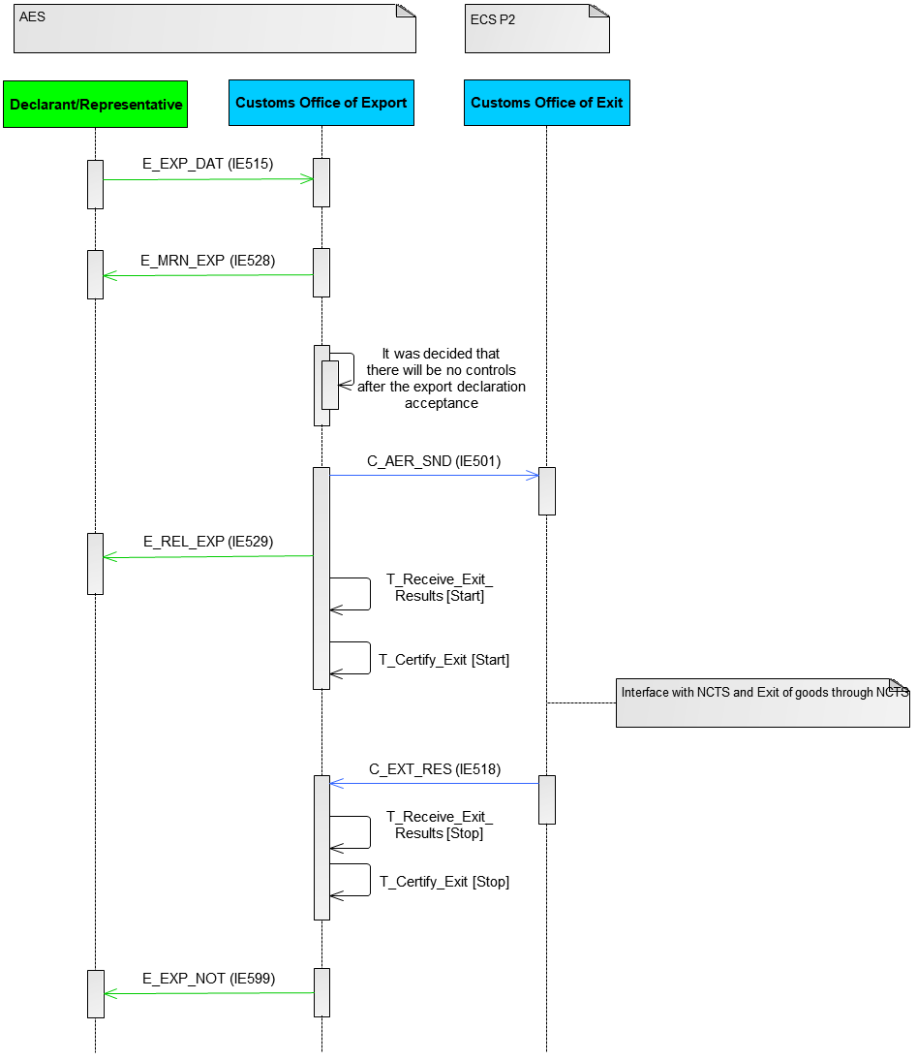

Figure 161: E-EXP-EFT-A-TP-004 Non-appropriate Office of Destination - Release for Exit by alternative evidence (Transitional Scenario) (Case 1: Office of Export [AES] and Office of Exit [ECS-P2])

It is worth noting that figure above does not show conversion of messages which might be required for its execution if NECA use a conversion service. It shows only the IE numbers to be exchanged in the Common Domain. Based on the transition strategy, the common domain exchange with a role in the legacy phase (ECS-P2) shall be performed as per ECS-P2 specifications. Appendix A defines the mapping of messages per phase which shall be used for CD IEs conversion (e.g. upgrade from CD501B to CD501C, downgrade from CD510C to CD510B).

##### Case 2: Office of Export [ECS-P2] and Office of Exit [AES]

This scenario (Figure 162) describes the case when the Customs Office of Export is in ECS-P2 and the Customs Office of Exit in AES. In the particular case, the AES at the Customs Office of Exit receives the ‘Destination Control Results to AES’ N_DES_CON (IE042) message with the flag “Appropriate Office of Destination” = 0 (i.e. non-appropriate Office of Destination).

This scenario starts at **[Step 12]** of the E-EXP-EFT-M-002 Core Flow of the Export Followed by Transit – Internal Transit, however this scenario assumes that the NCTS at the Customs Office of Departure, based on the reception of the ‘Arrival Advice’ C_ARR_ADV (IE006), does not consider the Customs Office of Destination as appropriate and thus the generated ‘Destination Control Results to AES’ N_DES_CON (IE042) message sets the flag ‘Appropriate Office of Destination’ to ‘0-No’ (i.e. non-appropriate Office of Destination).

**[Step 13]** The involved export operations are transited to the final state “Handled Elsewhere” at the Customs Office of Exit.

The process is expected to continue with Follow-up procedure (scenarios ECSP2-EXP-ENQ-TP-Follow-Up with exit resumed (Transitional Scenario) and ECSP2-EXP-ENQ-TP-Follow-Up with negative response (Transitional Scenario)) and/or APoE.

* In case of APoE, Office of Exit (AES), which is in "Handled Elsewhere" state following B2 control result at Office of Exit, shall ignore (not reject) the IE524 without any further processing or change in Office of Exit status;
* In case of invalidation by Office of Export (as an action from follow-up - no sufficient APoE), Office of Exit (AES), which is in "Handled Elsewhere" state following B2 control result at Office of Exit, shall respond with IE591 (downgraded to IE901) without any further processing or change in Office of Exit status. This is needed because Office of Export (ECS-P2) expects a positive acknowledgement to proceed with the cancellation although Office of Exit (AES) is in a final state.



Figure 162: E-EXP-EFT-A-TP-004 Non-appropriate Office of Destination - Release for Exit by alternative evidence (Transitional Scenario) (Case 2: Office of Export [ECS-P2] and Office of Exit [AES])

#### E-EXP-EFT-A-TP-005 Departure notifies Office of Exit for non appropriate Office of Destination – Invalidation due to lack of or insufficient alternative evidence (Transitional Scenario)

Similar to E-EXP-EFT-A-TP-004 Departure notifies Office of Exit for non-appropriate Office of Destination – Release for Exit by alternative evidence (Transitional Scenario)(IV.3.5.2).

Alternative evidence which would lead to invalidation will never be performed. Both sub-scenarios are described in Case 1: Office of Export [AES] and Office of Exit [ECS-P2] (IV.3.5.2.1) and Case 2: Office of Export [ECS-P2] and Office of Exit [AES] (IV.3.5.2.2).

#### E-EXP-QMI-E-TP-001 Movement Information unavailable (Transitional Scenario)

##### Case 1: Office of Export [ECS-P2] and Requesting Customs Office [AES-P1]

This scenario describes the case of “E-EXP-QMI-E-001 Movement Information unavailable” when the Customs Office of Export is in ECS-P2 and the Requesting Customs Office is in AES-P1.

This scenario defines that AES-P1 Requesting Customs Office must consider as valid the reception of ‘Functional NACK’ C_FUN_NCK (IE906) (e.g. unknown MRN) from the Customs Office of Export is in ECS-P2 as a negative response alternative of a ‘Response To Export Query’ C_EXP_RSP (IE538).

**[Step 1]** If the movement information is not available at the Requesting Customs Office, the Requesting Customs Office sends an export query to the Country of Export via an ‘Export Query’ C_EXP_QUE (IE527) message.

**[Step 2]** The Customs Office of Export queries for the movement information and since the information is not available, the Customs Office of Export provides the response to the export query to the Requesting Customs Office via a Functional NACK C_FUN_NCK (IE906) message.



Figure : E-EXP-QMI-E-TP-001 Movement Information unavailable (Transitional Scenario) (Case 1: Office of Export [ECS-P2] and Requesting Customs Office [AES-P1])

##### Case 2: Office of Export [AES-P1] and Requesting Customs Office [ECS-P2]

This scenario describes the case of “E-EXP-QMI-E-001 Movement Information unavailable” when the Customs Office of Export is in AES-P1 and the Requesting Customs Office is in ECS-P2.

**[Step 1]** If the movement information is not available at the Requesting Customs Office, the Requesting Customs Office sends an export query to the Country of Export via an ‘Export Query’ C_EXP_QUE (IE527) message.

**[Step 2]** The Customs Office of Export queries for the movement information and since the information is not available, the Customs Office of Export provides the response to the export query to the Requesting Customs Office via a Functional NACK C_FUN_NCK (IE906) message.



Figure : E-EXP-QMI-E-001 Movement Information unavailable (Transitional Scenario) (Case 2: Office of Export [AES-P1] and Requesting Customs Office [ECS-P2])

#### ECSP2-EXP-ENQ-TP-Follow-Up with exit resumed (Transitional Scenario)

##### Case 1: Office of Export [ECS-P2] and Office of Exit [AES]

The scenario is based on ECS-P2 scenario “Follow-Up with Exit resumed” defined in [R7] and the handling by AES-P1 Customs Office of Exit.

The scenario defines that AES at the Customs Office of Exit must ignore the reception of an ‘Export Follow-Up Request’ C_EXP_FUR (IE584) when the Customs Office of Export is in ECS-P2.

The flow continues with “Follow-Up with Exit resumed” ECS-P2 scenario up until the point where the ECS-P2 Customs Office of Export request an exit confirmation from the AES-P1 Customs Office of Exit via an ‘Export Follow-Up Request’ C_EXP_FUR (IE584) message. In this case, the AES-P1 Customs Office of Exit will receive the ‘Export Follow-Up Request’ C_EXP_FUR (IE584) and will not provide any reply to the ECS-P2 Customs Office of Export and will **not reject** the message[125].

A further action at this point (not depicted in the model) would be to follow “Manual Closure at Export based on alternative proof” ECS-P2 scenario [R7]. In this case, the re-synchronisation sub-case would take place. Following the use of the IE904/IE905 mechanism and assuming that the movement has exited as per “Follow-Up with Exit resumed” ECS-P2 scenario [R7], the AES-P1 Customs Office of Exit will send the Exit Results C_EXT_RES (ΙΕ518) to the ECS-P2 Customs Office of Export.



Figure : ECSP2-EXP-ENQ-TP-Follow-Up with exit resumed (Transitional Scenario)(Case 1: Office of Export [ECS-P2] and Office of Exit [AES])

#### ECSP2-EXP-ENQ-TP-Follow-Up with negative response (Transitional Scenario)

##### Case 1: Office of Export [ECS-P2] and Office of Exit [AES]

The scenario is based on “Follow-Up with negative response” ECS-P2 scenario defined in [R7] and the handling by AES-P1 Customs Office of Exit.

The scenario defines that AES at the Customs Office of Exit must ignore the reception of an ‘Export Follow-Up Request’ C_EXP_FUR (IE584) when the Customs Office of Export is in ECS-P2.

The flow continues with “Follow-Up with negative response” ECS-P2 scenario up until the point where the ECS-P2 Customs Office of Export request an exit confirmation from the AES-P1 Customs Office of Exit via an ‘Export Follow-Up Request’ C_EXP_FUR (IE584) message. In this case, the AES-P1 Customs Office of Exit will receive the ‘Export Follow-Up Request’ C_EXP_FUR (IE584) and will not provide any reply to the ECS-P2 Customs Office of Export and will **not reject** the message125.

A further action at this point (not depicted in the model) would be

* to follow “Manual Closure at Export based on alternative proof” ECS-P2 scenario [R7] and specifically the APoE case would take place. Following the use of the IE904/IE905 mechanism and assuming that the movement has not exited as per “Follow-Up with negative response” ECS-P2 scenario [R7], the ECS-P2 Customs Office of Export will send the ‘Forwarded Arrival Advice’ C_ARR_FWD (IE524) to the AES-P1Customs Office of Exit (handling as diversion).
* to decide the movement cancellation at the ECS-P2 Customs Office of Export following the use of the IE904/IE905 mechanism and the identification that the movement has not exited.



Figure : ECSP2-EXP-ENQ-TP-Follow-Up with negative response (Transitional Scenario) (Case 1: Office of Export [ECS-P2] and Office of Exit [AES])

#### E-EXP-EFT-A-TP-006 Departure notifies Office of Exit of unsatisfactory destination control results - Release for Exit by alternative evidence (Transitional Scenario)

##### Case 1: Office of Export [AES] and Office of Exit [ECS-P2]

This scenario describes the case of Export Followed by Transit when the Customs Office of Export is in AES and the Customs of Exit is in ECS-P2.

The flow continues up until **[****Step 7****]** of the E-EXP-CFL-M-001 Core flow scenario. In this case however, the Customs Office of Exit interfaces with NCTS and the goods exit is handled in NCTS.

**[Step 8]** ECS-P2 at the Customs Office of Exit will send the ‘Exit Results’ C_EXT_RES (IE518) with Transit flag = ‘1’, Control result code = ‘A4’ and the Transit MRNs declared in PRODUCED DOCUMENTS/CERTIFICATES. The state of the involved export operation is set to the final state “**Exited**”.

**[Step 9]** The Time Limit to Receive Exit Results (T_Receive_Exit_Results) stops in AES at the Customs Office of Export.

AES verifies that the exit control results are found positive at the Customs Office of Export.

The movement state at the Customs Office of Export is set to “Exported” and the Time Limit to Certify Exit (T_Certify_Exit) stops at this point **[Step 10]**.

**[Step 11]** Finally, the Customs Office of Export notifies the Declarant/Representative via an ‘Export Notification’ E_EXP_NOT (IE599) message that the movement has successfully exited the European Union Customs Territory providing all the export details.

The case of unsatisfactory destination control results is not identifiable in ECS-P2 and hence no further action (alternative evidence) can be performed in AES at the Customs of Export following reception of ‘Exit Results’ C_EXT_RES (IE518). In AES TO-BE functionality, when Customs of Export and Customs of Exit are both in AES phase, the state machine of the Customs of Export will be updated to “Under Exit Confirmation Request” if ‘Exit Results’ C_EXT_RES (IE518) has B3 control result (not satisfactory control results) while Customs of Exit state will be set to the final state “Handled Elsewhere”. This transition will not be possible in the scenario of ECS-P2 at the Customs of Exit since will send ‘Exit Results’ C_EXT_RES (IE518) without control result B3 (not supported in ECS-P2) and therefore Customs of Export cannot identify such case. Consequently, the AES at the Customs of Export state will be based on ‘Exit Results’ C_EXT_RES (IE518) control result (A4 or B1) – in this case ‘A4’ - so no alternative evidence will be triggered in AES at the Customs Office of Export.



Figure : E-EXP-EFT-A-TP-006 Departure notifies Office of Exit of unsatisfactory destination control results - Release for Exit by alternative evidence (Transitional Scenario) (Case 1: Office of Export [AES] and Office of Exit [ECS-P2])

##### Case 2: Office of Export [ECS-P2] and Office of Exit [AES]

This scenario (Figure 168) describes the case when the Customs Office of Export is in ECS-P2 and the Customs Office of Exit in AES. In the particular case, the AES at the Customs Office of Exit receives the ‘Destination Control Results to AES’ N_DES_CON (IE042) message with major discrepancies registered.

This scenario starts at **[Step 12]** of the E-EXP-EFT-M-002 Core Flow of the Export Followed by Transit – Internal Transit, however this scenario assumes that the NCTS at the Customs Office of Departure registers ‘Destination Control Results to AES’ N_DES_CON (IE042) with major discrepancies.

**[Step 13]** The involved export operations are transited to the final state “Handled Elsewhere” at the Customs Office of Exit.

The process is expected to continue with Follow-up procedure (scenarios ECSP2-EXP-ENQ-TP-Follow-Up with exit resumed (Transitional Scenario) and ECSP2-EXP-ENQ-TP-Follow-Up with negative response (Transitional Scenario)) and/or APoE.

* In case of APoE, Office of Exit (AES), which is in "Handled Elsewhere" state following B3 control result at Office of Exit, shall ignore (not reject) the IE524 without any further processing or change in Office of Exit status;
* In case of invalidation by Office of Export (as an action from follow-up - no sufficient APoE), Office of Exit (AES), which is in "Handled Elsewhere" state following B3 control result at Office of Exit, shall respond with IE591 (downgraded to IE901) without any further processing or change in Office of Exit status. This is needed because Office of Export (ECS-P2) expects a positive acknowledgement to proceed with the cancellation although Office of Exit (AES) is in a final state.



Figure : E-EXP-EFT-A-TP-006 Departure notifies Office of Exit of unsatisfactory destination control results - Release for Exit by alternative evidence (Transitional Scenario) (Case 2: Office of Export [ECS-P2] and Office of Exit [AES])

#### E-EXP-EFT-A-TP-007 Departure notifies Office of Exit of unsatisfactory destination control results - Invalidation due to lack of or insufficient alternative evidence

Similar to E-EXP-EFT-A-TP-004 Departure notifies Office of Exit for non-appropriate Office of Destination – Release for Exit by alternative evidence (Transitional Scenario)(IV.3.5.2).

Alternative evidence which would lead to invalidation will never be performed. Both sub-scenarios are described in Case 1: Office of Export [AES] and Office of Exit [ECS-P2] and Case 2: Office of Export [ECS-P2] and Office of Exit [AES].

## Principles for Data Structures and IEs during TP

### Data Mapping and Conversion of IEs

The conversion of IEs from one phase to another can be employed by NAs in the “To Be” phase for the smooth transition of operations during the Transition Period and to facilitate Protocol for Common Domain exchanges during TP as defined in section IV.5 and the communication with “Legacy” protocol.

There are two sub-types of the IE conversion process as show in Figure 169:

* **Upgrade**: a process when a source IE message in “Legacy” structural format is to be converted (upgraded) to the target IE message in “To Be” structural format applicable during the transition period.
* **Downgrade**: a process when a source IE message in “To Be” structural format is to be converted (downgraded) to the target IE message in “Legacy” structural format.

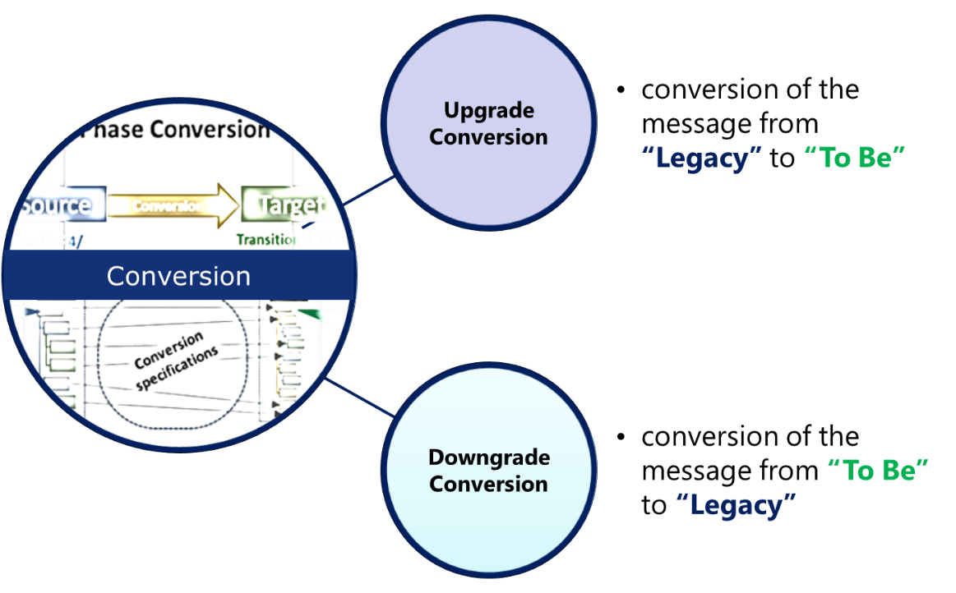

Figure : Upgrade and Downgrade IE conversion

The Data Mapping Package (DMP) [R9] of “Legacy” vs. “To Be” defines the Data Mapping Artefacts & Reports for the “To Be”. The DMP incorporates, amongst other artefacts, the definition of Data Mapping per IE message. The latter specifies:

* the data elements (Data Groups and Data Items) applicable to pertinent IE message of the “To Be” system under assessment and for each data element,
* a mapping to the relevant data elements (Data Groups and Data Items) of current operational systems (“Legacy”).
* per data element information like multiplicity, optionality, format, applicable codelist, applicable R&Cs.
* for each data mapping item, the resolution for Upgrade and Downgrade and whenever a TRT and/or BRT (IV.4.2) must be applied along with tracking information.

The DMP [R9] is the major input along with the messages structures of DDXNA appendices in order to define the Conversion Technical Specifications (CTS) package [R8]. The Conversion Technical Specifications (CTS) is the technical specifications for the conversion of IEs by defining for each IE the conversion (upgrade or downgrade) both in human readable format and technical format (XSLT). The Conversion Technical Specifications (CTS) complements common specifications of DDNA for the conversion process during the Transition Period.

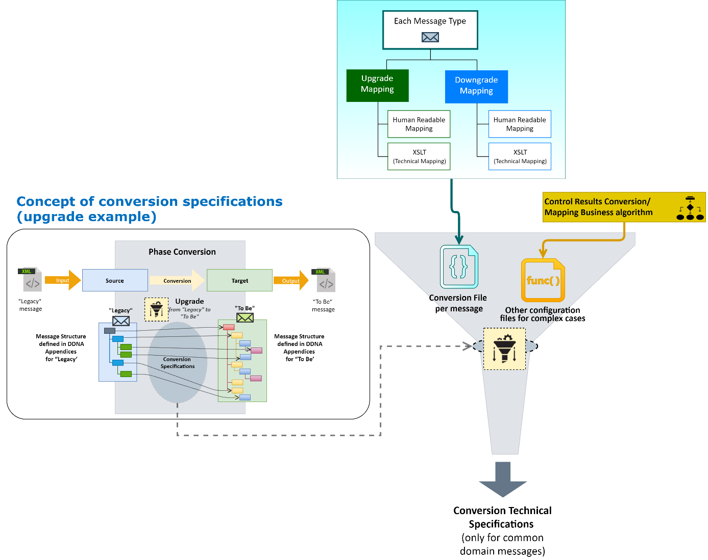

Figure : Conversion Technical Specifications

|  |  |
| --- | --- |
| 1. Warning | 1. The Conversion Technical Specifications (CTS) [R8] package will be the reference package for the conversion process during the Transition Period. 2. The Conversion Technical Specifications (CTS) [R8] package concerns only the Common Domain IEs. For External Domain, only data mapping is provided as strongly recommended in DMP [R9]. 3. The conversion of IEs irrespective of implementation (National implementation, N/ieCA, C/ieCA) must be compliant with Conversion Technical Specifications (CTS) [R8]. 4. CS/ieCA will use the Conversion Technical Specifications (CTS) package [R8] for the conversion. |

Please refer to Table 17 in section IV.3.1.1, which presents Common Domain IEs for conversion.

### Technical Message Structures

The Technical Message Structures for “To Be” phase is defined in IV.3 of DDCOM [A11] and further explained in [A10]. Therefore, the *Transitional Structural Constraints* with the form of TRTs (Technical Rules for Transition) and the *Business Structural Changes/Constraints* with the form of BRTs (Business Rules for Transition) have been added on top of applicable Rules and Conditions to facilitate the smooth transition with one implementation of “To Be” NA.

TRTs and BRTs (category 1 (BRT-1) and category 2 (BRT-2)) are applied based on certain timing conditions:

* A TRT is a restriction enforcing stricter message structure before the end of the TP. Its purpose is to ensure message compatibility with pre-UCC (“Legacy”) NCAs during TP. A TRT is applicable when message submission date ≤ end of TP.
* A BRT-1 enforces a relaxed validation of R/C before the end and is applicable for the whole lifecycle of any movement opened during the Transitional Period. A BRT-1 is applicable (validated) only when Decl. acceptance date ≤ end of TP. So, BRT-1 is related with the movement lifecycle.
* A BRT-2 applies some UCC data requirements, defining the final structure for movements accepted after transition. A BRT Category 2 is applicable (validated) when Decl. acceptance date > end of TP. So, BRT-2 is related with the movement lifecycle.

Figure 171 shows all classes of Rules and Conditions applicable in a Technical Message Structure of “To Be” phase as per DDCOM principles [A11].

Section IV.4.3 defines the decisive date for validating TRTs and BRTs per case.

Finally, Figure 171 shows that there is a sequence of validation. The logic of validation is defined in IV.6 of DDCOM [A11]. Figure 172 shows how the Technical Message Structure is adapted based on the applicability of TRTs and BRTs during Transition Period and after Transition (final period).



Figure : Technical Message Structures and BRTs/TRTs

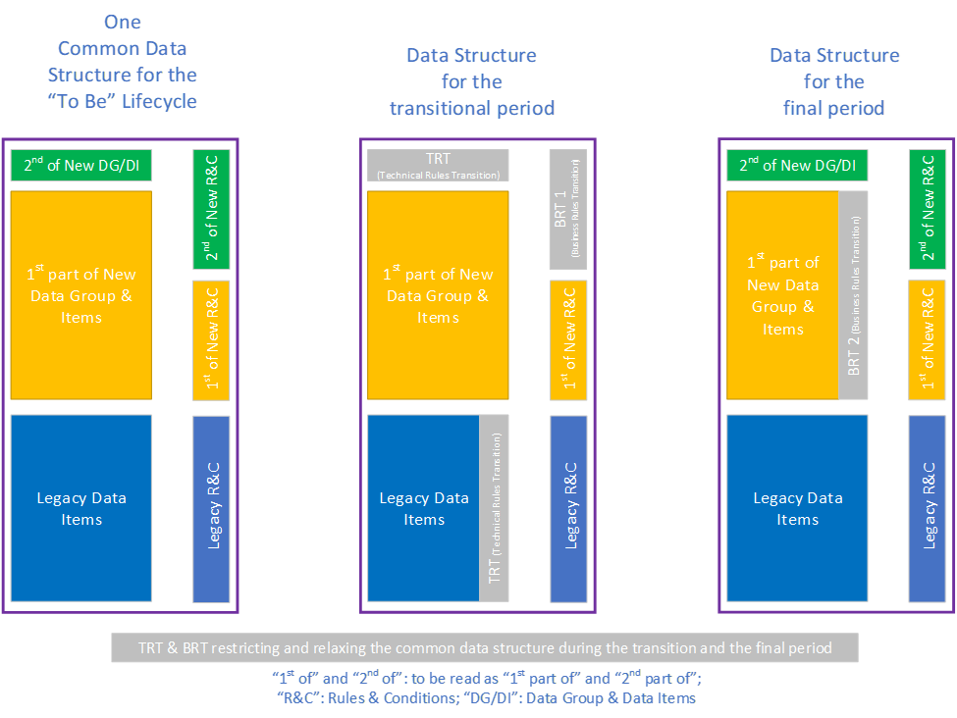

Figure : The data structure for the transition and final periods by orchestrating the BRT and TRT

### Decisive date for BRT/TRT validation

The following Table 40 defines the decisive date and the timing conditions per case for validating TRTs and BRTs.

|  |  |  |  |  |
| --- | --- | --- | --- | --- |
| **Class of Rule** | **Related CD IEs** | **Related ED/ND IEs** | **Decisive Date** | **Timing Condition for TRT/BRT Validation** |
| **TRT** | All IEs where TRTs are applicable | | Submission date/Reception date of IE by NCA  (system date and time) | Decisive Date ≤ end date of TP |
| **BRT-1** | All IEs where BRT-1s are applicable | CC515C, CC507C | Reception date of IE by NCA  (system date and time) | Decisive Date ≤ end date of TP |
| All IEs except CC515C, CC507C where BRT-1s are applicable | Declaration acceptance date  (declarationAcceptanceDate) | Decisive Date ≤ end date of TP |
| **BRT-2** | All IEs where BRT-2s are applicable | CC515C, CC507C | Reception date of IE by NCA  (system date and time) | Decisive Date > end date of TP |
| All IEs except CC515C, CC507C where BRT-2s are applicable | Declaration acceptance date  (declarationAcceptanceDate) | Decisive Date > end date of TP |

Table : Decisive date for BRT/TRT validation

### Codelist Analysis and Mapping between “Legacy” and “To Be”

A number of new codelists defined and some existing codelists changed in compliance with UCC [A1] requirements. The “To Be” codelists are used in the “To Be” message structures as defined in DDNXA Appendices of “To Be”

A codelist mapping and codelist value mapping analysis performed between “Legacy” and “To Be” only for the common codelists (defined in CS/RD2). This codelist analysis is important during the Transition Period and is required for the proper IE conversion process. The codelist analysis outcome for common codelists is defined in [R9].

For national Codelists or Codelists containing national values, it is NA responsibility to perform such mapping. This is activity is considered as required in the context of transition in external domain.

### R&Cs in NCTS-P4/ECS-P2

Any R/Cs common to “Legacy” and “To Be” must remain synchronized to avoid rejections in Common Domain exchanges (after conversion) during the Transition Period. Any change on NCTS-P4/ECS-P2 will be handled via change management of those systems.

## Protocol for Common Domain exchanges during TP

The Common Domain Protocol Policy is the set of Technical Systems Specifications applicable during the Transitional Period. It contains the “Legacy” DDNA, the “To Be” DDNA and the transitional rules of interoperability defined below.

The framework of common domain policy is defined in AES and NCTS-P5 Transition Implementation [A10] built on the rules of **Protocol interoperability**:

* The applicable DDNA (“Legacy” or “To Be”) for the IE at stake, and the associated upgrade-conversion or downgrade-conversion of the IE at the sending & receiving side.

Note there is no need for a receiving “To Be” NA to firewalling its “Legacy” traders from undue new “To Be” IEs as the previous sections have NOT identified ANY scenario which would raise such a risk and therefore justify such a defensive mechanism.

To be noted that during the transition window (see 4.1.3 of AES and NCTS-P5 Transition Implementation [A10]) some “To Be” NA may only serve/support the business continuity part of the “To Be” scope. They will declare this in the CS/MIS (see section IV.2.2).

### General principles

The following generic principles must be applied by NA in “To Be” operational mode during TP:

1. Sender NA in “To Be” operational mode shall always perform identification of Recipient NA operational mode prior submission to the Common Domain and check in CS/MIS whether the receiving NA is supporting the scenario/IE/State in which the sending NA wishes to engage the receiving NA.
2. Receiving NA in “To Be” operational mode shall check and assign the incoming IE to the system which will be responsible to handle it as per national implementation and on the basis whether it concerns movement record creation (e.g. IE501/IE503) or movement record update (other IEs such as IE510).

### Common domain exchange patterns

During the TP, the common domain exchanges will involve NAs in of the following operational mode:

* NA in “Legacy” operational mode
* NA in “To Be” operational mode

Combining the above cases, the following five common domain exchange patterns have been identified during the transition period as defined in Table 41. Each pattern refers at IE level and for each IE per scenario. A scenario might use more than one CD exchange pattern.

| Pattern | Group | Sending NA operational mode | Receiving NA operational mode | STD-IE Scope Applicable in the CD |
| --- | --- | --- | --- | --- |
|  | CD exchanges between NAs in “Legacy” | “Legacy” | “Legacy” | * “Legacy” protocol [R7] |
| 2 | CD exchanges between NA in “Legacy” and NA “To Be” | “Legacy” | “To Be” | * “Legacy” protocol [R7] |
| 3 | “To Be” | “Legacy” | * “Legacy” protocol [R7] |
| 4 | CD exchanges between NAs in “To Be” | “To Be” (sending in “To Be” Interface) | “To Be” | * Mandatory Existing processes (continuity) (IV.3.1) * New processes between “To Be” countries (IV.3.2) * Existing processes upgraded under UCC to be applied at the end of the Transition (IV.3.4) |
| 5 | “To Be” (sending in “Legacy” Interface)[126] | “To Be” | * “Legacy” protocol [R7] |

Table : Common Domain exchanges patterns during TP

# Central Services

The Section II of DDCOM [A11] is applicable to AES.

# Systems Administration

The Section III of DDCOM [A11] is applicable to AES.

# Technical Message Structure

The Section IV of DDCOM [A11] is applicable to AES.

# Design principles

The Section V of DDCOM [A11] is applicable to AES. Any deviation or AES specific information is specified below.

## Approach

The Section V.1 of DDCOM [A11] is applicable to AES. However, it should be noted that, as stated, the GRN is a key to uniquely identify the Guarantee Information only in Transit.

## Exception Handling

Section V3 and V5 of DDCOM [A11] are applicable to AES-P1 and define the exception handling mechanism and principles. These sections define what shall be implemented for AES-P1 in terms exception handling both after and during Transition Period. It should be noted that for AES-P1 External Domain the following messages are used to report functional errors:

* Rejection from Office of Export (IE556: E_EXP_REJ);
* Rejection from Office of Exit (IE557: E_EXT_REJ).

## Constraints

### Timing constraints

See Section Timers of this document.

### Suspension of sending messages

The following table identifies, which messages should not be sent to an NA when each of the following specific Business Services is unavailable at that NA.  
The Suspension of sending messages must apply only in case of System Unavailability Type “N” as described in II.2.2.4 of DDCOM [A11].

| **Technical code** | **Messages** |
| --- | --- |
| L-All | IE071, IE412, IE501, IE502, IE503, IE510, IE518, IE524, IE527, IE533, IE538, IE540, IE541, IE542, IE543, IE545, IE563, IE564, IE588, IE591, IE592, IE594, IE595, IE601, IE603, IE906, IE908, IE909, IE910, IE911, IE917, IE971 |
| P – Presentation Processing | IE540, IE542, IE543, IE564, IE592 |
| S – Exit Summary Declaration Processing | IE601, IE603 |

Table 42: Suspension of sending messages for AES

# XML message formatting

The Section VII of DDCOM [A11] is applicable to AES.

# Transport of messages via CCN/CSI

The Section VIII of DDCOM [A11] is applicable to AES defining the principles for the Transport of messages via CCN/CSI. Any deviation or AES specific information is specified below

## The CCN communication reminder

### The Quality of Service

The Section VIII.2.6 of DDCOM [A11] is applicable to AES.

In the following table the main messages for AES are defined.

| **IE** | **IE Name** | **Reference** | **Message Type string** | **H.P.[127]** | **CORE[128]** |
| --- | --- | --- | --- | --- | --- |
| 411 | Sending of statistics data | C_STA_SND | “CD411C -MSG.AES”  &  “CD411C -MSG.AES” |  |  |
| 501 | AER | C_AER_SND | “CD501C-MSG.AES” |  |  |
| 502 | Declaration Request Export | C_EXP_REQ | “CD502C-MSG.AES” |  |  |
| 503 | AER Response | C_AER_RSP | “CD503C-MSG.AES” |  |  |
| 510 | Export Invalidation Notification | C_INV_EXP | “CD510C-MSG.AES” |  |  |
| 518 | Exit Results | C_EXT_RES | “CD518C-MSG.AES” |  |  |
| 524 | Forwarded Arrival Advice | C_ARR_FWD | “CD524C-MSG.AES” |  |  |
| 527 | Export Query | C_EXP_QUE | “CD527C-MSG.AES” |  |  |
| 533 | Matched Data Declaration | C_MAT_DAT | “CD533C-MSG.AES” |  |  |
| 538 | Response to Export Query | C_EXP_RSP | “CD538C-MSG.AES” |  |  |
| 540 | Pre-release/Control Notification | C_PRC_NOT | “CD540C-MSG.AES” |  |  |
| 541 | Control Results from Presentation Customs Office | C_PRE_RES | “CD541C-MSG.AES” |  |  |
| 542 | Release Rejection Notification | C_PRE_REJ | “CD542C-MSG.AES” |  |  |
| 543 | Release Notification to Presentation Customs Office | C_REL_PRE | “CD543C-MSG.AES” |  |  |
| 545 | Pre-release/Control Acknowledgement | C_PRE_ACK | “CD545C-MSG.AES” |  |  |
| 563 | Control Decision from Presentation Customs Office | C_PRE_DEC | “CD563C-MSG.AES” |  |  |
| 564 | Reminder for Control Decision | C_CTR_REM | “CD564C-MSG.AES” |  |  |
| 588 | Certification of Exit on Alternative Evidence Notification | C_ALT_EVD | “CD588C-MSG.AES” |  |  |
| 591 | Invalidation Acknowledgement | C_INV_ACK | “CD591C-MSG.AES” |  |  |
| 592 | Exit Results to Presentation Customs Office | C_EXT_PCO | “CD592C-MSG.AES” |  |  |
| 601 | EXS | C_EXS_SND | “CD601C-MSG.AES” |  |  |
| 603 | Exit Summary Declaration Response | C_EXS_RSP | “CD603C-MSG.AES” |  |  |
| 594 | Status Request | C_STD_REQ | “CD594C-MSG.AES” |  |  |
| 595 | Status Response | C_STD_RSP | “CD595C-MSG.AES” |  |  |
| 906 | Functional NACK | C_FUN_NCK | “CD906C-MSG.AES” |  |  |
| 917 | XML NACK | XML NACK | “CD917C-MSG.AES” |  |  |

Table 43: Main Information Exchanges for AES

1. Action: I = Insert; R = Replace
2. Applicable to NCTS-P4, ECS-P2 and ICS-P1
3. Applicable to NCTS-P5 and AES
4. In alignment with ECS-P2
5. Guidelines attached dictating the cases this data element must be filled in.
6. An Authorisation is not always necessary in the declaration.
7. Once revised to align with the latest legal provisions and the final accepted technical specifications as stated in section I.2.3
8. The paper-based declaration for AES is not part of the UCC legislation. During the transitional period, the EAD paper-based document can be used as in ECS-P2. Regarding the post transitional period, additional description for the usage of the EAD will be provided in the Export Guidance document for MSs and Trade.
9. Depending on the national implementation, ‘Exit Notification’ E_EXT_NOT (IE590) could be provided by a Port Authority via existing commercial, port or transport information system or by the carrier at exit.
10. The Article 172 (1) of the UCC foresees that to accept a Customs declaration the goods must be presented to Customs. The Article 226 of UCC IA defines that the declarant must be notified and receive the MRN number upon acceptance of the declaration.
11. Since this IE560 simply indicates a Control Intention (i.e. indicates that the Customs Officer at the OoExp has the intention to potentially control the goods after they arrived) and does not indicate a Control Decision, this IE560 (indicating Control Intention) will not change the movement state. After acceptance (state "Accepted"), another IE560 (indicating Control Decision) will be sent in case there is a control decision to perform controls. In this case, since the IE560 indicates Control Decision (and not intention) the state will be updated to "Under Control".
12. The “TRANSPORT EQUIPMENT” (in case of containerised goods) and “LOCATION OF GOODS” recorded in the ‘Export Presentation Notification’ E_PRE_NOT (IE511) shall be considered as the baseline data (concerning transport equipment and location of goods) for the particular Export Declaration.
13. NAs may decide to implement the specific case following the suggested flow of this scenario or the standard Export Core Flow (E-EXP-CFL-M-001).
14. In the scenarios of Centralised Clearance for Export, the Supervising Customs Office is the Customs Office of Export.
15. In DDNXA the Export declaration is transmitted from the SCO to the PCO after the full validation of the SCO and the acceptance of the declaration and the completion of risk analysis. This is stated in the Article 231 of UCC IA 2015/2447, as follows: “Where the supervising customs office has accepted the customs declaration transmits immediately to the customs office of presentation the customs declaration and the results of the related risk analysis”. The PCO performs the necessary controls and validation including risk analysis for national purposes, upon receipt of the declaration and notify about its intention to perform controls, considering also the initial recommendation of the SCO. All required supporting documents for both the PCO and SCO are included in IE515. Codification relies on commonly defined and governed code lists to allow harmonization and proper declaration validation. In the case that any additional documents should be requested by PCO from the Declarant/Representative (through the SCO), the mechanism has been designed in CCE for enabling this.
16. The SCO is the office responsible for validating and accepting the Export Declaration, that is why it performs all validations (including cross-check) and all communication with the Member State of Export. All the validations concern the content of the declaration (including the cross-check which concern the content of the e-ADs against the content of the Export Declaration). Following principles apply:

    Legally the e-AD is forwarded to the Member State where the export declaration is lodged (Article 21 of the Recast Excise Directive), which is also the Member State where the SCO is situated. This means, that goods may not be located next to the MSA of Export;

    SCO will do the documentary cross-check. In case information needs to be available at the PCO for performing the required controls, EMCS system provides the mechanism (IE904-IE905-IE934) to retrieve all required information (this mechanism does not involve message exchange between PCO NECA and EMCS). See DDNEA Appendix D under EMCS project [R7], for the latest valid specifications.
17. In export the approved functional specifications and as well all discussions with MS participating in the project activities and bilateral discussions with other ECCG members led to the following conclusion: there is a one to one relationship between the Simplified and the Supplementary Declaration. The process of submission of the periodic aggregated declarations (for the case of Entry into the declarant’s records for Export) does not fall under AES scope but under the National Export systems processes as defined in AES Business Case and Vision Document. Nevertheless, TAXUD in collaboration with MS will analyse the request expressed by some Member States, to define this national message of the External domain (to be used for the case of Entry into the declarant’s records and simplified declarations for Export) and include it as an Addendum to the DDNXA accepted package in 2020.
18. Provided that the Supervising Customs Office decides that documentary controls are required (by the Supervising Customs Office) with the need to request documents, AES at the Supervising Customs Office also sends to the Declarant/Representative an ‘Export Control Decision Notification’ E_EXP_CTR (IE560) for requesting documents during the documentary controls, prior to the ‘Pre-release/Control Notification’ C_PRC_NOT (IE540 recommending Pre-release). In this case, since a ‘Pre-release/Control Notification’ C_PRC_NOT (IE540 recommending Pre-release) was preceded by a control decision, the state of the movement at the Supervising Customs Office is updated from “Accepted” to “Under Control”.
19. The communication of the requested documents from the Declarant/Representative to the Supervising Customs Office (following an ‘Export Control Decision Notification’ E_EXP_CTR (IE560) from the Supervising Customs Office to the Declarant/Representative) is up to national implementation (e.g. national single window), so it is handled outside the system.
20. In case where the controls which are deemed required are documentary controls without the need to request any documents, the flow alters by not including the communication from AES at the Supervising Customs Office to the Declarant/Representative via an ‘Export Control Decision Notification’ E_EXP_CTR (IE560). At any case, the state of the movement at the Supervising Customs Office is updated to “Under Control”.
21. The Control Result Code equal to “A2: Considered Satisfactory” is used, when the Presentation Customs Office was not able to perform the declared controls, even though the previously sent ‘Control Decision from Presentation Customs Office’ C_PRE_DEC (IE563) had indicated the decision of the Presentation Customs Office to perform controls.
22. The same message exchanges will be transmitted in case where documentary controls are deemed required to be performed by Supervising Customs Office without the need to request documents, and the control results are satisfactory. The only difference lies in that no Export Control Decision Notification’ E_EXP_CTR (IE560) is communicated to the Declarant/Representative about the upcoming documentary controls. At any case, the state of the movement at the Supervising Customs Office is updated from “Accepted” to “Under Control”.
23. No matter if a ‘Customs Export Control Decision Notification’ E_EXP_CTR (IE560) for requesting documents during documentary controls was previously sent (Step 3) to the Declarant/Representative, another IE560 (for notifying controls) is sent at this point informing the Declarant/Representative about the physical controls or other type of controls which may need the physical presence of the Declarant/Representative and for requesting documents, if necessary.
24. It may be a case the Presentation Customs Office to decide on documentary controls to be performed, without the need to request documents. At this case, this step is redundant as no Customs Export Control Decision Notification’ E_EXP_CTR (IE560) will be communicated from the Supervising Customs Office to the Declarant/Representative upon these control activities. At any case, the state of the movement at the Supervising Customs Office remains as is (“Under Control”).
25. The Control Result Code equal to “A2: Considered Satisfactory” is used, when the Presentation Customs Office was not able to perform the necessary controls.
26. If after acceptance of the Export Declaration the Trader requests the Export Declaration to be amended and this request is accepted, the ‘Pre-release/Control Notification’ C_PRC_NOT (IE540) that is sent to the PCO contains the information of the amended Export Declaration. This amendment can happen only after the acceptance of the declaration and before SCO concludes its assessment in terms of release/controls and has communicated this information to the PCO.
27. It must be highlighted, that the ‘Invalidation Acknowledgement’ C_INV_ACK (IE591) result (positive/negative) shall consider the latest information including the case of national diversion. Even though the ‘Export Invalidation Notification’ C_INV_EXP (IE510) is sent to the Customs Office of Exit received the AER C_AER_SND (IE501) or latest ‘AER Response’ C_AER_RSP (IE503) positive (in case of international diversion) from Customs Office of Export, the received National application shall respond with the latest information available nationally. This means that if national diversion has occurred, the ‘Invalidation Acknowledgement’ C_INV_ACK (IE591) shall include the latest Customs Office of Exit handling the export operation (following national diversions) and shall consider the status at that office for responding.
28. In NCTS P5 the differentiation in invalidation after release for transit, is that the Office of Departure is able to invalidate the transit declaration (after receiving a request from the Holder of the Transit Procedure by alternative non-electronic means) only if the following conditions are satisfied:

    The state of the movement is any of the following:

    Movement released, or

    Enquiry recommended, or

    Under enquiry request;

    The ‘Arrival Advice’ C_ARR_ADV (IE006), the ‘Notification Crossing Frontier’ C_NCF_NOT (IE118), the ‘Notification Leaving Security Area’ (IE168), the ‘Incident Notification’ C_INC_NOT (IE180) messages have not been receive.
29. The allowable states for invalidation in the Customs Office of Exit are depicted in section III.5.3.1.2.
30. MUST CN Code List: “Must” is a value of an attribute that accompanies CN codes in the relevant reference data list. Goods falling within the MUST CN codes are always Excise goods. As described in [Step 1] above, in case an ‘Export Declaration’ E_EXP_DAT (IE515) contains a Commodity Code in the MUST CN list which does not have any reference to the e-AD (by ARC and UBR), the automatic process must be re-directed for a manual decision by the Customs Officer that will case by case either accept the Export Declaration without reference to e-AD or reject it (the rejection of an Export Declaration demands the submission of a new one).
31. MAY CN Code list: “May” is a value of an attribute that accompanies CN codes in the relevant reference data list. Goods falling within the MAY CN codes could be Excise goods, but not necessarily. If the Commodity Code concerns Excise goods that belong to the MAY CN Code List, then the ARC and UBR are optional in the Export Declaration E_EXP_DAT (IE515). When both are provided (ARC and UBR) the Export Declaration E_EXP_DAT (IE515) is processed as per the present flow, with goods under excise duty suspension arrangement (hence the interface with EMCS is applicable). When the ARC and/or UBR are not provided, the Export Declaration E_EXP_DAT (IE515) is processed without interfacing with EMCS (E-EXP-CFL-M-001 Core ).
32. It shall be noted that the e-ADs (that their ARCs and UBRs are provided in the ‘Export Declaration’ E_EXP_DAT (IE515)) do not necessarily come from the same Excise consignor. Thus, the ‘Export Declaration’ E_EXP_DAT (IE515) may contain information that concerns multiple Excise consignors.
33. Multiple ‘e-AD Request’ N_EAD_REQ (IE532) messages may be sent, i.e. as many as the number of the different ARC contained in the specific ‘Export Declaration’ E_EXP_DAT (IE515). Then, the AES at the Customs Office of Export expects from the EMCS at the MSA of Export the corresponding number of response messages (either positive: ‘e-AD’ N_EAD_VAL (IE801) messages; or negative: ‘e-AD Request Rejection’ N_EAD_REJ (IE8xx) messages).
34. The specifications of the ‘e-AD’ N_EAD_VAL (IE801) and ‘e-AD Request Rejection’ N_EAD_REJ (IE8xx) are provided in the folder EMCS_IEs of the DDNXA Appendices for demonstration purposes only. See DDNEA Appendix D under EMCS project [R7], for the latest valid specifications.
35. The validations to be performed as part of the cross-checking are classified according to their optionality (Mandatory or Recommended) and to their implementation time (2022 or 2024 considering the legislation enforcement), as follows:

    For **each e-AD Body** in the ‘e-AD’ N_EAD_VAL (IE801), **there is a GOODS ITEM** in the Export Declaration E_EXP_DAT (IE515) which has:

    **Mandatory Steps to be implemented by 2022 (for Member States in AES-P1)**:

    * The same ARC (as the respective e-AD);
    * The same UBR.

    **Mandatory Steps to be implemented by 2024 (for all Member States):**

    * The same CN Code;
    * The same Net mass.

    **Recommended Step to be implemented by 2024 (for all Member States):**

    * Supplementary units;
    * The respective e-AD in the correct state.

   
36. One ‘Export Declaration Acceptance Notification to MSA of Export’ N_MSA_ACC (IE539) is sent per ‘Export Declaration’ E_EXP_DAT (IE515). That is, the ‘Export Declaration Acceptance Notification to MSA of Export’ N_MSA_ACC (IE539) concerns all e-ADs (ARCs) contained in the respective ‘Export Declaration’ E_EXP_DAT (IE515).
37. One ‘Release for Export Notification to MSA of Export’ N_REL_DES (IE535) is sent per ‘Export Declaration’ E_EXP_DAT (IE515). That is, the ‘Release for Export Notification to MSA of Export’ N_REL_DES (IE535) concerns all e-ADs (ARCs) contained in the respective ‘Export Declaration’ E_EXP_DAT (IE515).
38. One ‘e-AD Negative Cross Check Result’ N_EAD_RES (IE537) is sent per ‘Export Declaration’ E_EXP_DAT (IE515). That is, the ‘e-AD Negative Cross Check Result’ N_EAD_RES (IE537) concerns all e-ADs (ARCs) contained in the respective ‘Export Declaration’ E_EXP_DAT (IE515).
39. The Control Result Code equal to “A2: Considered Satisfactory” is used, when the Customs Office of Export was not able to perform the necessary controls.
40. One ‘Non-Release for Export Notification to MSA of Export’ N_NON_DES (IE534) is sent per ‘Export Declaration’ E_EXP_DAT (IE515). That is, the ‘Non-Release for Export Notification to MSA of Export’ N_NON_DES (IE534) concerns all e-ADs (ARCs) contained in the respective ‘Export Declaration’ E_EXP_DAT (IE515).
41. One ‘‘Exit Results to MSA of Export’ N_EXT_MSA (IE598) is sent per ‘Export Declaration’ E_EXP_DAT (IE515). That is, the ‘Exit Results to MSA of Export’ N_EXT_MSA (IE598) concerns all e-ADs (ARCs) contained in the respective ‘Export Declaration’ E_EXP_DAT (IE515).
42. Under Article 189 UCC DA [A3] - Reg. (EU) n° 2015/2446, external transit must also be used if either Union goods are exported to a common transit country or Union good exports pass through a common transit country and one of the following applies:

    (1) the Union goods have undergone customs export formalities with a view to refunds being granted on export to third countries under the common agricultural policy;

    (2) the Union goods have come from intervention stocks, they are subject to measures of control as to their use or destination, and they have undergone customs formalities on export to third countries under the common agricultural policy;

    (3) the Union goods are eligible for the repayment or remission of import duties on condition that they are placed under External transit in accordance with Article 118 (4) of the UCC [A1].
43. The validations to be performed by the AES as the Customs Office of Exit as described in section III.4.1.8.
44. The validations to be performed by the AES as the Customs Office of Exit as described in section III.4.1.8. However, the excise specific cross-checks will not be performed in internal transit.
45. After a submitted ‘Declaration Request Export’ C_EXP_REQ (IE502), an automated ‘AER Response’ C_AER_RSP (IE503) (positive/negative) will be sent from the Customs Office of Export. The automated ‘AER Response’ C_AER_RSP (IE503) should be issued within 60 seconds, as stated in III.6.2. Even though the actual implementation of the Export followed by Transit interface is a national issue (therefore the exception handling may vary depending on the national implementation), it is expected that the MRN export validation for a transit declaration shall wait 60 seconds, as per the timing response recommendations above.
46. In case of a delayed response from the Customs Office of Export:

    1. The Holder of the Transit procedure might wait for the availability of the Export MRN(s) at the Customs Office of Exit (i.e. after receiving ‘AER Response’ C_AER_RSP (IE503) response from the Customs Office of Export);
    2. The transit declaration might be accepted without the validation of the declared Export MRN(s). However, in such case, the Export MRN(s) must be checked/validated before the release of Transit, since a Transit movement cannot be released if the declared Export MRN(s) are not valid or cannot be validated.

    In the very exceptional cases of unavailability of the service (like unavailability of the Customs Office of Export) prior lodging the transit declaration, as a pure fallback solution for unblocking the transit procedure, the transit declaration might not include the Export MRN(s). In such case, the transit declaration will be validated and accepted, and the Transit formalities will follow. However, the pertinent Export MRN(s) will remain open until Enquiry procedure is started for those Export MRN(s) and it is expected those Export MRN(s) to close with Alternative Evidence assuming that Transit movement is completed (see III.4.1.11 Enquiry Procedure).

    Nevertheless, the above are indicative, since the DDNXA does not define the fallback procedure. As per I.1.1 DDNXA usage policy, the fallback scenarios will be defined in a separate fallback document which will be produced by DG TAXUD.
47. In certain cases, it may be possible the timer T_Receive_Alternative_Evidence to be extended manually by the Customs Officer, before its expiration. In case the extended T_Receive_Alternative_Evidence timer expires, the Customs Officer may decide to initiate the invalidation process (as depicted in the next scenario E-EXP-ENQ-A-002 Expiry of timer to receive exit results - Invalidation after expiry of time limit to receive Alternative Evidence).
48. Figure 86 depicts the case that, after the expiration of the Time Limit to Receive Alternative Evidence (T_Receive_Alternative_Evidence), the invalidation process is initiated after the decision of the Customs Officer. However, it is possible to allow the invalidation process to be triggered automatically after the expiration of the Time Limit to Receive Alternative Evidence (T_Receive_Alternative_Evidence). This is up to national implementation.
49. In case the MRN is unknown to the Customs Office of Exit, the returned Status Response’ C_STD_RSP (IE595) shall contain the status “None”.
50. The ‘Status Response’ C_STD_RSP (IE595) shall include the latest information including the case of national diversion. Even though the ‘Status Request’ C_STD_REQ (IE594) is sent to the Customs Office of Exit that received the AER C_AER_SND (IE501) or the latest ‘AER Response’ C_AER_RSP (IE503) positive (in case of international diversion) from Customs Office of Export, the received National application shall respond with the latest information available nationally. This means that if national diversion has occurred, the ‘Status Response’ C_STD_RSP (IE595) shall include the latest Customs Office of Exit handling the export operation (following national diversions) and the latest status of the export operation at that office.
51. Under this state, the “None” state shall be provided given that movement is not accepted yet and therefore shall be treated as “unknown”.
52. These states correspond to the description of the ‘F..’ codes in CS/RD2 code list ‘Customs Operation State Type’ (CL058). The ‘F..’ codes must be used by the Office of Export in Status Request C_STD_REQ (IE594) messages.
53. Under the “Reported to Requested AES Office” column, the previous Required (R) state is reported instead of the actual Strongly Recommended (SR) state (since only the Required states are mandatory for implementation). However, if in the previous R state the invalidation is allowed, whereas in the actual SR state the invalidation is not allowed, then the actual SR state (instead of the previous R state) must be reported in the status response.
54. Previous Required state is reported. Invalidation is allowed also in this state.
55. This strongly recommended state must be reported since invalidation is not allowed at this state.
56. These states correspond to the description of the ‘G..’ codes in CS/RD2 code list ‘Customs Operation State Type’ (CL058). The ‘G..’ codes must be used by the Office of Exit in Status Response C_STD_RSP (IE595) messages.
57. Possible values:

    **M (Mandatory)**: Duration is defined based on the legislation

    **SR (Strongly Recommended)**: Duration proposed but not legally defined.
58. This limit may, in duly circumstances, be extended up to 120 days from the date of the release of goods, as per Article 147 (2) of UCC DA [A3].Also, a longer time-limit may be provided as up to 3 years since the date on which the Customs debt was incurred upon case (is set according to the authorisation), as referred in Article 147 (3) UCC DA [A3] and Article 103 (1) of UCC [A1].
59. The following TAO values are possible:

    1: Feasible: Transition is feasible based on IE and STD continuity indicators

    2: Feasible with resolution: a special resolution/transitional message exchange protocol is necessary for resolving discontinuity.

    3: Blocking/Not Feasible: there is no resolution with transitional message exchange protocol for the particular scenario.
60. The following GAI values are possible:

    1: Continuity: A message exchange protocol of previous phase also exists in new phase.

    2: Phase In: Particular process of the message exchange protocol introduced in new phase and has no previous equivalent in previous phase.

    3: Phase Out: Particular process of the message exchange protocol of previous phase is discontinued.
61. There are some differences on states where invalidation/cancellation can be accepted in AES-P1 compared to ECS-P2. When “To Be” and “Legacy” communicates, each office assesses the invalidation based on its state machine. Detailed information can be found in Appendix M.
62. This scenario indicated with Gap Analysis Indicator = 2 since no similar ECS-P2 scenario identified in [R8]. Nevertheless, it is not linked with any ECS-P2 scenario for interoperability in terms of common domain exchanges because it does not have impact on common domain exchanges.
63. Multiple Diversions (AES/EXP/DIV/E-EXP-DIV-A-002 Multiple Diversions) is considered compatible with the following assumptions/notes:

    Case OoExp AES and OoExt ECS-P2: Reception of IE524 by OoExt ECS-P2 triggers a final state "Arrived Elsewhere". Multiple diversion would be supported if OoExt is different from previous one. Therefore, the movement might not be diverted back to a Customs Office of Exit where goods previously presented (declared or diverted office at exit). Though, even this depends on NA implementation. if a new presentation of goods (IE507) is allowed at this OoExt, the process can be re-started and hence diverted back a previous declared/actual office.

    It is worth noting that current TSD of DDNXA ECS-P2 [R8] (III.4.1.4.1 International Diversion Accepted) defines that IE524 shall be sent to Declared OoExt. In the case of multiple diversions, it is not apparent that OoExp sends IE524 either to Declared OoExt or to the previous actual OoExt. Submission of more than one IE524 to OoExt will lead to rejection (IE906 as out of sequence).

    Case OoExp ECS-P2 and OoExt AES: Although no specific scenario exists, from STD at Export, it is shown that OoExp can accept second IE502.
64. This ECS-P2 scenario has been phased out (indicated with Gap Analysis Indicator = 3) from AES-P1. No similar AES-P1 scenario identified. Nevertheless, it is linked with AES-P1 scenario for interoperability in terms of common domain exchanges in case of communication with “Legacy” NA.
65. This list does not include messages for interfacing with CS/MIS, which must be supported by NA. Please refer to Appendix A.
66. This column determines if the construction and the submission of the IE must be processed.

    An “M” means that the NA must implement the construction and the sending of this Information Exchange in full compliance with Appendix Q2 in order to comply with AES legal base, while “R”, “SR” and “O” indicate that it is recommended, strongly recommended and optional for the NA to do so, respectively.

    A blank cell means that in case of:

    E_ IE, the IE does not need to be sent during AES-P1;

    C_ IE, the IE shall not be sent during AES-P1
67. This column determines if the reception and the processing of the IE must be implemented.

    An “M” means that the NA must implement the reception and the processing of this IE in full compliance with Appendix Q2 in order to comply with AES legal base, while “R”, “SR” and “O” indicate that it is recommended, strongly recommended and optional for the NA to do so, respectively.

    A blank cell means that in case of:

    E_ IE, the IE does not need to be received during AES-P1;

    C_ IE, the IE shall not be received during AES-P1.
68. This column provides a status of IE compared to ECS-P2.

    if the IE exists in AES-P1 with a different version (message type) compared to ECS-P2, then it is indicated as "*Modified*".

    If the IE exists in AES-P1 with the same version (message type) as in ECS-P2, then it is indicated as "*Unchanged*".

    if a new IE introduced in AES-P1 with a different number and version (message type) so as to replace an IE of ECS-P2, then it is indicated as "*Replacement (To Be)*". The previous IE number is presented in the list.

    if an IE does not exist anymore in AES-P1 but only in ECS-P2 since it was replaced, then it is indicated as "*Replacement (Legacy)*". The new IE number is presented in the list.

    if a new IE introduced in AES-P1 (no predecessor in ECS-P2), then it is indicated as "*Added*".

    if an IE of ECS-P2 does not exist in AES-P1 (no successor in AES-P1), then it is indicated as "*Deleted*".
69. This is a new IE (“Added”) however has been mapped to CD524B of ECS-P2 IE message for conversion purposes in order to ensure business continuity.
70. This is a new IE (“Added”). In case a conversion is needed due to communication with “Legacy” NA this will be done as per DDCOM [A11] exception handling V.3.2.1.5.
71. The following TAO values are possible:

    1: Feasible: Transition is feasible based on IE and STD continuity indicators

    2: Feasible with resolution: a special resolution/transitional message exchange protocol is necessary for resolving discontinuity.

    3: Blocking/Not Feasible: there is no resolution with transitional message exchange protocol for the particular scenario.
72. The following GAI values are possible:

    1: Feasible: Transition is feasible based on IE and STD continuity indicators

    2: Feasible with resolution: a special resolution/transitional message exchange protocol is necessary for resolving discontinuity.

    3: Blocking/Not Feasible: there is no resolution with transitional message exchange protocol for the particular scenario.
73. This list does not include messages for interfacing with CS/MIS, which must be supported by NA. Please refer to Appendix A.
74. This column determines if the construction and the submission of the IE must be processed.

    An “M” means that the NA must implement the construction and the sending of this Information Exchange in full compliance with Appendix Q2 in order to comply with AES legal base, while “R”, “SR” and “O” indicate that it is recommended, strongly recommended and optional for the NA to do so, respectively.

    A blank cell means that in case of:

    E_ IE, the IE does not need to be sent during AES-P1;

    C_ IE, the IE shall not be sent during AES-P1
75. This column determines if the reception and the processing of the IE must be implemented.

    An “M” means that the NA must implement the reception and the processing of this IE in full compliance with Appendix Q2 in order to comply with AES legal base, while “R”, “SR” and “O” indicate that it is recommended, strongly recommended and optional for the NA to do so, respectively.

    A blank cell means that in case of:

    E_ IE, the IE does not need to be received during AES-P1;

    C_ IE, the IE shall not be received during AES-P1.
76. This column provides a status of IE compared to ECS-P2.

    if the IE exists in AES-P1 with a different version (message type) compared to ECS-P2, then it is indicated as "*Modified*".

    If the IE exists in AES-P1 with the same version (message type) as in ECS-P2, then it is indicated as "*Unchanged*".

    if a new IE introduced in AES-P1 with a different number and version (message type) so as to replace an IE of ECS-P2, then it is indicated as "*Replacement (To Be)*". The previous IE number is presented in the list.

    if an IE does not exist anymore in AES-P1 but only in ECS-P2 since it was replaced, then it is indicated as "*Replacement (Legacy)*". The new IE number is presented in the list.

    if a new IE introduced in AES-P1 (no predecessor in ECS-P2), then it is indicated as "*Added*".

    if an IE of ECS-P2 does not exist in AES-P1 (no successor in AES-P1), then it is indicated as "*Deleted*".
77. The following TSAO values are possible:

    1: Feasible: Transition is feasible based on IE and STD continuity indicators

    2: Feasible with resolution: a special resolution/transitional message exchange protocol is necessary for resolving discontinuity.

    3: Blocking/Not Feasible: there is no resolution with transitional message exchange protocol for the particular scenario.
78. The following GAI values are possible:

    1: Feasible: Transition is feasible based on IE and STD continuity indicators

    2: Feasible with resolution: a special resolution/transitional message exchange protocol is necessary for resolving discontinuity.

    3: Blocking/Not Feasible: there is no resolution with transitional message exchange protocol for the particular scenario.
79. Although no special scenario exists in AES, the case is valid as per ECS-P2 scenario.
80. this scenario is indicated with GAI=3 meaning that has been phased out in AES-P1. New scenarios have been added in AES-P1 for alternative evidence. Therefore, this scenario is considered as not applicable **if Customs Office of Export is in AES-P1 phase** given that a different process exists in AES-P1 for alternative evidence**. However, if Customs Office of Exit is in AES,** then this scenario must be handled as diversion by receiving the IE524 (no mapping to AES scenario was performed since diversion scenarios involves other exchanges).
81. The following TAO values are possible:

    1: Feasible: Transition is feasible based on IE and STD continuity indicators

    2: Feasible with resolution: a special resolution/transitional message exchange protocol is necessary for resolving discontinuity.

    3: Blocking/Not Feasible: there is no resolution with transitional message exchange protocol for the particular scenario.
82. The following GAI values are possible:

    1: Feasible: Transition is feasible based on IE and STD continuity indicators

    2: Feasible with resolution: a special resolution/transitional message exchange protocol is necessary for resolving discontinuity.

    3: Blocking/Not Feasible: there is no resolution with transitional message exchange protocol for the particular scenario.
83. This scenario indicated with Gap Analysis Indicator = 2 since no similar ECS-P2 scenario identified in [R7] – New Processes. Nevertheless, it is linked with ECS-P2 scenario for interoperability in terms of common domain exchanges when “Legacy” office is involved.
84. This column determines if the construction and the submission of the IE must be processed.

    An “M” means that the NA must implement the construction and the sending of this Information Exchange in full compliance with Appendix Q2 in order to comply with AES legal base, while “R”, “SR” and “O” indicate that it is recommended, strongly recommended and optional for the NA to do so, respectively.

    A blank cell means that in case of:

    E_ IE, the IE does not need to be sent during AES-P1;

    C_ IE, the IE shall not be sent during AES-P1
85. This column determines if the reception and the processing of the IE must be implemented.

    An “M” means that the NA must implement the reception and the processing of this IE in full compliance with Appendix Q2 in order to comply with AES legal base, while “R”, “SR” and “O” indicate that it is recommended, strongly recommended and optional for the NA to do so, respectively.

    A blank cell means that in case of:

    E_ IE, the IE does not need to be received during AES-P1;

    C_ IE, the IE shall not be received during AES-P1.
86. This column provides a status of IE compared to ECS-P2.

    if the IE exists in AES-P1 with a different version (message type) compared to ECS-P2, then it is indicated as "*Modified*".

    If the IE exists in AES-P1 with the same version (message type) as in ECS-P2, then it is indicated as "*Unchanged*".

    if a new IE introduced in AES-P1 with a different number and version (message type) so as to replace an IE of ECS-P2, then it is indicated as "*Replacement (To Be)*". The previous IE number is presented in the list.

    if an IE does not exist anymore in AES-P1 but only in ECS-P2 since it was replaced, then it is indicated as "*Replacement (Legacy)*". The new IE number is presented in the list.

    if a new IE introduced in AES-P1 (no predecessor in ECS-P2), then it is indicated as "*Added*".

    if an IE of ECS-P2 does not exist in AES-P1 (no successor in AES-P1), then it is indicated as "*Deleted*".
87. The following TAO values are possible:

    1: Feasible: Transition is feasible based on IE and STD continuity indicators

    2: Feasible with resolution: a special resolution/transitional message exchange protocol is necessary for resolving discontinuity.

    3: Blocking/Not Feasible: there is no resolution with transitional message exchange protocol for the particular scenario.
88. The following GAI values are possible:

    1: Feasible: Transition is feasible based on IE and STD continuity indicators

    2: Feasible with resolution: a special resolution/transitional message exchange protocol is necessary for resolving discontinuity.

    3: Blocking/Not Feasible: there is no resolution with transitional message exchange protocol for the particular scenario.
89. This column determines if the construction and the submission of the IE must be processed.

    An “M” means that the NA must implement the construction and the sending of this Information Exchange in full compliance with Appendix Q2 in order to comply with AES legal base, while “R”, “SR” and “O” indicate that it is recommended, strongly recommended and optional for the NA to do so, respectively.

    A blank cell means that in case of:

    E_ IE, the IE does not need to be sent during AES-P1;

    C_ IE, the IE shall not be sent during AES-P1
90. This column determines if the reception and the processing of the IE must be implemented.

    An “M” means that the NA must implement the reception and the processing of this IE in full compliance with Appendix Q2 in order to comply with AES legal base, while “R”, “SR” and “O” indicate that it is recommended, strongly recommended and optional for the NA to do so, respectively.

    A blank cell means that in case of:

    E_ IE, the IE does not need to be received during AES-P1;

    C_ IE, the IE shall not be received during AES-P1.
91. This column provides a status of IE compared to ECS-P2.

    if the IE exists in AES-P1 with a different version (message type) compared to ECS-P2, then it is indicated as "*Modified*".

    If the IE exists in AES-P1 with the same version (message type) as in ECS-P2, then it is indicated as "*Unchanged*".

    if a new IE introduced in AES-P1 with a different number and version (message type) so as to replace an IE of ECS-P2, then it is indicated as "*Replacement (To Be)*". The previous IE number is presented in the list.

    if an IE does not exist anymore in AES-P1 but only in ECS-P2 since it was replaced, then it is indicated as "*Replacement (Legacy)*". The new IE number is presented in the list.

    if a new IE introduced in AES-P1 (no predecessor in ECS-P2), then it is indicated as "*Added*".

    if an IE of ECS-P2 does not exist in AES-P1 (no successor in AES-P1), then it is indicated as "*Deleted*".
92. The following TAO values are possible:

    1: Feasible: Transition is feasible based on IE and STD continuity indicators

    2: Feasible with resolution: a special resolution/transitional message exchange protocol is necessary for resolving discontinuity.

    3: Blocking/Not Feasible: there is no resolution with transitional message exchange protocol for the particular scenario.
93. The following GAI values are possible:

    1: Feasible: Transition is feasible based on IE and STD continuity indicators

    2: Feasible with resolution: a special resolution/transitional message exchange protocol is necessary for resolving discontinuity.

    3: Blocking/Not Feasible: there is no resolution with transitional message exchange protocol for the particular scenario.
94. This column determines if the construction and the submission of the IE must be processed.

    An “M” means that the NA must implement the construction and the sending of this Information Exchange in full compliance with Appendix Q2 in order to comply with AES legal base, while “R”, “SR” and “O” indicate that it is recommended, strongly recommended and optional for the NA to do so, respectively.

    A blank cell means that in case of:

    E_ IE, the IE does not need to be sent during AES-P1;

    C_ IE, the IE shall not be sent during AES-P1
95. This column determines if the reception and the processing of the IE must be implemented.

    An “M” means that the NA must implement the reception and the processing of this IE in full compliance with Appendix Q2 in order to comply with AES legal base, while “R”, “SR” and “O” indicate that it is recommended, strongly recommended and optional for the NA to do so, respectively.

    A blank cell means that in case of:

    E_ IE, the IE does not need to be received during AES-P1;

    C_ IE, the IE shall not be received during AES-P1.
96. This column provides a status of IE compared to ECS-P2.

    if the IE exists in AES-P1 with a different version (message type) compared to ECS-P2, then it is indicated as "*Modified*".

    If the IE exists in AES-P1 with the same version (message type) as in ECS-P2, then it is indicated as "*Unchanged*".

    if a new IE introduced in AES-P1 with a different number and version (message type) so as to replace an IE of ECS-P2, then it is indicated as "*Replacement (To Be)*". The previous IE number is presented in the list.

    if an IE does not exist anymore in AES-P1 but only in ECS-P2 since it was replaced, then it is indicated as "*Replacement (Legacy)*". The new IE number is presented in the list.

    if a new IE introduced in AES-P1 (no predecessor in ECS-P2), then it is indicated as "*Added*".

    if an IE of ECS-P2 does not exist in AES-P1 (no successor in AES-P1), then it is indicated as "*Deleted*".
97. The following TAO values are possible:

    1: Feasible: Transition is feasible based on IE and STD continuity indicators

    2: Feasible with resolution: a special resolution/transitional message exchange protocol is necessary for resolving discontinuity.

    3: Blocking/Not Feasible: there is no resolution with transitional message exchange protocol for the particular scenario.
98. The following GAI values are possible:

    1: Feasible: Transition is feasible based on IE and STD continuity indicators

    2: Feasible with resolution: a special resolution/transitional message exchange protocol is necessary for resolving discontinuity.

    3: Blocking/Not Feasible: there is no resolution with transitional message exchange protocol for the particular scenario.
99. This column determines if the construction and the submission of the IE must be processed.

    An “M” means that the NA must implement the construction and the sending of this Information Exchange in full compliance with Appendix Q2 in order to comply with AES legal base, while “R”, “SR” and “O” indicate that it is recommended, strongly recommended and optional for the NA to do so, respectively.

    A blank cell means that in case of:

    E_ IE, the IE does not need to be sent during AES-P1;

    C_ IE, the IE shall not be sent during AES-P1
100. This column determines if the reception and the processing of the IE must be implemented.

     An “M” means that the NA must implement the reception and the processing of this IE in full compliance with Appendix Q2 in order to comply with AES legal base, while “R”, “SR” and “O” indicate that it is recommended, strongly recommended and optional for the NA to do so, respectively.

     A blank cell means that in case of:

     E_ IE, the IE does not need to be received during AES-P1;

     C_ IE, the IE shall not be received during AES-P1.
101. This column provides a status of IE compared to ECS-P2.

     if the IE exists in AES-P1 with a different version (message type) compared to ECS-P2, then it is indicated as "*Modified*".

     If the IE exists in AES-P1 with the same version (message type) as in ECS-P2, then it is indicated as "*Unchanged*".

     if a new IE introduced in AES-P1 with a different number and version (message type) so as to replace an IE of ECS-P2, then it is indicated as "*Replacement (To Be)*". The previous IE number is presented in the list.

     if an IE does not exist anymore in AES-P1 but only in ECS-P2 since it was replaced, then it is indicated as "*Replacement (Legacy)*". The new IE number is presented in the list.

     if a new IE introduced in AES-P1 (no predecessor in ECS-P2), then it is indicated as "*Added*".

     if an IE of ECS-P2 does not exist in AES-P1 (no successor in AES-P1), then it is indicated as "*Deleted*".
102. The following TAO values are possible:

     1: Feasible: Transition is feasible based on IE and STD continuity indicators

     2: Feasible with resolution: a special resolution/transitional message exchange protocol is necessary for resolving discontinuity.

     3: Blocking/Not Feasible: there is no resolution with transitional message exchange protocol for the particular scenario.
103. The following GAI values are possible:

     1: Feasible: Transition is feasible based on IE and STD continuity indicators

     2: Feasible with resolution: a special resolution/transitional message exchange protocol is necessary for resolving discontinuity.

     3: Blocking/Not Feasible: there is no resolution with transitional message exchange protocol for the particular scenario.
104. This column determines if the construction and the submission of the IE must be processed.

     An “M” means that the NA must implement the construction and the sending of this Information Exchange in full compliance with Appendix Q2 in order to comply with AES legal base, while “R”, “SR” and “O” indicate that it is recommended, strongly recommended and optional for the NA to do so, respectively.

     A blank cell means that in case of:

     E_ IE, the IE does not need to be sent during AES-P1;

     C_ IE, the IE shall not be sent during AES-P1
105. This column determines if the reception and the processing of the IE must be implemented.

     An “M” means that the NA must implement the reception and the processing of this IE in full compliance with Appendix Q2 in order to comply with AES legal base, while “R”, “SR” and “O” indicate that it is recommended, strongly recommended and optional for the NA to do so, respectively.

     A blank cell means that in case of:

     E_ IE, the IE does not need to be received during AES-P1;

     C_ IE, the IE shall not be received during AES-P1.
106. This column provides a status of IE compared to ECS-P2.

     if the IE exists in AES-P1 with a different version (message type) compared to ECS-P2, then it is indicated as "*Modified*".

     If the IE exists in AES-P1 with the same version (message type) as in ECS-P2, then it is indicated as "*Unchanged*".

     if a new IE introduced in AES-P1 with a different number and version (message type) so as to replace an IE of ECS-P2, then it is indicated as "*Replacement (To Be)*". The previous IE number is presented in the list.

     if an IE does not exist anymore in AES-P1 but only in ECS-P2 since it was replaced, then it is indicated as "*Replacement (Legacy)*". The new IE number is presented in the list.

     if a new IE introduced in AES-P1 (no predecessor in ECS-P2), then it is indicated as "*Added*".

     if an IE of ECS-P2 does not exist in AES-P1 (no successor in AES-P1), then it is indicated as "*Deleted*".
107. The particular IE number is used for different purpose in AES-P1 compared to the use in ECS-P2.
108. The following TAO values are possible:

     1: Feasible: Transition is feasible based on IE and STD continuity indicators

     2: Feasible with resolution: a special resolution/transitional message exchange protocol is necessary for resolving discontinuity.

     3: Blocking/Not Feasible: there is no resolution with transitional message exchange protocol for the particular scenario.
109. The following GAI values are possible:

     1: Feasible: Transition is feasible based on IE and STD continuity indicators

     2: Feasible with resolution: a special resolution/transitional message exchange protocol is necessary for resolving discontinuity.

     3: Blocking/Not Feasible: there is no resolution with transitional message exchange protocol for the particular scenario.
110. This column determines if the construction and the submission of the IE must be processed.

     An “M” means that the NA must implement the construction and the sending of this Information Exchange in full compliance with Appendix Q2 in order to comply with AES legal base, while “R”, “SR” and “O” indicate that it is recommended, strongly recommended and optional for the NA to do so, respectively.

     A blank cell means that in case of:

     E_ IE, the IE does not need to be sent during AES-P1;

     C_ IE, the IE shall not be sent during AES-P1
111. This column determines if the reception and the processing of the IE must be implemented.

     An “M” means that the NA must implement the reception and the processing of this IE in full compliance with Appendix Q2 in order to comply with AES legal base, while “R”, “SR” and “O” indicate that it is recommended, strongly recommended and optional for the NA to do so, respectively.

     A blank cell means that in case of:

     E_ IE, the IE does not need to be received during AES-P1;

     C_ IE, the IE shall not be received during AES-P1.
112. This column provides a status of IE compared to ECS-P2.

     if the IE exists in AES-P1 with a different version (message type) compared to ECS-P2, then it is indicated as "*Modified*".

     If the IE exists in AES-P1 with the same version (message type) as in ECS-P2, then it is indicated as "*Unchanged*".

     if a new IE introduced in AES-P1 with a different number and version (message type) so as to replace an IE of ECS-P2, then it is indicated as "*Replacement (To Be)*". The previous IE number is presented in the list.

     if an IE does not exist anymore in AES-P1 but only in ECS-P2 since it was replaced, then it is indicated as "*Replacement (Legacy)*". The new IE number is presented in the list.

     if a new IE introduced in AES-P1 (no predecessor in ECS-P2), then it is indicated as "*Added*".

     if an IE of ECS-P2 does not exist in AES-P1 (no successor in AES-P1), then it is indicated as "*Deleted*".
113. The following TAO values are possible:

     1: Feasible: Transition is feasible based on IE and STD continuity indicators

     2: Feasible with resolution: a special resolution/transitional message exchange protocol is necessary for resolving discontinuity.

     3: Blocking/Not Feasible: there is no resolution with transitional message exchange protocol for the particular scenario.
114. The following GAI values are possible:

     1: Feasible: Transition is feasible based on IE and STD continuity indicators

     2: Feasible with resolution: a special resolution/transitional message exchange protocol is necessary for resolving discontinuity.

     3: Blocking/Not Feasible: there is no resolution with transitional message exchange protocol for the particular scenario.
115. The following TAO values are possible:

     1: Feasible: Transition is feasible based on IE and STD continuity indicators

     2: Feasible with resolution: a special resolution/transitional message exchange protocol is necessary for resolving discontinuity.

     3: Blocking/Not Feasible: there is no resolution with transitional message exchange protocol for the particular scenario.
116. The following GAI values are possible:

     1: Feasible: Transition is feasible based on IE and STD continuity indicators

     2: Feasible with resolution: a special resolution/transitional message exchange protocol is necessary for resolving discontinuity.

     3: Blocking/Not Feasible: there is no resolution with transitional message exchange protocol for the particular scenario.
117. Although some of IEs existed for Export Process and EXS in ECS-P2, no IE version of ECS-P2 is added in this table because the Re-Export Notification process is new in AES-P1.
118. This column determines if the construction and the submission of the IE must be processed.

     An “M” means that the NA must implement the construction and the sending of this Information Exchange in full compliance with Appendix Q2 in order to comply with AES legal base, while “R”, “SR” and “O” indicate that it is recommended, strongly recommended and optional for the NA to do so, respectively.

     A blank cell means that in case of:

     E_ IE, the IE does not need to be sent during AES-P1;

     C_ IE, the IE shall not be sent during AES-P1
119. This column determines if the reception and the processing of the IE must be implemented.

     An “M” means that the NA must implement the reception and the processing of this IE in full compliance with Appendix Q2 in order to comply with AES legal base, while “R”, “SR” and “O” indicate that it is recommended, strongly recommended and optional for the NA to do so, respectively.

     A blank cell means that in case of:

     E_ IE, the IE does not need to be received during AES-P1;

     C_ IE, the IE shall not be received during AES-P1.
120. The following TAO values are possible:

     1: Feasible: Transition is feasible based on IE and STD continuity indicators

     2: Feasible with resolution: a special resolution/transitional message exchange protocol is necessary for resolving discontinuity.

     3: Blocking/Not Feasible: there is no resolution with transitional message exchange protocol for the particular scenario.
121. The following GAI values are possible:

     1: Feasible: Transition is feasible based on IE and STD continuity indicators

     2: Feasible with resolution: a special resolution/transitional message exchange protocol is necessary for resolving discontinuity.

     3: Blocking/Not Feasible: there is no resolution with transitional message exchange protocol for the particular scenario.
122. This column determines if the construction and the submission of the IE must be processed.

     An “M” means that the NA must implement the construction and the sending of this Information Exchange in full compliance with Appendix Q2 in order to comply with AES legal base, while “R”, “SR” and “O” indicate that it is recommended, strongly recommended and optional for the NA to do so, respectively.

     A blank cell means that in case of:

     E_ IE, the IE does not need to be sent during AES-P1;

     C_ IE, the IE shall not be sent during AES-P1
123. This column determines if the reception and the processing of the IE must be implemented.

     An “M” means that the NA must implement the reception and the processing of this IE in full compliance with Appendix Q2 in order to comply with AES legal base, while “R”, “SR” and “O” indicate that it is recommended, strongly recommended and optional for the NA to do so, respectively.

     A blank cell means that in case of:

     E_ IE, the IE does not need to be received during AES-P1;

     C_ IE, the IE shall not be received during AES-P1.
124. This column provides a status of IE compared to ECS-P2.

     if the IE exists in AES-P1 with a different version (message type) compared to ECS-P2, then it is indicated as "*Modified*".

     If the IE exists in AES-P1 with the same version (message type) as in ECS-P2, then it is indicated as "*Unchanged*".

     if a new IE introduced in AES-P1 with a different number and version (message type) so as to replace an IE of ECS-P2, then it is indicated as "*Replacement (To Be)*". The previous IE number is presented in the list.

     if an IE does not exist anymore in AES-P1 but only in ECS-P2 since it was replaced, then it is indicated as "*Replacement (Legacy)*". The new IE number is presented in the list.

     if a new IE introduced in AES-P1 (no predecessor in ECS-P2), then it is indicated as "*Added*".

     if an IE of ECS-P2 does not exist in AES-P1 (no successor in AES-P1), then it is indicated as "*Deleted*".
125. AES-P1 Customs Office of Exit can identify the ‘Export Follow-Up Request’ C_EXP_FUR (IE584) message from the CSI message type and therefore not converted or processed.
126. If IE is produced from “Legacy” system of NA, then it is highly strongly recommended to use the native format (“Legacy” interface) to minimize conversion needs.
127. H.P. = High Priority
128. CORE = Core Business Messages for AES